5. S0474 — TYPEFRAME
Field | Details
Software Name | TYPEFRAME
ATT&CK ID | S0474
Type | Malware — Backdoor / Trojan
Supported Platforms | Windows
Threat Actor Association | Lazarus Group (HIDDEN COBRA)
Main Purpose | Remote access backdoor with destructive capability
ATT&CK Techniques | T1059.003, T1486, T1105, T1071.001, T1547.001

2. Description
TYPEFRAME is a Remote Access Trojan (RAT) associated with Lazarus Group. The malware has been used during targeted cyber espionage campaigns to establish remote access, execute commands, transfer files, and maintain long-term control over compromised Windows systems.

TYPEFRAME is commonly delivered through malicious Microsoft Word documents containing VBA macros. Once executed, the malware deploys multiple persistence and defense evasion techniques including registry modification, encrypted configuration storage, firewall modification, and service creation.

The malware also supports proxy functionality, file transfer operations, remote shell access, and encrypted communications over non-standard ports, making it a flexible and stealth-focused espionage implant.

3. Threat Actor Association
Threat Actor | Lazarus Group
MITRE ID | G0032
Also Known As | Hidden Cobra, Zinc, Diamond Sleet
Origin | North Korea
Active Since | At least 2018
Motive+ | Cyber Espionage and Financial Theft

4. Supported Platforms
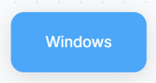

5. ATT&CK Techniques Used

Tactic | ID | Technique Name
Execution | T1059.003 | Windows Command Shell
Execution | T1059.005 | Visual Basic
Persistence | T1543.003 | Windows Service
Defense Evasion | T1140 | Decode Files or Information
Defense Evasion | T1027.011 | Fileless Storage
Defense Evasion | T1027.013 | Encrypted/Encoded File
Defense Evasion | T1070.004 | File Deletion
Defense Evasion | T1686.003 | Modify Windows Firewall
Discovery | T1083 | File and Directory Discovery
Discovery | T1680 | Local Storage Discovery
Command & Control | T1571 | Non-Standard Port
Command & Control | T1090 | Proxy
Command & Control | T1105 | Ingress Tool Transfer
User Execution | T1204.002 | Malicious File
Persistence | T1112 | Modify Registry

6. Execution Method
TYPEFRAME is typically delivered through malicious Microsoft Word documents containing VBA macros (T1059.005). The victim is prompted to enable macro execution, after which the malware begins execution on the compromised Windows host.

Once active, TYPEFRAME deploys encoded and encrypted payloads that are decrypted during runtime using RC4 and XOR-based routines (T1140, T1027.013). The malware then installs malicious DLL modules, creates Windows services for persistence (T1543.003), and modifies registry locations to store encrypted configuration data (T1112).
TYPEFRAME can execute commands using Windows Command Shell (cmd.exe) (T1059.003), transfer files between the victim and attacker systems (T1105), and open Windows Firewall rules to allow remote incoming connections (T1686.003).
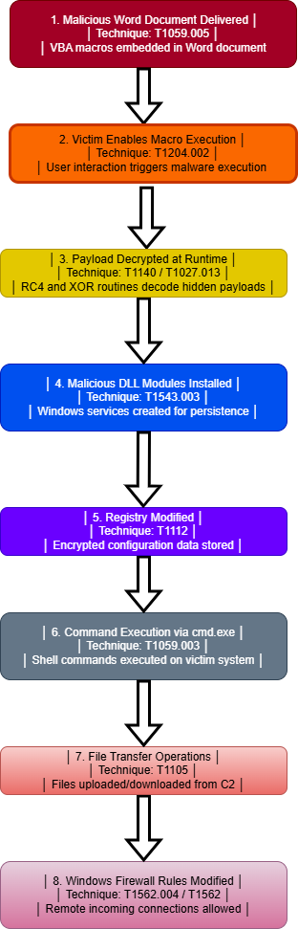

7. Persistence Techniques
TYPEFRAME deploys multiple persistence mechanisms to maintain long-term access on compromised systems.
The malware can install malicious DLL modules as Windows services (T1543.003), enabling automatic execution during system startup. It also stores encrypted configuration data within Windows Registry locations (T1112), allowing the malware to preserve operational settings across reboots.

Method | Technique | Detail
Windows Services | T1543.003 | Creates malicious Windows services
Registry Modification | T1112 | Stores encrypted configuration data in Registry

8. Privilege Escalation
No dedicated privilege escalation technique has been publicly documented for TYPEFRAME. However, creation of Windows services and firewall modification operations may require elevated privileges on the compromised host.

Detail | Explanation
No Explicit Escalation | No dedicated escalation exploit publicly documented
Elevated Operations | Service creation and firewall changes may require administrator access

9. Defense Evasion
TYPEFRAME deploys several defense evasion mechanisms designed to avoid endpoint detection and complicate forensic analysis.
Encrypted Payloads
The malware uses RC4 encryption and XOR encoding to protect malicious payloads and configuration data.
Fileless Storage
Encrypted configuration data may be stored directly inside Registry locations to reduce file-based detection visibility.
File Deletion
TYPEFRAME can delete files from the victim system to remove forensic evidence after execution.
Firewall Modification
The malware can modify Windows Firewall settings to allow remote connections and bypass local security controls.

Layer | Technique | Detail
Payload Encryption | T1027.013 | Uses RC4 and XOR encoded payloads
Runtime Decryption | T1140 | Decrypts payloads during execution
Fileless Storage | T1027.011 | Stores encrypted data inside Registry
File Deletion | T1070.004 | Deletes files to remove evidence
Firewall Modification | T1686.003 | Opens firewall rules for remote access

10. Credential Access
No dedicated credential theft functionality has been publicly documented for TYPEFRAME.

Detail | Explanation
No Direct Credential Theft | Credential harvesting capability not publicly observed
Primary Function | Remote access and espionage operations

11. Discovery Techniques
TYPEFRAME deploys multiple discovery techniques to gather information about the compromised system.
The malware can enumerate files and directories (T1083) and collect local storage information including disk volume details (T1680).

Method | Technique | Detail
File Discovery | T1083 | Searches directories and files
Local Storage Discovery | T1680 | Collects disk volume information

12. Lateral Movement
No direct lateral movement capability has been publicly documented for TYPEFRAME. However, the malware can deploy proxy functionality (T1090), enabling compromised systems to relay attacker traffic and potentially support lateral operations.

Detail | Explanation
No Explicit Lateral Movement | No propagation mechanism publicly documented
Proxy Capability | T1090 may assist indirect lateral operations

13. Command & Control (C2)
TYPEFRAME communicates with attacker-controlled infrastructure using encrypted communications over non-standard ports such as 443, 8080, and 8443 (T1571).
The malware also supports proxy functionality (T1090) and file transfer operations (T1105), enabling remote command execution and operational control.

Method | Technique | Detail
Non-Standard Ports | T1571 | Uses ports 443, 8080, and 8443
Proxy Functionality | T1090 | Compromised host can act as proxy
File Transfer | T1105 | Uploads and downloads files

14. Exfiltration
TYPEFRAME supports upload and download operations between attacker-controlled systems and the compromised host. This capability may be used to exfiltrate sensitive files during espionage operations.

Method | Technique | Detail
File Transfer | T1105 | Uploads stolen files to attacker infrastructure
Remote Access | T1059.003 | Supports remote command execution

15. Impact Analysis
TYPEFRAME provides attackers with long-term remote access and operational control over compromised Windows systems. Its persistence mechanisms, encrypted communications, and stealth-focused design make it highly effective for cyber espionage operations.
Successful compromise may result in:
- remote attacker access
- persistent system compromise
- sensitive file theft
- covert command execution
- long-term espionage activity

Impact Type | Technique | Detail
Persistent Access | T1543.003 | Creates malicious Windows services
Stealth Operations | T1027.011 | Stores encrypted data inside Registry
Remote Command Execution | T1059.003 | Executes attacker-controlled shell commands
Data Theft | T1105 | Transfers files between victim and attacker
Defense Evasion | T1070.004 | Deletes files to reduce forensic evidence

16. Indicators of Compromise (IOCs)
File System IOCs
IOC | Detail
Suspicious DLL services | Malicious Windows service modules
Malicious Word documents | Documents containing VBA macros
Deleted temporary files | Possible evidence cleanup activity

Behavioral IOCs
IOC | Detail
cmd.exe spawned from Office | Possible macro-based execution
Firewall rule modification | Unauthorized firewall changes
Service creation activity | Unexpected Windows service installation
Registry modification | Encrypted configuration storage

Network IOCs
IOC | Detail
Connections over ports 8080/8443 | Non-standard encrypted C2 traffic
FakeTLS communications | Suspicious encrypted sessions
Outbound beaconing | Communication with attacker infrastructure

17. Detection & Mitigation
Detection Methods
Method | Technique | Detail
Office Macro Monitoring | T1059.005 | Detect malicious VBA execution
Registry Monitoring | T1112 | Alert on suspicious Registry modifications
Service Creation Detection | T1543.003 | Monitor unauthorized Windows service creation
Firewall Change Monitoring | T1686.003 | Detect unexpected firewall modifications
Behavioral EDR | T1059.003 | Detect suspicious cmd.exe execution from Office

Mitigation Methods
Method | Detail
Disable Office Macros | Block unsigned VBA macros by default
Application Allowlisting | Prevent execution of unauthorized binaries and DLLs
EDR Behavioral Detection | Detect suspicious service creation and process execution
Registry Monitoring | Alert on suspicious Registry key modifications
Email Security Gateway | Sandbox malicious Office attachments and phishing emails
Network Monitoring | Monitor outbound traffic over non-standard ports

18. References & Sources
# | Author | Title | Year | Source
1 | MITRE ATT&CK | S0474 — TYPEFRAME | 2026 | MITRE ATT&CK TYPEFRAME Entry
2 | US-CERT | MAR-10135536-12 – North Korean Trojan: TYPEFRAME | 2018 | US-CERT Advisory
3 | MITRE ATT&CK | Lazarus Group Profile | 2026 | MITRE ATT&CK Group

