6. S0475 - BackConfig

1. Name & Type
Name | BackConfig
ATT&CK ID | S0475
Type | Malware — Modular Custom Trojan (Plugin Architecture)
Also Known As | Used by Patchwork / Hangover Group
Version | 1.0
Created | 13 July 2020 (MITRE entry)
Last Modified | 16 April 2025

2. Description
BackConfig is a custom Trojan with a flexible plugin architecture used by the Patchwork threat actor group (also known as the Hangover Group). Its modular design allows operators to load additional plugins to expand capabilities — minimizing on-disk footprint by loading only the modules needed for specific operations. BackConfig uses HTTPS for encrypted C2 communications, blending with legitimate web traffic. Updated versions have targeted government and military organizations in South Asia, consistent with Patchwork's geopolitical focus.

Key Characteristics
- Plugin architecture — extensible by loading additional capability modules
- HTTPS-based C2 — all communications encrypted, blending with legitimate traffic
- Minimal on-disk footprint — only necessary plugins loaded per operation
- Targets government and military organizations in South Asia
- Delivered via spearphishing with customized lure content

3. Threat Actor Association
Threat Actor | Patchwork (Hangover Group)
Also Known As | Dropping Elephant, Chinastrats, Monsoon
Origin | South Asia-nexus APT
Active Since | At least 2015
Motive | Cyber Espionage — intelligence collection against South Asian geopolitical targets
Primary Targets | Government, military organizations in South Asia (Pakistan, China, surroundings)

4. Supported Platforms
Platform | Notes
Windows | All known BackConfig variants target Windows environments

5. ATT&CK Techniques Used
Tactic | ID | Technique Name
Initial Access | T1566 | Phishing — spearphishing targeting government and military organizations
Execution | T1059 | Command and Scripting Interpreter — executes attacker commands on compromised hosts
Execution | T1204 | User Execution — victim opens malicious attachment
C2 | T1071.001 | Application Layer Protocol: Web Protocols — HTTPS-based encrypted C2
C2 | T1105 | Ingress Tool Transfer — plugin retrieval from C2 server
Discovery | T1082 | System Information Discovery — collects system info for operator reconnaissance

Attack Chain Flow Diagram
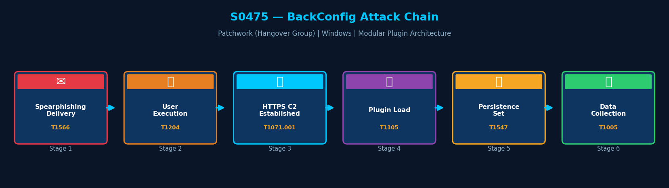
Figure: BackConfig attack chain with MITRE ATT&CK technique IDs

6. Execution Method
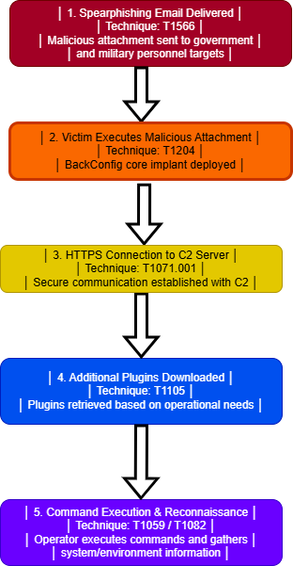
BackConfig is delivered via spearphishing targeting South Asian government and military personnel. On execution, it establishes HTTPS communication with its C2 server and can load additional plugins tailored to the specific operational requirements of the target environment.

7. Persistence Techniques
BackConfig achieves persistence through plugins loaded from its C2 server. Common persistence mechanisms delivered via plugins include Registry Run keys and scheduled tasks, tailored to the specific target environment.

Method | Technique | Detail
Registry Run Keys (via plugin) | T1547.001 | Persistence plugin sets Registry Run key for automatic startup
Scheduled Tasks (via plugin) | T1053.005 | Scheduled task plugin establishes regular re-execution
Plugin-Based Approach | — | Core implant delegates persistence to dynamically loaded plugins

8. Privilege Escalation
Detail | Explanation
No Explicit Escalation in Core | BackConfig core does not perform privilege escalation
Plugin-Delivered Escalation | Privilege escalation may be delivered via specialized plugins
Initial Access Vector | Spearphishing to government staff may provide elevated account access

9. Defense Evasion
BackConfig uses HTTPS to encrypt all C2 traffic, blending with legitimate web communications. The plugin architecture minimizes on-disk footprint — only the core implant and active plugins are present. Loading only necessary modules per operation reduces the detectable attack surface.

Layer | Technique | Detail
HTTPS Encryption | T1071.001 | All C2 traffic HTTPS-encrypted — indistinguishable from legitimate web traffic
Minimal Footprint | — | Plugin architecture — only active modules present on disk at any time
Selective Plugin Loading | — | Only plugins needed for current operation loaded — reduces detection surface

10. Credential Access
Method | Technique | Detail
Via Credential Plugin | T1555 | Credential theft capability may be delivered via specialized plugin
System Reconnaissance | T1082 | System information collection may include credential-related data
Delegates to Plugin | — | Core BackConfig does not have built-in credential theft — plugin-dependent

11. Discovery Techniques
BackConfig collects system information (T1082) from compromised hosts to support operator reconnaissance and targeting decisions. Additional discovery may be provided via plugins.

What It Discovers | Technique | Method
System Information | T1082 | Collects OS info, hostname, hardware, installed software details
Plugin-Extended Discovery | — | Additional discovery capabilities may be loaded via plugins from C2

12. Lateral Movement
BackConfig's core does not include lateral movement capability. The plugin architecture may enable operators to load lateral movement plugins as needed.

Detail | Explanation
No Core Lateral Movement | BackConfig core deploys no built-in lateral movement technique
Plugin Architecture | Additional lateral movement plugins may be loaded from C2 server
HTTPS C2 as Pivot | TLS-encrypted channel could be used to tunnel traffic for pivot purposes

13. Command & Control (C2)
BackConfig uses HTTPS for all C2 communications, encrypting traffic to evade network-layer inspection. The plugin architecture allows C2 functionality to be updated without redeploying the core implant.

Method | Technique | Detail
HTTPS | T1071.001 | All C2 communications HTTPS-encrypted — blends with legitimate web traffic
Plugin Retrieval | T1105 | Additional plugins downloaded from C2 server as needed
Dynamic Updates | — | Core implant updated via plugin delivery without full redeployment

14. Exfiltration
Method | Technique | Detail
HTTPS C2 Channel | T1071.001 | Data exfiltrated through HTTPS C2 communications — encrypted in transit
Plugin-Based Collection | T1005 | Data collection performed by loaded plugins and transmitted via HTTPS C2
What is Stolen | — | Government documents, credentials, system intelligence from South Asian targets

15. Impact Analysis
BackConfig has targeted South Asian government and military entities, providing Patchwork with a persistent, adaptable presence enabling intelligence collection against geopolitical targets. Its plugin architecture allows escalation of capability over time without redeployment.

Impact Type | Technique | Detail
Espionage | T1005 | Long-term covert intelligence collection from government and military targets
Credential Theft (via plugin) | T1555 | Credentials stolen via plugin modules deployed to target environment
Persistent Access | T1547.001 | Persistence via plugins ensures long-term foothold
Adaptable Capability | — | Plugin architecture allows escalation without redeployment

16. Indicators of Compromise (IOCs)

File System IOCs
IOC | Detail
Unknown DLL in non-system directory | Unusual plugin or DLL file loaded by core Trojan process
Core BackConfig executable | Executable dropped in unexpected path following spearphishing

Behavioral IOCs
IOC | Detail
HTTPS connections to unknown endpoints | Core implant establishing HTTPS sessions to non-recognized infrastructure
DLL loading from %APPDATA% | Unexpected DLL loaded from user-writable directory by running process

Network IOCs
IOC | Detail
HTTPS to unknown infrastructure | Encrypted connections to attacker-controlled server not matching known services
Regular HTTPS beaconing | Periodic encrypted requests to same external IP — C2 check-in pattern

17. Detection & Mitigation

Detection Methods
Method | Technique | Detail
SSL Inspection | T1071.001 | Deploy TLS inspection to detect C2 beacon patterns in HTTPS traffic
DLL Load Monitoring | T1105 | Monitor DLL loads from non-system directories via Sysmon Event ID 7
Application Control | — | Block unsigned executables via AppLocker or Windows Defender Application Control
Email Gateway | T1566 | Block spearphishing attachments targeting government organization domains

Mitigation Methods
Method | Detail
SSL/TLS Inspection | Deploy TLS inspection on perimeter to identify encrypted C2 patterns
Application Allowlisting | Block unsigned DLL loading and executable deployment
Email Security Gateway | Block spearphishing with malicious attachments targeting government targets
EDR with Plugin Detection | Deploy EDR rules to detect unusual DLL loading by processes

Overall Defensive Posture
BackConfig's HTTPS encryption and plugin architecture make both network and endpoint detection challenging. A layered approach combining TLS inspection, application allowlisting, and behavioral EDR rules provides the best defensive coverage.

18. References & Sources
# | Author / Source | Title | URL
1 | MITRE ATT&CK | S0475 — BackConfig | https://attack.mitre.org/software/S0475/
2 | Unit 42 (Palo Alto) | Updated BackConfig Malware Targeting South Asia (May 2020) | https://unit42.paloaltonetworks.com/
3 | MITRE ATT&CK | Group G0040 — Patchwork | https://attack.mitre.org/groups/G0040/

