7. S0476 - Valak

1. Name & Type
Name | Valak
ATT&CK ID | S0476
Type | Malware — Multi-Stage Modular Malware / Enterprise Information Stealer
Also Known As | Associated with TA551 (SHATHAK) / ConfCrew / Gozi operator ecosystem
Version | 30+ versions documented
Created | 13 July 2020 (MITRE entry)
Last Modified | 16 April 2025

2. Description
Valak is a sophisticated multi-stage modular malware first observed in late 2019, initially classified as a loader but later identified as a full-capability enterprise information stealer. It specializes in Microsoft Exchange server credential theft and domain certificate exfiltration. Over 30 versions were released in approximately 6 months, reflecting aggressive professional development. Valak stores payloads in the Windows Registry and as Alternate Data Streams (ADS) — both less visible than on-disk files. It explicitly abandoned PowerShell in later versions to evade PowerShell-based detection tools. Distributed alongside banking trojans Ursnif (Gozi) and IcedID.

Key Characteristics
- Steals Microsoft Exchange credentials and domain certificates via the exchgrabber plugin
- Stores payloads and config in Windows Registry and Alternate Data Streams — avoids on-disk files
- Explicitly abandoned PowerShell to evade PowerShell-based detections
- 30+ versions in under 6 months — rapid professional development
- Distributed alongside Ursnif and IcedID banking trojans

3. Threat Actor Association
Threat Actor | TA551 (SHATHAK) / ConfCrew / Gozi Operator Ecosystem
Classification | Financially Motivated Cybercriminal
Active Since | Late 2019
Primary Targets | US and German enterprises — Microsoft Exchange environments
Motive | Financial — credential theft, corporate espionage, banking trojan delivery
Associated Malware | Ursnif (Gozi), IcedID

4. Supported Platforms
Platform | Notes
Windows | All Valak variants target Windows enterprise environments — Exchange server focus

5. ATT&CK Techniques Used
Tactic | ID | Technique Name
Initial Access | T1566.001 | Spearphishing Attachment — Word documents with macros in target's native language
Execution | T1059.007 | JavaScript — ADS-stored JS executed via wscript.exe
Persistence | T1053.005 | Scheduled Task — wscript.exe scheduled task for persistence
Persistence | T1112 | Modify Registry — C2, config, payloads stored in HKCU\...\Appsw64
Defense Evasion | T1027 | Obfuscated Files or Information — ADS storage, obfuscated JS
Defense Evasion | T1564.004 | Hide Artifacts: NTFS File Attributes — Alternate Data Streams
Credential Access | T1552.001 | Credentials in Files — Exchange credentials via exchgrabber plugin
Discovery | T1087 | Account Discovery — enumerates local admin accounts
Exfiltration | T1041 | Exfiltration Over C2 Channel — credentials and certs exfiltrated over HTTP

Attack Chain Flow Diagram
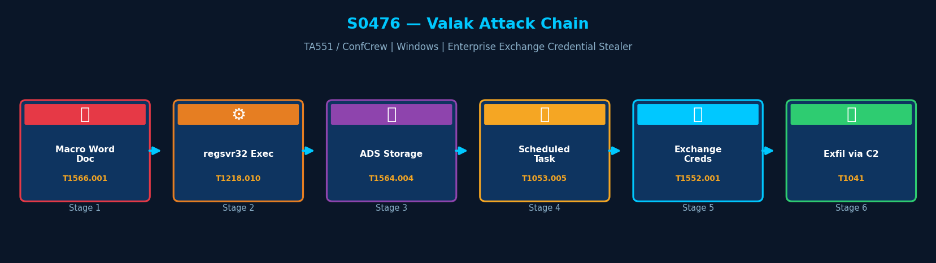
Figure: Valak attack chain with MITRE ATT&CK technique IDs

6. Execution Method
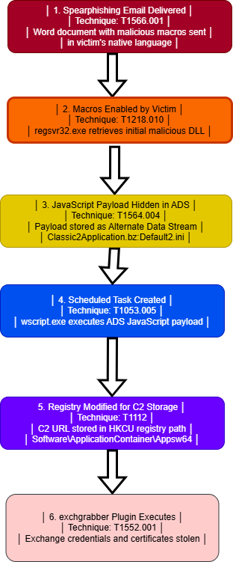
Valak campaigns begin with a spearphishing email containing a Microsoft Word document with malicious macros, written in the target's native language to increase open rates. When macros are enabled, regsvr32.exe retrieves an initial DLL. Subsequent stages use JavaScript stored as Alternate Data Streams executed by wscript.exe.

7. Persistence Techniques
Valak creates a scheduled task that executes wscript.exe to run JavaScript stored as an Alternate Data Stream (Default2.ini). C2 details and configuration are stored in the Windows Registry under HKCU\Software\ApplicationContainer\Appsw64. This dual persistence mechanism (scheduled task + registry) ensures reliable re-execution.

Method | Technique | Detail
Scheduled Task | T1053.005 | Task executes wscript.exe with ADS JavaScript file — runs on schedule
Registry Modification | T1112 | C2 URL and config stored in HKCU\Software\ApplicationContainer\Appsw64
ADS Storage | T1564.004 | JavaScript payload stored as Alternate Data Stream — invisible to standard dir listing

8. Privilege Escalation
Detail | Explanation
No Explicit Escalation | Valak operates with victim account privileges
HKCU Registry Access | Scheduled task and Registry modifications use HKCU — no admin required
Exchange Access | exchgrabber plugin accesses Exchange via Credential Manager — requires user-level credentials

9. Defense Evasion
Valak employs multiple advanced evasion techniques. It stores payloads as Alternate Data Streams and in the Windows Registry — both less visible than on-disk files. It explicitly abandoned PowerShell in later versions to avoid PowerShell-based detection tools. It checks the geographic location of infected machines, targeting only US and German enterprise environments.

Layer | Technique | Detail
ADS Storage | T1564.004 | Payloads stored as Alternate Data Streams — invisible to standard file listings
Registry Storage | T1112 | C2 and config stored in Windows Registry — no additional on-disk files
No PowerShell | T1027 | Explicitly abandoned PowerShell to evade PowerShell-based detection tools
Geo-Targeting | — | Checks victim location — only activates in US and German enterprise environments

10. Credential Access
Method | Technique | Detail
exchgrabber plugin | T1552.001 | Enumerates Exchange credentials from Windows Credential Manager
autodiscover.xml harvest | T1552.001 | Harvests Exchange server details and domain certificates
clientgrabber plugin | T1552.001 | Steals email credentials stored in the Windows Registry
2FA Reading | — | Can read Google Authenticator codes displayed on screen

11. Discovery Techniques
Valak enumerates local administrator accounts (T1087) on compromised hosts to support privilege escalation and credential theft planning.

What It Discovers | Technique | Method
Local Admin Accounts | T1087 | Enumerates local admin accounts on compromised host
Exchange Configuration | T1082 | autodiscover.xml provides Exchange server topology information

12. Lateral Movement
Valak does not perform lateral movement directly. However, the Exchange credentials and domain certificates it steals can enable lateral movement through email-based attacks, credential reuse, or domain certificate abuse.

Detail | Explanation
No Direct Lateral Movement | Valak itself deploys no lateral movement technique
Credential-Enabled Lateral Access | Stolen Exchange credentials and domain certs may enable lateral movement by operators
Distributed with IcedID | Companion IcedID banking trojan may perform lateral movement in broader campaign

13. Command & Control (C2)
Valak uses HTTP C2 to communicate with over 50 known servers across its versions. The C2 URL is stored in the Windows Registry under HKCU\Software\ApplicationContainer\Appsw64\ServerUrl, read dynamically by the scheduled task.

Method | Technique | Detail
HTTP C2 | T1071.001 | Communications to 50+ known C2 servers across Valak versions
Registry-Stored URL | T1112 | C2 URL in HKCU\Software\ApplicationContainer\Appsw64\ServerUrl
Plugin Communication | T1105 | exchgrabber and clientgrabber plugins communicate via same C2 channel

14. Exfiltration
Method | Technique | Detail
HTTP C2 Exfiltration | T1041 | Stolen credentials and certificates exfiltrated over HTTP C2 channel
What is Stolen | — | Exchange credentials, domain certificates, email account credentials
Scope | — | US and German enterprise Exchange environments — high-value credential targets

15. Impact Analysis
Valak is a severe enterprise threat. Stolen Exchange credentials enable full email account takeover, impersonation of executives, and delivery of banking trojans. Domain certificate theft enables man-in-the-middle attacks on internal encrypted communications. Its rapid evolution (30+ versions) makes sustained signature-based defense ineffective.

Impact Type | Technique | Detail
Exchange Credential Theft | T1552.001 | Full Exchange account takeover enabling email surveillance and BEC
Domain Certificate Theft | T1552.001 | Domain certs enable MitM attacks on internal encrypted communications
Banking Trojan Delivery | T1105 | Delivers Ursnif and IcedID for financial fraud alongside espionage
Enterprise Email Compromise | T1041 | Stolen credentials used for Business Email Compromise operations

16. Indicators of Compromise (IOCs)

File System IOCs
IOC | Detail
Classic2Application.bz:Default2.ini | ADS file deployed in C:\Users\Public\ — key persistence indicator
HKCU\Software\ApplicationContainer\Appsw64 | Registry key storing C2 URL, config, and payloads

Behavioral IOCs
IOC | Detail
Scheduled task running wscript.exe | Scheduled task executing wscript.exe with ADS file as argument
regsvr32.exe spawned by Office | Microsoft Office process spawning regsvr32.exe — macro execution indicator
Keychain API calls from Office | Credential Manager access from Office-related processes

Network IOCs
IOC | Detail
HTTP to known Valak C2 servers | HTTP traffic to 50+ known Valak C2 server IPs and domains
Regular HTTP beaconing from wscript.exe | wscript.exe making periodic HTTP connections to external IPs

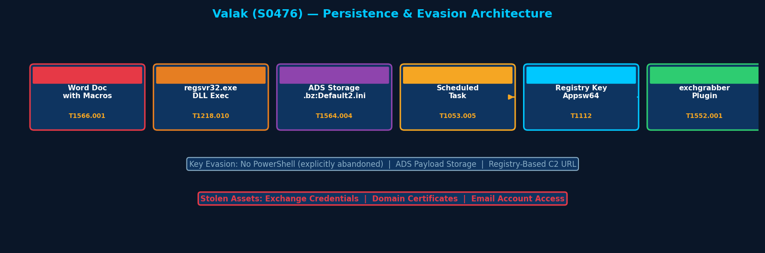
Figure: Valak persistence and evasion architecture — ADS storage, Registry C2, Scheduled Task

17. Detection & Mitigation

Detection Methods
Method | Technique | Detail
Scheduled Task Monitoring | T1053.005 | Alert on scheduled tasks executing wscript.exe with ADS file arguments (Sysmon)
ADS Detection | T1564.004 | Detect Alternate Data Stream creation in C:\Users\Public\ (Sysmon Event ID 15)
Registry Alert | T1112 | Alert on modifications under HKCU\Software\ApplicationContainer (SIEM)
Macro Policy | T1566.001 | Disable Office macros by policy or restrict to signed macros only (GPO)
Exchange Credential Monitor | T1552.001 | Alert on Credential Manager access from unexpected processes

Mitigation Methods
Method | Detail
Disable Office Macros | Disable macros by GPO or restrict to digitally signed macros only
ADS Monitoring | Enable Sysmon Event ID 15 to detect Alternate Data Stream creation
Registry Monitoring | Deploy SIEM rules alerting on HKCU\Software\ApplicationContainer modifications
SSL Inspection | Inspect outbound HTTP from wscript.exe and Office processes
Exchange Hardening | Enable MFA on Exchange accounts — limit credential theft impact

Overall Defensive Posture
Valak's combination of ADS storage, Registry-based C2, and deliberate PowerShell avoidance make it one of the more evasion-capable malware families in this report. Behavioral detection at the scheduled task creation and ADS creation events provides the highest-value detection opportunities.

18. References & Sources
# | Author / Source | Title | URL
1 | MITRE ATT&CK | S0476 — Valak | https://attack.mitre.org/software/S0476/
2 | Cybereason | Valak: More than Meets the Eye (May 2020) | https://www.cybereason.com/
3 | SentinelLabs | Valak and the Connection to Gozi Loader ConfCrew (2020) | https://www.sentinelone.com/
4 | Unit 42 | Evolution of Valak (2020) | https://unit42.paloaltonetworks.com/

