8. S0477 - Goopy

1. Name & Type
Name | Goopy
ATT&CK ID | S0477
Type | Malware — Windows Backdoor / Trojan
Also Known As | Shares code similarities with Denis backdoor — both used by APT32
Version | 1.0
Created | 13 July 2020 (MITRE entry)
Last Modified | 16 April 2025

2. Description
Goopy is a Windows backdoor used by APT32 (OceanLotus), named for its masquerading of the legitimate Google Updater executable (googleupdate.exe). This impersonation causes Goopy to appear as a benign Google system process in process listings, task managers, and security tools that allowlist known Google binaries. It shares code similarities with APT32's Denis backdoor and was deployed in Operation Cobalt Kitty — a major APT32 campaign against large Asian corporations. APT32 is a Vietnam-nexus threat group targeting private sector, government, journalists, and dissidents.

Key Characteristics
- Masquerades as legitimate Google Updater executable (googleupdate.exe)
- HTTP-based C2 communications — blends with normal web traffic
- Shares code similarities with APT32's Denis backdoor
- Deployed in Operation Cobalt Kitty against Asian corporations
- May bypass security tools that allowlist known Google processes

3. Threat Actor Association
Threat Actor | APT32 (OceanLotus)
MITRE ID | G0050
Also Known As | OceanLotus, SeaLotus, Canvas Cyclone, BISMUTH, ATK17
Origin | Vietnam — state-linked espionage group
Active Since | At least 2014
Motive | Cyber Espionage — corporate intelligence, government surveillance, dissident targeting
Past Operations | Operation Cobalt Kitty, Operation OceanSalt

4. Supported Platforms
Platform | Notes
Windows | All known Goopy variants target Windows environments

5. ATT&CK Techniques Used
Tactic | ID | Technique Name
Initial Access | T1566 | Phishing — spearphishing or watering-hole initial access
Execution | T1204 | User Execution — victim executes initial payload
Defense Evasion | T1036 | Masquerading — impersonates legitimate Google Updater executable
Defense Evasion | T1055 | Process Injection — code injection into legitimate processes for stealth
C2 | T1071.001 | Application Layer Protocol: Web Protocols — HTTP-based C2
Collection | T1005 | Data from Local System — collects and stages data for exfiltration
Discovery | T1082 | System Information Discovery — system and environment reconnaissance

Attack Chain Flow Diagram
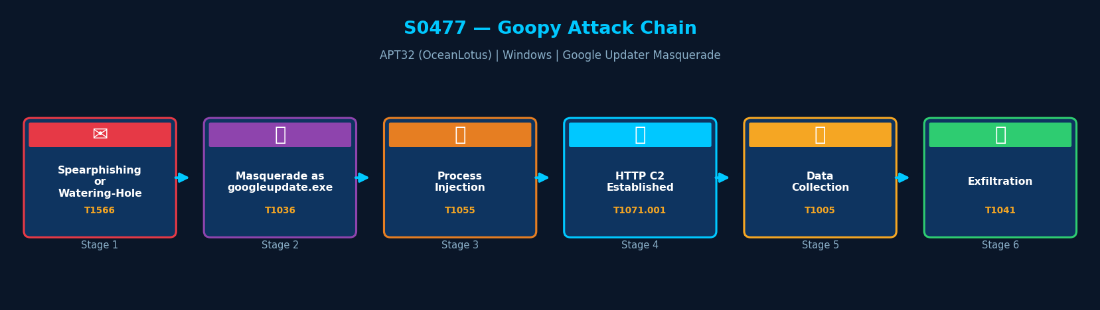
Figure: Goopy attack chain with MITRE ATT&CK technique IDs

6. Execution Method
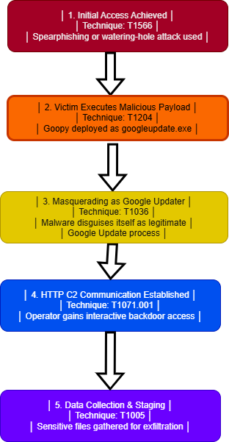
Goopy is deployed within APT32's broader intrusion chain following initial access via spearphishing or watering-hole attacks. It impersonates the Google Updater process and establishes an HTTP-based backdoor. APT32 may inject Goopy code into legitimate processes to further reduce its detection profile.

7. Persistence Techniques
APT32 uses multiple persistence mechanisms across its toolset. Goopy, by masquerading as googleupdate.exe, may leverage scheduled tasks or autorun entries that mimic legitimate Google Update behavior to survive reboots.

Method | Technique | Detail
Masquerade-Based Persistence | T1036 | Process named googleupdate.exe may be set in autorun mimicking Google Update
Scheduled Task (likely) | T1053 | Scheduled task mimicking Google Update check behavior for persistence
APT32 Toolkit | — | Other APT32 tools in same intrusion provide additional persistence mechanisms

8. Privilege Escalation
Detail | Explanation
No Explicit Escalation | Goopy does not document explicit privilege escalation techniques
Process Injection | T1055 — injection into privileged processes may grant elevated access
APT32 Toolkit | Other APT32 tools in the intrusion may perform privilege escalation

9. Defense Evasion
Goopy's primary evasion technique is masquerading as the legitimate Google Updater executable (T1036). This may bypass security tools that allowlist known Google processes. Process injection further hides malicious activity within legitimate process contexts.

Layer | Technique | Detail
Masquerading | T1036 | Binary named googleupdate.exe — appears as legitimate Google system process
Process Injection | T1055 | Injects code into legitimate processes — hides within trusted process context
HTTP C2 | T1071.001 | C2 over HTTP — blends with normal web traffic patterns

10. Credential Access
Method | Technique | Detail
No Direct Credential Theft | — | Goopy does not include built-in credential theft modules
APT32 Toolkit | — | Other APT32 tools in the same intrusion perform credential harvesting
Data Collection | T1005 | System data including potential credential files may be collected and staged

11. Discovery Techniques
Goopy collects system information (T1082) from compromised hosts to support operator reconnaissance. Additional discovery may be performed manually by the operator through the HTTP backdoor.

What It Discovers | Technique | Method
System Information | T1082 | Collects OS info, hostname, hardware, and environment details
Manual Discovery | — | Operator performs additional discovery through interactive HTTP backdoor access

12. Lateral Movement
Goopy does not include explicit lateral movement capability. Lateral access within APT32 operations is performed by companion tools in the broader toolkit.

Detail | Explanation
No Direct Lateral Movement | Goopy deploys no built-in lateral movement technique
APT32 Toolkit | Other APT32 tools perform lateral movement in the same intrusion
Masquerade Pivot | googleupdate.exe masquerade may enable movement to systems with Google software whitelisted

13. Command & Control (C2)
Goopy uses HTTP for C2 communications, receiving operator instructions and exfiltrating collected data. This mirrors other APT32 backdoors and blends with normal web traffic patterns.

Method | Technique | Detail
HTTP | T1071.001 | HTTP-based C2 — operator instructions received and data exfiltrated
Blends with Traffic | — | HTTP C2 from a process named googleupdate.exe appears highly legitimate

14. Exfiltration
Method | Technique | Detail
HTTP C2 Exfiltration | T1071.001 | Staged local data exfiltrated through HTTP C2 channel
What is Stolen | T1005 | System information, sensitive local files, staged corporate intelligence data
APT32 Campaign Scope | — | Operation Cobalt Kitty: corporate espionage against large Asian corporations

15. Impact Analysis
Goopy was deployed in Operation Cobalt Kitty against large Asian corporations, enabling persistent access, lateral movement by companion tools, and long-term intelligence collection. APT32's targeting spans corporate espionage, government surveillance, and dissident monitoring.

Impact Type | Technique | Detail
Corporate Espionage | T1005 | Long-term persistent access enabling sustained data collection from Asian corporations
Persistent Backdoor | T1036 | Masquerade persistence makes eviction difficult without hash verification
Evasion of Allowlisting | — | Google process masquerade may bypass application allowlist controls

16. Indicators of Compromise (IOCs)

File System IOCs
IOC | Detail
googleupdate.exe in non-standard path | Process in %APPDATA% or unexpected path — not C:\Program Files (x86)\Google\Update\
Hash mismatch | Binary named googleupdate.exe with hash not matching legitimate Google file

Behavioral IOCs
IOC | Detail
googleupdate.exe making HTTP connections | Google Updater process initiating HTTP connections to unknown external IPs
Office or script process spawning googleupdate.exe | Unexpected parent process for googleupdate.exe

Network IOCs
IOC | Detail
HTTP C2 from googleupdate.exe | HTTP beacon traffic from process claiming to be Google Updater to unknown IPs

17. Detection & Mitigation

Detection Methods
Method | Technique | Detail
Path Validation | T1036 | Verify all googleupdate.exe processes run from C:\Program Files (x86)\Google\Update\ only
Hash Verification | T1036 | EDR hash check — flag googleupdate.exe with non-Google hash
Network Monitor | T1071.001 | Alert on HTTP C2 patterns from processes impersonating system utilities
Process Tree Analysis | T1055 | Alert on unusual parent-child process relationships involving googleupdate.exe

Mitigation Methods
Method | Detail
File Integrity Monitoring | Monitor for googleupdate.exe outside legitimate Google path
Application Allowlisting | Enforce hash-based allowlisting — name alone insufficient to trust a binary
Network Monitoring | Alert on HTTP connections from googleupdate.exe to unfamiliar external IPs
EDR Behavioral Detection | Flag masquerading binaries using process path and hash validation rules

Overall Defensive Posture
Goopy's masquerading technique is particularly effective against name-based allowlisting tools. Hash-based verification of all googleupdate.exe instances is the most reliable countermeasure. The combination of path validation and hash checking in EDR provides strong detection coverage.

18. References & Sources
# | Author / Source | Title | URL
1 | MITRE ATT&CK | S0477 — Goopy | https://attack.mitre.org/software/S0477/
2 | Cybereason | Operation Cobalt Kitty — Dahan, A. (2017) | https://www.cybereason.com/
3 | MITRE ATT&CK | Group G0050 — APT32 | https://attack.mitre.org/groups/G0050/

