9. S0478 - EventBot

1. Name & Type
Name | EventBot
ATT&CK ID | S0478
Type | Malware — Android Banking Trojan / Information Stealer
Also Known As | Targets 200+ financial apps — PayPal, Revolut, Barclays, Coinbase, HSBC UK and more
Version | Multiple versions: 0.0.0.1 through 0.4.0.1
Created | 13 July 2020 (MITRE entry)
Last Modified | 16 April 2025

2. Description
EventBot is a sophisticated Android banking trojan discovered by Cybereason Nocturnus in March 2020. It abuses Android's Accessibility Service to steal data from over 200 financial applications including PayPal Business, Revolut, Barclays, UniCredit, CapitalOne UK, HSBC UK, Santander UK, TransferWise, Coinbase, and Paysafecard. EventBot intercepts SMS messages to bypass two-factor authentication (2FA), enabling full account takeover even for security-aware users. It targets users in the US and Europe and is distributed via malicious APK files outside the official Google Play Store, masquerading as Adobe Flash or Microsoft Word for Android.

Key Characteristics
- Abuses Android Accessibility Service to monitor all app interactions on device
- Steals credentials from 200+ financial apps — banking, crypto, money transfer
- Intercepts SMS messages — bypasses two-factor authentication (2FA)
- Masquerades as Adobe Flash or Microsoft Word for Android
- Distributed via malicious APK sideloading — not from Google Play Store
- Multiple versions observed — expanding capabilities across 0.0.0.1 to 0.4.0.1

3. Threat Actor Association
Threat Actor | Unknown — financially motivated cybercriminals
Attribution | No definitive attribution — newly developed malware family
Targets | US and European users — banking, cryptocurrency, money transfer app users
Motive | Financial — credential theft and full bank/crypto account takeover
First Identified | March 2020 (Cybereason Nocturnus)

4. Supported Platforms
Platform | Notes
Android | All versions target Android devices — abuses Android Accessibility Service

5. ATT&CK Techniques Used
Tactic | ID | Technique Name
Collection | T1417 | Input Capture — keylogging via Accessibility Service across 200+ financial apps
Collection | T1412 | Capture SMS Messages — intercepts SMS for 2FA code theft
Discovery | T1418 | Software Discovery — enumerates installed financial applications
Collection | T1533 | Data from Local System — steals financial app data via accessibility events
C2 | T1437 | Application Layer Protocol — HTTP-based C2 with gate parameter patterns
Collection | T1409 | Stored Application Data — accesses data in targeted financial apps

Attack Chain Flow Diagram
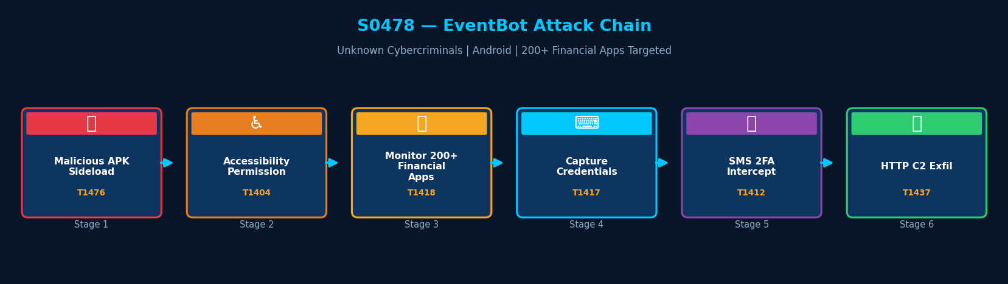
Figure: EventBot attack chain with MITRE ATT&CK technique IDs

6. Execution Method
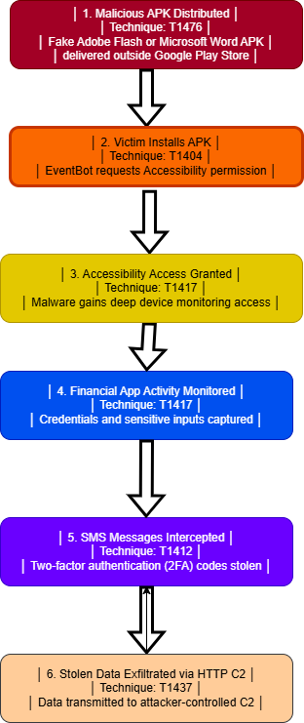
EventBot masquerades as a legitimate Android application (Adobe Flash, Microsoft Word) distributed via malicious APK files outside the official Google Play Store. After installation, it requests Accessibility Service permission. Once granted, it gains deep OS-level access to monitor all app interactions on the device.

7. Persistence Techniques
EventBot uses the RECEIVE_BOOT_COMPLETED Android permission to auto-launch after device reboot. It runs as a persistent background service continuously monitoring device activity.

Method | Technique | Detail
RECEIVE_BOOT_COMPLETED | T1402 | Android permission ensures EventBot launches automatically after device reboot
Background Service | — | Runs as persistent background service — continuous monitoring
Remote Config Updates | — | Dynamically updates targeted app list from C2 — no redeployment needed

8. Privilege Escalation
Detail | Explanation
Accessibility Service | Android Accessibility Service provides privileged access to all app interactions
No Root Required | EventBot operates without requiring device root — uses legitimate Android API
All App Access | Accessibility permission grants visibility into all apps on device — equivalent to full access

9. Defense Evasion
EventBot masquerades as legitimate applications (Adobe Flash, Microsoft Word) to reduce suspicion during installation. It dynamically updates its configuration and targeted app list remotely, avoiding redeployment when adding new target apps.

Layer | Technique | Detail
App Masquerading | — | Disguises as Adobe Flash or Microsoft Word — trusted names reduce suspicion
Dynamic Config Updates | — | Remotely updates targeted app list — no redeployment needed for new targets
Accessibility Abuse | T1417 | Uses legitimate Android API — not flagged as suspicious by OS itself

10. Credential Access
Method | Technique | Detail
Accessibility Keylogging | T1417 | Captures all credentials entered in 200+ financial apps via Accessibility events
SMS 2FA Interception | T1412 | Intercepts SMS 2FA codes — full bypass of multi-factor authentication
Stored App Data | T1409 | Accesses credential data stored within targeted financial applications

11. Discovery Techniques
EventBot enumerates all installed applications on the device to identify financial app targets and dynamically update its monitoring list based on what is installed.

What It Discovers | Technique | Method
Installed Financial Apps | T1418 | Enumerates all installed apps — identifies banking, crypto, and payment targets
App Version Info | T1418 | Collects version information to adapt exploitation approach per app

12. Lateral Movement
EventBot operates solely on the compromised Android device. It does not perform lateral movement to other devices or network systems.

Detail | Explanation
No Lateral Movement | EventBot has no lateral movement capability beyond the compromised device
Account Takeover Impact | Stolen credentials may enable attackers to access corporate systems via personal banking apps

13. Command & Control (C2)
EventBot communicates with its C2 server via HTTP. Identified C2 patterns include specific URL gate parameters. C2 servers observed include domains on GoDaddy hosting infrastructure.

Method | Technique | Detail
HTTP | T1437 | Primary C2 channel — HTTP requests with specific gate URL parameters
C2 Domains | — | ora.carlaarrabitoarchitetto[.]com, ora.studiolegalebasili[.]com
C2 IP | — | 31.214.157[.]6 — GoDaddy hosted infrastructure
URL Pattern | — | HTTP gate parameter: gate_cb8a5aea1ab302f0_c in request paths

14. Exfiltration
Method | Technique | Detail
HTTP Exfiltration | T1437 | Stolen credentials and 2FA codes exfiltrated via HTTP C2 channel
What is Stolen | — | Banking credentials, crypto wallet access, 2FA codes, financial app data
Targeted Apps | — | PayPal, Revolut, Barclays, HSBC UK, Coinbase, Paysafecard, 200+ others

15. Impact Analysis
EventBot can fully compromise online banking accounts, cryptocurrency wallets, and email/social media accounts. Its SMS 2FA interception defeats a common security control, making account takeover feasible even for security-aware users. On BYOD devices, it poses severe risk to both personal and corporate financial data.

Impact Type | Technique | Detail
Full Bank Account Takeover | T1417 | Credentials from 200+ banking apps enable complete account access
2FA Defeat | T1412 | SMS interception bypasses MFA on banking and crypto accounts
Crypto Wallet Drain | T1417 | Coinbase and wallet app credentials enable complete crypto asset theft
BYOD Corporate Risk | — | If installed on corporate BYOD device, corporate accounts at risk

16. Indicators of Compromise (IOCs)

File System IOCs
IOC | Detail
APK from outside Google Play | Adobe Flash or Microsoft Word APK installed from unknown source
Accessibility Service granted to unknown app | Unknown app with Accessibility Service permission active

Behavioral IOCs
IOC | Detail
Accessibility Service monitoring all apps | Unrecognized app monitoring all screen interactions continuously
SMS reading by non-SMS app | Financial app or Adobe Flash imitation reading all incoming SMS

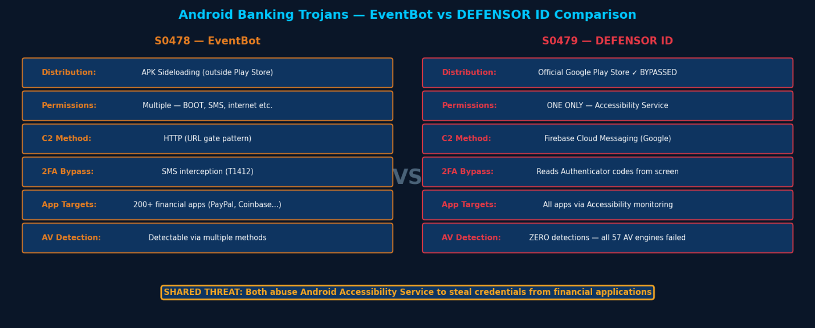
Network IOCs
IOC | Detail
HTTP to ora.carlaarrabitoarchitetto[.]com | Known EventBot C2 domain — block at DNS and network perimeter
HTTP to ora.studiolegalebasili[.]com | Known EventBot C2 domain — block at DNS and network perimeter
IP 31.214.157[.]6 | Known EventBot C2 IP address — block at network perimeter
Figure: EventBot vs DEFENSOR ID — Android banking trojan comparison

17. Detection & Mitigation

Detection Methods
Method | Technique | Detail
Accessibility Service Audit | T1417 | Review all apps with Accessibility Service access — revoke all unrecognized apps
APK Source Restriction | T1476 | Disable sideloading (unknown sources) via MDM policy on all devices
Network Block | T1437 | Block known EventBot C2 domains and IPs at DNS and network perimeter
MDM App Allowlisting | — | Use MDM to enforce app allowlisting on BYOD corporate devices

Mitigation Methods
Method | Detail
Disable Sideloading | Disable installation from unknown sources via MDM policy across all devices
Accessibility Service Controls | Restrict Accessibility Service grants to IT-approved applications only
Network Perimeter Blocks | Block known EventBot C2 domains and IPs at DNS, proxy, and firewall level
Mobile Threat Defense | Deploy MTD solution to detect anomalous Accessibility Service behavior
User Education | Train staff not to install apps from outside Google Play Store

Overall Defensive Posture
EventBot's use of the legitimate Android Accessibility Service API makes OS-level detection difficult. Defensive strategy must focus on preventing installation (sideloading restrictions), auditing Accessibility permissions, and blocking known C2 infrastructure at the network level.

18. References & Sources
# | Author / Source | Title | URL
1 | MITRE ATT&CK | S0478 — EventBot | https://attack.mitre.org/software/S0478/
2 | Cybereason | EventBot: A New Mobile Banking Trojan is Born (April 2020) | https://www.cybereason.com/
3 | India CERT | Android EventBot Malware Alert (May 2020) | https://www.cert-in.org.in/
4 | SecurityWeek | New EventBot Android Malware Targets Nearly 300 Financial Apps (2020) | https://www.securityweek.com/

