2. S0471 - build_downer
Field | Details
Software Name | build_downer
ATT&CK ID | S0471
Type | Malware — Downloader
Supported Platforms | Windows
Threat Actor Association | BRONZE BUTLER (TICK)
Main Purpose | First-stage download with self-persistence capability
ATT&CK Techniques | T1547.001, T1071.001, T1105, T1566

2. Description
build_downer is a BRONZE BUTLER downloader used since at least 2019, identified during Operation ENDTRADE. Unlike BBK, build_downer achieves its own persistence by writing itself to the Windows Registry Run key — making it self-sustaining across system reboots without relying on a secondary payload. Named after its PDB string, it uses HTTP for C2 communications. Its self-persistence capability makes it more operationally dangerous than BBK as a standalone implant, providing BRONZE BUTLER with a reliable long-term foothold in compromised environments.

Key Characteristics
- Self-persistence via Windows Registry Run key — survives reboots independently
- HTTP-based C2 communication — downloads second-stage payloads
- Named after PDB string — BRONZE BUTLER malware naming convention
- More persistent than BBK — does not need a secondary payload to re-establish execution
- Delivered via spearphishing using compromised legitimate email accounts

3. Threat Actor Association
Threat Actor | BRONZE BUTLER
MITRE ID | G0060
Also Known As | TICK, REDBALDKNIGHT, Swirl Typhoon
Origin | China — state-linked espionage group
Active Since | At least 2008
Motive | Cyber Espionage — classified data theft from Japanese defense and industrial sectors

4. Supported Platforms
Platform | Notes
Windows | Primary platform — all variants target Windows environments

5. ATT&CK Techniques Used
Tactic | ID | Technique Name
Initial Access | T1566 | Phishing — spearphishing via compromised legitimate email accounts
Execution | T1204 | User Execution — victim opens and runs initial payload
Persistence | T1547.001 | Registry Run Keys / Startup Folder — self-persistence on victim machine
C2 | T1071.001 | Application Layer Protocol: Web Protocols — HTTP-based C2
C2 | T1105 | Ingress Tool Transfer — downloads second-stage payloads from C2

Attack Chain Flow Diagram
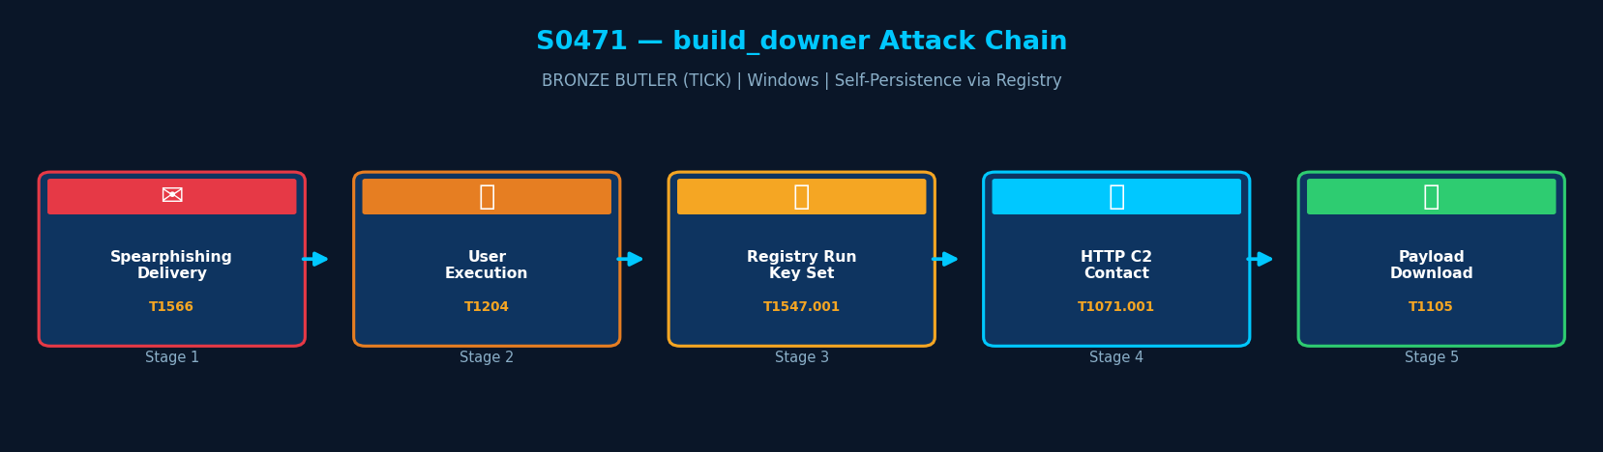Figure: build_downer attack chain with MITRE ATT&CK technique IDs

6. Execution Method
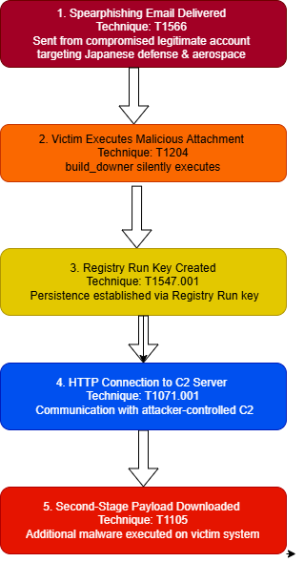
build_downer is delivered via spearphishing using compromised legitimate email accounts targeting Japanese defense and aerospace industries. On execution, it immediately writes a Registry Run key for persistence, then contacts its C2 server via HTTP to download and execute the second-stage payload
7. Persistence Techniques
No publicly documented persistence mechanism has been directly attributed to build_downer within MITRE ATT&CK reporting. Current assessments indicate the malware primarily functions as a temporary downloader responsible for deploying secondary payloads that later establish persistence.
Detail | Explanation
No Explicit Persistence | MITRE ATT&CK does not publicly document persistence behavior
Operational Role | Functions mainly as a payload delivery mechanism
Assessment | Persistence likely handled by secondary malware

8. Privilege Escalation
No explicit privilege escalation mechanism has been publicly associated with build_downer. The malware appears to operate using the privileges available within the compromised execution context.
Detail | Explanation
No Direct Escalation | No documented privilege escalation capability
Assessed Behavior | Operates using existing user permissions

9. Defense Evasion
build_downer deploys multiple defense evasion mechanisms designed to reduce detection by security tools and hinder malware analysis.
Layer 1 — Obfuscation
Payloads are stored in encoded or obfuscated form to complicate static malware analysis.
Layer 2 — Runtime Decryption
The malware decrypts malicious payloads only during execution, minimizing readable malicious content on disk.
Layer 3 — Process Injection
Malicious code is injected into legitimate Windows processes to blend malicious behavior with trusted system activity.
Layer | Technique | Detail
Obfuscation | T1027 | Uses obfuscated payload delivery
Runtime Decryption | T1140 | Decrypts malicious content during execution
Process Injection | T1055 | Injects into trusted Windows processes

10. Credential Access
Method | Technique | Detail
No Credential Access | — | build_downer does not perform credential theft
Delegates to Payload | — | Second-stage backdoors (Daserf, Datper) perform credential harvesting

11. Discovery Techniques
build_downer does not perform discovery operations. All host and network enumeration is conducted by the second-stage backdoors it downloads and executes.

Detail | Explanation | Technique
No Built-in Discovery | build_downer performs no host or network enumeration | —
Delegates to Payload | Daserf and Datper perform discovery after deployment | T1082, T1016

12. Lateral Movement
build_downer does not perform lateral movement. Lateral access is conducted by companion tools deployed after the second-stage backdoor is established.

Detail | Explanation
No Lateral Movement | build_downer deploys no lateral movement capability
Delegates to Payload | Second-stage tools handle lateral movement after deployment

13. Command & Control (C2)
build_downer uses HTTP to communicate with its C2 server, primarily to download and execute second-stage payloads. The C2 URL and server details are encoded in the binary, making static analysis via network indicators possible if hashes are available.

Method | Technique | Detail
HTTP | T1071.001 | Primary C2 channel — HTTP requests to attacker-controlled server
Ingress Tool Transfer | T1105 | Downloads and executes second-stage payloads from C2 server

14. Exfiltration
Method | Technique | Detail
No Exfiltration | — | build_downer does not collect or exfiltrate data
Delegates to Payload | — | Second-stage backdoors perform data collection and exfiltration

15. Impact Analysis
build_downer provides BRONZE BUTLER with a persistent, self-restarting downloader foothold that survives reboots. This enables reliable delivery of advanced backdoors over time, supporting long-term espionage operations against Japan's defense and industrial sector targets.

15. Impact Analysis
build_downer provides BRONZE BUTLER with a persistent, self-restarting downloader foothold that survives reboots. This enables reliable delivery of advanced backdoors over time, supporting long-term espionage operations against Japan's defense and industrial sector targets.

Impact Type | Technique | Detail
Persistent Foothold | T1547.001 | Self-persistence ensures access survives reboots independently
Espionage Gateway | T1105 | Delivers advanced backdoors enabling long-term classified data theft
Operational Resilience | — | One of four TICK downloaders — provides redundancy in case of detection

16. Indicators of Compromise (IOCs)

File System IOCs
IOC | Detail
Registry Run key entry | HKCU\Software\Microsoft\Windows\CurrentVersion\Run — unexpected new entry
PDB string artifacts | TICK malware PDB naming in process memory

Behavioral IOCs
IOC | Detail
Registry write on first execution | New Run key created immediately after unknown executable runs
HTTP outbound from %APPDATA% | Executable in user directory initiating HTTP beacon to unknown domain

Network IOCs
IOC | Detail
Regular HTTP beaconing | HTTP requests at regular intervals to previously-unseen external domain
Encoded payload in HTTP response | Encrypted second-stage PE delivered in HTTP response body

17. Detection & Mitigation

Detection Methods
Method | Technique | Detail
Registry Run Key Monitoring | T1547.001 | Alert on new Run key entries created by unknown or unsigned processes (Sysmon)
Outbound HTTP from %APPDATA% | T1071.001 | Monitor HTTP connections from executables in user-writable directories
Email Sandbox | T1566 | Sandbox all email attachments before delivery

Mitigation Methods
Method | Detail
Restrict Registry Write Access | Apply GPO to restrict Registry Run key modifications for standard users
AppLocker | Block unsigned binary execution from user-writable directories
Email Security Gateway | Block and sandbox compressed archive attachments from external senders
EDR Behavioral Detection | Deploy rules to flag Registry modification by newly-executed unknown processes

Overall Defensive Posture
build_downer's self-persistence via the Registry Run key makes it more resilient than BBK. Detection at the Registry write event (Sysmon Event ID 13) is the highest-value detection opportunity. Early blocking at the email gateway prevents delivery entirely.

18. References & Sources
# | Author / Source | Title | URL
1 | MITRE ATT&CK | S0471 — build_downer | https://attack.mitre.org/software/S0471/
2 | Trend Micro | Operation ENDTRADE (2019) | https://www.trendmicro.com/
3 | Secureworks | BRONZE BUTLER Threat Profile | https://www.secureworks.com/
4 | MITRE ATT&CK | Group G0060 — BRONZE BUTLER | https://attack.mitre.org/groups/G0060/

