1. S0470 - BBK
Field | Details
Software Name | BBK
ATT&CK ID | S0470
Type | Malware - Downloader
Supported Platforms | Windows
Threat Actor Association | BRONZE BUTLER (TICK, REDBALDKNIGHT, Swirl Typhoon)
Main Purpose | First-stage payload download and delivery
ATT&CK Techniques | T1071.001, T1105, T1566, T1204
Description
BBK is a first-stage downloader malware used by the APT group BRONZE BUTLER, also known as TICK, REDBALDKNIGHT, and Swirl Typhoon, since at least 2019. The malware was discovered during Operation ENDTRADE, a cyber espionage campaign mainly targeting defence, aerospace, chemical, and satellite companies in Japan.

The main purpose of BBK is to act as an initial infection tool. Once a system is infected, BBK connects to an attacker-controlled command-and-control (C2) server through HTTP communication and downloads additional malware onto the victim’s system. These second-stage malware tools include backdoors such as Daserf, Datper, and XXMM, which allow attackers to gain deeper access, steal information, and maintain control over infected networks.

BRONZE BUTLER uses multiple versions of downloader malware, including BBK, build_downer, down_new, and Avenger. These variants are designed with different antivirus evasion techniques so that if one version is detected by security software, the group can continue operations using another variant. This approach increases the group’s flexibility and helps maintain long-term access to targeted systems.

Threat Actor
Field | Detail
Threat Actor | BRONZE BUTLER
Also Known As | TICK, REDBALDKNIGHT, Swirl Typhoon
Origin | Assessed East Asian threat actor
Motivation | Cyber Espionage
Primary Targets | Defence, Aerospace, Government, Satellite Industries
Campaign | Operation ENDTRADE
Activity Period | At least 2019 — Present

ATT&CK Technique Used
Tactic | ID | Technique Name
Initial Access | T1566 | Phishing — spearphishing via compromised legitimate email accounts
Execution | T1204 | User Execution — victim opens and runs initial payload
C2 | T1071.001 | Application Layer Protocol: Web Protocols — HTTP-based C2
C2 | T1105 | Ingress Tool Transfer — downloads second-stage backdoors from C2

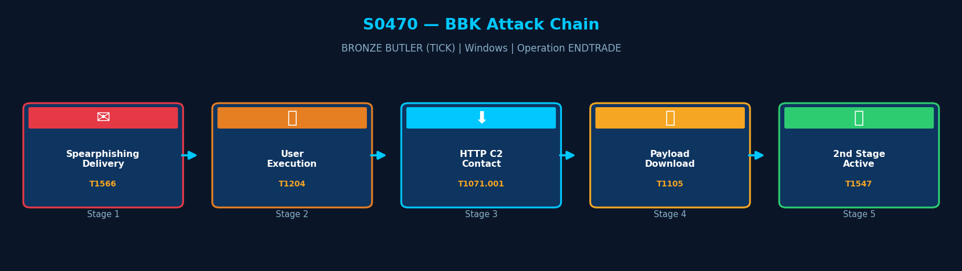
Execution Method
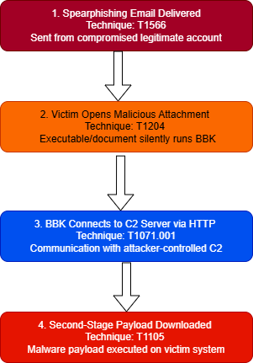
BBK is delivered via spearphishing emails sent from compromised legitimate email accounts, specifically targeting employees in Japanese defense, aerospace, chemical, and satellite industries. The initial payload is typically an executable or document that, when opened by the victim, silently executes BBK. BBK then immediately initiates HTTP communication with its attacker-controlled C2 server to download and execute the second-stage payload.

Persistence Techniques
BBK itself does not establish persistence. Its role is limited to the initial download and execution of second-stage backdoors. Persistence is handled by the secondary payloads retrieved (e.g., Daserf, Datper, XXMM), which typically use Registry Run keys or scheduled tasks to survive reboots.

Detail | Explanation
Own Persistence | BBK does not set its own persistence mechanism
Delegates to Payload | Second-stage backdoors handle persistence via Registry Run keys or scheduled tasks
Implication | If BBK is caught early, no persistence is left behind — reducing remediation complexity

Privilege Escalation
No dedicated privilege escalation technique has been publicly attributed to BBK. Available reporting suggests the malware assumes execution within an already compromised user context.

Detail | Explanation
No Explicit Escalation | No privilege escalation behavior publicly documented
Assessed Behavior | Operates using privileges already obtained during initial compromise

Defense Evasion
BBK deploys several defense evasion techniques to reduce forensic visibility and hinder malware analysis.
Layer 1 — Steganography
The malware hides encrypted payload data inside image files, making malicious traffic appear visually benign during network inspection.
Layer 2 — Payload Decryption
Downloaded payloads are stored in encrypted form and decrypted only during execution, significantly complicating static malware analysis.
Layer 3 — Process Injection
BBK injects malicious code into legitimate Windows processes such as svchost.exe, allowing malicious activity to blend with trusted system processes.

Layer | Technique | Detail
Steganography | T1027.003 | Hides payloads inside image files
Payload Decryption | T1140 | Decrypts payloads only during runtime
Process Injection | T1055 | Injects code into legitimate processes

Credential Access
No direct credential theft capability has been publicly documented for BBK. Its primary functionality focuses on malware delivery rather than credential harvesting.

Detail | Explanation
No Credential Theft | No dedicated credential access module documented
Operational Role | Downloader used for secondary malware deployment

Discovery Techniques
BBK does not perform discovery operations itself. All post-exploitation discovery is conducted by the second-stage backdoors it downloads and executes.

Detail | Explanation | Technique
No Built-in Discovery | BBK performs no host or network enumeration | —
Delegates to Payload | Daserf and Datper perform system discovery after deployment | T1082, T1016
Implication | Minimal host interaction before second-stage — reduces detection opportunity

Lateral Movement
BBK does not perform lateral movement. Its sole purpose is to establish the initial foothold and download the second-stage payload. Lateral movement is conducted by companion tools deployed by the second-stage backdoors.

Detail | Explanation
No Lateral Movement | BBK deploys no lateral movement capability
Delegates to Payload | Second-stage tools (Daserf, Datper) handle lateral movement
Implication | Lateral movement occurs only after successful second-stage deployment

Command & Control (C2)
BBK uses HTTP to communicate with its attacker-controlled C2 server. The primary purpose of this C2 communication is to download and execute the second-stage payload. BRONZE BUTLER's C2 infrastructure has historically included servers registered to entities in East Asia.

Method | Technique | Detail
HTTP | T1071.001 | Primary C2 channel — downloads second-stage payloads via HTTP
Ingress Tool Transfer | T1105 | Retrieves encrypted or encoded second-stage payloads from C2

Exfiltration
Method | Technique | Detail
No Exfiltration | — | BBK does not collect or exfiltrate data — this is performed by second-stage tools
Delegates to Payload | — | Daserf and Datper backdoors perform data collection and exfiltration after deployment
Impact Analysis
BBK's impact is enabling the delivery of advanced second-stage backdoors into targeted environments. While BBK itself causes no direct damage, it is the gateway through which BRONZE BUTLER achieves long-term espionage access to classified-data-holding organizations in Japan's defense and industrial sectors.

Impact Type | Technique | Detail
Initial Access Enabler | T1105 | Downloads and executes second-stage backdoors for long-term espionage
Espionage Gateway | — | Provides BRONZE BUTLER entry point into classified-data environments
Operational Resilience | — | One of four concurrent downloaders — detection of BBK does not halt TICK operations

Indicators of Compromise (IOCs)
File System IOCs
IOC | Detail
Suspicious image files | Potential steganographic payload containers
Temporary payload files | Downloaded secondary malware components
Injected svchost.exe processes | Possible malicious process injection activity

Behavioral IOCs
IOC | Detail
cmd.exe spawning unexpected processes | Potential payload execution
Runtime payload decryption | Encrypted malware decoded during execution
Process injection behavior | Code injection into trusted Windows processes

Network IOCs
IOC | Detail
Outbound HTTP beaconing | Communication with attacker-controlled servers
Unusual web traffic patterns | Frequent payload retrieval activity
Download requests to suspicious domains | Potential second-stage malware delivery

Detection & Mitigation
Method | Technique | Detail
Outbound HTTP Monitoring | T1071.001 | Alert on HTTP connections from executables in user-writable directories
Email Attachment Sandbox | T1566 | Sandbox all email attachments before delivery to endpoints
Process-Network Correlation | T1105 | Correlate new process creation with immediate outbound network connections in SIEM
PDB String Hunt | T1027 | Memory scan for TICK PDB string naming conventions across endpoints

Mitigation Methods
Method | Detail
Application Allowlisting | Block unsigned binary execution from %APPDATA% and %TEMP% via AppLocker
Email Security Gateway | Inspect and sandbox all email attachments — block compressed archives from external senders
EDR Behavioral Detection | Deploy EDR with rules to flag processes that immediately call out to the internet on first run
Network Segmentation | Limit outbound HTTP access from workstations to reduce C2 beacon reach

References & Sources
# | Author / Source | Title | URL
1 | MITRE ATT&CK | S0470 — BBK | https://attack.mitre.org/software/S0470/
2 | Trend Micro | Operation ENDTRADE: TICK's Multi-Stage Backdoors (2019) | https://www.trendmicro.com/
3 | Secureworks | BRONZE BUTLER Threat Profile | https://www.secureworks.com/research/threat-profiles/bronze-butler
4 | MITRE ATT&CK | Group G0060 — BRONZE BUTLER | https://attack.mitre.org/groups/G0060/

