3. S0472 - down_new

1. Name & Type
Name | down_new
ATT&CK ID | S0472
Type | Malware — Downloader (AV Evasion Focus)
Also Known As | Part of BRONZE BUTLER (TICK) Operation ENDTRADE downloader family
Version | 1.0
Created | 10 June 2020 (MITRE entry)
Last Modified | 21 October 2023

2. Description
down_new is a custom downloader used by BRONZE BUTLER since at least 2019 as part of Operation ENDTRADE. It shares the same HTTP C2 mechanism as BBK and build_downer but was developed as a separate variant to provide signature diversity. BRONZE BUTLER engineers down_new with adjustable parameters between versions specifically to bypass AV pattern detection, reflecting the group's sophisticated operational security. Payloads downloaded by down_new may arrive encrypted to evade network-layer inspection.

Key Characteristics
- Adjustable AV evasion parameters — a key differentiator from BBK and build_downer
- HTTP-based C2 — downloads encrypted or encoded second-stage payloads
- Named after PDB string — BRONZE BUTLER naming convention
- Provides signature diversity in TICK's four-downloader toolkit
- Delivered via spearphishing using compromised legitimate email accounts

3. Threat Actor Association
Threat Actor | BRONZE BUTLER
MITRE ID | G0060
Also Known As | TICK, REDBALDKNIGHT, Swirl Typhoon
Origin | China — state-linked espionage group
Active Since | At least 2008
Motive | Cyber Espionage — classified data theft from Japanese defense and industrial sectors

4. Supported Platforms
Platform | Notes
Windows | Primary platform — all variants target Windows environments

5. ATT&CK Techniques Used
Tactic | ID | Technique Name
Initial Access | T1566 | Phishing — spearphishing via compromised legitimate email accounts
Execution | T1204 | User Execution — victim opens and runs initial payload
Defense Evasion | T1027 | Obfuscated Files or Information — AV evasion via adjustable parameters
C2 | T1071.001 | Application Layer Protocol: Web Protocols — HTTP-based C2
C2 | T1105 | Ingress Tool Transfer — downloads encrypted payloads from C2

Attack Chain Flow Diagram
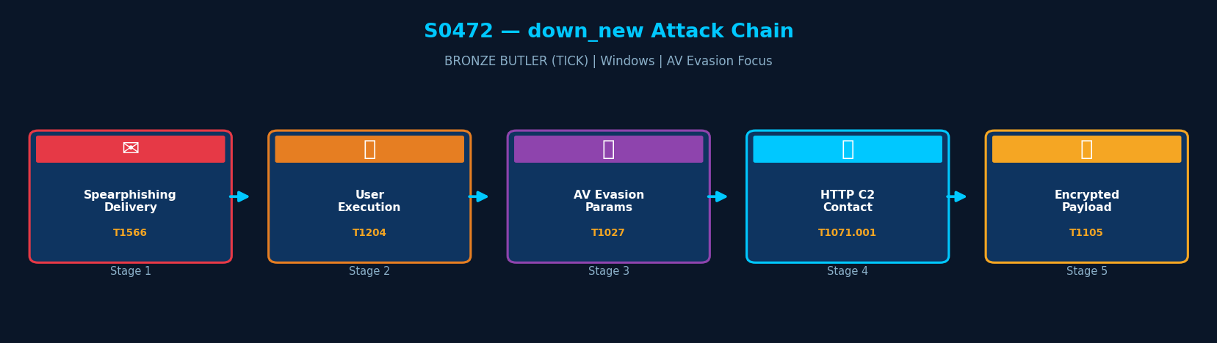
Figure: down_new attack chain with MITRE ATT&CK technique IDs

6. Execution Method
down_new is delivered via spearphishing using compromised legitimate email accounts. On victim execution, it initiates HTTP communication with its C2 server and downloads an encrypted or encoded second-stage payload. The encryption of the payload in transit helps evade network-level inspection.
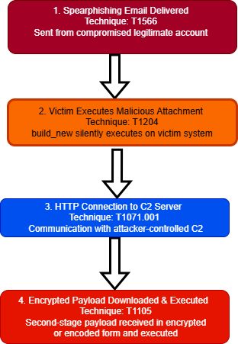

7. Persistence Techniques
down_new delegates persistence to the second-stage payloads it downloads. The downloader itself does not set Registry keys or scheduled tasks — its role is solely to retrieve and launch the next-stage tool.

Detail | Explanation | Technique
No Own Persistence | down_new does not establish its own persistence | —
Delegates to Payload | Second-stage backdoors handle persistence via Registry or scheduled tasks | T1547, T1053

8. Privilege Escalation
Detail | Explanation
No Explicit Escalation | down_new does not perform privilege escalation
Victim Account Privileges | Operates with whatever privileges the victim account holds at execution

9. Defense Evasion
down_new's primary evasion mechanism is its adjustable AV parameter design — parameters within the binary are modified between versions to produce different signatures, bypassing pattern-based AV detection. BRONZE BUTLER's rapid iteration across four downloader variants means blocking one does not block the others.

Layer | Technique | Detail
Adjustable Parameters | T1027 | Internal parameters modified per version to evade AV pattern signatures
Encrypted Payload Transfer | T1027 | Downloaded payload encrypted in transit — evades network-layer inspection
Legitimate Account Delivery | T1566 | Compromised email accounts reduce phishing detection probability

10. Credential Access
Method | Technique | Detail
No Credential Access | — | down_new does not perform credential theft
Delegates to Payload | — | Second-stage backdoors (Daserf, Datper) handle credential harvesting

11. Discovery Techniques
down_new performs no discovery operations. All host and network enumeration is conducted by the second-stage backdoors downloaded and executed by down_new.

Detail | Explanation | Technique
No Built-in Discovery | down_new performs no enumeration | —
Delegates to Payload | Daserf and Datper perform system discovery after deployment | T1082, T1016

12. Lateral Movement
down_new does not perform lateral movement. This is handled entirely by companion tools deployed via the second-stage backdoor.

Detail | Explanation
No Lateral Movement | down_new deploys no lateral movement capability
Delegates to Payload | Second-stage tools handle all lateral movement

13. Command & Control (C2)
down_new uses HTTP to connect to its C2 server. Payloads retrieved may be XOR-encrypted or encoded to evade both static analysis and network content inspection.

Method | Technique | Detail
HTTP | T1071.001 | Primary C2 channel — HTTP requests to attacker-controlled server
Encrypted Payload | T1105 | Second-stage payload delivered encrypted or encoded in HTTP response

14. Exfiltration
Method | Technique | Detail
No Exfiltration | — | down_new does not collect or exfiltrate data
Delegates to Payload | — | Second-stage backdoors perform data collection and exfiltration

15. Impact Analysis
down_new's primary impact is enabling delivery of second-stage backdoors with enhanced AV evasion. Its adjustable parameter design makes it harder to block via signature-based controls compared to BBK, providing BRONZE BUTLER with a more resilient initial-access tool.

Impact Type | Technique | Detail
Enhanced AV Evasion | T1027 | Adjustable parameters mean each version has a different AV signature
Espionage Gateway | T1105 | Enables deployment of advanced backdoors for classified data collection
Toolkit Resilience | — | One of four downloaders — detection does not halt TICK operations

16. Indicators of Compromise (IOCs)

File System IOCs
IOC | Detail
PDB string in memory | TICK malware PDB naming convention in process memory artifacts
Unknown executable in %TEMP% | Executable dropped in temporary directory by email attachment

Behavioral IOCs
IOC | Detail
HTTP outbound on first run | Process immediately initiates HTTP connection to unknown domain
Encrypted HTTP response | Encoded or encrypted content delivered in HTTP response body from C2

Network IOCs
IOC | Detail
HTTP beaconing | Regular interval HTTP requests to previously-unseen external domain
Encoded payload in response | Non-standard content in HTTP response body — possible encrypted PE file

17. Detection & Mitigation

Detection Methods
Method | Technique | Detail
Network Anomaly Detection | T1071.001 | Alert on HTTP connections from new or unsigned executables in user directories
Email Attachment Sandbox | T1566 | Sandbox all email attachments — flag compressed archives from external senders
Process-Network Correlation | T1105 | Correlate process creation with immediate outbound HTTP in SIEM
Content Inspection | T1027 | Inspect HTTP response bodies for encoded or encrypted PE file signatures

Mitigation Methods
Method | Detail
AppLocker | Block execution of unsigned binaries from %TEMP% and %APPDATA%
Email Security Gateway | Block and sandbox compressed archive email attachments
Network Monitoring | Alert on outbound HTTP from workstations to unfamiliar external IPs
EDR Behavioral Detection | Flag processes making network connections immediately on first execution

Overall Defensive Posture
down_new's AV evasion focus makes signature-based detection less reliable. Behavioral detection — particularly process-network correlation (new process immediately calling out to the internet) — is the most reliable detection approach.

18. References & Sources
# | Author / Source | Title | URL
1 | MITRE ATT&CK | S0472 — down_new | https://attack.mitre.org/software/S0472/
2 | Trend Micro | Operation ENDTRADE (2019) | https://www.trendmicro.com/
3 | MITRE ATT&CK | Group G0060 — BRONZE BUTLER | https://attack.mitre.org/groups/G0060/

