WEEK6
9. Create a React Application named “cricketapp” with the following components:
Players.js:
import React from 'react';

const players = [
{ name: 'Player 1', score: 90 },
{ name: 'Player 2', score: 5 },
{ name: 'Player 3', score: 30 },
{ name: 'Player 4', score: 20 },
{ name: 'Player 5', score: 100 },
{ name: 'Player 6', score: 60 },
{ name: 'Player 7', score: 22 },
{ name: 'Player 8', score: 11 },
{ name: 'Player 9', score: 80},
{ name: 'Player 10', score: 40 },
{ name: 'Player 11', score: 10 },
];

export function Players() {
return (
<ul>
{players.map((item, idx) => (
<li key={idx}>
Mr.{item.name} - <span>{item.score}</span>
</li>
))}
</ul>
);
}

export function PlayersBelow() {
return (
<ul>
{players
.filter((item) => item.score <= 70)
.map((item, idx) => (
<li key={idx}>
Mr. {item.name} - <span>{item.score}</span>
</li>
))}
</ul>
);
}

export function OddPlayers() {
const oddPlayers = players.filter((_, index) => index % 2 === 0);
const [first, , third, , fifth] = oddPlayers;

return (
<ul>
<li> First: {first?.name} - {first?.score}</li>
<li> Third: {third?.name} - {third?.score}</li>
<li> Fifth: {fifth?.name} - {fifth?.score}</li>
</ul>
);
}

export function EvenPlayers() {
const evenPlayers = players.filter((_, index) => index % 2 !== 0);
const [, second, , fourth, , sixth] = evenPlayers;

return (
<ul>
<li> Second: {second?.name} - {second?.score}</li>
<li> Fourth: {fourth?.name} - {fourth?.score}</li>
<li> Sixth: {sixth?.name} - {sixth?.score}</li>
</ul>
);
}

const T20Players =['First Player', 'Second Player', 'Third Player'];
const RanjiTrophyPlayers=['Fourth Player', 'Fifth Player', 'Sixth Player'];

export const IndianPlayers = [...T20Players, ...RanjiTrophyPlayers];

export function ListOfIndianPlayers({ IndianPlayers }) {
return (
<ul>
{IndianPlayers.map((player, idx) => (
<li key={idx}>{player}</li>
))}
</ul>
);
}

App.js:
import React from 'react';
import './App.css';
import { Players, PlayersBelow, OddPlayers, EvenPlayers, IndianPlayers, ListOfIndianPlayers } from './components/Players';

function App() {
var flag = false;
if(flag){
return(
<div>
<h1>List of Players</h1>
<Players />
<h1>List of Players Below 70</h1>
<PlayersBelow />
</div>
)
}else{
return(
<div>
<div>
<h1>Indian team</h1>
<h1>Odd Players</h1>
<OddPlayers />
<h1>Even Players</h1>
<EvenPlayers />
</div>
<div>
<h1>List of Indian Players merged</h1>
<ListOfIndianPlayers IndianPlayers={IndianPlayers} />
</div>
</div>
)
}

}

export default App;
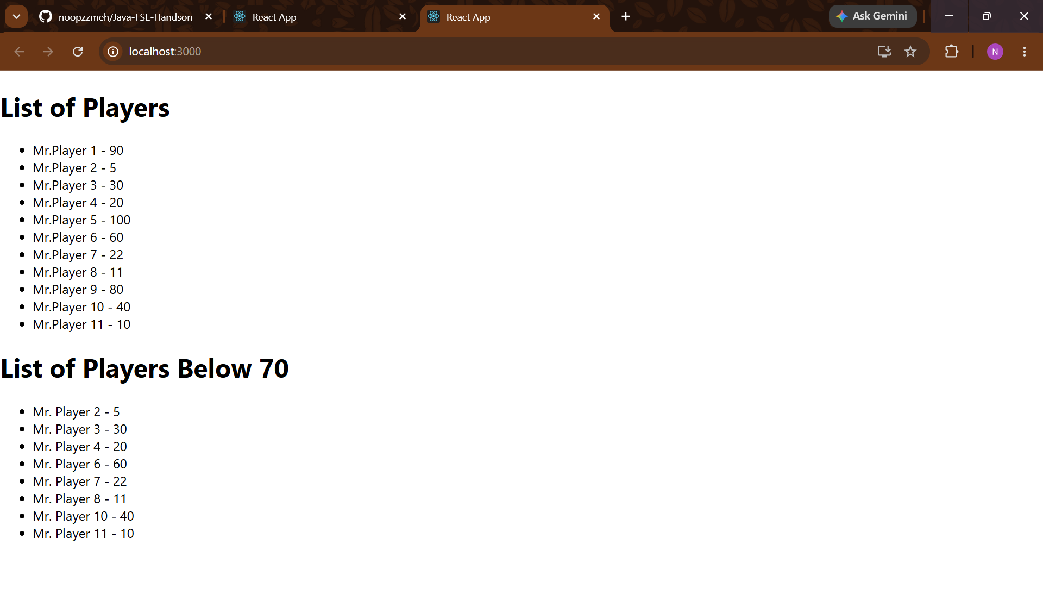

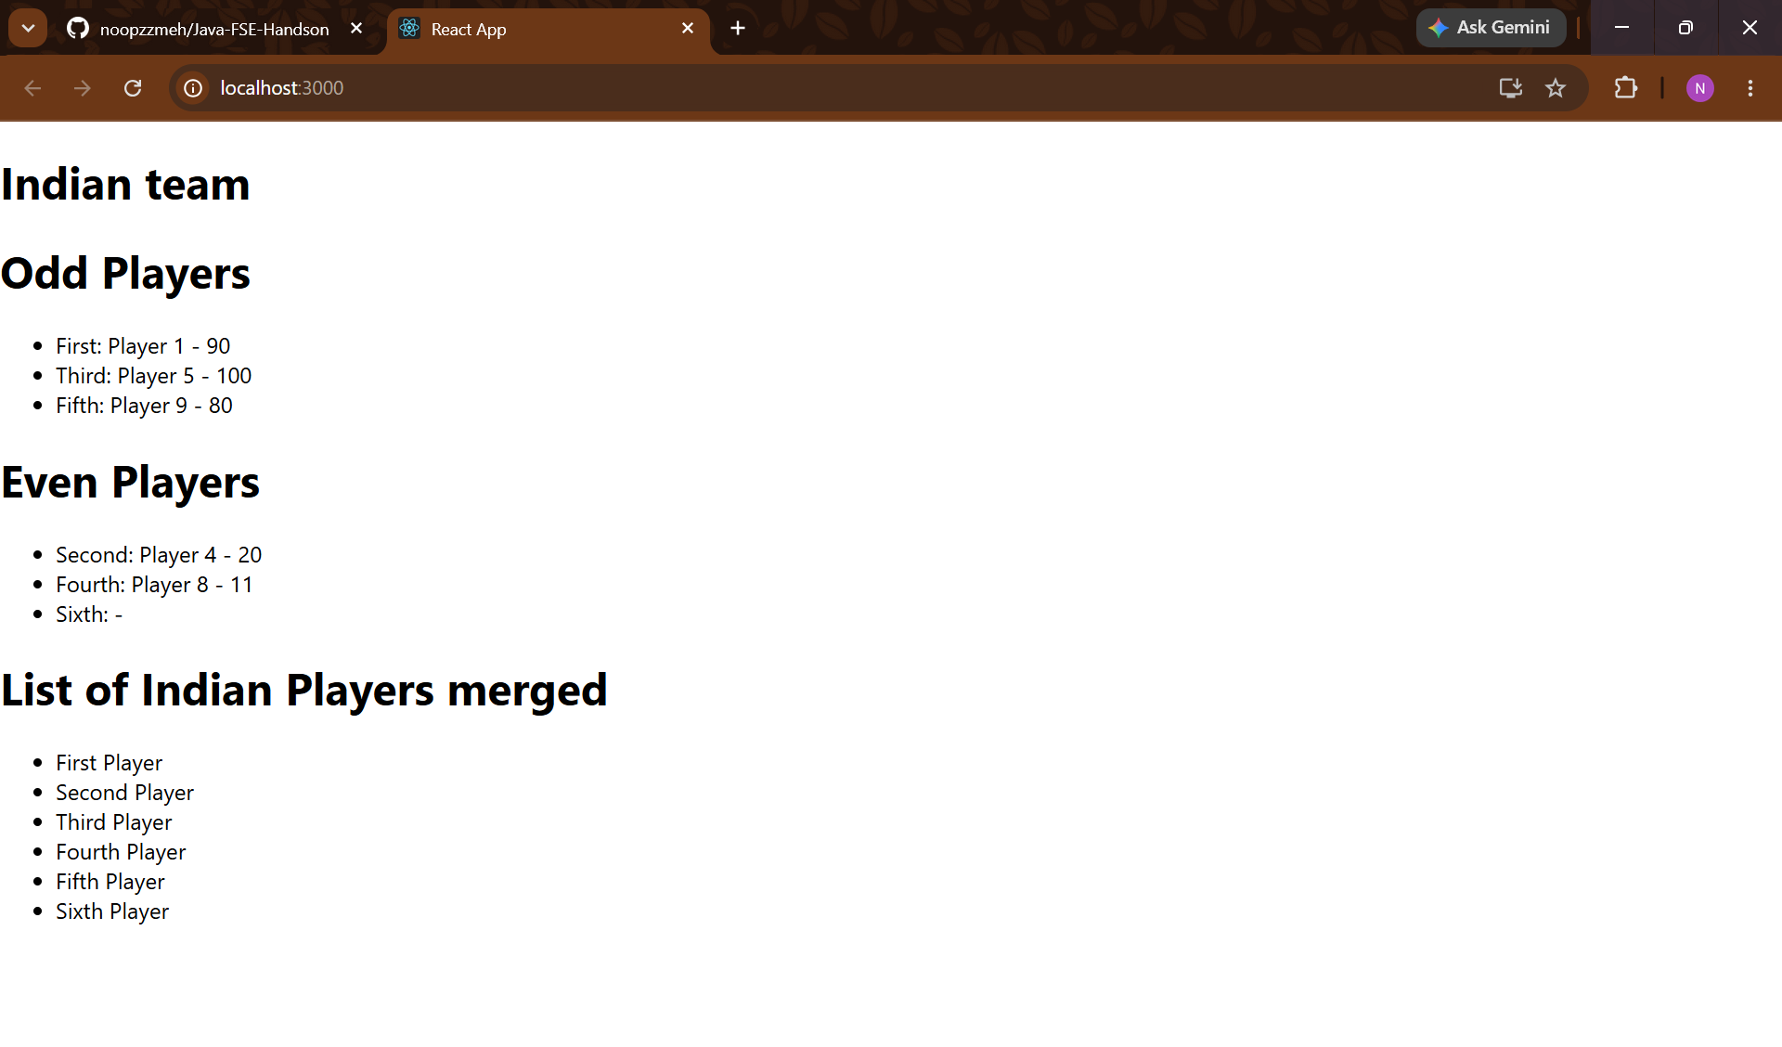
10. Create a React Application named “officespacerentalapp” which uses React JSX to create elements, attributes and renders DOM to display the page.
Home.js:
import React from 'react';
import image from './image.png';

function Home() {
const element = "Office Space"
const jsxatt = <img src={image} width="350px" height="350px" alt="Office Space" />
const ItemName = {Name:"DBS", Rent:50000,Address:"Chennai"}
let colors = [];
if(ItemName.Rent <= 60000){
colors.push("red");
}else{
colors.push("green");
}

return(
<div>
<h1>{element}, at Affordable Range</h1>
{jsxatt}
<h1>Name: {ItemName.Name}</h1>
<h1 style={{ color: colors[0] }}>Rent: {ItemName.Rent}</h1>
<h1>Address: {ItemName.Address}</h1>
</div>
)
}
export default Home;

App.js:
import logo from './logo.svg';
import './App.css';
import React from 'react';
import Home from './components/Home';
function App() {
return (
<div>
<Home />
</div>
);
}

export default App;

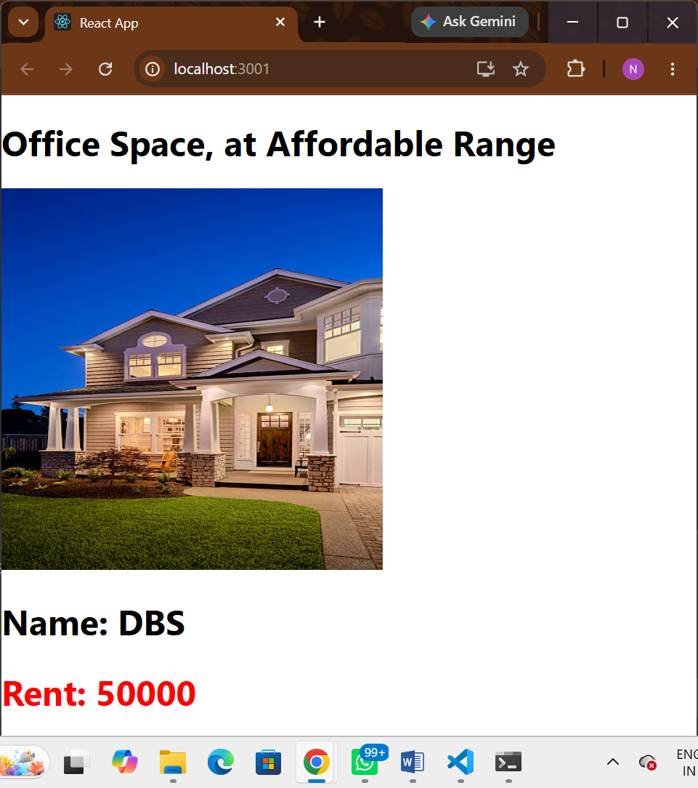

11. Create a React Application “eventexamplesapp” to handle various events of the form elements in HTML.

CurrencyConvertor.js:
import React, { useState } from "react";

function CurrencyConvertor() {
const [amount, setAmount] = useState("");
const [currency, setCurrency] = useState("");

function handleSubmit(e) {
e.preventDefault();

const euros = amount / 90; // Example: 1 Euro = ₹90
alert(`Converting to Euro Amount is {amount} = €${euros.toFixed(2)}`);
}

return (
<div>
<h1>Currency Convertor!!</h1>

<form onSubmit={handleSubmit}>
<label>Amount: </label>
<input
type="number"
value={amount}
onChange={(e) => setAmount(e.target.value)}
/>

<br /><br />

<label>Currency: </label>
<input
type="text"
value={currency}
onChange={(e) => setCurrency(e.target.value)}
/>

<br /><br />

<button type="submit">Convert</button>
</form>
</div>
);
}

export default CurrencyConvertor;

App.js:

import logo from './logo.svg';
import './App.css';
import {useState} from "react";
import CurrencyConvertor from './components/CurrencyConvertor';

function App() {
const [count, setCount] = useState(5);
return (
<div>
<span>{count}</span>
<br />
<button onClick={() => setCount(count + 1)}>
Increment
</button>
<br />
<button onClick={() => setCount(count - 1)}>
Decrement
</button>
<br />
<button onClick={()=>alert("Hello Member!")}>
Say Welcome
</button>
<br />
<button onClick={()=>alert("I was clicked")}>
Click on me
</button>
<br />
<CurrencyConvertor />
</div>
);
}

export default App;

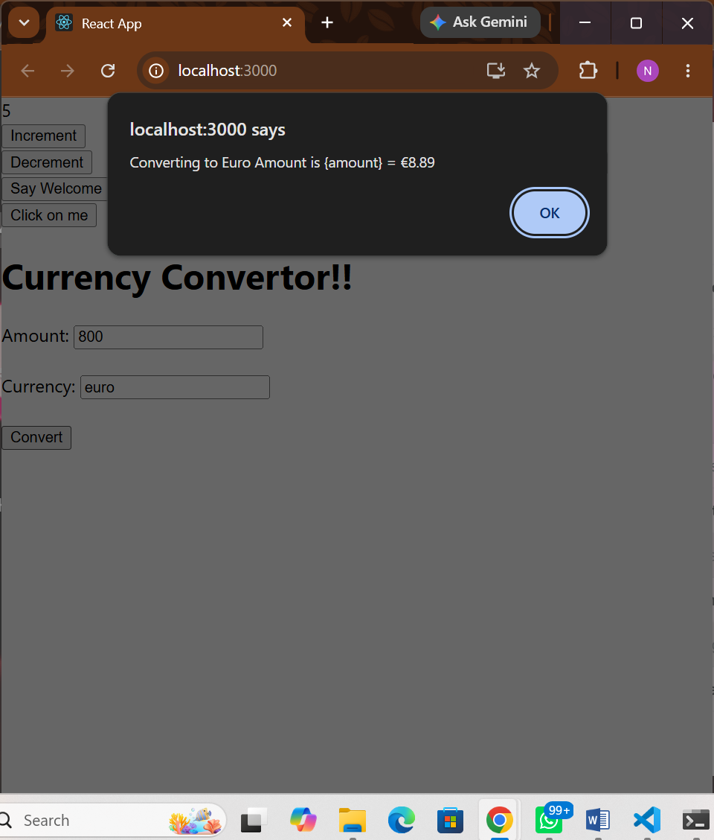
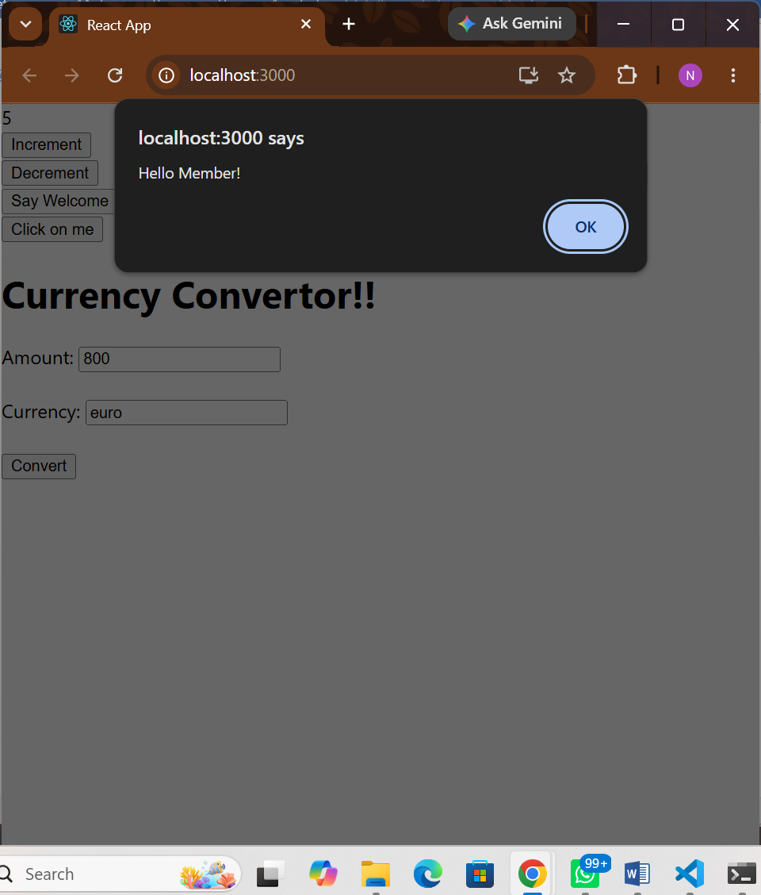
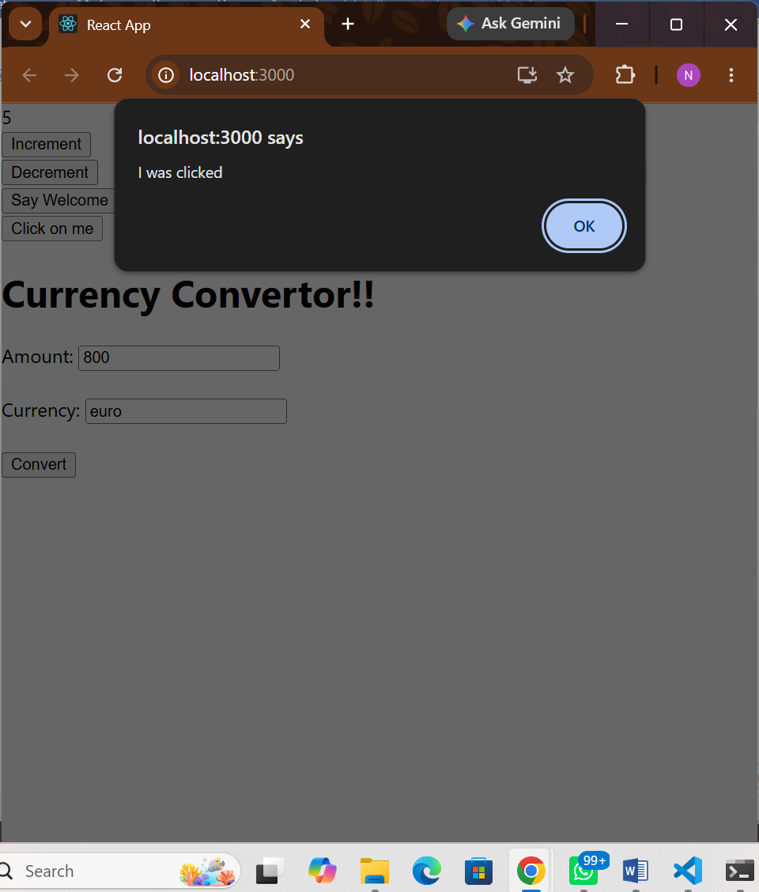

12. Create a React Application named “ticketbookingapp” where the guest user can browse the page where the flight details are displayed whereas the logged in user only can book tickets.

The Login and Logout buttons should accordingly display different pages. Once the user is logged in the User page should be displayed. When the user clicks on Logout, the Guest page should be displayed.

loggingDetails.js:
import React, { useState } from "react";

function UserGreeting() {
return <h1>Welcome Back!</h1>;
}

function GuestGreeting() {
return <h1>Please Sign Up.</h1>;
}

function Greeting(props) {
const isLoggedIn = props.isLoggedIn;

if (isLoggedIn) {
return <UserGreeting />;
}

return <GuestGreeting />;
}

function LoginButton(props) {
return (
<button onClick={props.onClick}>
Login
</button>
);
}

function LogoutButton(props) {
return (
<button onClick={props.onClick}>
Logout
</button>
);
}

function LoginControl() {
const [isLoggedIn, setIsLoggedIn] = useState(false);

function handleLoginClick() {
setIsLoggedIn(true);
}

function handleLogoutClick() {
setIsLoggedIn(false);
}

let button;

if (isLoggedIn) {
button = <LogoutButton onClick={handleLogoutClick} />;
} else {
button = <LoginButton onClick={handleLoginClick} />;
}

return (
<div>
<Greeting isLoggedIn={isLoggedIn} />
{button}
</div>
);
}

export default LoginControl;

App.js:
import logo from './logo.svg';
import './App.css';
import LoginControl from './components/loggingDetails';

function App() {
return (
<div className="App">
<LoginControl />
</div>
);
}

export default App;

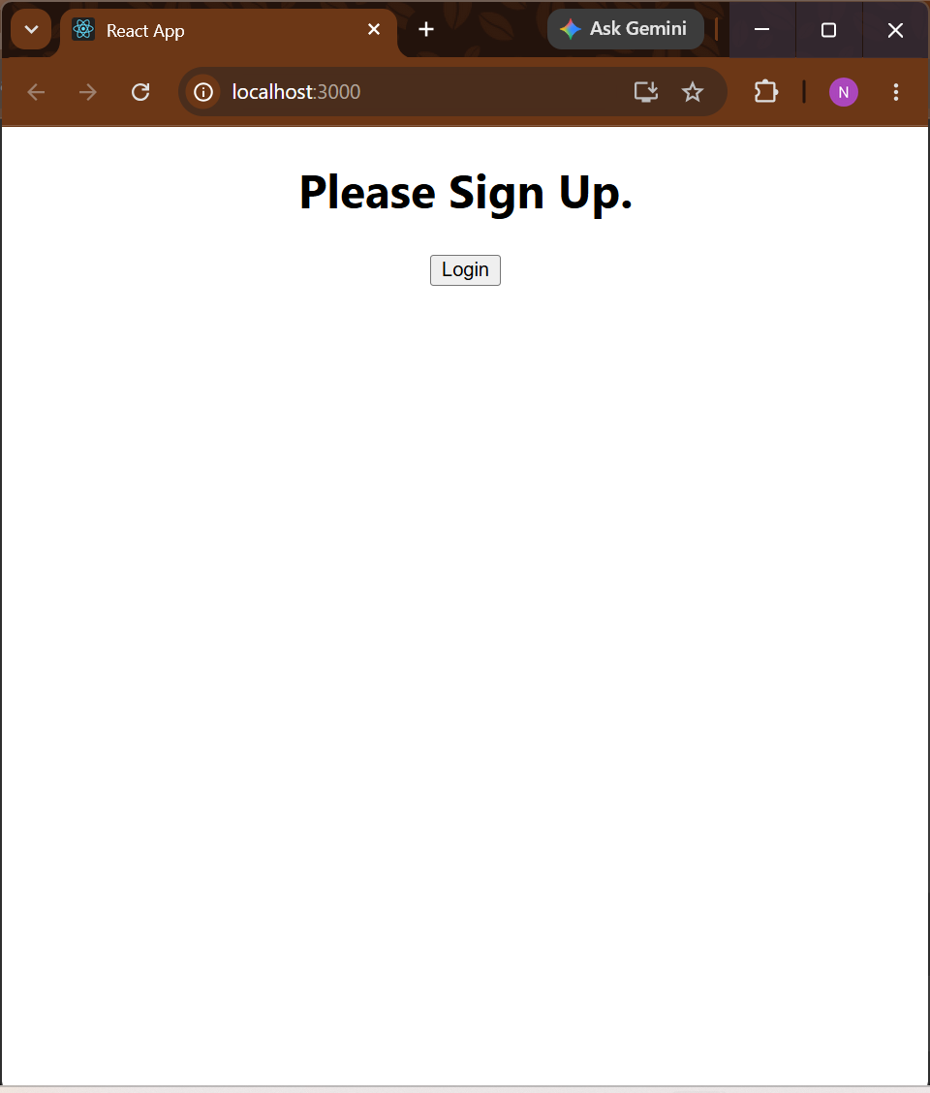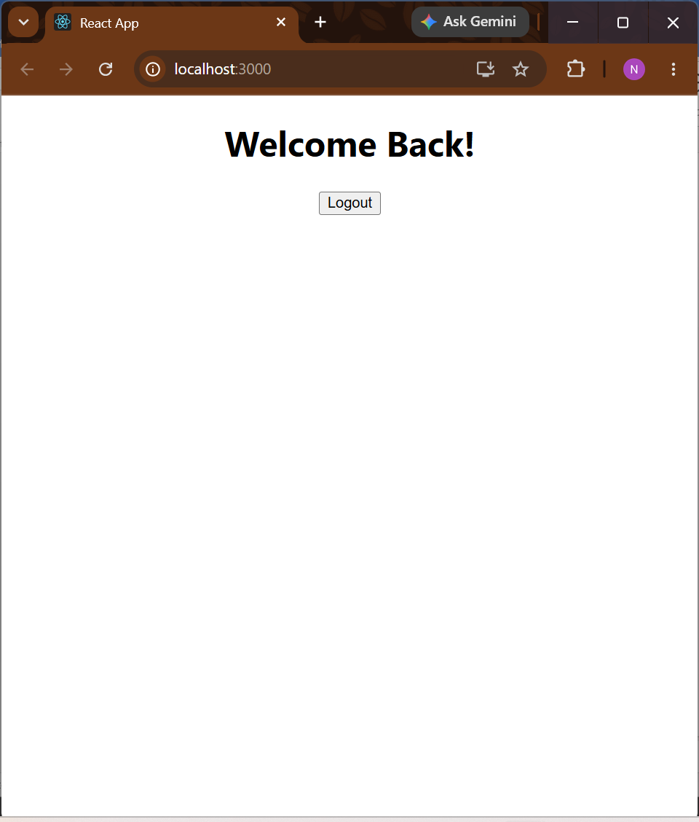

13. Create a React App named “bloggerapp” in with 3 components.

- Book Details
- Blog Details
- Course Details

Implement this with as many ways possible of Conditional Rendering.

BlogDetails.js:
import React from "react";

const BlogDetails = (props) => {
return (
<>
{props.blogs.map((blog) => (
<div key={blog.id}>
<h3>{blog.title}</h3>
<h4>{blog.author}</h4>
</div>
))}
</>
);
};

export default BlogDetails;

BookDetails.js:
import React from "react";

const BookDetails = (props) => {
return (
<>
{props.books.map((book) => (
<div key={book.id}>
<h3>{book.name}</h3>
<h4>{book.price}</h4>
</div>
))}
</>
);
};

export default BookDetails;

CourseDetails.js:
import React from "react";

const CourseDetails = (props) => {
return (
<>
{props.courses.map((course) => (
<div key={course.id}>
<h3>{course.name}</h3>
<h4>{course.fee}</h4>
</div>
))}
</>
);
};

export default CourseDetails;

books.js:
const books = [
{ id: 101, name: "Master React", price: 670 },
{ id: 102, name: "Deep Dive into Angular 11", price: 800 },
{ id: 103, name: "Mongo Essentials", price: 450 }
];

export default books;

courses.js:
const courses = [
{ id: 1, name: "React JS", fee: 5000 },
{ id: 2, name: "Angular", fee: 4500 },
{ id: 3, name: "Node JS", fee: 4000 }
];

export default courses;

blogs.js:
const blogs = [
{ id: 1, title: "React Basics", author: "John" },
{ id: 2, title: "Conditional Rendering", author: "David" },
{ id: 3, title: "React Hooks", author: "Smith" }
];

export default blogs;

