Create a Spring Web Project using Maven

pom.xml:
<?xml version="1.0" encoding="UTF-8"?>
<project xmlns="http://maven.apache.org/POM/4.0.0" xmlns:xsi="http://www.w3.org/2001/XMLSchema-instance"
xsi:schemaLocation="http://maven.apache.org/POM/4.0.0 https://maven.apache.org/xsd/maven-4.0.0.xsd">
<modelVersion>4.0.0</modelVersion>
<parent>
<groupId>org.springframework.boot</groupId>
<artifactId>spring-boot-starter-parent</artifactId>
<version>4.1.0</version>
<relativePath/> <!-- lookup parent from repository -->
</parent>
<groupId>com.cognizant</groupId>
<artifactId>spring-learn</artifactId>
<version>0.0.1-SNAPSHOT</version>
<name/>
<description/>
<url/>
<licenses>
<license/>
</licenses>
<developers>
<developer/>
</developers>
<scm>
<connection/>
<developerConnection/>
<tag/>
<url/>
</scm>
<properties>
<java.version>17</java.version>
</properties>
<dependencies>
<dependency>
<groupId>org.springframework.boot</groupId>
<artifactId>spring-boot-starter-webmvc</artifactId>
</dependency>

<dependency>
<groupId>org.springframework.boot</groupId>
<artifactId>spring-boot-devtools</artifactId>
<scope>runtime</scope>
<optional>true</optional>
</dependency>
<dependency>
<groupId>org.springframework.boot</groupId>
<artifactId>spring-boot-starter-webmvc-test</artifactId>
<scope>test</scope>
</dependency>
</dependencies>

<build>
<plugins>
<plugin>
<groupId>org.springframework.boot</groupId>
<artifactId>spring-boot-maven-plugin</artifactId>
</plugin>
</plugins>
</build>

</project>

SpringLearnApplicationTests.java:
package com.cognizant.spring_learn;

import org.junit.jupiter.api.Test;
import org.springframework.boot.test.context.SpringBootTest;

@SpringBootTest
class SpringLearnApplicationTests {

@Test
void contextLoads() {
}

}

SpringLearnApplication.java:
package com.cognizant.spring_learn;

import org.springframework.boot.SpringApplication;
import org.springframework.boot.autoconfigure.SpringBootApplication;

@SpringBootApplication
public class SpringLearnApplication {

public static void main(String[] args) {
SpringApplication.run(SpringLearnApplication.class, args);
}

}
OUTPUT:
------------------------------------------------------------------------
BUILD SUCCESS
------------------------------------------------------------------------
Total time: 4.563 s
Finished at: 2026-07-10T14:05:29+05:30
------------------------------------------------------------------------

Spring Core – Load Country from Spring Configuration XML

SpringLearnApplication.java:
package com.cognizant.spring_learn;

import org.slf4j.Logger;
import org.slf4j.LoggerFactory;
import org.springframework.context.ApplicationContext;
import org.springframework.context.support.ClassPathXmlApplicationContext;

public class SpringLearnApplication {

private static final Logger LOGGER =
LoggerFactory.getLogger(SpringLearnApplication.class);

public static void main(String[] args) {

displayCountry();
}

public static void displayCountry() {

ApplicationContext context =
new ClassPathXmlApplicationContext("country.xml");

Country country = context.getBean("country", Country.class);

LOGGER.debug("Country : {}", country.toString());

((ClassPathXmlApplicationContext) context).close();
}
}
OUTPUT:
Inside Country Constructor.
Inside setCode()
Inside setName()
Country : Country [code=IN, name=India]

Country.java:
package com.cognizant.spring_learn;

import org.slf4j.Logger;
import org.slf4j.LoggerFactory;

public class Country {

private static final Logger LOGGER = LoggerFactory.getLogger(Country.class);

private String code;
private String name;

public Country() {
LOGGER.debug("Inside Country Constructor.");
}

public String getCode() {
LOGGER.debug("Inside getCode()");
return code;
}

public void setCode(String code) {
LOGGER.debug("Inside setCode()");
this.code = code;
}

public String getName() {
LOGGER.debug("Inside getName()");
return name;
}

public void setName(String name) {
LOGGER.debug("Inside setName()");
this.name = name;
}

@Override
public String toString() {
return "Country [code=" + code + ", name=" + name + "]";
}
}

country.xml:
<?xml version="1.0" encoding="UTF-8"?>

<beans xmlns="http://www.springframework.org/schema/beans"
xmlns:xsi="http://www.w3.org/2001/XMLSchema-instance"
xsi:schemaLocation="
http://www.springframework.org/schema/beans
https://www.springframework.org/schema/beans/spring-beans.xsd">

<bean id="country"
class="com.cognizant.springlearn.Country">

<property name="code" value="IN"/>
<property name="name" value="India"/>

</bean>

</beans>

Hello World RESTful Web Service:
HelloController.java:
package com.cognizant.spring_learn.controller;

import org.slf4j.Logger;
import org.slf4j.LoggerFactory;
import org.springframework.web.bind.annotation.GetMapping;
import org.springframework.web.bind.annotation.RestController;

@RestController
public class HelloController {

private static final Logger LOGGER =
LoggerFactory.getLogger(HelloController.class);

@GetMapping("/hello")
public String sayHello() {

LOGGER.info("START");

String message = "Hello World!!";

LOGGER.info("END");

return message;
}
}

SpringLearnApplication.java:
package com.cognizant.spring_learn;

import org.springframework.boot.SpringApplication;
import org.springframework.boot.autoconfigure.SpringBootApplication;

@SpringBootApplication
public class SpringLearnApplication {

public static void main(String[] args) {
SpringApplication.run(SpringLearnApplication.class, args);
}

}
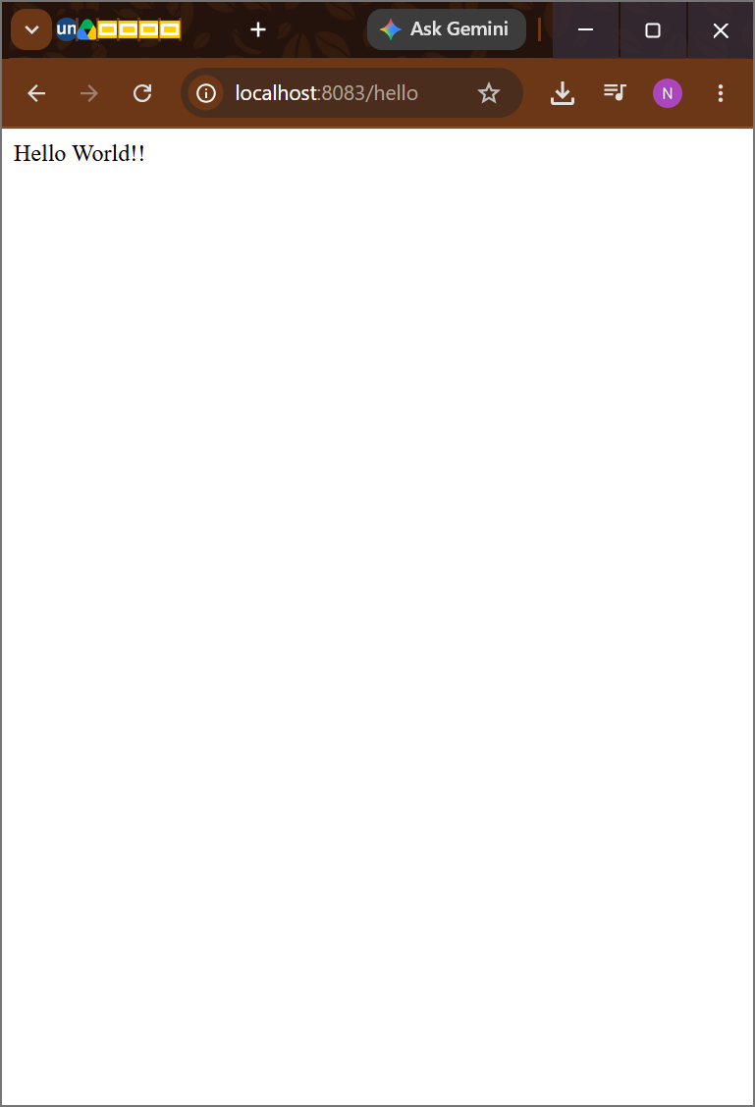
REST - Country Web Service

CountryController.java:
package com.cognizant.spring_learn.controller;

import com.cognizant.spring_learn.Country;
import org.springframework.context.support.ClassPathXmlApplicationContext;
import org.springframework.web.bind.annotation.RequestMapping;
import org.springframework.web.bind.annotation.RestController;

@RestController
public class CountryController {

@RequestMapping("/country")
public Country getCountryIndia() {
try (ClassPathXmlApplicationContext context =
new ClassPathXmlApplicationContext("country.xml")) {
return context.getBean("country", Country.class);
}
}
}

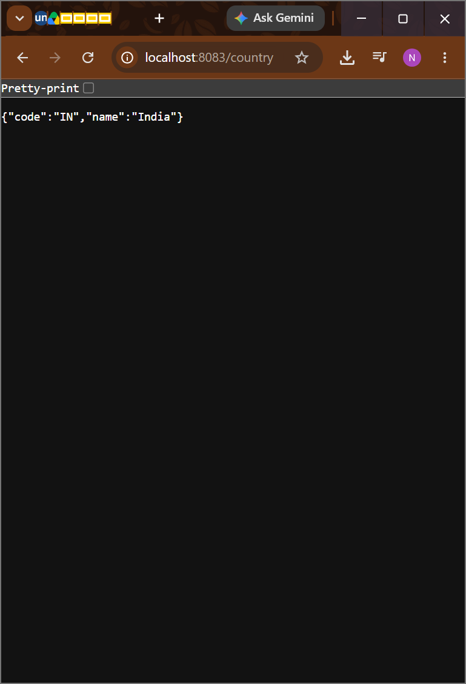
REST - Get country based on country code

CountryController.java:
package com.cognizant.spring_learn.controller;

import org.springframework.beans.factory.annotation.Autowired;
import org.springframework.web.bind.annotation.GetMapping;
import org.springframework.web.bind.annotation.PathVariable;
import org.springframework.web.bind.annotation.RestController;

import com.cognizant.spring_learn.Country;
import com.cognizant.spring_learn.service.CountryService;

@RestController
public class CountryController {

private final CountryService countryService;

@Autowired
public CountryController(CountryService countryService) {
this.countryService = countryService;
}

@GetMapping("/country")
public Country getCountryIndia() {
return countryService.getCountry("IN");
}

@GetMapping("/countries/{code}")
public Country getCountry(@PathVariable String code) {
return countryService.getCountry(code);
}
}
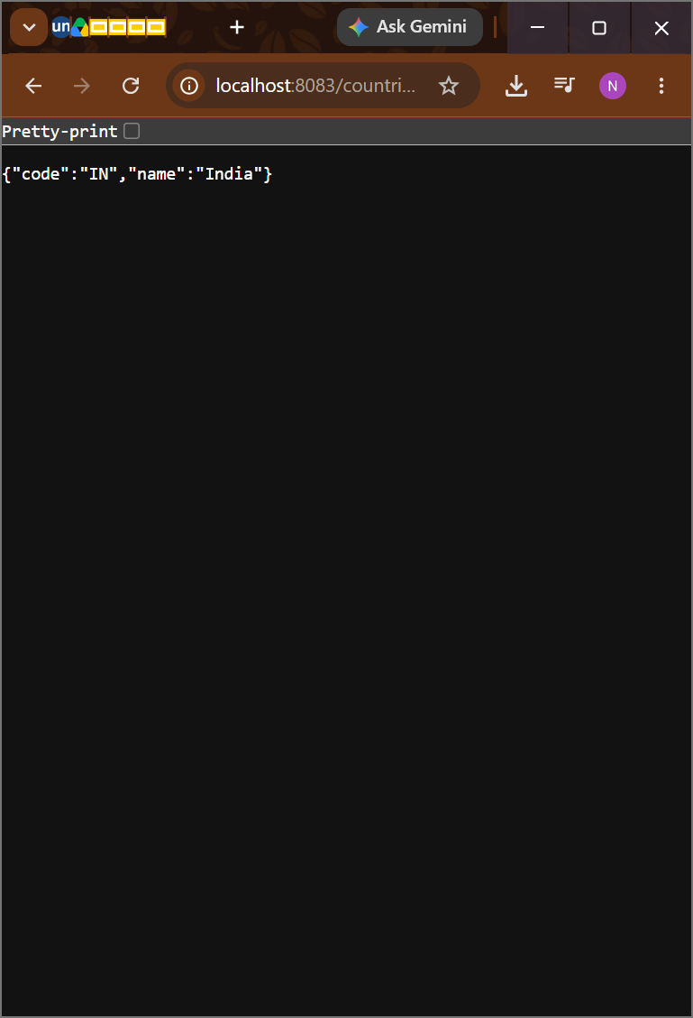
Create authentication service that returns JWT

SecurityController.java:
package com.cognizant.spring_learn.config;

import org.springframework.context.annotation.Bean;
import org.springframework.context.annotation.Configuration;
import org.springframework.security.config.annotation.web.builders.HttpSecurity;
import org.springframework.security.web.SecurityFilterChain;

@Configuration
public class SecurityConfig {

@Bean
SecurityFilterChain filterChain(HttpSecurity http) throws Exception {

http
.csrf(csrf -> csrf.disable())
.authorizeHttpRequests(auth -> auth
.requestMatchers("/authenticate").authenticated()
.anyRequest().permitAll())
.httpBasic();

return http.build();
}
}

JwtUtil.java:
package com.cognizant.spring_learn.util;

import java.util.Date;

import org.springframework.stereotype.Component;

import io.jsonwebtoken.Jwts;
import io.jsonwebtoken.SignatureAlgorithm;

@Component
public class JwtUtil {

private final String SECRET = "secretkey";

public String generateToken(String username) {

return Jwts.builder()
.setSubject(username)
.setIssuedAt(new Date())
.setExpiration(new Date(System.currentTimeMillis() + 1200000))
.signWith(SignatureAlgorithm.HS256, SECRET)
.compact();
}
}
pom.xml:
<dependency>
<groupId>io.jsonwebtoken</groupId>
<artifactId>jjwt</artifactId>
<version>0.9.1</version>
</dependency>

