WEEK5:
- Create a new React Application with the name “myfirstreact”, Run the application to print “welcome to the first session of React” as heading of that page.
PS C:\Users\DELL> npx create-react-app myfirstreact
Need to install the following packages:
create-react-app@5.1.0
Ok to proceed? (y) y

Creating a new React app in C:\Users\DELL\myfirstreact.

Installing packages. This might take a couple of minutes.
Installing react, react-dom, and react-scripts with cra-template...

added 1296 packages in 2m

272 packages are looking for funding
run `npm fund` for details

Installing template dependencies using npm...

added 17 packages, and removed 1 package in 4s

271 packages are looking for funding
run `npm fund` for details
npm warn allow-scripts 2 packages have install scripts not yet covered by allowScripts:
npm warn allow-scripts core-js@3.49.0 (install: (install scripts present))
npm warn allow-scripts core-js-pure@3.49.0 (install: (install scripts present))
npm warn allow-scripts
npm warn allow-scripts Run `npm approve-scripts --allow-scripts-pending` to review, or `npm approve-scripts <pkg>` to allow.
Removing template package using npm...

removed 1 package, and audited 1312 packages in 5s

271 packages are looking for funding
run `npm fund` for details

28 vulnerabilities (9 low, 6 moderate, 13 high)

To address issues that do not require attention, run:
npm audit fix

To address all issues (including breaking changes), run:
npm audit fix --force

Run `npm audit` for details.
npm warn allow-scripts 2 packages have install scripts not yet covered by allowScripts:
npm warn allow-scripts core-js@3.49.0 (install: (install scripts present))
npm warn allow-scripts core-js-pure@3.49.0 (install: (install scripts present))
npm warn allow-scripts
npm warn allow-scripts Run `npm approve-scripts --allow-scripts-pending` to review, or `npm approve-scripts <pkg>` to allow.

Success! Created myfirstreact at C:\Users\DELL\myfirstreact
Inside that directory, you can run several commands:

npm start
Starts the development server.

npm run build
Bundles the app into static files for production.

npm test
Starts the test runner.

npm run eject
Removes this tool and copies build dependencies, configuration files
and scripts into the app directory. If you do this, you can’t go back!

We suggest that you begin by typing:

cd myfirstreact
npm start

Happy hacking!
PS C:\Users\DELL> cd myfirstreact
PS C:\Users\DELL\myfirstreact> npm start

> myfirstreact@0.1.0 start
> react-scripts start

(node:18004) [DEP0176] DeprecationWarning: fs.F_OK is deprecated, use fs.constants.F_OK instead
(Use `node --trace-deprecation ...` to show where the warning was created)
(node:18004) [DEP_WEBPACK_DEV_SERVER_ON_AFTER_SETUP_MIDDLEWARE] DeprecationWarning: 'onAfterSetupMiddleware' option is deprecated. Please use the 'setupMiddlewares' option.
(node:18004) [DEP_WEBPACK_DEV_SERVER_ON_BEFORE_SETUP_MIDDLEWARE] DeprecationWarning: 'onBeforeSetupMiddleware' option is deprecated. Please use the 'setupMiddlewares' option.
Starting the development server...
Compiled successfully!

You can now view myfirstreact in the browser.

Local: http://localhost:3000
On Your Network: http://172.18.150.44:3000

Note that the development build is not optimized.
To create a production build, use npm run build.

webpack compiled successfully
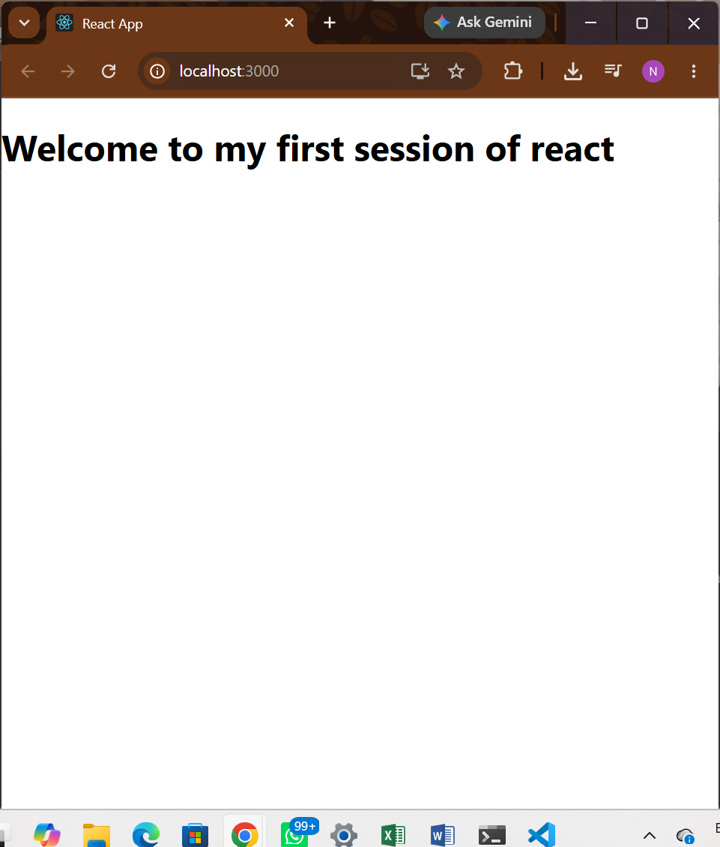

2. Create a react app for Student Management Portal named StudentApp and create a component named Home which will display the Message “Welcome to the Home page of Student Management Portal”. Create another component named About and display the Message “Welcome to the About page of the Student Management Portal”. Create a third component named Contact and display the Message “Welcome to the Contact page of the Student Management Portal”. Call all the three components.
Home.js:
import React,{Component} from 'react';

class Home extends Component{
render(){
return (
<div>
<h1>Welcome to the Home Page of Student Management Portal</h1>
</div>
);
}
}
export default Home;
About.js:
import React,{Component} from 'react';

class About extends Component{
render(){
return (
<div>
<h1>Welcome to the About Page of Student Management Portal</h1>
</div>
);
}
}
export default About;

Contact.js:
import React,{Component} from 'react';

class Contact extends Component{
render(){
return (
<div>
<h1>Welcome to the Contact Page of Student Management Portal</h1>
</div>
);
}
}

export default Contact;

App.js:
import logo from './logo.svg';
import './App.css';
import Home from './Components/Home';
import About from './Components/About';
import Contact from './Components/Contact';

function App() {
return (
<div className="Container">
<Home />
<About />
<Contact />
</div>
);
}

export default App;

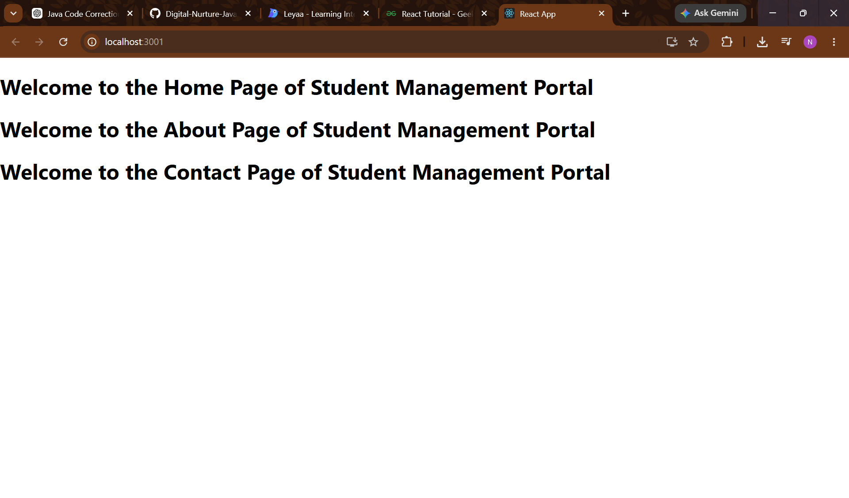
3.
CalculateScore.js:
import '../Stylesheets/mystyle.css';

const percentToDecimal = (decimal) => {
return (decimal.toFixed(2) + '%');
};
const calScore = (total,goal) => {
return percentToDecimal(total/goal);
};

export const CalculateScore = ({Name,School,total,goal})=>(
<div className="formatstyle">
<h1><font color="Brown">Student Details:</font></h1>
<div className="Name"><b><span>Name:</span></b><span>{Name}</span></div>
<div className="School"><b><span>School:</span></b><span>{School}</span></div>
<div className="Total"><b><span>Total:</span></b><span>{total}</span></div>
<div className="Score"><b><span>Score:</span></b><span>{calScore(total, goal)}</span></div>
</div>
)

mystyle.css:
.Name{
font-weight: 300;
color:blue
}
.School{
color: crimson;
}
.Total{
color: darkmagenta;
}
.formatStyle{
text-align: center;
font-size: large;
}
.Score{
color: forestgreen;
}

App.js:
import logo from './logo.svg';
import './App.css';
import {CalculateScore} from './Components/CalculateScore';
function App() {
return (
<div>
<CalculateScore Name={"Steve"} School={"ABC School"} total={80} goal={100}></CalculateScore>
</div>
);
}

export default App;

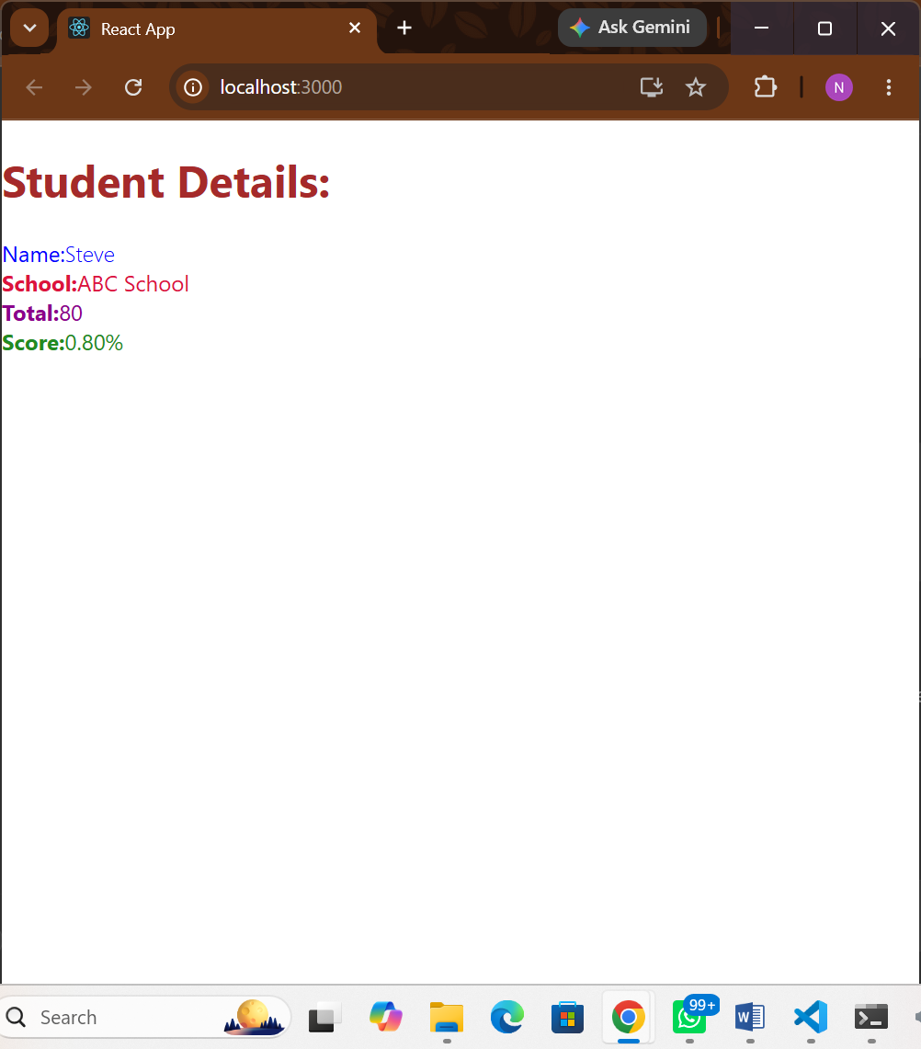

4. Implement componentDidMount() hook, Implementing componentDidCatch() life cycle hook.
Post.js:
class Post{
constructor(id,title,body){
this.id = id;
this.title = title;
this.body = body;
}
}
export default Post;

Posts.js:
import React from 'react';

class Posts extends React.Component {
constructor(props) {
super(props);
this.state = { posts: [] };
}

loadPosts() {
fetch('https://jsonplaceholder.typicode.com/posts')
.then((response) => response.json())
.then((posts) => this.setState({ posts }))
.catch((error) => console.error('Error occurred in Posts component:', error));
}

componentDidMount() {
this.loadPosts();
}

render() {
return (
<div>
<h1>Posts</h1>
<ul>
{this.state.posts.map((post) => (
<li key={post.id}>
<h2>{post.title}</h2>
<p>{post.body}</p>
</li>
))}
</ul>
</div>
);
}
}

export default Posts;

App.js:
import './App.css';
import Posts from './Posts';

function App() {
return (
<>
<Posts />
</>
);
}

export default App;

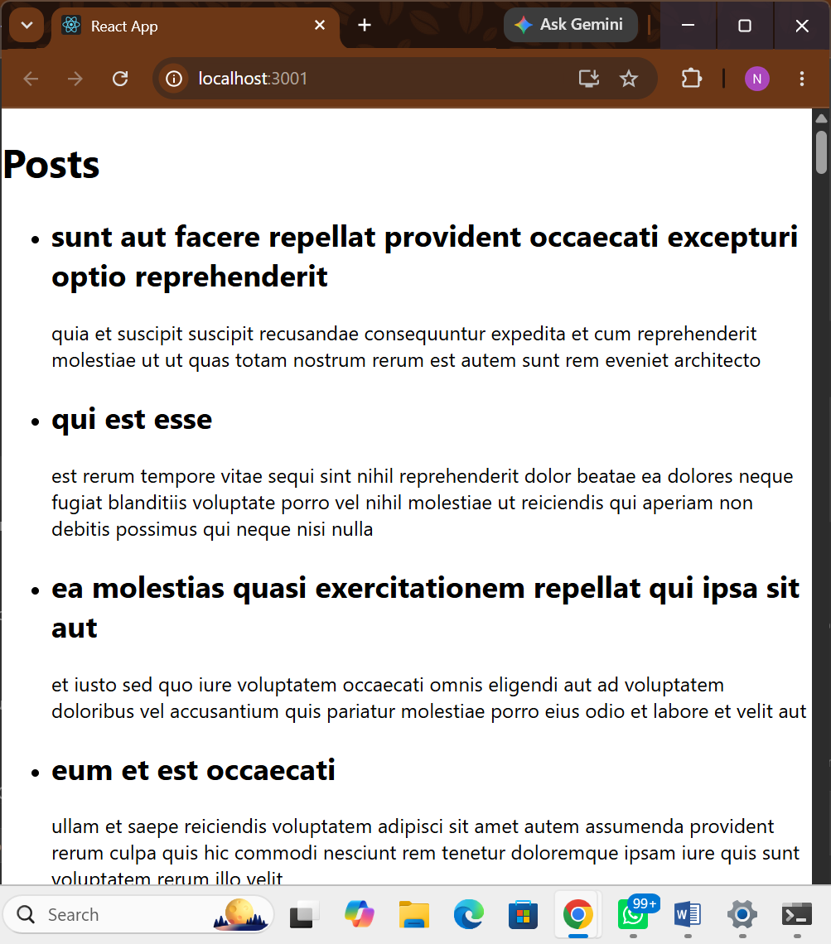
5. My Academy team at Cognizant want to create a dashboard containing the details of ongoing and completed cohorts. A react application is created which displays the detail of the cohorts using react component. You are assigned the task of styling these react components.
Cohort.module.css:
.box {
width: 300px;
display: inline-block;
margin: 10px;
padding-top: 10px;
padding-bottom: 10px;
padding-left: 20px;
padding-right: 20px;
border: 1px solid black;
border-radius: 10px;
}

dt {
font-weight: 500;
}

.ongoing {
color: green;
}

.defaultStatus {
color: blue;
}

CohortDetails.js:
import styles from './CohortDetails.module.css';

function CohortDetails(props) {
const isOngoing = props.cohort.currentStatus?.toLowerCase() === 'ongoing';
const headingClass = isOngoing ? styles.ongoing : styles.defaultStatus;

return (
<div className={styles.box}>
<h3 className={headingClass}>
{props.cohort.cohortCode} -
<span>{props.cohort.technology}</span>
</h3>
<dl>
<dt>Started On</dt>
<dd>{props.cohort.startDate}</dd>
<dt>Current Status</dt>
<dd>{props.cohort.currentStatus}</dd>
<dt>Coach</dt>
<dd>{props.cohort.coachName}</dd>
<dt>Trainer</dt>
<dd>{props.cohort.trainerName}</dd>
</dl>
</div>
);
}

export default CohortDetails;

App.js:
import logo from './logo.svg';
import './App.css';
import { CohortsData} from './Cohort'
import CohortDetails from './CohortDetails';

function App() {

return (
<div>
<h1>Cohorts Details</h1>
{CohortsData.map(cohort => <CohortDetails cohort={cohort}/>)}
</div>
);
}

export default App;

