**NWIT 291 – Cybersecurity Capstone Hands-on Lab**

**Lab 3-Cloud Account and Cloud Security Career Path Research**

**Noor Imran**

**Montgomery College**

**NWIT-291-41341**

**Tesfaye Lemma**

**Section 1: Cloud Account Creation**

**1. Dashboard**

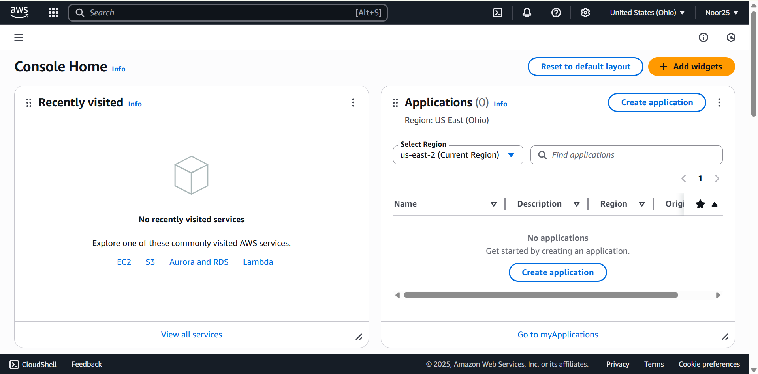

**2. Security Hub**

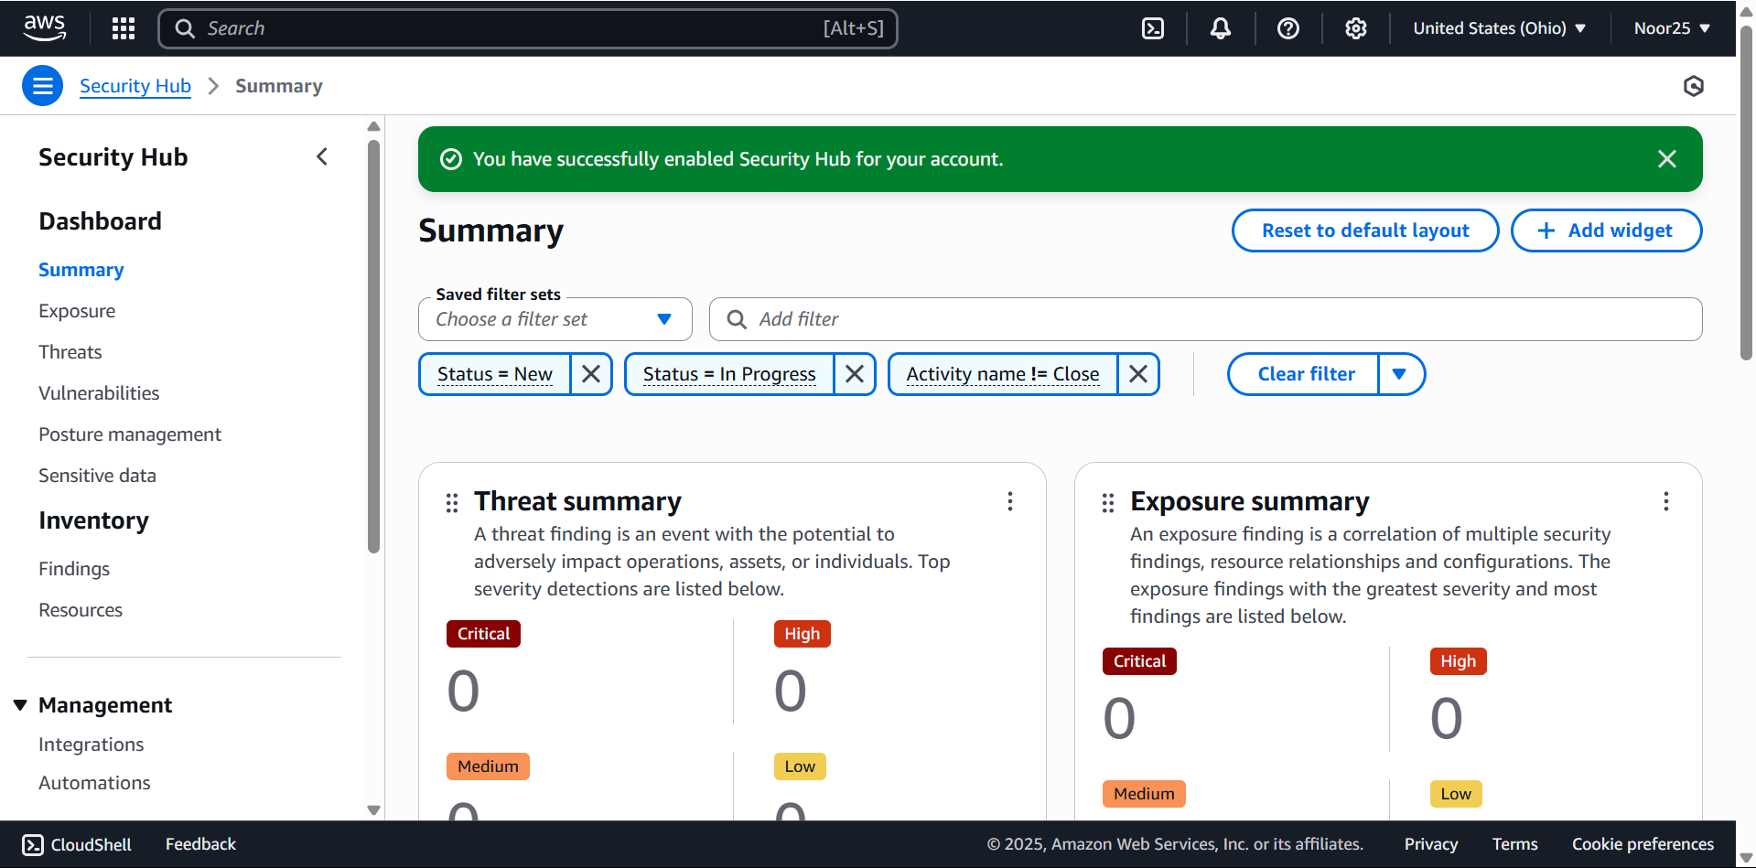

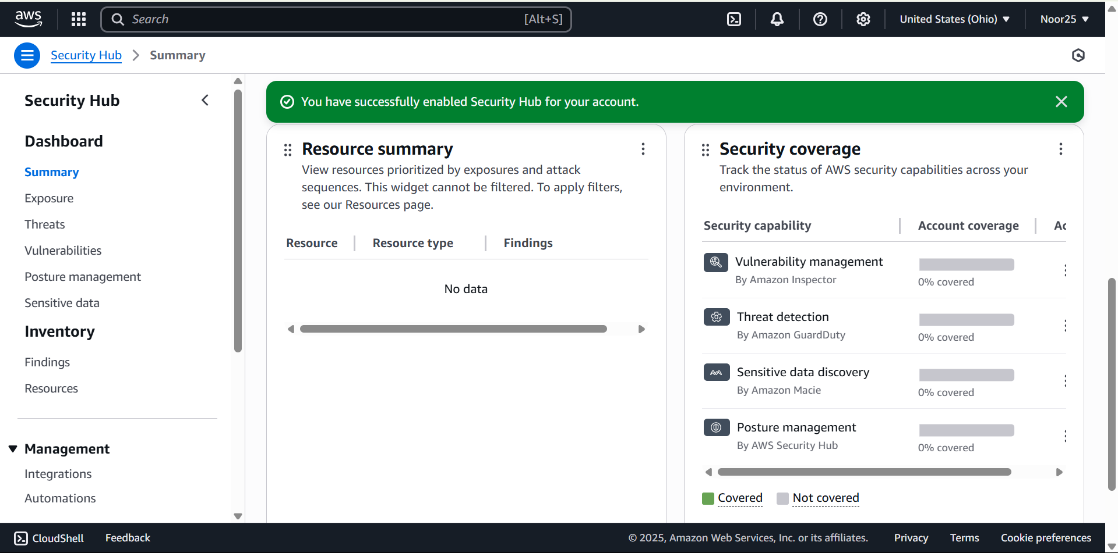

**3. IAM**

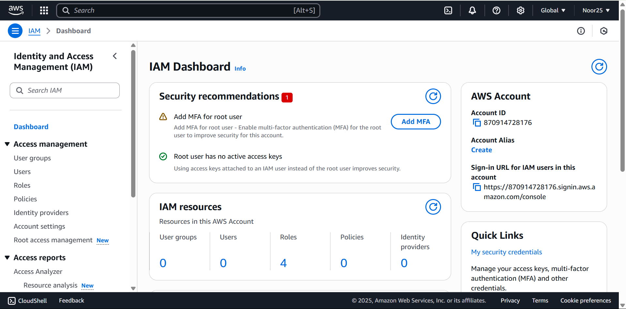

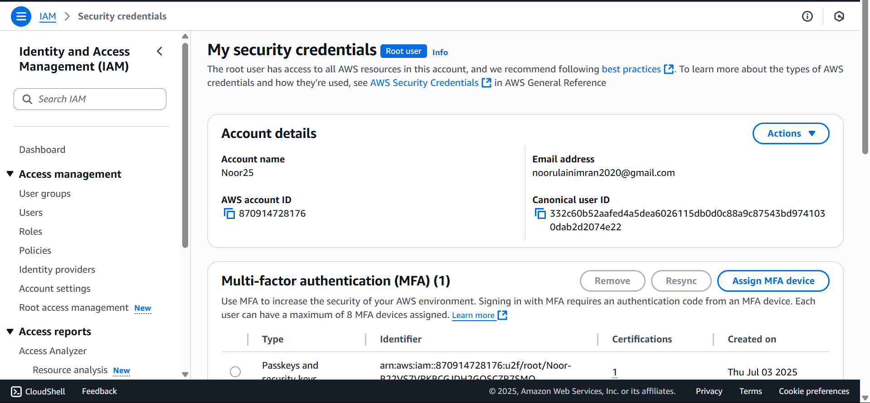

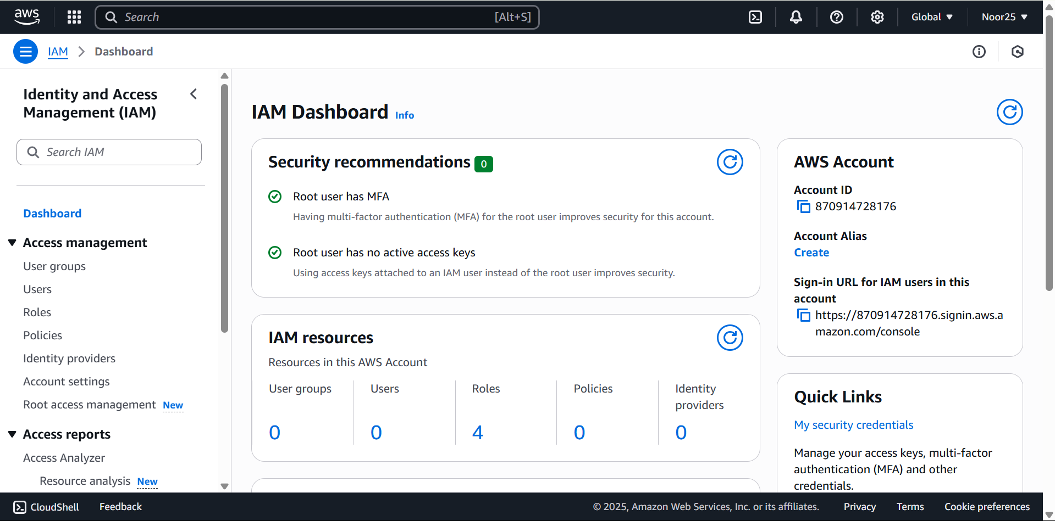

**AWS Platform – Initial Impressions Summary**

Setting up an AWS account was quite simple, although it requires you to validate your ID via phone and payment details. Once in the AWS Console, there is a surprising amount of service options available, even just through the free version. The dashboard is sleek but overwhelming when you're not used to working with clouds at first. Using search and “Recently visited” helped navigate around it more efficiently, though.

For security, AWS seems to have good protection tools readily available out of the box. I looked at IAM (Identity and Access Management), by which you are able to manage users, roles, and permissions. I also looked at CloudTrail, which maintains a record of all account activity, and Security Hub, by which all findings of security are centralized throughout services. Using multi-factor authentication (MFA) on the root account is strongly recommended and very easy to implement.

AWS offers a feature-rich and secure environment to learn cloud technology. The learning curve is quite steep, but due to the level of control and documentation, it is a great platform to explore seriously.

**Section 2: Cloud Security Career Path Comparison**

**Cloud Security Career Path Comparison**

|  |  |  |  |  |
| --- | --- | --- | --- | --- |
| **Role** | **Responsibilities & Titles** | **Average Salary (U.S.)** | **Recommended Certifications** | **Common Skills & Technologies** |
| Cloud Security Architect | Designs secure cloud infrastructure, performs risk assessments, leads incident response planning. Common titles include Cloud Security Architect and Cloud Solutions Architect. | $158,000–171,000 | AWS Certified Security – Specialty, Google Professional Cloud Security Engineer, Azure Security Engineer Associate, (ISC)² CCSP | Cloud architecture, IAM, encryption/KMS, network security, Zero Trust, compliance standards (NIST, ISO, HIPAA) |
| Cloud Security Engineer | Implements security controls, monitors threats, integrates security into DevOps processes. Common titles include Cloud Security Engineer and DevSecOps Engineer. | $146,000–152,000 | AWS Security Specialty, Azure Security Engineer Associate, Google Cloud Security Engineer, (ISC)² CCSP | Scripting (Python, Terraform), SIEM tools, CI/CD pipelines, vulnerability scanning, container security, logging tools |
| Cloud Compliance Analyst | Reviews cloud environments for regulatory compliance, manages risk frameworks, conducts audits. Common titles include Cloud Compliance Analyst and GRC Analyst. | $80,000–120,000 | (ISC)² CCSP, CSA CCSK, CISA, CompTIA Security+, platform-specific compliance certs | Policy writing, compliance standards (GDPR, PCI-DSS), audit tools, documentation, governance frameworks |

**Conclusion and Justification**

Having looked at all three options, I find that Cloud Security Engineer is the best fit for me considering my technical capabilities, future aspirations, and individual passions. I have a tendency to be attracted to hands-on, trouble-shooting jobs that allow me to deploy real-time fixes and deal face-to-face with infrastructure and security tools. The engineer career offers that amount of involvement and learning process that I prefer and enjoy doing.

My fascination with automation, scripting, and the generalization of security as a DevOps pipeline is also increasing, particularly in tools and products such as Terraform, Kubernetes, and cloud-native threat detection systems. I also like to resolve the security related problems, set IAM policies, and protect the systems with code, which fits the current Cloud Security Engineers tasks without any problem.

Looking ahead, I plan to begin with the AWS Certified Security – Specialty certification to build platform-specific expertise. Thereafter, I will take the (ISC)2 Certified Cloud Security Professional (CCSP) to demonstrate a wider knowledge of the principles of cloud security. These certifications will create a solid understanding and grant me with possibilities to expand into Azure or Google Cloud platforms in the future, in the event where I require them. Not only does this career opportunity suit my present capabilities, there are growth opportunities in the future to pursue a career in the profession such as architect or consultant.

**References**

Coursera. (2025a). *7 Popular Cloud Security Certifications for 2025*. Coursera. https://www.coursera.org/articles/popular-cloud-security-certifications

Coursera. (2025b). *Cloud Security Engineer Salary: What You Can Expect to Earn (2025)*. Coursera. https://www.coursera.org/articles/cloud-security-engineer-salary

Udoezika, O. (2023, March 5). *Are you interested in a career in technology but confused about which path to take? Look no further! In this article, we’ll explore the exciting worlds of Cloud Engineering and Cybersecurity, and discover their unique differences in terms of income, scope, job responsibilities, and career paths. Fir*. Linkedin.com. https://www.linkedin.com/pulse/cloud-engineering-vs-cybersecurity-which-career-pays-more-udoezika