Create a Group “Admins” BY CLI:
osboxes@osboxes:~$ aws iam create-group --group-name Admins

RESULT:

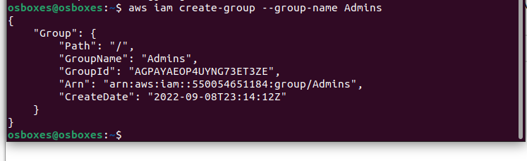

- Create another group “Testers” by CLI .

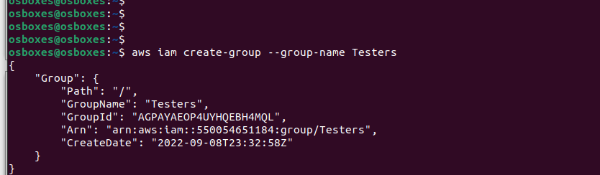

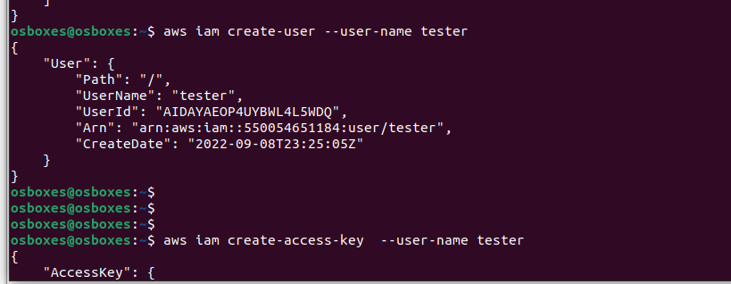
create new user “tester” and his credentials:

- Adding the user “tester” to the group “Testers” by the following command:

osboxes@osboxes:~$
osboxes@osboxes:~$ aws iam add-user-to-group --user-name tester --group-name Testers
osboxes@osboxes:~$

- Attach a group policy “AmazonEC2ReadOnlyAccess ” to the group Testers by the below command:

osboxes@osboxes:~$ aws iam attach-group-policy –policy-arn arn:aws:iam::aws:policy/AmazonEC2ReadOnlyAccess --group-name Testers

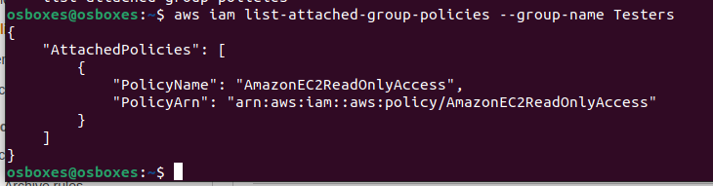
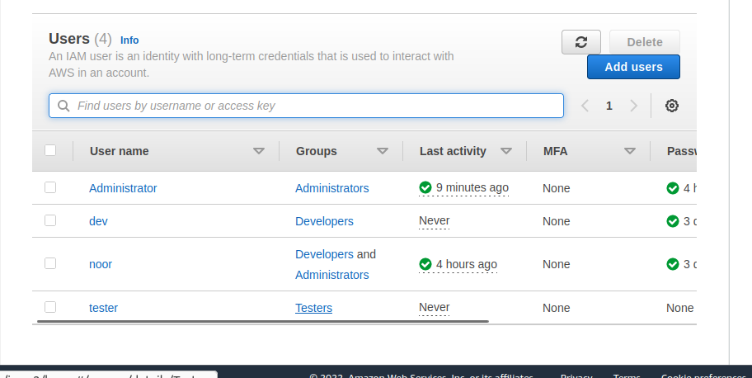
- we can see it below :

