

Sukkur

Institute of Business Administration

University

Software Design Specification (SDS)

**Smart Teleclinic Application**

|  |  |
| --- | --- |
| Project Name | Smart Teleclinic Application |
| Supervisor | Dr. Ghulam Mujtaba |
| Co-Supervisor |  |
| Project Lead | Alizay |
| Project Team | Noor ul Ain  Razwan Ali |
| Submission Date | 11 February, 2023 |

Supervisor Signature: ___________

Contents

**1.0 Introduction of Design Document** 3

**2.0 Entity Relationship Diagram (ERD)** 3

**3.0 Sequence Diagrams** 4

**4.0 Architecture Design Diagram** 6

**5.0 Class Diagram** 7

**6.0 Activity Diagram**

**7.0 Test Cases** 8

# **1.0 Introduction of Design Document**

This document provides entity relationship diagram, sequence of the application (sequence diagram), class diagram, architecture design and database design for our system. In essence, this document provides a visual depiction of the system design as it is being created. This document is intended to help the development team understand.

# **2.0 Entity Relationship Diagram (ERD)**

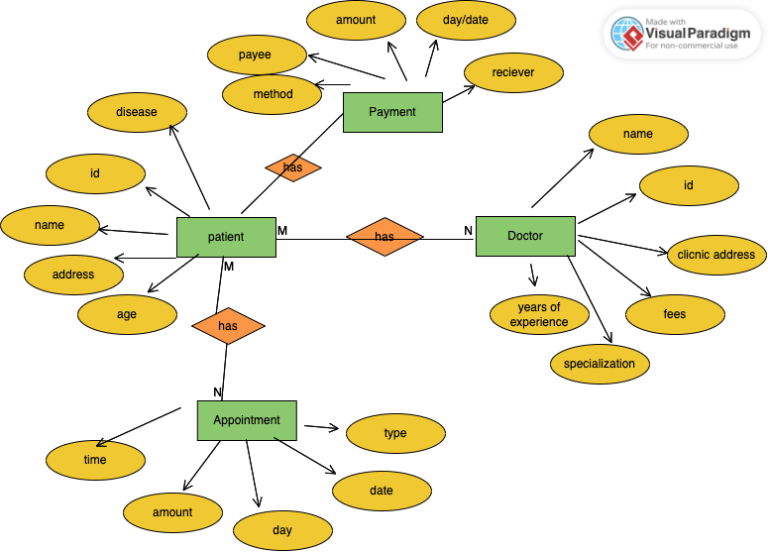

*Figure 1 Entity Relation Diagram*

**Figure 1:** This figure shows entity relationship between entities of the system. Users have to register in order to get access to the application. All the User data will be stored on the database. Appointments can be booked of three types. Payment can also be made via jazz cash or e-wallet transactions

# 

# **3.0 Sequence Diagrams**

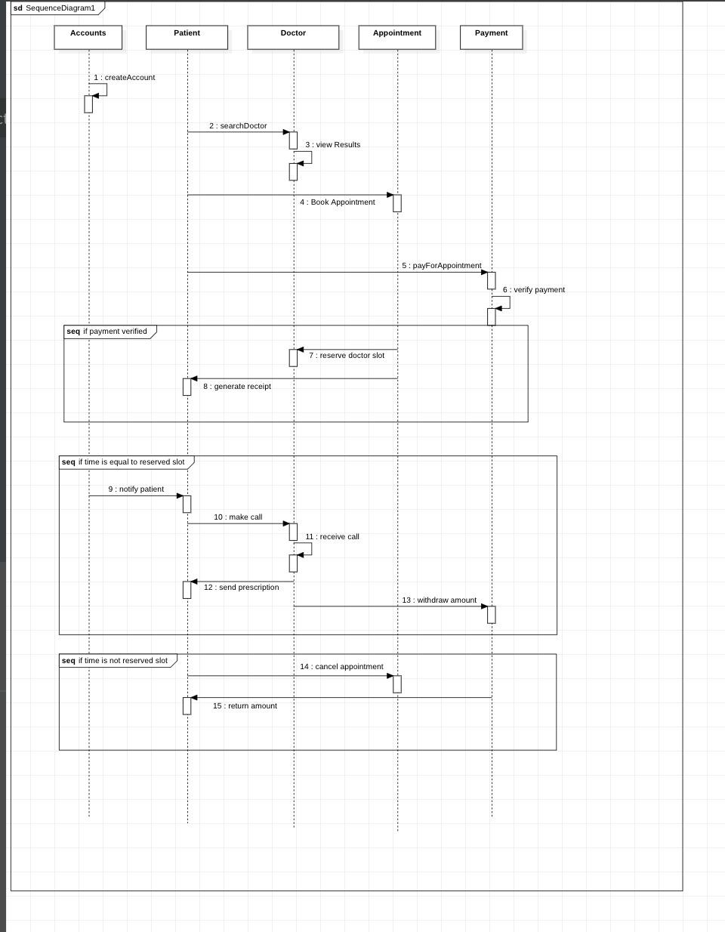



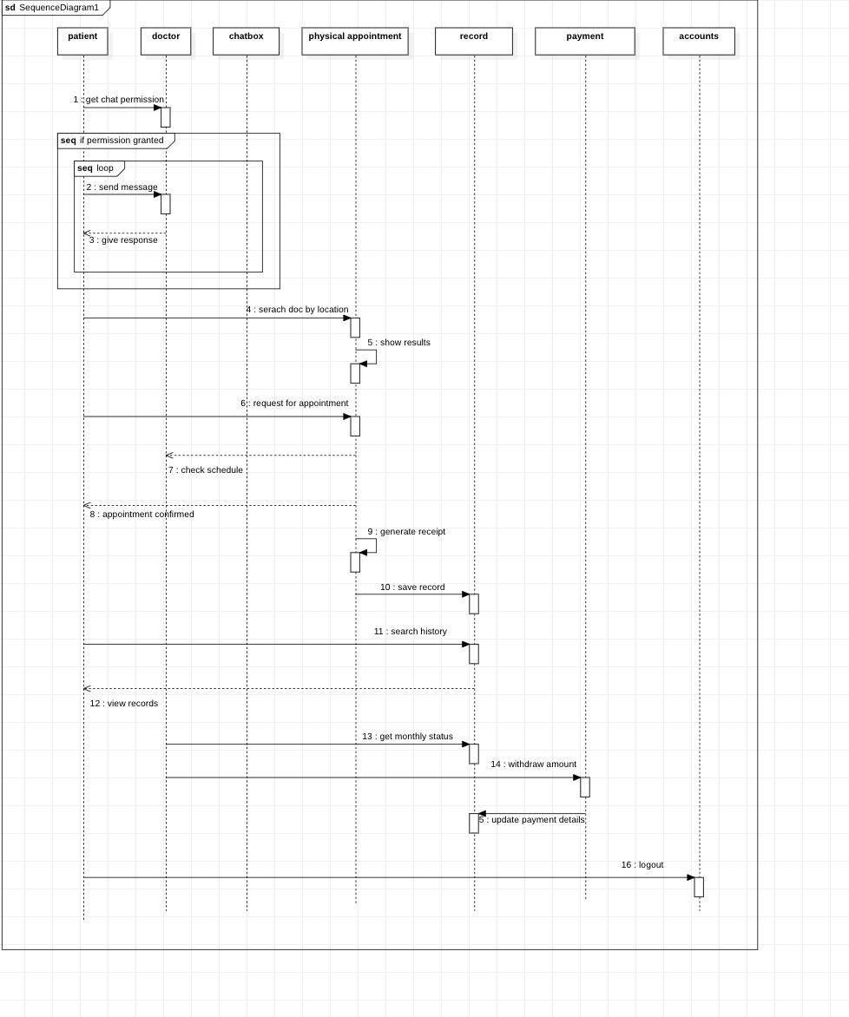

**Figure 2:** This figure shows communication and flow of the system. According to the diagram above, the user will have to create the account according to its type. Patients then will be able to book search doctors by different attributes and then book appointments. The doctor then chooses to accept or decline the booking. If the payment done by the patient is successful then reserve the doctor slot and send notification to the patient and make a call. Else the patient can cancel the appointment before the reserved time. Patients can also ask for the chat permission from the doctor. Both doctor and patients will be able to see their activities through the history section of the application.

**4.0 Architecture Design Diagram**

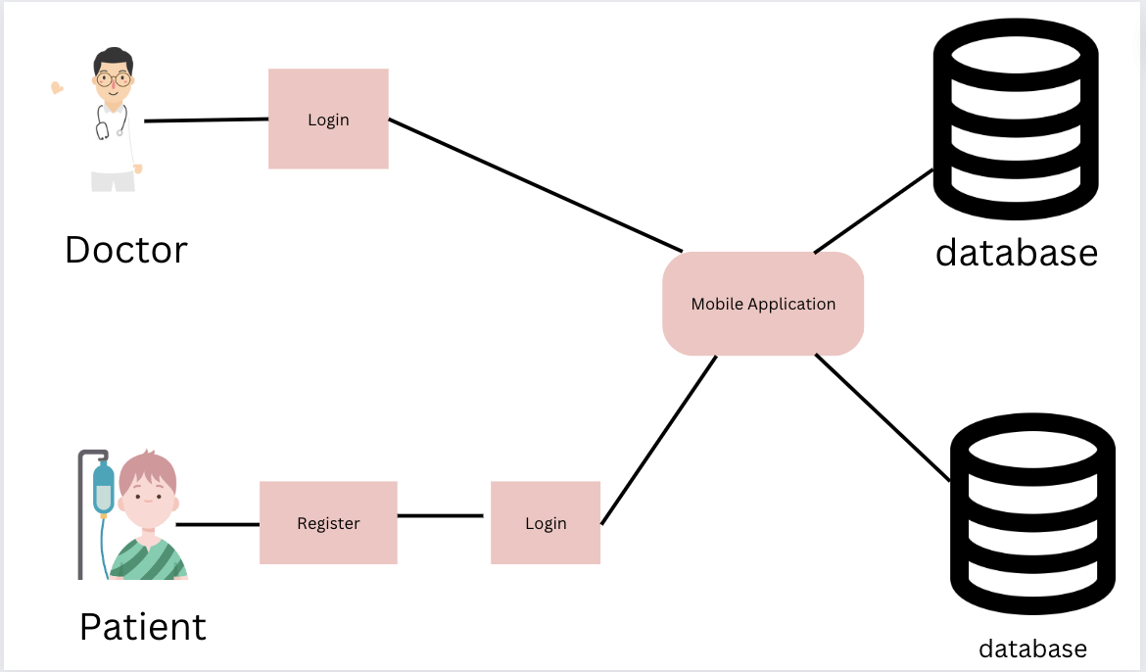

**Figure 4:** This is a 3 tier architecture. Both patient and doctor can access mobile app though logging in . The mobile app will be connected to the database which will allow it to keep records and history of patients which the doctors can see.

# **5.0 Class Diagram**

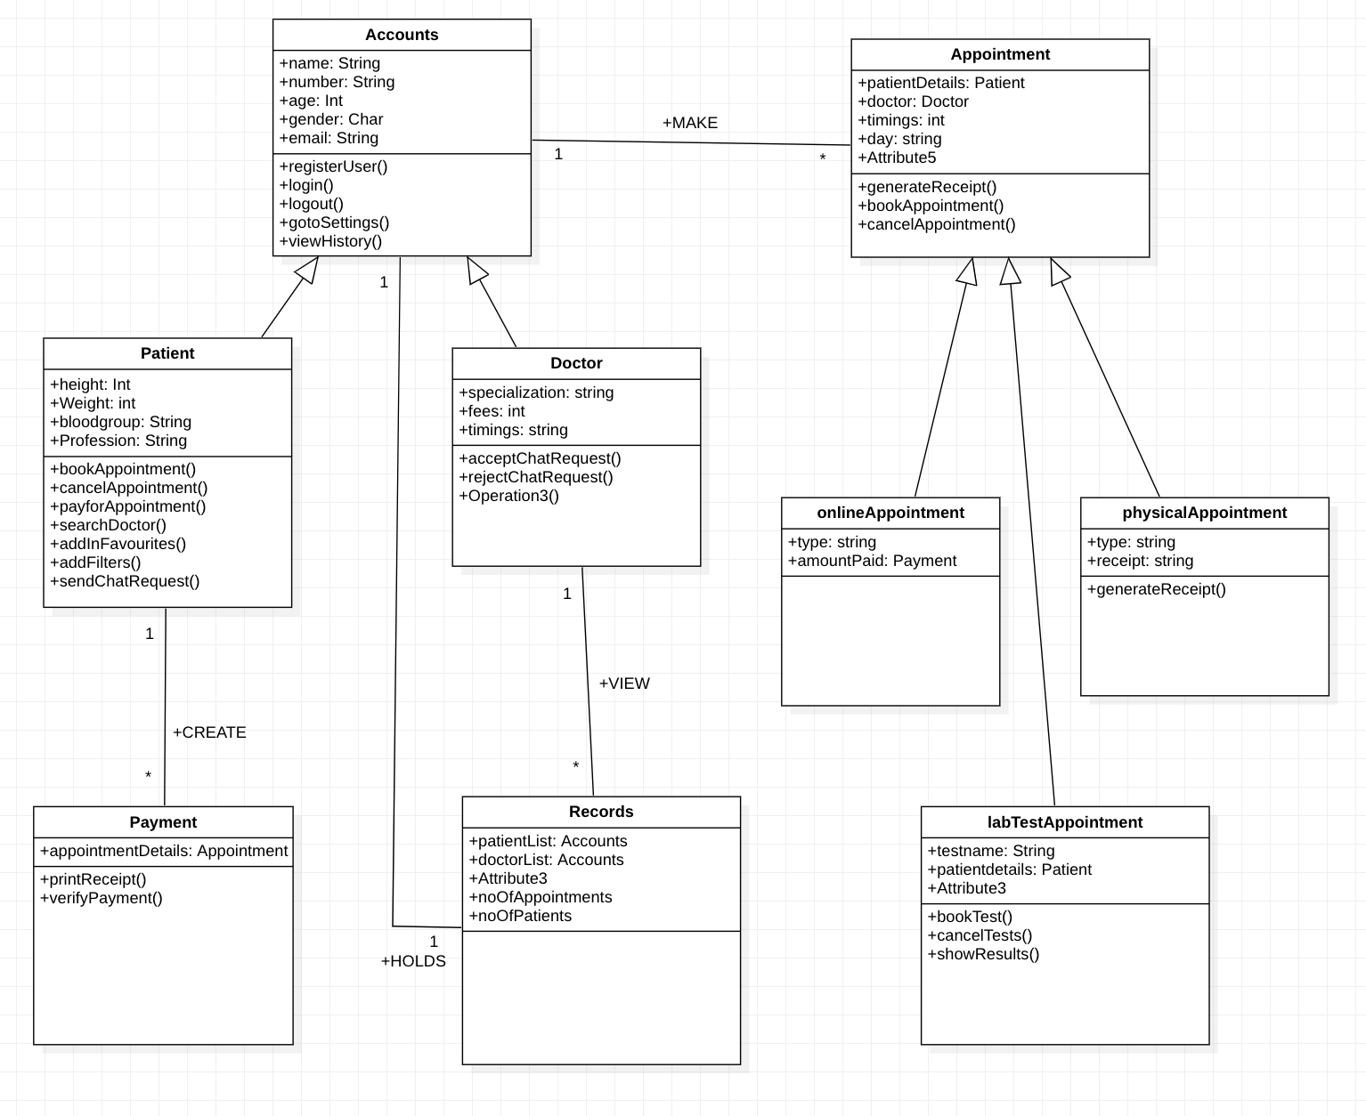

*Figure 5 Class Diagram*

**Figure 5:** This figure shows the classes of the system. All the classes that will be used in the system are shown in figure. There will be two super classes. Some of the classes will extend them. The relationship between them is also mentioned clearly.

# **6.0 Activity Diagram**

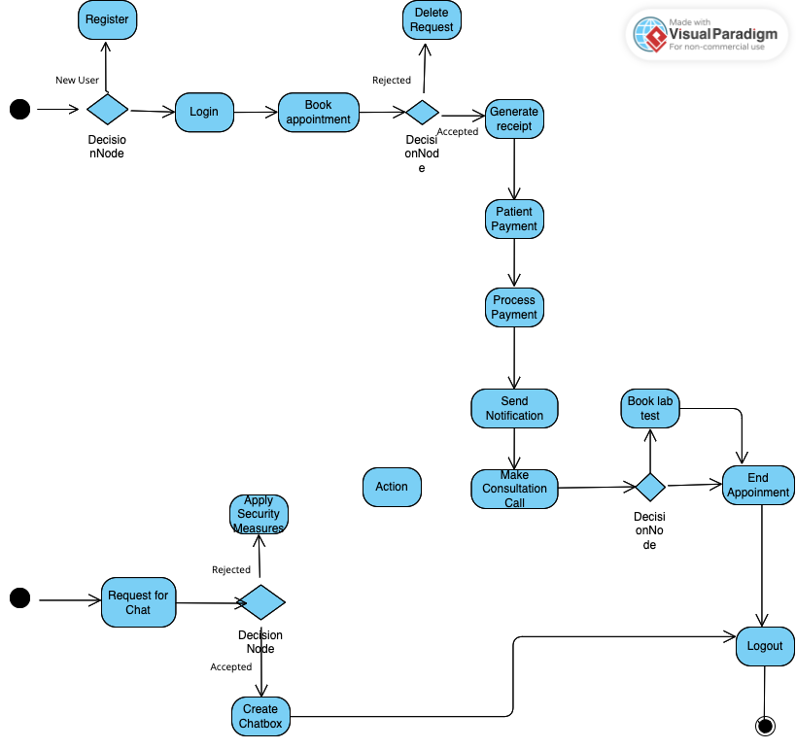

# 

**Figure 6:** This figure shows the flow of activities in the system. This is exactly how the application will work when a user interacts with it.

# 

# **7.0 Test Cases**

|  |  |  |  |
| --- | --- | --- | --- |
| ID | Feature of Test | Execution Step | Expected Result |
| 1 | Check Sign up | Provide Name, email, password, age and profession that will be saved in the database | Show Homepage of the application |
| 2 | Check Login | Enter Email and password | Show Homepage of the application |
| 3 | Filter | Use the filter option to select the blood type | Fetch the doctors of the selected area and filtered price. |
| 4 | Show clinic location | User will click on the button to get to see the directions of the clinic. | The application will open the google maps and give directions. |