 | Hashemite University | 
Prince Al-Hussein bin Abdullah II Faculty for Information
Technology
 | Department of Information Technology
Data Mining Report (2)
For Students Use
Title of the project: | Anomaly Detection Using Isolation Forest
Student Name | Noor Ma'moun Abu Shawar
Student ID | 2332659

Project Guidelines & Instructions
In this report, Team group are required to clearly and logically introduce their project. Follow the guidelines below:

The team project are required to complete a project that applies Data Mining techniques to extract meaningful insights from a dataset.
• The project must be original work
• Use Python (e.g., Pandas, Scikit-learn, or similar tools) or Weka tools

1. Dataset Description:
- Dataset source: Kaggle datasets
  - Credit Card Fraud Detection Dataset
  - IoT Sensor Dataset
- Number of instances (records):
  - Credit Card Dataset: 284,807 records
  - IoT Dataset: 3000 records
- Number of features (attributes):
  - Credit Card Dataset: 30 features
  - IoT Dataset: 5 features

- Data types (numerical, categorical, etc.): Mostly numerical data.
- Target variable (if applicable): The project uses unsupervised learning, so labels were not used during training.

2. Data Preprocessing
- Handling missing values: Missing values were checked and handled when necessary.
- Removing duplicates: • Duplicate rows were checked.
- Data cleaning: The datasets were cleaned before training the model.
- Encoding categorical variables: No encoding was needed because the datasets were numerical.
- Normalization / Standardization: Feature scaling was applied using StandardScaler.
- Outlier detection and handling: Isolation Forest was used to detect anomalies.
3. Data Exploration & Visualization
- EDA was performed using basic dataset information, class distribution visualization, and PCA scatter plots to understand anomaly behavior.
- Identify patterns and relationships: The model showed clear separation between normal and anomalous points.

4. Model Code Requirement

Outline the general methodology: The project applies Isolation Forest, an unsupervised anomaly detection algorithm.
Main Steps:
- Load datasets
- Preprocess data
- Train Isolation Forest
- Predict anomalies
- Visualize results
- Compare with LOF model
Model creation:
IsolationForest (contamination=0.01, random_state=42)
Training step:
The model was trained using fit_predict().
Key parameters:
- contamination
- random_state

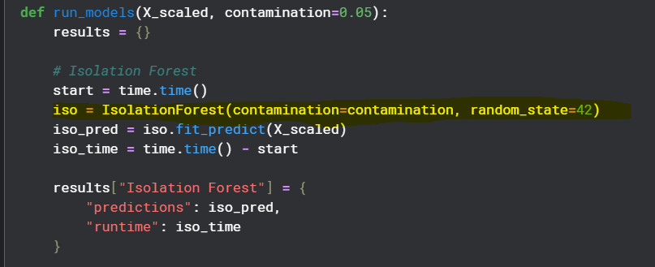
- Model creation

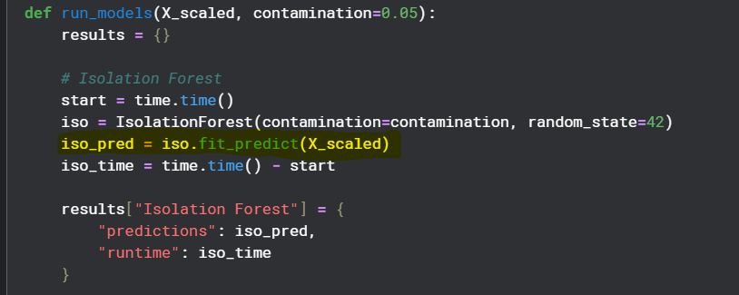
- Training step

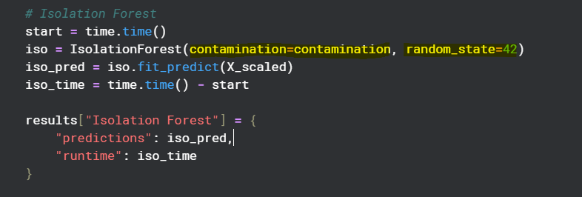
- Key parameters

5. Evaluation

The project was evaluated using:
- PCA visualization
- Runtime comparison
- Anomaly detection results
Results interpretation:
- Isolation Forest successfully detected anomalies in both datasets.
- The model showed high speed and scalability.
- Isolation Forest runtime was around 3 seconds, while LOF required around 244 seconds.
- PCA visualization showed clear separation between normal and anomalous points.

Figure 1: PCA visualization for Credit Card Dataset anomalies.
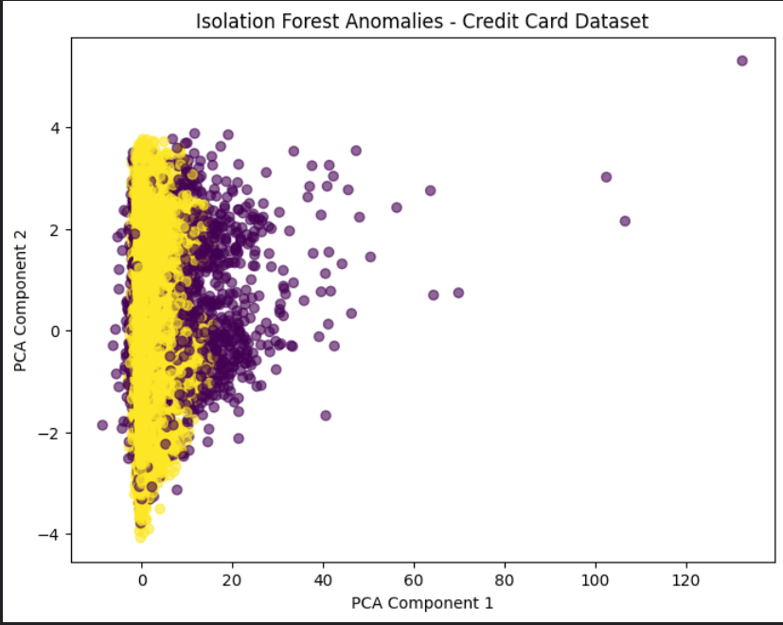

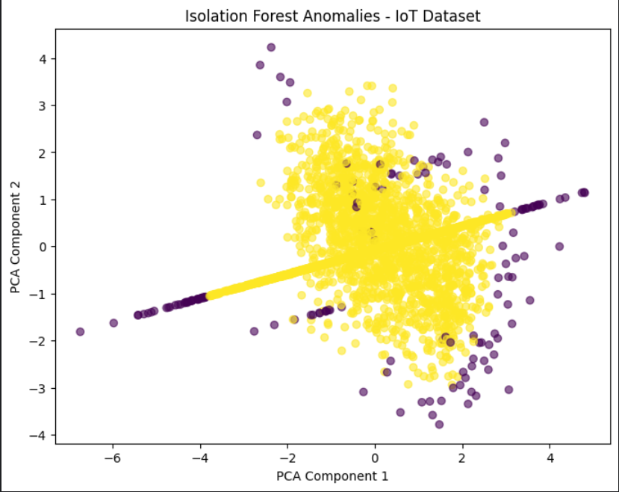

Figure 2: PCA visualization for IoT Dataset anomalies.

