|  |  |  |
| --- | --- | --- |
| Imagine The end of The world  It is easier to imagine | |  | | --- | | Project presented by:  Noor Hossam Gabre  20102405 | |



**Introduction**

My idea is to put the user in two modes

First: To save The earth From

Meteor

Second: is to simulate The end of the earth with meteor

It is also attached with sound effects to make the simulate more life

Some Screen shots of coded version

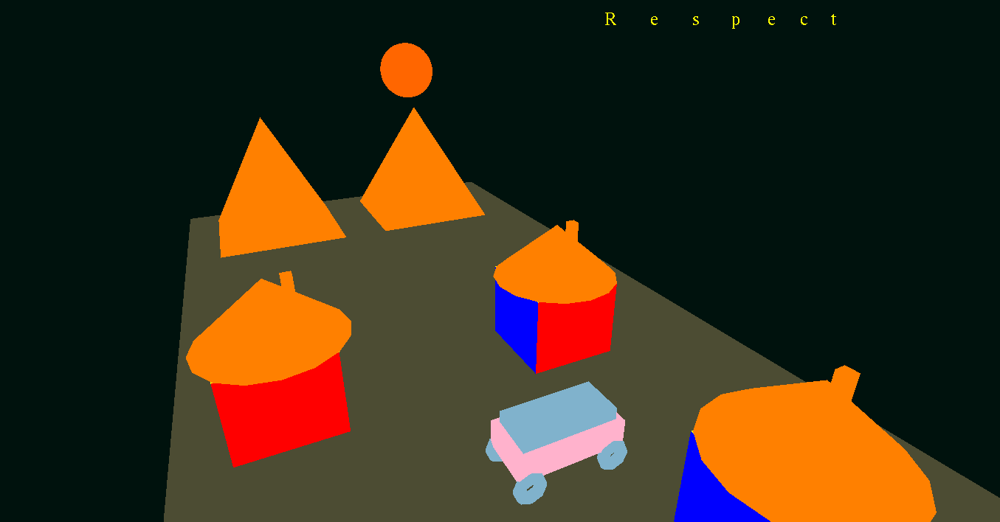

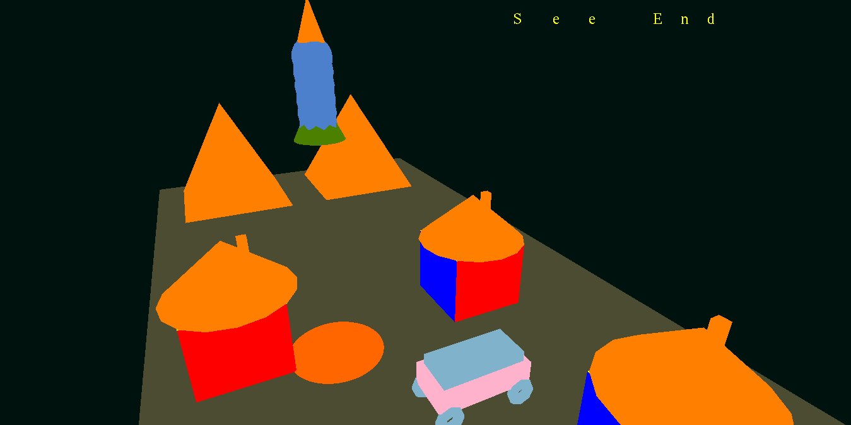

Some Screen shots of coded version

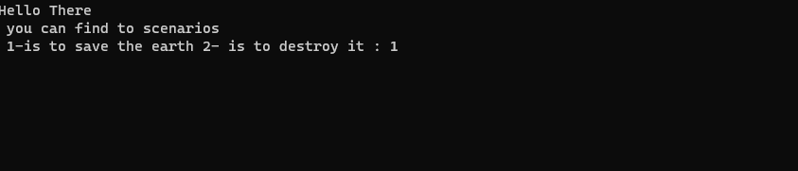

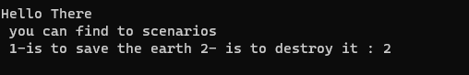

The main parts of project

1 the view Model , Keyboard and camera

It is a perspective view that can control the camera over x y z axis by the inputs of keyboard ->

* x: decrease the x value,
* X: increase x value,
* y: decrease y value,
* Y: increase y value,
* z: decrease z value,
* Z: increase z value

2-Houses

Contains two parts

First Part

The cube:

Which is manually made using matrix of vertices and it is the body of house

Second Part

The house attachments: which is build in functions in glut like solid cone

3-Rocket

Which is appear only in second mode because is the mode of the end of earth it made by build in function like cone and sphere with animation of increase y value

4 car

Appear in two modes which build with build in functions like cube

With animation of increase x axis

5-pyramids

Appear in two modes made manually with vertices

6-meteor

Appear in Second mode That will destroy the earth with animation of falling and then animation of explosion made by build in functions like sphere