PROJECT PROPOSAL
ShopSphere: A Relational Database System for an
E-Commerce Shopping Store
Submitted by: Noor Fatima
Roll Number: 23L-0946

Project Title
ShopSphere — A Relational Database System for an E-Commerce Shopping Store

Abstract
Online retail platforms depend on a database that can reliably track customers, products, inventory, orders, and payments while staying consistent under concurrent use. This project, ShopSphere, proposes and implements a normalized relational database for an e-commerce shopping store, covering the full design lifecycle from requirements and ER modeling through normalization, physical schema implementation, and validation with representative SQL queries. The design models customers and addresses, a hierarchical product catalog with variant-level stock, shopping carts and wishlists, orders and order line items, payments, shipments, product reviews, and discount coupons. The result is a schema that enforces referential integrity, avoids redundancy through normalization to at least 3NF, and supports realistic reporting needs such as best-seller rankings, customer spending history, and low-stock alerts.

Project Description

Introduction
Online retail has become the dominant channel through which consumers discover, compare, and purchase goods. Behind every storefront, however, sits a relational database that must reliably track customers, products, inventory, orders, and payments while remaining consistent under concurrent access. This project proposes the design and implementation of ShopSphere, a relational database system that models the core operations of an e-commerce shopping store.
The project is undertaken as coursework for the Database Systems module and is intended to demonstrate the full database design lifecycle: requirements gathering, conceptual modeling with an Entity-Relationship (ER) diagram, logical design through normalization, physical implementation using SQL DDL, and validation through representative queries and a lightweight application layer.

Problem Statement
Small and medium-sized retail businesses that move online often rely on spreadsheets or ad-hoc tools to track products and orders. This approach does not scale: it cannot enforce referential integrity between customers, orders, and payments, cannot efficiently answer analytical questions such as “which products are running low on stock” or “who are our highest-value customers,” and is prone to data duplication and anomalies. A well-normalized relational database, exposed through a defined schema and query layer, addresses these shortcomings directly.

Project Objectives
- Model the core entities and relationships of an e-commerce platform using an Entity-Relationship diagram.
- Translate the conceptual model into a normalized relational schema (up to 3NF/BCNF) that eliminates redundancy and update anomalies.
- Implement the schema in a relational DBMS (e.g., MySQL / PostgreSQL) with appropriate primary keys, foreign keys, and constraints.
- Populate the database with representative sample data and demonstrate correctness through a suite of SQL queries.
- Build a minimal application layer (CRUD interface or REST API) to demonstrate the schema supporting real user workflows such as browsing, cart management, and checkout.
- Document design decisions, trade-offs, and normalization justifications for evaluation.

Scope of the Project
The system covers the customer-facing and back-office data needs of a single-vendor or multi-vendor online store:
- Customer registration, authentication data, and multiple shipping/billing addresses.
- A hierarchical product catalog with categories, products, and variants (size/color/SKU-level stock).
- Shopping cart and wishlist management prior to checkout.
- Order placement, order line items, payments, and shipment tracking.
- Product reviews and ratings, and discount coupons applied at checkout.
Out of scope: real payment gateway integration, production-grade security/auth, and large-scale performance tuning — these are noted as future work near the end of this proposal.

Existing Systems and Related Work
Commercial platforms such as Shopify, Amazon, and Daraz implement similar data models at much larger scale, typically layering caching, search indices, and microservice boundaries over a relational or hybrid storage core. For the purposes of this course project, ShopSphere adopts the same conceptual building blocks — customers, catalog, cart, orders, payments — while keeping the implementation scoped to a single relational database suitable for classroom evaluation.

System Requirements

Functional Requirements
- A customer can register, log in, and manage multiple saved addresses.
- A customer can browse products by category, view product variants, and search/filter the catalog.
- A customer can add items to a cart or wishlist and adjust quantities before checkout.
- The system shall create an order from cart contents, decrement inventory, and record order line items.
- The system shall record a payment transaction per order and support at least one payment status workflow (pending → completed → refunded).
- The system shall track shipment status from processing through delivery.
- A customer can leave one review with a rating per purchased product.
- An administrator can add/update products, categories, and stock levels, and view sales reports.
- A coupon code can be applied to an order to reduce the total, subject to an expiry date.

Non-Functional Requirements
- Data integrity: all foreign keys enforced; stock quantity constrained to be non-negative.
- Consistency: order placement and inventory decrement occur within a single transaction.
- Normalization: schema normalized to at least 3NF to avoid insertion/update/deletion anomalies.
- Extensibility: schema should accommodate new product categories or attributes without structural rework.
- Performance: indexed foreign keys and searchable columns (e.g., product name, SKU) for common queries.

Conceptual Database Design (ER Model)
The conceptual model identifies the following core entity types, their key attributes, and the relationships among them. Weak entities and associative (junction) entities used to resolve many-to-many relationships are noted explicitly.

Entities and Attributes
Table 7.1 — Core Entities
Entity | Type | Key Attributes
Customer | Strong | CustomerID (PK), Name, Email (unique), Password, Phone, CreatedAt
Address | Weak (owner: Customer) | AddressID (PK), CustomerID (FK), Line1, City, PostalCode, Country, Type
Category | Strong (self-referencing) | CategoryID (PK), Name, ParentCategoryID (FK → Category)
Seller | Strong | SellerID (PK), StoreName, Email, Rating
Product | Strong | ProductID (PK), Name, Description, CategoryID (FK), SellerID (FK), BasePrice
ProductVariant | Weak (owner: Product) | VariantID (PK), ProductID (FK), SKU (unique), Size, Color, Price, StockQty
ProductImage | Weak (owner: Product) | ImageID (PK), ProductID (FK), URL, IsPrimary
Cart | Strong | CartID (PK), CustomerID (FK), CreatedAt
CartItem | Associative | CartItemID (PK), CartID (FK), VariantID (FK), Quantity
Order | Strong | OrderID (PK), CustomerID (FK), AddressID (FK), OrderDate, Status, TotalAmount
OrderItem | Associative | OrderItemID (PK), OrderID (FK), VariantID (FK), Quantity, UnitPrice
Payment | Weak (owner: Order) | PaymentID (PK), OrderID (FK), Method, Amount, Status, TransactionDate
Shipment | Weak (owner: Order) | ShipmentID (PK), OrderID (FK), Carrier, TrackingNumber, Status
Review | Associative | ReviewID (PK), ProductID (FK), CustomerID (FK), Rating, Comment, ReviewDate
Wishlist / WishlistItem | Assoc. (M:N resolver) | WishlistItemID (PK), CustomerID (FK), ProductID (FK)
Coupon | Strong | CouponID (PK), Code (unique), DiscountType, DiscountValue, ExpiryDate

Relationships and Cardinalities
Table 7.2 — Relationships
Relationship | Cardinality | Notes
Customer – Address | 1 : N | A customer may have several shipping/billing addresses.
Category – Category | 1 : N (recursive) | A category may have subcategories (self-join).
Seller – Product | 1 : N | A seller lists many products (supports a marketplace model).
Category – Product | 1 : N | Each product belongs to exactly one category.
Product – ProductVariant | 1 : N | Stock and price are tracked at the variant (SKU) level.
Customer – Cart – ProductVariant | M : N via CartItem | Resolved by the CartItem associative entity.
Customer – Order | 1 : N | A customer places many orders over time.
Order – ProductVariant | M : N via OrderItem | Resolved by the OrderItem associative entity.
Order – Payment | 1 : 1 (or 1:N for retries) | One primary payment record per order, extensible to installments.
Order – Shipment | 1 : 1 | One shipment record tracks fulfillment status.
Customer – Product (Review) | M : N via Review | A customer reviews a product at most once (unique constraint).
Customer – Product (Wishlist) | M : N via WishlistItem | Resolved by an associative entity.
Order – Coupon | M : N via OrderCoupon | Supports future multi-coupon stacking; typically 0 or 1 per order.

Schema Diagram
The diagram below renders the relational schema described above: each box is a table with its primary key (PK) and foreign keys (FK) listed, and arrows show the foreign-key relationships between tables, annotated with cardinality (1:1, 1:N, or resolved M:N via a junction table).
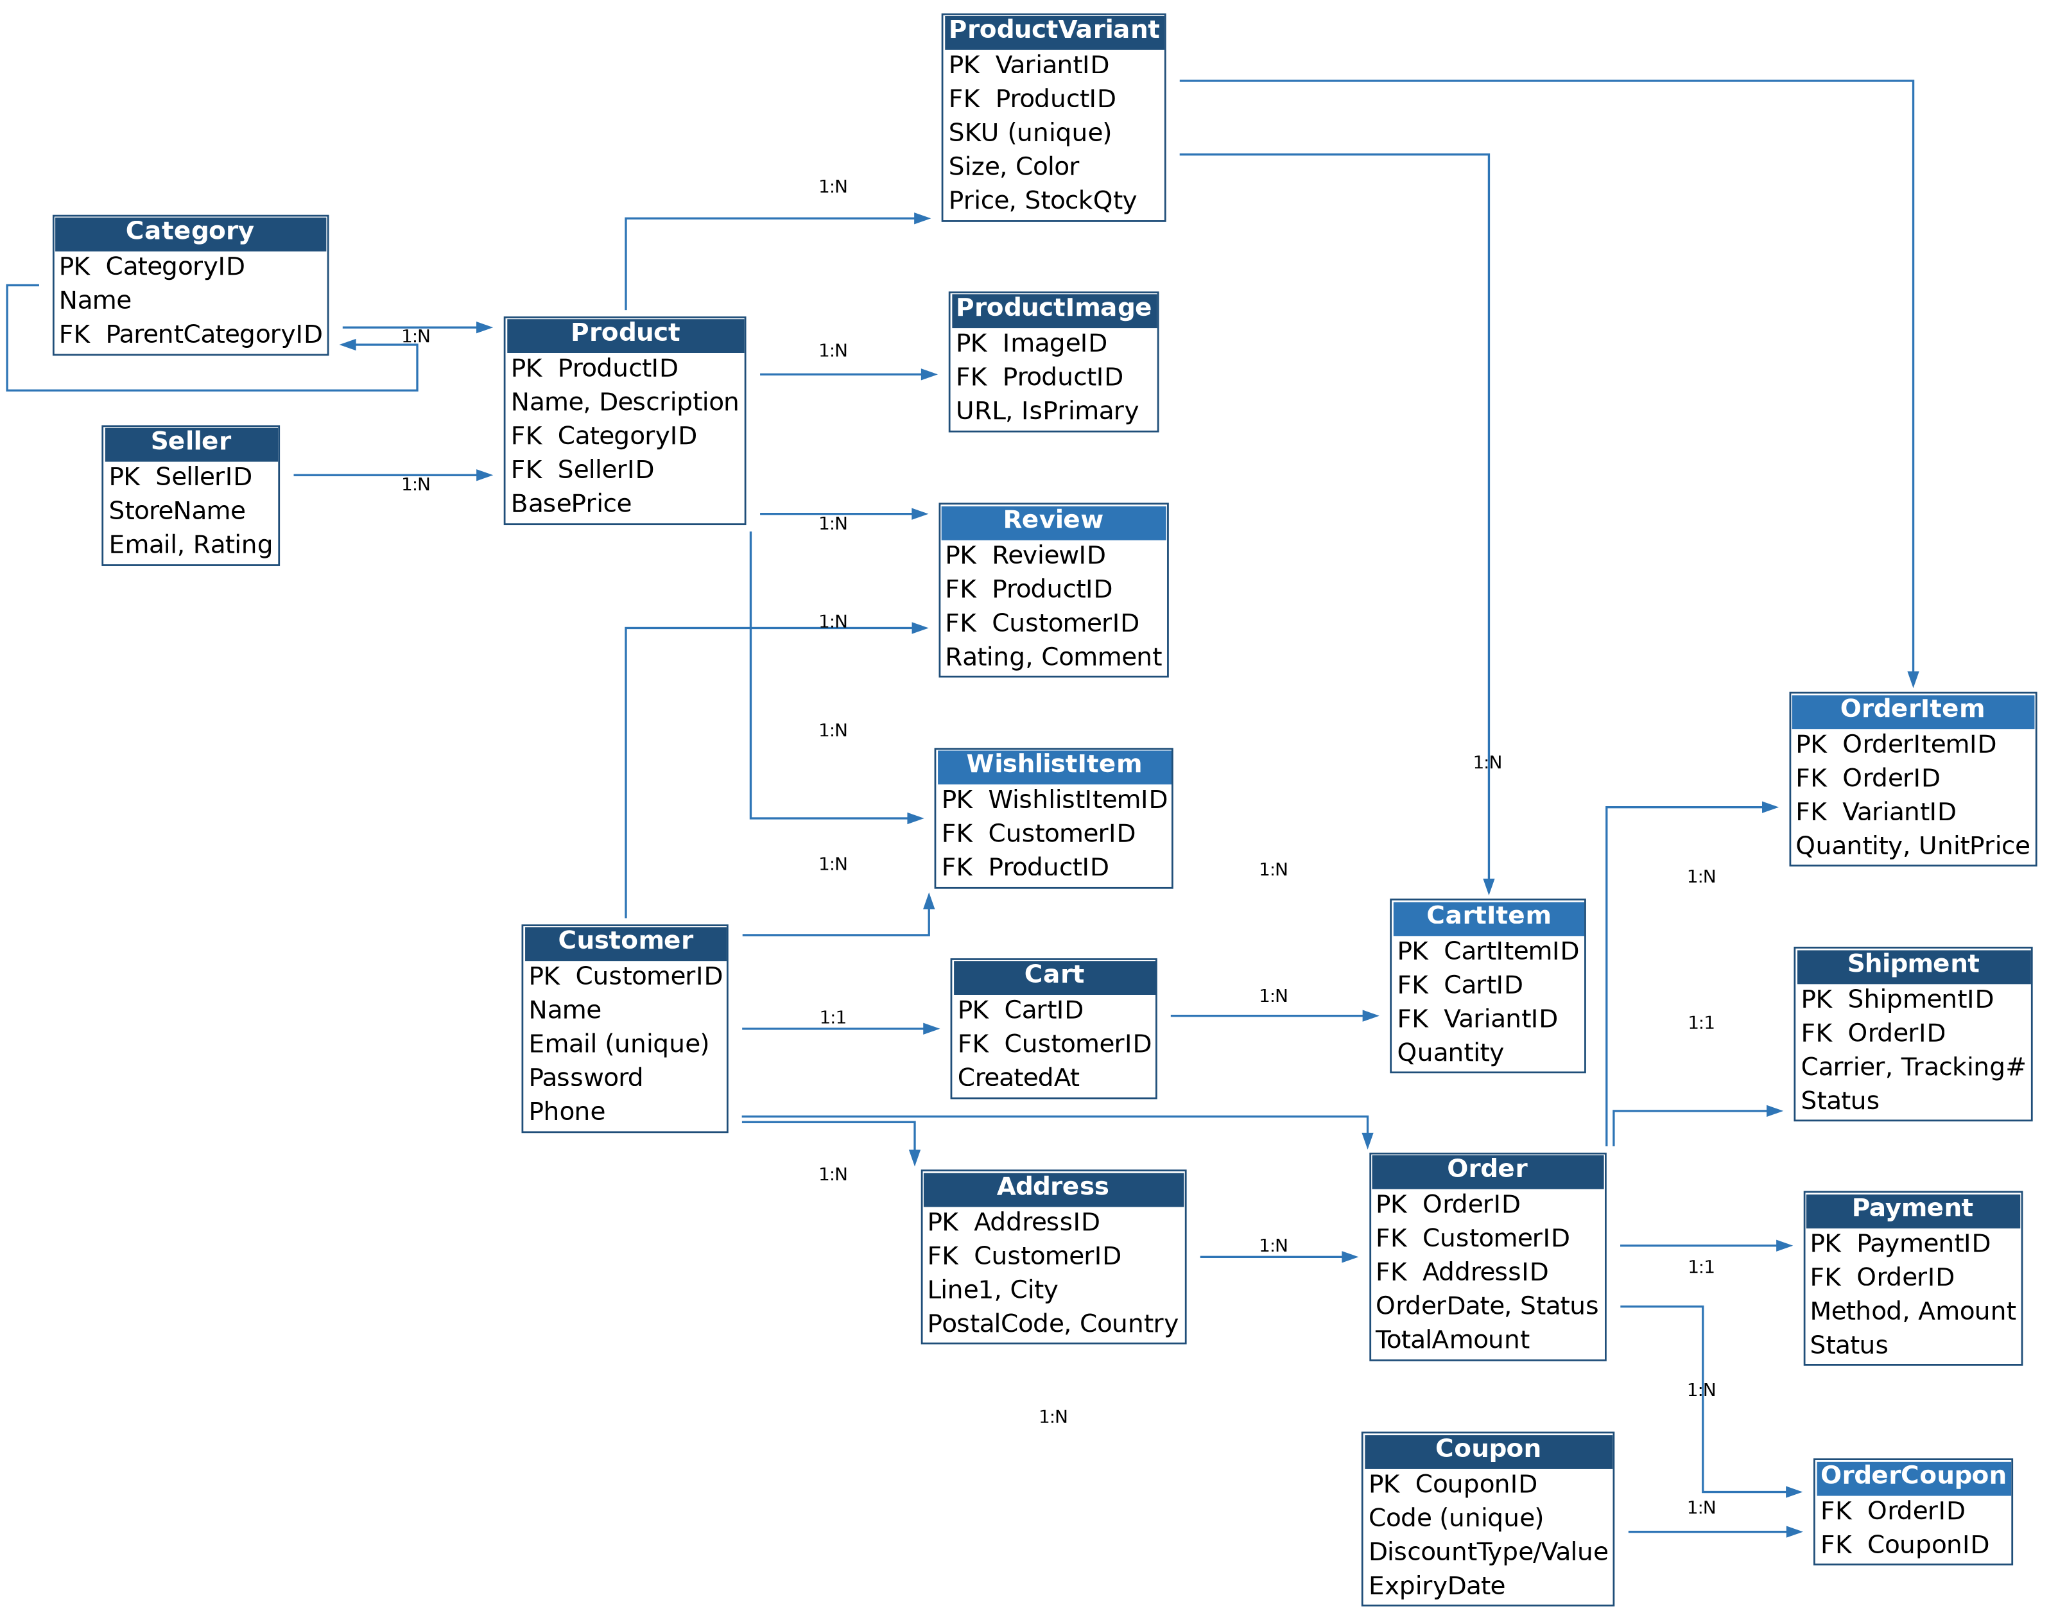
Figure 1: ShopSphere relational schema diagram, showing all tables, keys, and foreign-key relationships.

Logical Design and Normalization
The conceptual model above is translated into relations following standard normalization rules:
- 1NF: All attributes are atomic (e.g., a single address is not stored as a comma-separated string; each address is its own row in the Address relation).
- 2NF: Composite-key relations such as OrderItem and CartItem carry only attributes (Quantity, UnitPrice) that depend on the whole key (OrderID + VariantID), not on OrderID or VariantID alone.
- 3NF: Transitive dependencies are removed — for example, ProductVariant.Price does not depend on Product.CategoryID, and Order.TotalAmount is treated as a derived/denormalized convenience column, recomputable from OrderItem rows and documented as such rather than a hidden source of anomalies.
A brief justification for each normalization step, together with a before/after comparison for at least one relation (e.g., an initial flat Order table split into Order, OrderItem, Payment, and Shipment), will be included in the final report to demonstrate the reasoning process expected by the course rubric.

Proposed Relational Schema (DDL Summary)
The following abbreviated schema summarizes the physical tables to be created; full CREATE TABLE statements with constraints (PRIMARY KEY, FOREIGN KEY, CHECK, UNIQUE, NOT NULL) will be included in the implementation appendix.
Table 9.1 — Sample DDL Outline
Table | Primary Key | Foreign Keys
Customer | CustomerID | —
Address | AddressID | CustomerID → Customer
Category | CategoryID | ParentCategoryID → Category
Product | ProductID | CategoryID → Category, SellerID → Seller
ProductVariant | VariantID | ProductID → Product
Order | OrderID | CustomerID → Customer, AddressID → Address
OrderItem | OrderItemID | OrderID → Order, VariantID → ProductVariant
Payment | PaymentID | OrderID → Order
Shipment | ShipmentID | OrderID → Order
Review | ReviewID | ProductID → Product, CustomerID → Customer

System Architecture
The system follows a conventional three-tier architecture:
- Presentation tier: a lightweight web front end (or admin CLI) for browsing products and managing orders.
- Application/logic tier: a REST API (e.g., Node.js/Express) that mediates all reads and writes and enforces business rules not captured by database constraints (e.g., applying a coupon).
- Data tier: a relational DBMS (MySQL or PostgreSQL) hosting the schema described in Sections 7–9, with transactions used for multi-step operations such as checkout.

Sample Queries to Demonstrate the Schema
The following representative queries will be implemented and included in the final submission to validate that the schema supports realistic reporting and application needs:
- Top-selling products: total quantity sold per product, ranked descending, over a given date range.
- Customer lifetime value: total amount spent per customer across all completed orders.
- Low-stock alert: all product variants whose StockQty falls below a reorder threshold.
- Order detail view: a joined view of an order, its line items, payment status, and shipment status for a given OrderID.
- Monthly revenue report: total completed-order revenue grouped by month.
- Category performance: revenue and units sold rolled up by product category, including subcategories via the recursive Category relationship.

Expected Outcomes and Future Work
By the end of the project, ShopSphere will demonstrate a fully normalized, constraint-enforced relational database supporting the end-to-end lifecycle of an e-commerce order, backed by representative sample data and a working query/API layer. Potential extensions beyond course scope include multi-currency pricing, full-text product search, a recommendation engine driven by review/rating data, and horizontal scaling considerations for a production deployment.

Conclusion
This proposal has outlined the motivation, requirements, conceptual and logical design, and implementation plan for a relational database supporting an e-commerce shopping store. The design emphasizes correctness (through normalization and constraints), extensibility (through a category hierarchy and variant-level product modeling), and demonstrability (through a concrete set of validating queries), providing a solid foundation for the remaining implementation phases of the course project.

