# Assignment 1 - Testing & Grading Sheet
**Student Name:** Noora Almarri
**Student ID:** 202206911
**Date:** 5 march 2026

> **Instructions:** For each item below, take a screenshot and save it inside a `screenshots/` folder using the exact file name shown. The image will render automatically in this document. Resize your browser to the correct screen size before capturing.
---
## 1. Home Page - Small Screen (Mobile)
Resize your browser to **< 768px** width and take a full-page screenshot of `index.html`.
**Expected:** Navigation links stacked vertically, recipe cards in 1 column, sidebar below main content.
Save your screenshot as `screenshots/q1-home-mobile.png`
![Home page mobile](screenshots/q1-home-mobile.png)
---
## 2. Home Page - Medium Screen (Tablet)
Resize your browser to **768px-1023px** width and take a full-page screenshot of `index.html`.
**Expected:** Navigation links in a row, recipe cards in 2 columns.
Save your screenshot as `screenshots/q2-home-tablet.png`
![Home page tablet](screenshots/q2-home-tablet.png)
---
## 3. Home Page - Large Screen (Desktop)
Resize your browser to **1024px+** width and take a full-page screenshot of `index.html`.
**Expected:** Header with logo left and nav right, recipe cards in 3 columns, sidebar as a side column.

Save your screenshot as `screenshots/q3-home-desktop.png`
![Home page desktop](screenshots/q3-home-desktop.png)
---
## 4. Share Recipe Page
Take a screenshot of the full `share-recipe.html` page.
**Expected:** Same header/footer as home page, form with 2 fieldsets, submit and reset buttons.
Save your screenshot as `screenshots/q4-share-recipe.png`
![Share recipe page](screenshots/q4-share-recipe.png)
---
## 5. Navigation Between Pages
Take two screenshots showing:
- Clicking "Share Recipe" on `index.html` navigates to `share-recipe.html`
- Clicking "Recipes" on `share-recipe.html` navigates back to `index.html`
Save your screenshots as `screenshots/q5-nav-to-share.png` and `screenshots/q5-nav-to-home.png`
![Nav to share recipe](screenshots/q5-nav-to-share.png)
![Nav to home](screenshots/q5-nav-to-home.png)
---
## 6. Weekly Meal Plan Table
Take a screenshot of the meal plan table section.
**Expected:** Table with caption, thead, tbody, tfoot, scope attributes, colspan, zebra striping on hover.
Save your screenshot as `screenshots/q6-meal-plan-table.png`
![Meal plan table](screenshots/q6-meal-plan-table.png)
---

## 7. Recipe Cards Hover Effect

Take a screenshot showing a recipe card being hovered (with the card lifted/shadow effect).
Save your screenshot as `screenshots/q7-card-hover.png`
![Card hover effect](screenshots/q7-card-hover.png)
---
## 8. Form Validation
Take a screenshot showing form validation - try submitting the form without filling in the required fields.
**Expected:** Browser shows validation messages for required fields.
Save your screenshot as `screenshots/q8-form-validation.png`
![Form validation](screenshots/q8-form-validation.png)
---
## 9. Cooking Tutorial Video
Take a screenshot showing the embedded YouTube video on the home page.
Save your screenshot as `screenshots/q9-video.png`
![Cooking tutorial video](screenshots/q9-video.png)
---
## 10. Sidebar
Take a screenshot of the sidebar section showing cooking tips and resource links.
**Expected:** Ordered list of tips, unordered list of links (external, mailto, tel).
Save your screenshot as `screenshots/q10-sidebar.png`
![Sidebar](screenshots/q10-sidebar.png)

Screenshots:

1 – Home Page Layout 9Desktop)
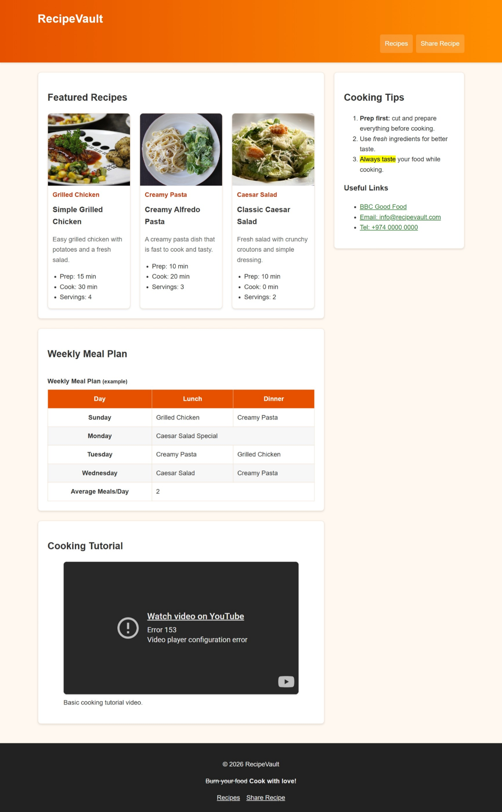
Explanation:
This screenshot shows the main layout of the RecipeVault website. It includes the header with the website title, the navigation menu, and the main content area displaying recipes. The layout is styled using CSS to organize the page clearly.

2 – Share recipe
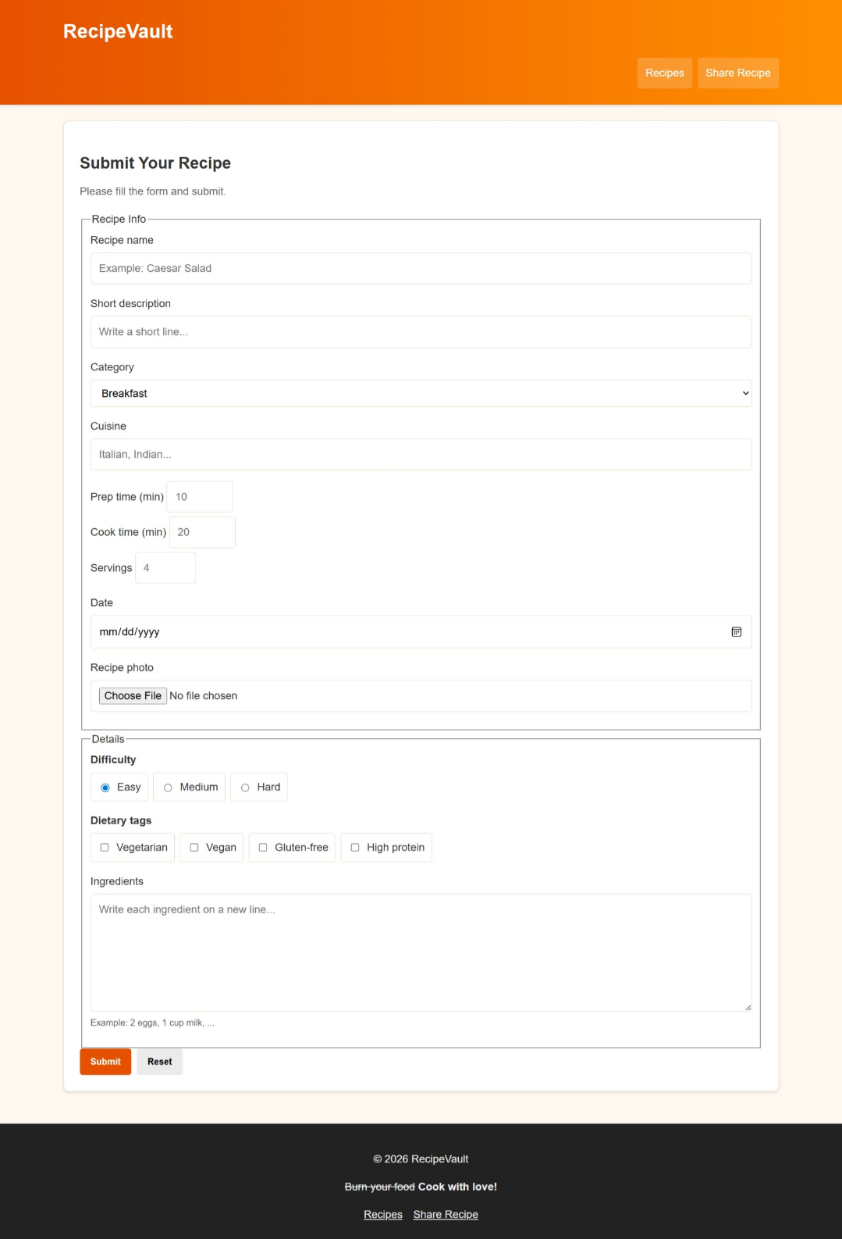
Explanation:
This screenshot shows the recipe card design. Each recipe displays the recipe name, an image, and a short description. CSS styling is used to align the cards and make them visually organized.
Weekly Meal Plan Table
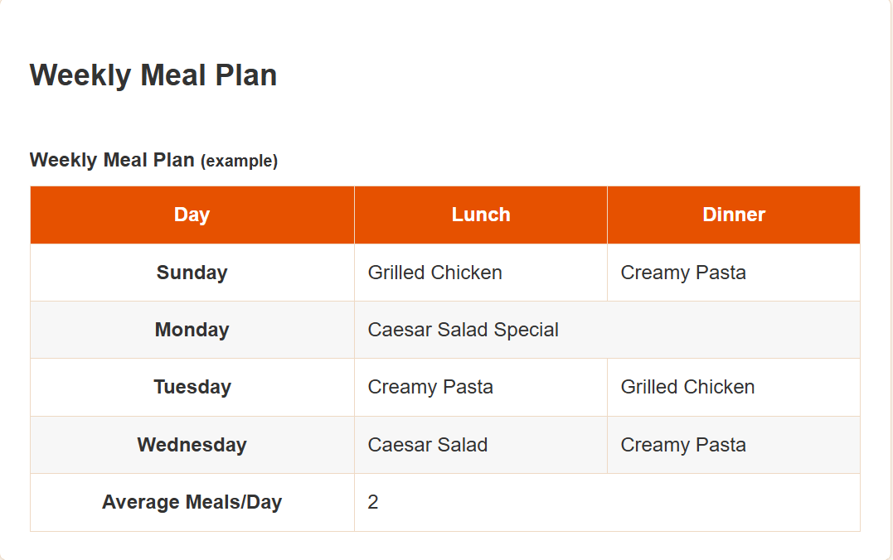
Explanation:
This screenshot shows the weekly meal plan table on the home page. The table includes a caption, <thead>, <tbody>, and <tfoot> sections. Column and row headers use <th> with scope attributes. The table also includes a colspan element and zebra striping for improved readability.

4 – Sidebar
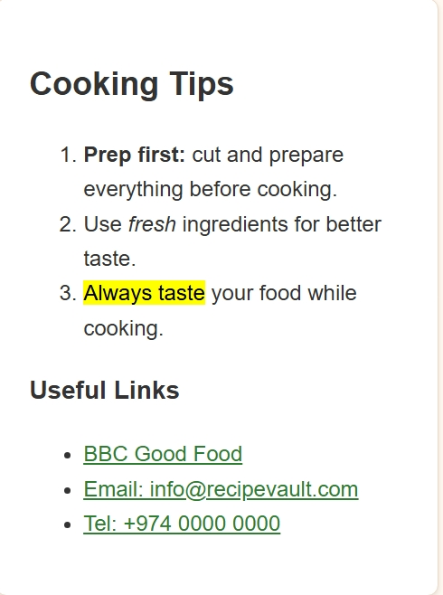
Explanation:
The sidebar is located on the right side of the home page and contains cooking tips and useful resource links. It is implemented using the <aside> element and includes an ordered list of tips and an unordered list of links such as an external website, email link, and phone link. The sidebar provides additional information without interrupting the main content.

Testing grading sheet
<p align="center">
<strong>Qatar University</strong><br>
College of Engineering - Department of Computer Science and Engineering<br>
<strong>CMPS 350 - Web Development</strong>
</p>

---

# Assignment 1 - Testing & Grading Sheet

**Student Name:** Noora Almarri
**Student ID:** 202206911
**Date:** 5 march 2026
> **Instructions:** For each item below, take a screenshot and save it inside a `screenshots/` folder using the exact file name shown. The image will render automatically in this document. Resize your browser to the correct screen size before capturing.

---

## 1. Home Page - Small Screen (Mobile)

Resize your browser to **< 768px** width and take a full-page screenshot of `index.html`.

**Expected:** Navigation links stacked vertically, recipe cards in 1 column, sidebar below main content.

Save your screenshot as `screenshots/q1-home-mobile.png`

![Home page mobile](screenshots/q1-home-mobile.png)

---

## 2. Home Page - Medium Screen (Tablet)

Resize your browser to **768px-1023px** width and take a full-page screenshot of `index.html`.

**Expected:** Navigation links in a row, recipe cards in 2 columns.

Save your screenshot as `screenshots/q2-home-tablet.png`

![Home page tablet](screenshots/q2-home-tablet.png)

---

## 3. Home Page - Large Screen (Desktop)

Resize your browser to **1024px+** width and take a full-page screenshot of `index.html`.

**Expected:** Header with logo left and nav right, recipe cards in 3 columns, sidebar as a side column.

Save your screenshot as `screenshots/q3-home-desktop.png`

![Home page desktop](screenshots/q3-home-desktop.png)

---

## 4. Share Recipe Page

Take a screenshot of the full `share-recipe.html` page.

**Expected:** Same header/footer as home page, form with 2 fieldsets, submit and reset buttons.

Save your screenshot as `screenshots/q4-share-recipe.png`

![Share recipe page](screenshots/q4-share-recipe.png)

---

## 5. Navigation Between Pages

Take two screenshots showing:

- Clicking "Share Recipe" on `index.html` navigates to `share-recipe.html`
- Clicking "Recipes" on `share-recipe.html` navigates back to `index.html`

Save your screenshots as `screenshots/q5-nav-to-share.png` and `screenshots/q5-nav-to-home.png`

![Nav to share recipe](screenshots/q5-nav-to-share.png)
![Nav to home](screenshots/q5-nav-to-home.png)

---

## 6. Weekly Meal Plan Table

Take a screenshot of the meal plan table section.

**Expected:** Table with caption, thead, tbody, tfoot, scope attributes, colspan, zebra striping on hover.

Save your screenshot as `screenshots/q6-meal-plan-table.png`

![Meal plan table](screenshots/q6-meal-plan-table.png)

---

## 7. Recipe Cards Hover Effect

Take a screenshot showing a recipe card being hovered (with the card lifted/shadow effect).

Save your screenshot as `screenshots/q7-card-hover.png`

![Card hover effect](screenshots/q7-card-hover.png)

---

## 8. Form Validation

Take a screenshot showing form validation - try submitting the form without filling in the required fields.

**Expected:** Browser shows validation messages for required fields.

Save your screenshot as `screenshots/q8-form-validation.png`

![Form validation](screenshots/q8-form-validation.png)

---

## 9. Cooking Tutorial Video

Take a screenshot showing the embedded YouTube video on the home page.

Save your screenshot as `screenshots/q9-video.png`

![Cooking tutorial video](screenshots/q9-video.png)

---

## 10. Sidebar

Take a screenshot of the sidebar section showing cooking tips and resource links.

**Expected:** Ordered list of tips, unordered list of links (external, mailto, tel).

Save your screenshot as `screenshots/q10-sidebar.png`

![Sidebar](screenshots/q10-sidebar.png)

---

## TodaGrading Summary

| # | Criteria | Points | Score |
| - | ------------------------------------------------------------------------------------------------------- | ------------- | -------------- |
| 1 | HTML Structure & Semantics - Semantic elements, heading hierarchy, lists, links, images with figures | 25 | /25 |
| 2 | Tables - caption, thead/tbody/tfoot, th scope, colspan | 10 | /10 |
| 3 | Forms & Accessibility - Input types, fieldsets, labels, validation, ARIA, multimedia | 20 | /20 |
| 4 | CSS Styling - Variables, selectors, box model, typography, colors, backgrounds, pseudo-classes, shadows | 25 | /25 |
| 5 | Responsive Layout - Media queries, Flexbox, Grid, responsive nav/cards/table | 20 | /20 |
| | **Total** | **100** | **/100** |

**Instructor Comments:**

