ANALYSIS OF RETINOPATHY

Statistical Analysis Report

1. Background and Study Design
Testing retinopathy risk factors
This report presents a comprehensive statistical analysis of retinopathy among the study population. A total of 200 patients were analyzed.

2. Data Cleaning Methodology
1. Standardized 12 column names to snake_case
2. Capped 3 outliers in 'age_years' (24.80, 82.80)
3. Capped 1 outliers in 'bmi' (15.35, 41.35)
4. Capped 1 outliers in 'hba1c' (3.39, 11.89)
5. Capped 6 outliers in 'diabetes_duration' (-12.00, 27.20)
6. Capped 2 outliers in 'dbp' (52.59, 109.09)
7. Capped 1 outliers in 'cholesterol' (87.55, 295.15)
8. Total outliers capped across all variables: 14
9. Cleaning complete. Final shape: (200, 12)

3. Table 1: Baseline Characteristics
Variable | Without retinopathy | With retinopathy | Test | p | Effect Size
age_years | 54.7 +/- 11.0 | 53.9 +/- 11.3 | Welch's t = 0.48 | 0.629 | d = 0.08
bmi | 28.3 +/- 4.8 | 28.8 +/- 4.7 | Welch's t = -0.70 | 0.488 | d = 0.11
hba1c | 7.5 +/- 1.4 | 8.3 +/- 1.8 | Welch's t = -2.94 | 0.004 | d = 0.47
diabetes_duration | 7.3 +/- 7.1 | 11.8 +/- 6.8 | U = 2349.00 | <.001 | r = 0.35
sbp | 132.1 +/- 14.3 | 134.0 +/- 14.9 | Welch's t = -0.83 | 0.409 | d = 0.13
dbp | 80.7 +/- 9.8 | 81.3 +/- 11.7 | Welch's t = -0.32 | 0.747 | d = 0.05
cholesterol | 190.3 +/- 36.0 | 190.2 +/- 41.2 | Welch's t = 0.02 | 0.987 | d = 0.00
gender (female) | 81 (57.9%) | 30 (50.0%) | 0.76 | 0.385 | V = 0.044
gender (male) | 59 (42.1%) | 30 (50.0%)
smoking (current) | 29 (20.7%) | 11 (18.3%) | 2.58 | 0.275 | V = 0.080
smoking (former) | 46 (32.9%) | 14 (23.3%)
smoking (never) | 65 (46.4%) | 35 (58.3%)
hypertension (no) | 83 (59.3%) | 39 (65.0%) | 0.36 | 0.548 | V = 0.030
hypertension (yes) | 57 (40.7%) | 21 (35.0%)
nephropathy (no) | 95 (67.9%) | 38 (63.3%) | 0.21 | 0.647 | V = 0.023
nephropathy (yes) | 45 (32.1%) | 22 (36.7%)
Table. Baseline characteristics stratified by retinopathy. Continuous: M ± SD or Mdn [IQR]. Effect sizes: Cohen's d or rank-biserial r.

4. Bivariate Analysis Results
A total of 16 candidate predictors were evaluated for their association with retinopathy.
Bivariate analysis revealed significant associations between retinopathy and diabetes_duration (all p < .05).
Multivariable logistic regression identified 2 independent predictors of retinopathy: hba1c (aOR = 1.301, 95% CI [1.057, 1.601]); diabetes_duration (aOR = 1.080, 95% CI [1.034, 1.128]).
The model explained 9.8% of the variance (McFadden's pseudo-R² = 0.098).
The model demonstrated good discrimination with an AUC of 0.715.

5. Multivariable Regression
Predictor | aOR | 95% CI | p
age_years | 0.991 | [0.962, 1.021] | 0.548
bmi | 1.027 | [0.958, 1.101] | 0.455
hba1c | 1.301 | [1.057, 1.601] | 0.013 | *
diabetes_duration | 1.080 | [1.034, 1.128] | <.001 | ***
sbp | 1.007 | [0.983, 1.031] | 0.579
dbp | 1.011 | [0.980, 1.043] | 0.483
cholesterol | 0.999 | [0.990, 1.008] | 0.803
Table. Independent predictors of retinopathy from multivariable logistic regression. aOR = adjusted odds ratio; CI = confidence interval. *p < .05, **p < .01, ***p < .001.

Model fit: pseudo-R² = 0.098, AIC = 236.4, N = 200

6. Figures
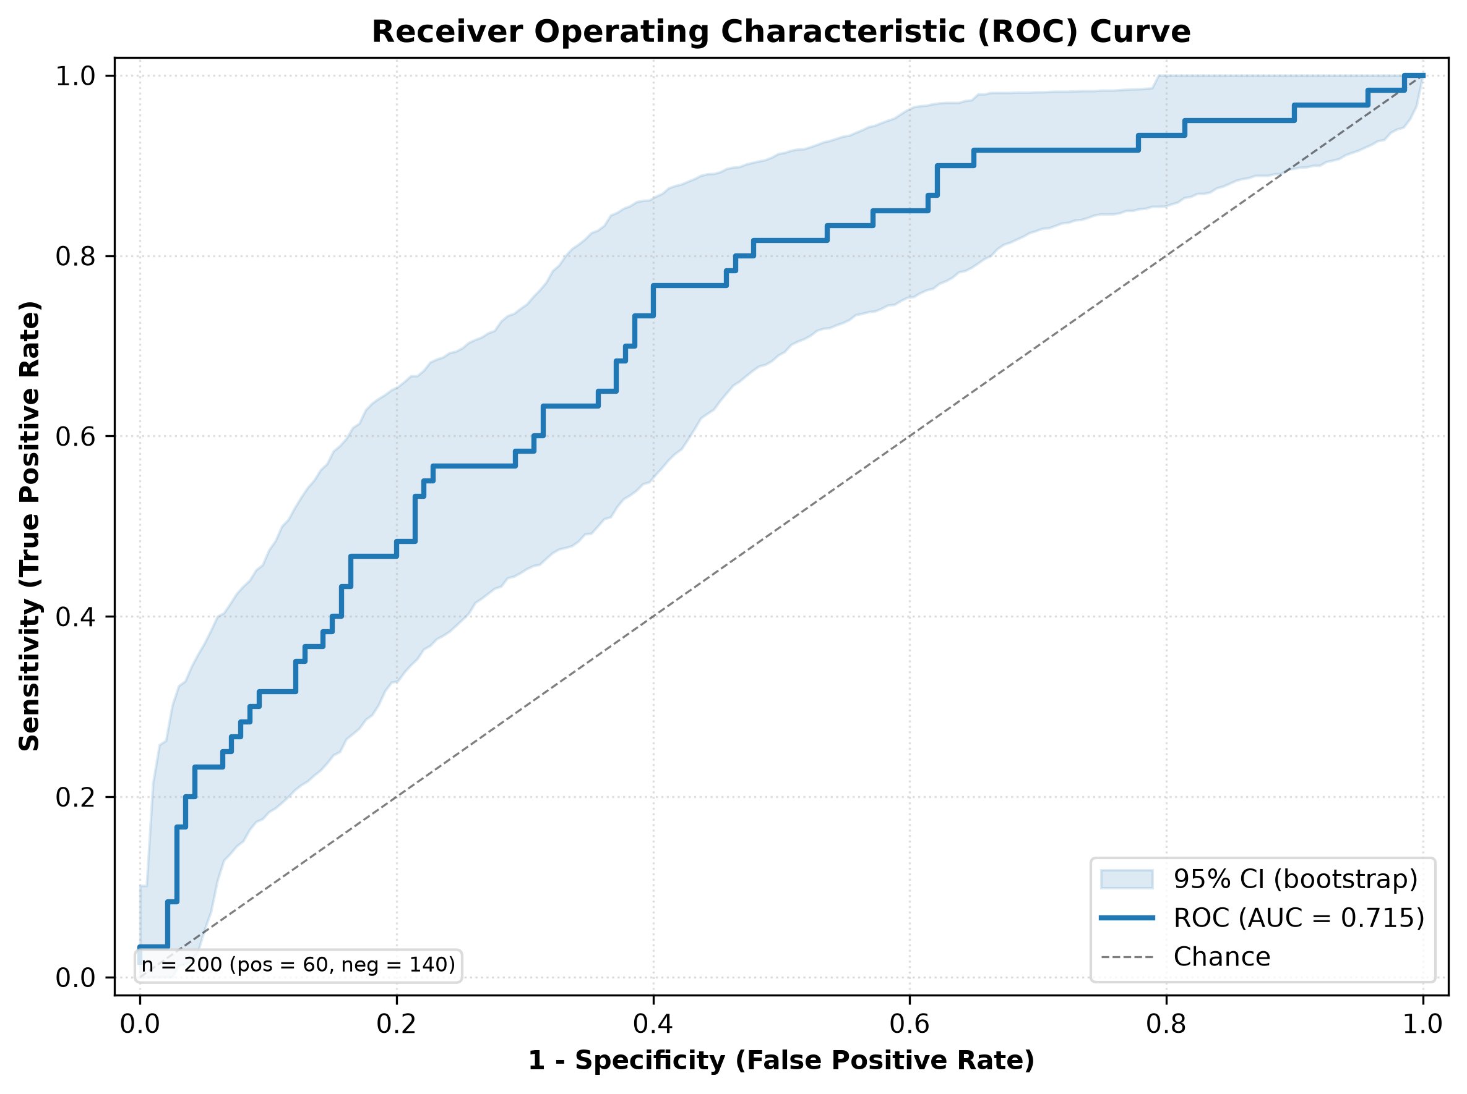
Figure. ROC curve of the logistic regression model for predicting retinopathy. AUC = 0.715

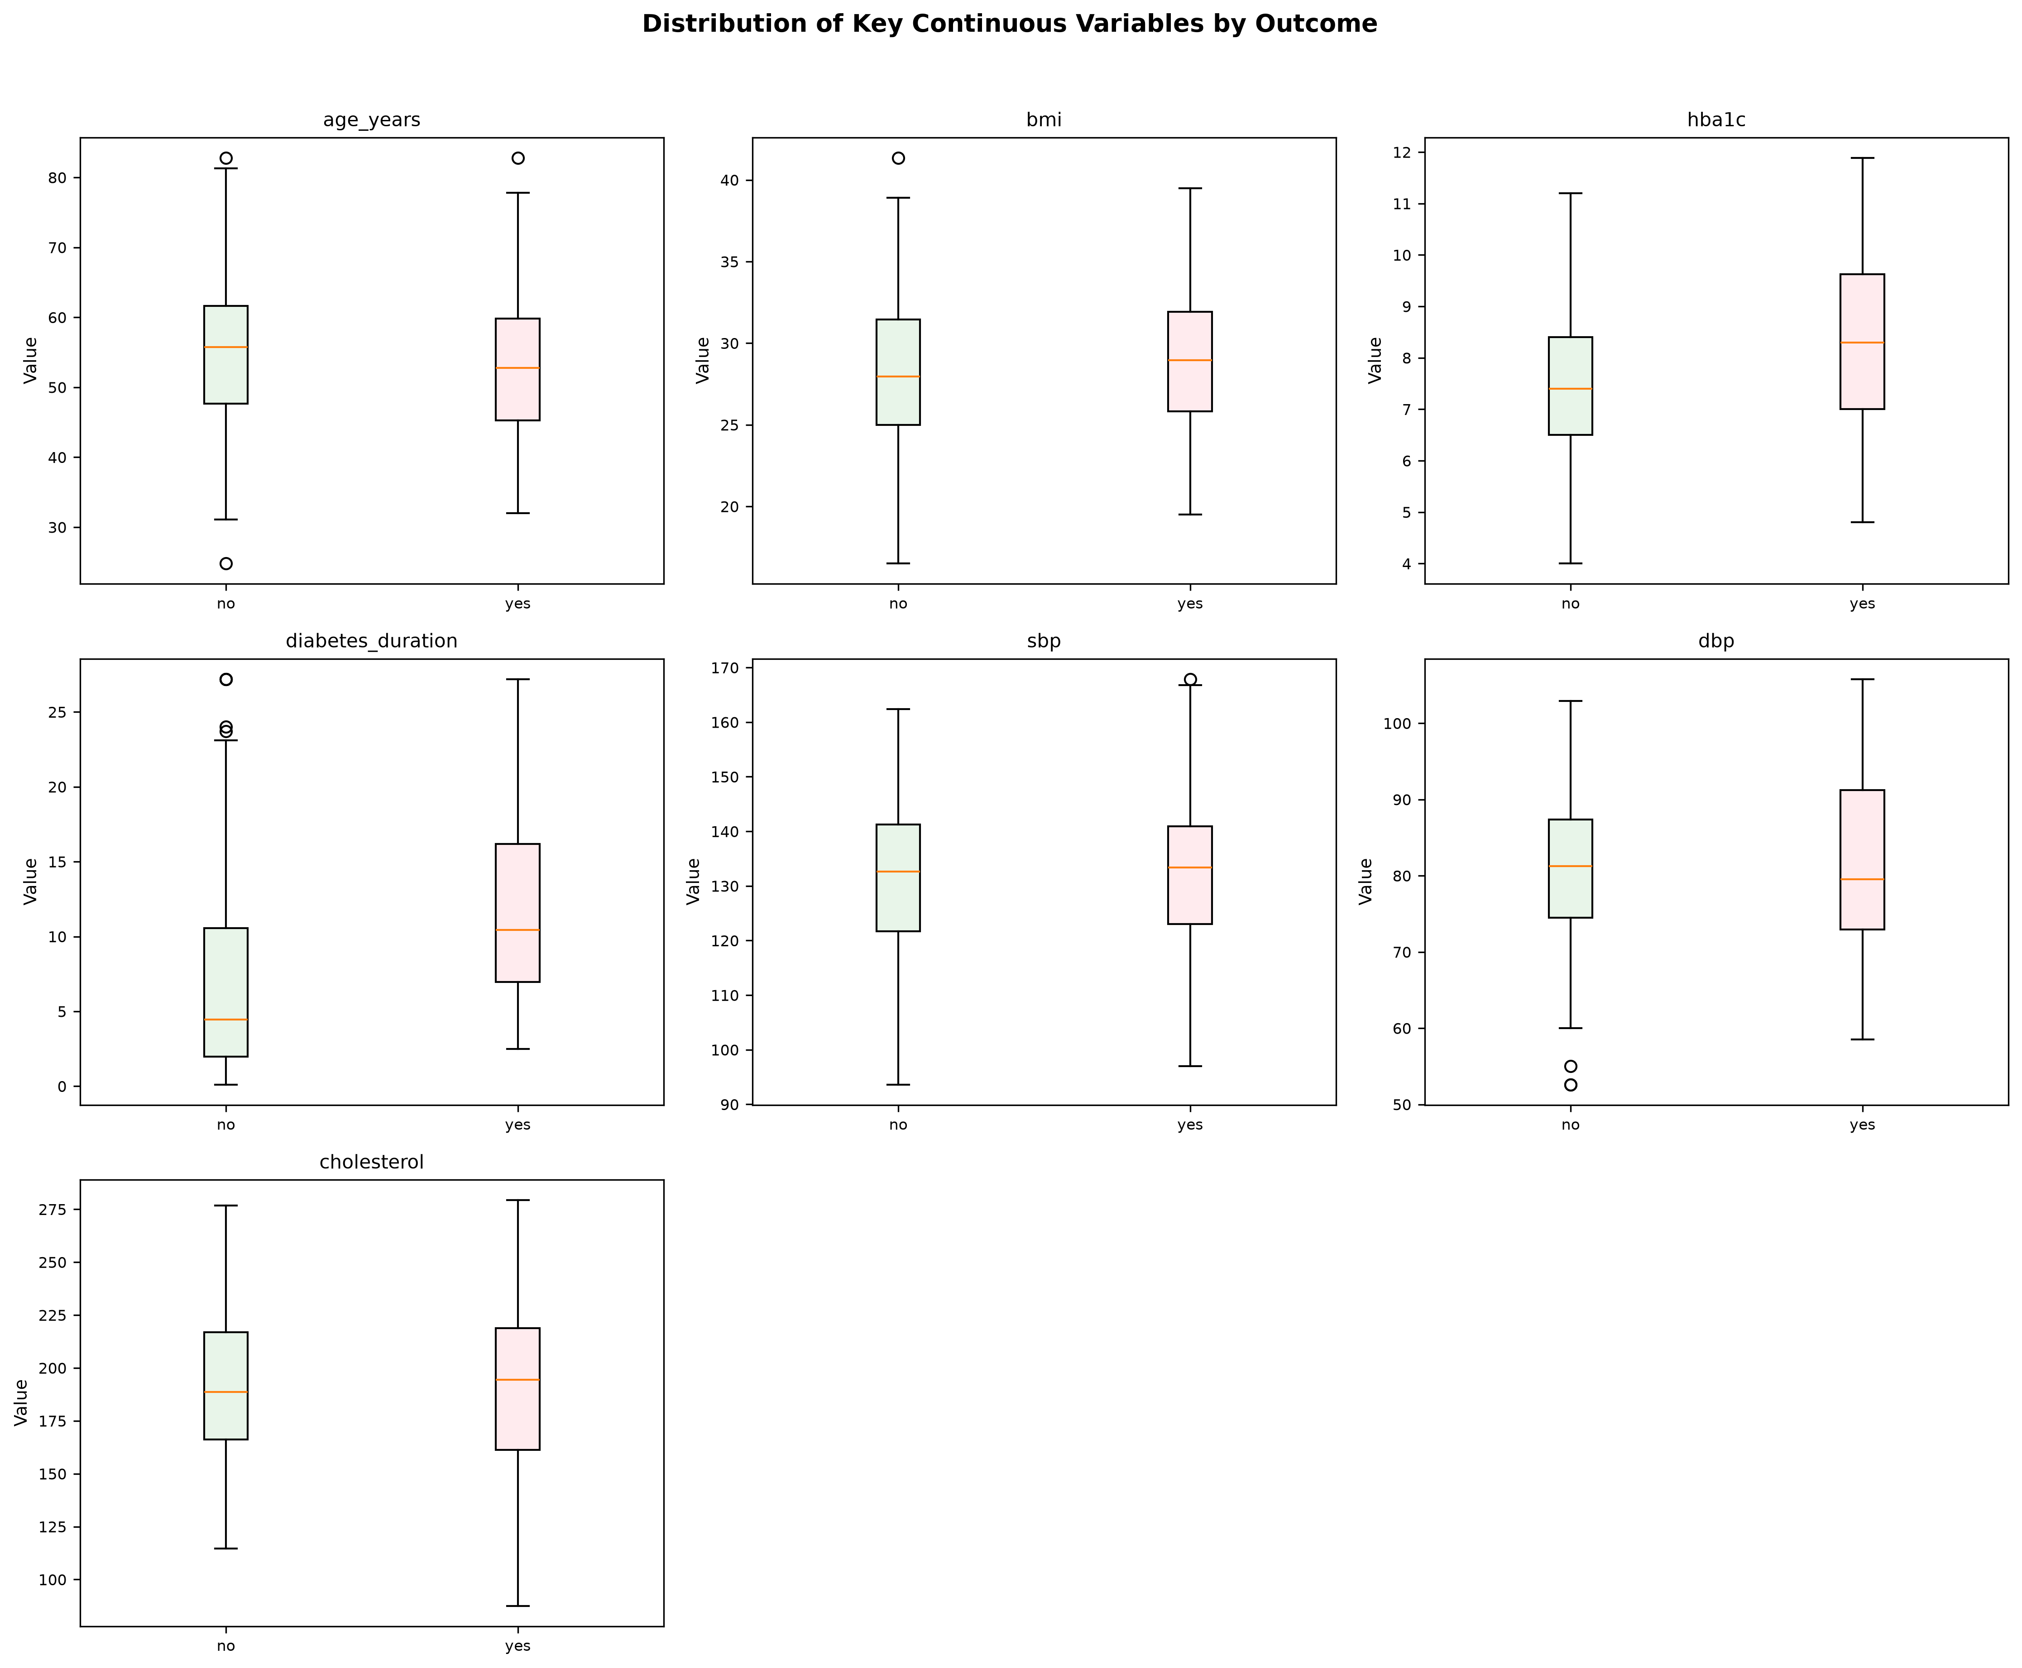
Figure. Distribution of key clinical variables by retinopathy status. Boxes represent median and IQR; whiskers extend to 1.5×IQR.

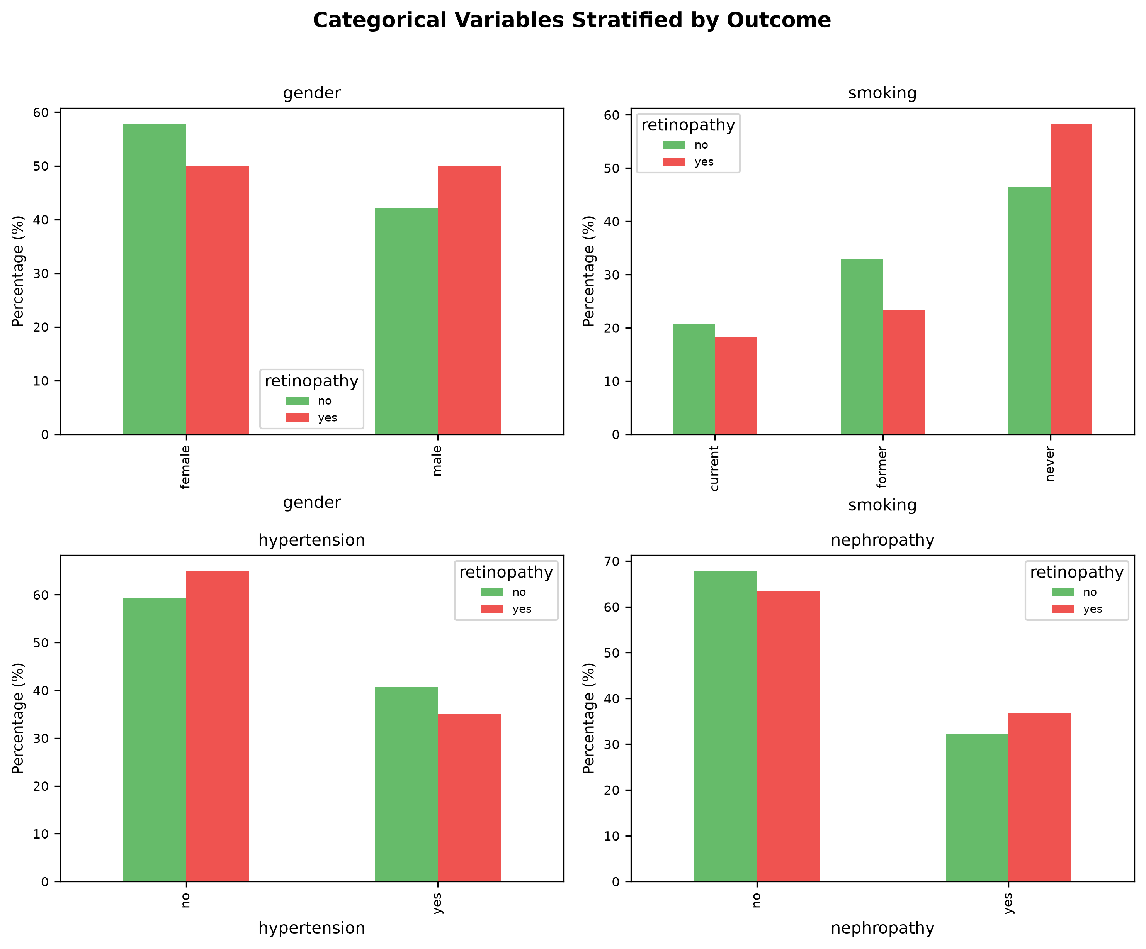
Figure. Distribution of categorical variables stratified by retinopathy status. Percentages computed within each group.

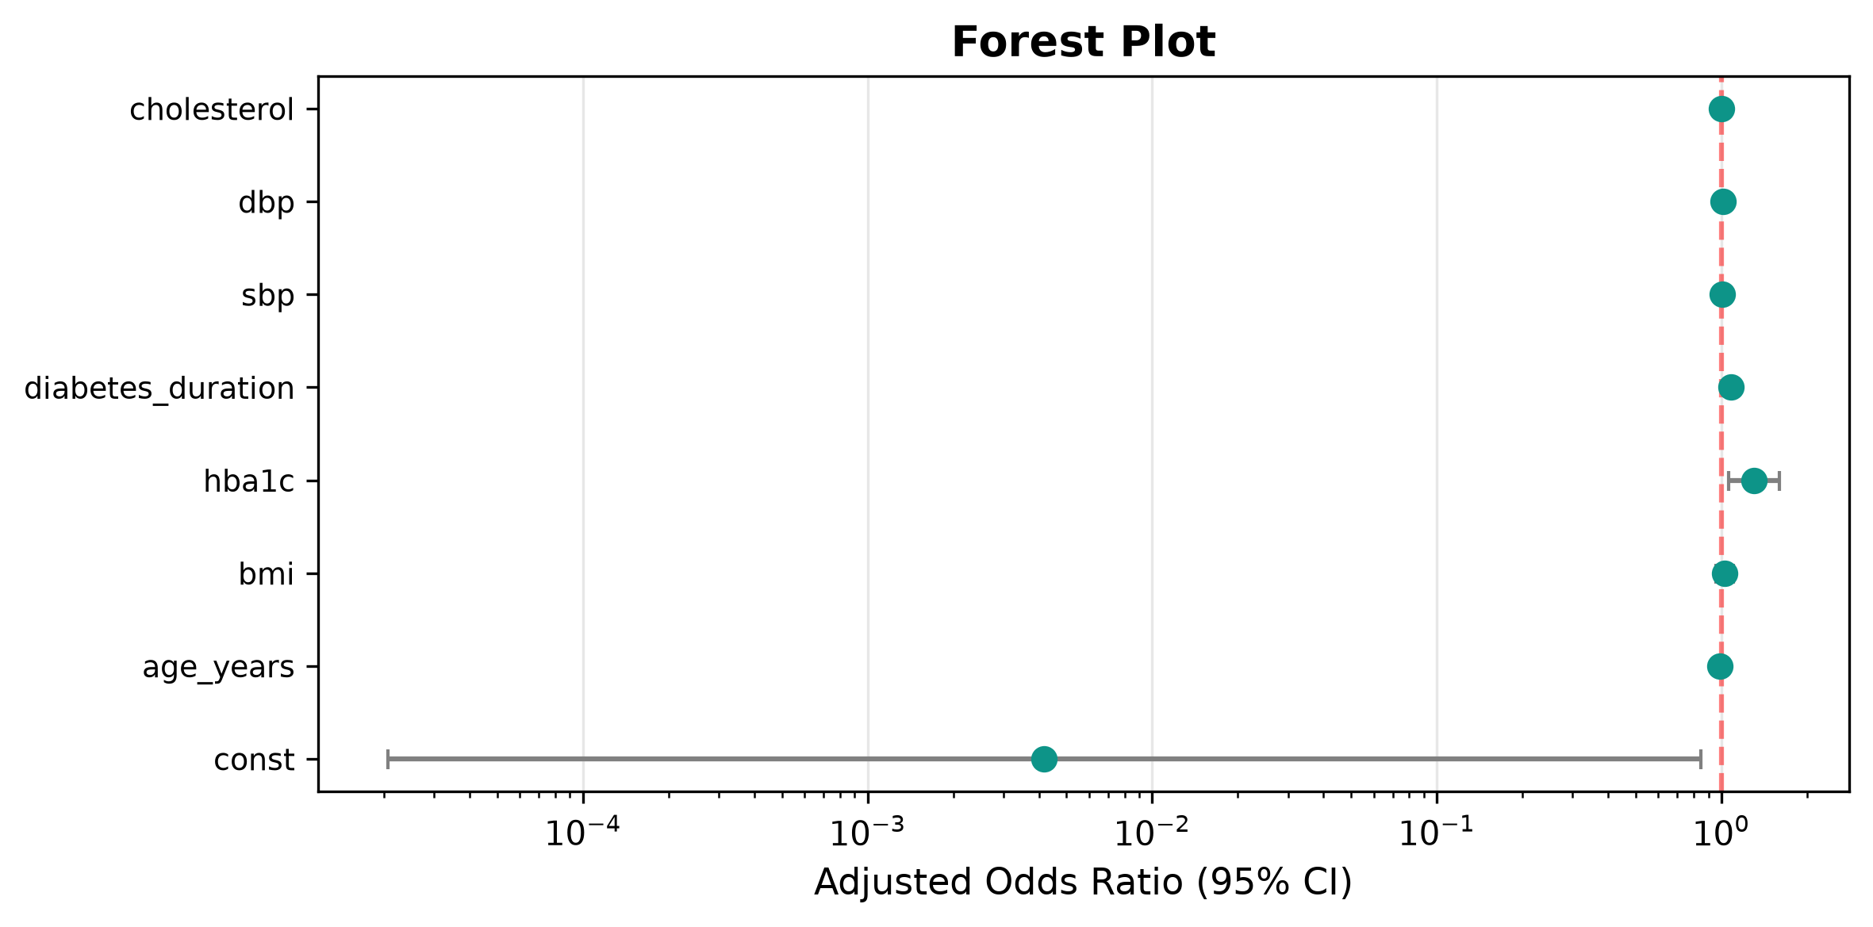
Figure. Forest plot of adjusted odds ratios. Points = point estimates; error bars = 95% CI. Vertical dashed line at aOR = 1.0.

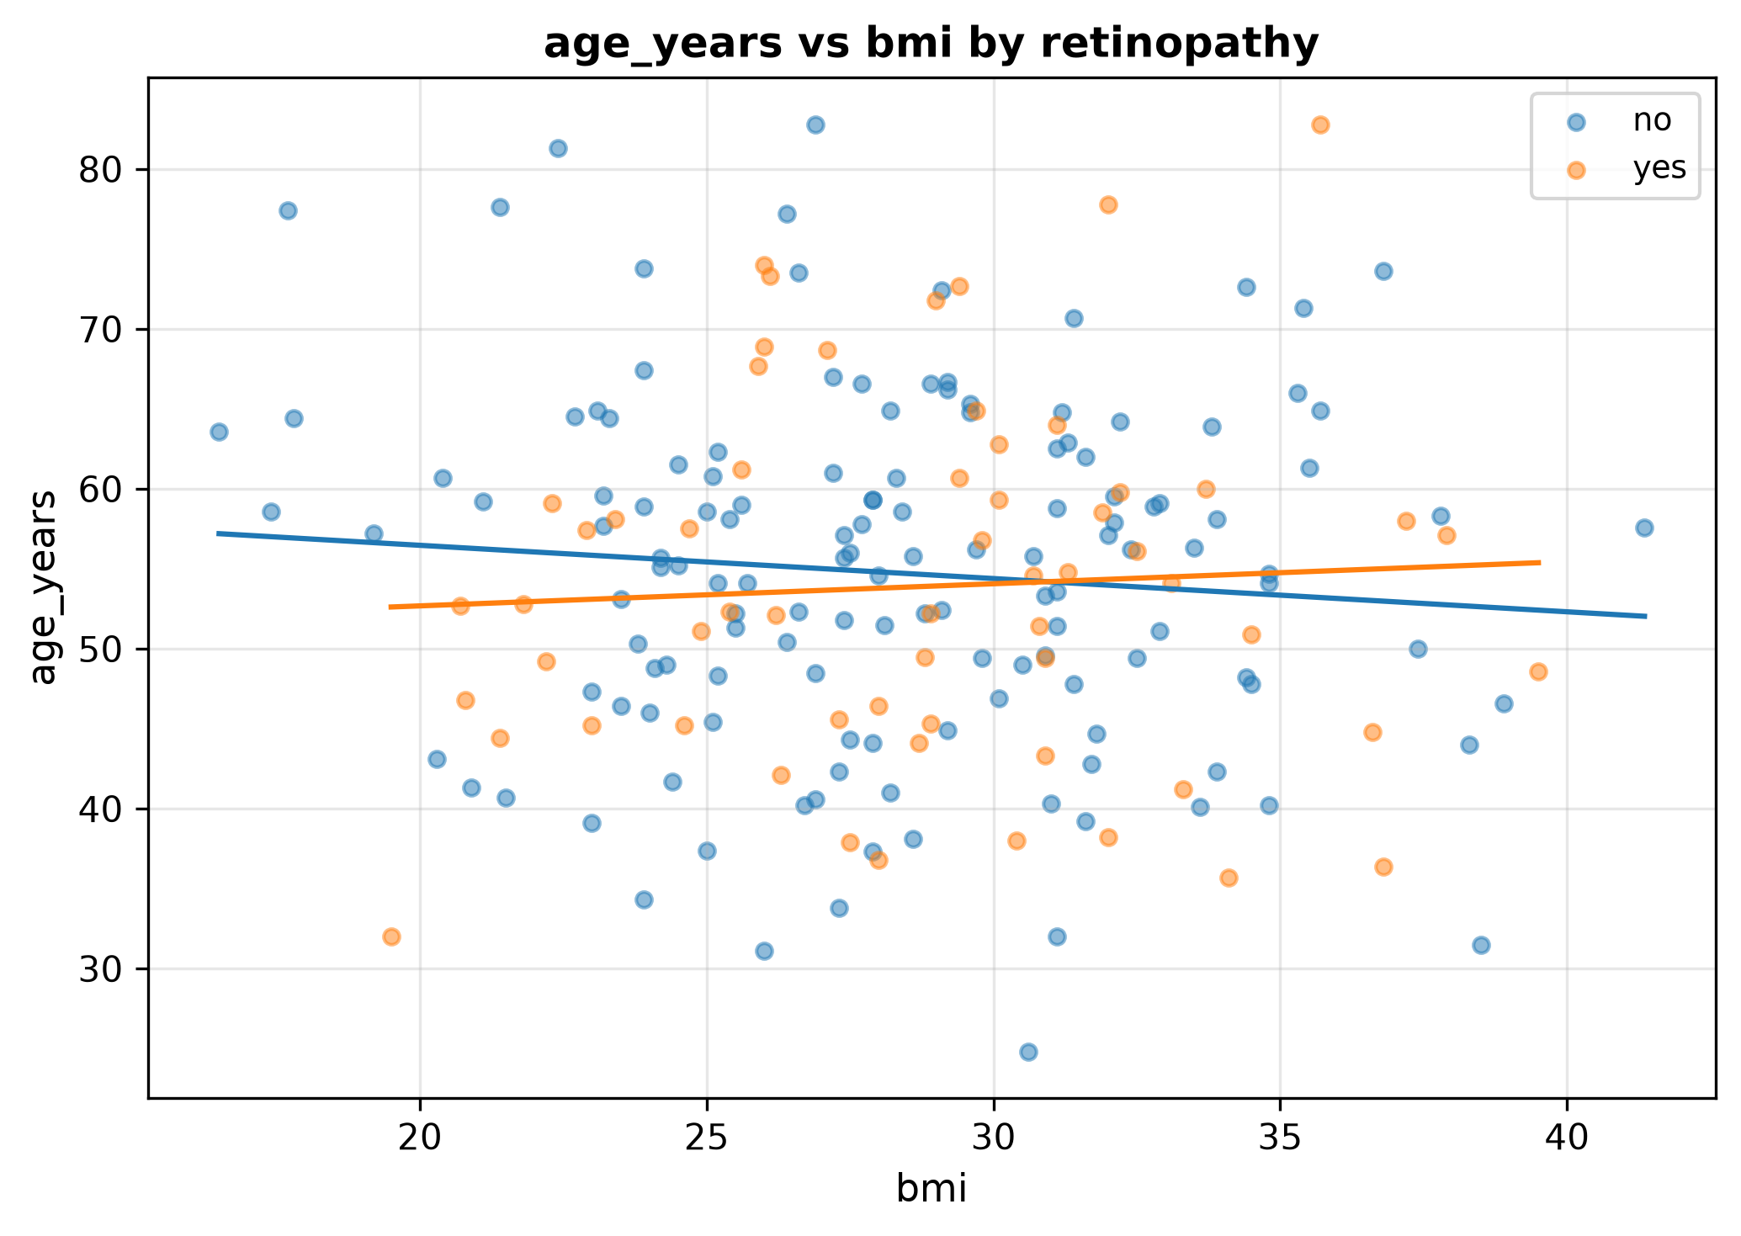
Figure. Relationship between key continuous variables by retinopathy status.

7. Discussion and Conclusions
A total of 16 candidate predictors were evaluated for their association with retinopathy.
Bivariate analysis revealed significant associations between retinopathy and diabetes_duration (all p < .05).
Multivariable logistic regression identified 2 independent predictors of retinopathy: hba1c (aOR = 1.301, 95% CI [1.057, 1.601]); diabetes_duration (aOR = 1.080, 95% CI [1.034, 1.128]).
The model explained 9.8% of the variance (McFadden's pseudo-R² = 0.098).
The model demonstrated good discrimination with an AUC of 0.715.
These findings should be interpreted considering the study's limitations, including the observational design and potential residual confounding.

