Test DOCXOPT
FOO | BAR
foo | asd
baz | ghi
Another table comes after, with its own column width definitions
FOO2 | BAR2
foo | asd
baz | ghi

Images
This image uses default (black border, img default width)
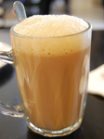
This image uses overriden formatting (no border, 2 inch width)


