Figures Tests
A picture of my favourite drink
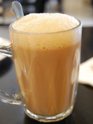
Captions

Figure : a teh tarik kurang manis
With alignment. Alignment tag must be preceeded with an empty line.

Figure : test caption
Fixed width

Figure : test caption
More attributes

Figure : test caption

All together

Figure : test caption

Figure : test caption

