**Advantages of maven**

1. Will create standard folder structure 🡪 support 1800 folder structures
2. It will download the all dependencies automatically (transitive dependency management 🡪 means one dependency depends another dependency)
3. Maven will build the project with in less time
4. Maven will package the project
5. Maven will execute the junit test cases
6. Maven will deploy the project

**How to work with maven?**

Maven can be used in 2 ways

1. Using command prompt (we need to install)

* Build team / infra team use this command prompt

1. Using IDE like (Eclipse/MyEclipse/STS…)

* Developers

**Terminology related to maven**

1. **Architype** - project template (or) project structure

* Standalone app - maven-architype-quickstart
* Web app - maven-architype-webapp
* EJB app - maven-architype-j2ee

1. Once we choosing this **architype** then we need to choose **groupId 🡪** groupId we simply called as a company name (unique identifier)
2. **artifactId:** Project name
3. **version:** 1.0-SNAPSHOT 🡪 snapshot is nothing but project still under development once project is completed, we can change the version from **SNAPSHOT** to  **FINAL (**or) **FIXED**

**maven project:**

SimpleApp

* src (source code)
  + main – actual application logic
  + test – unit testing code
* pom.xml (project object model)

**maven project by using command prompt**

1. interactive mode

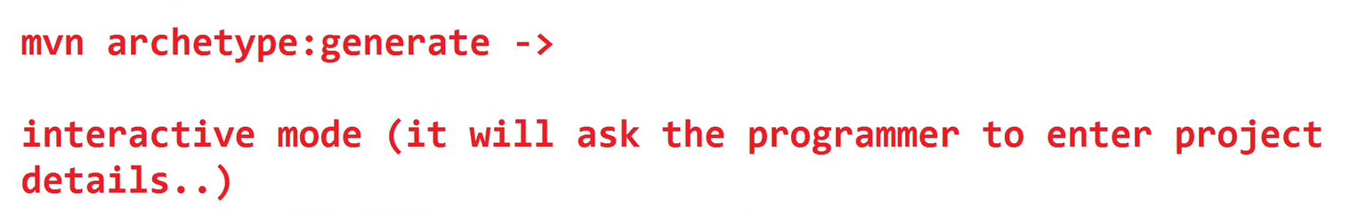

1. batch mode

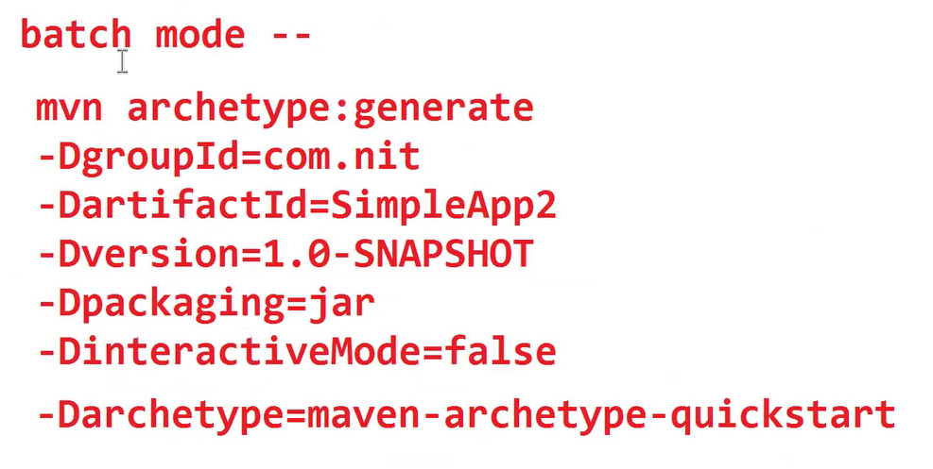

**Folder Structure**

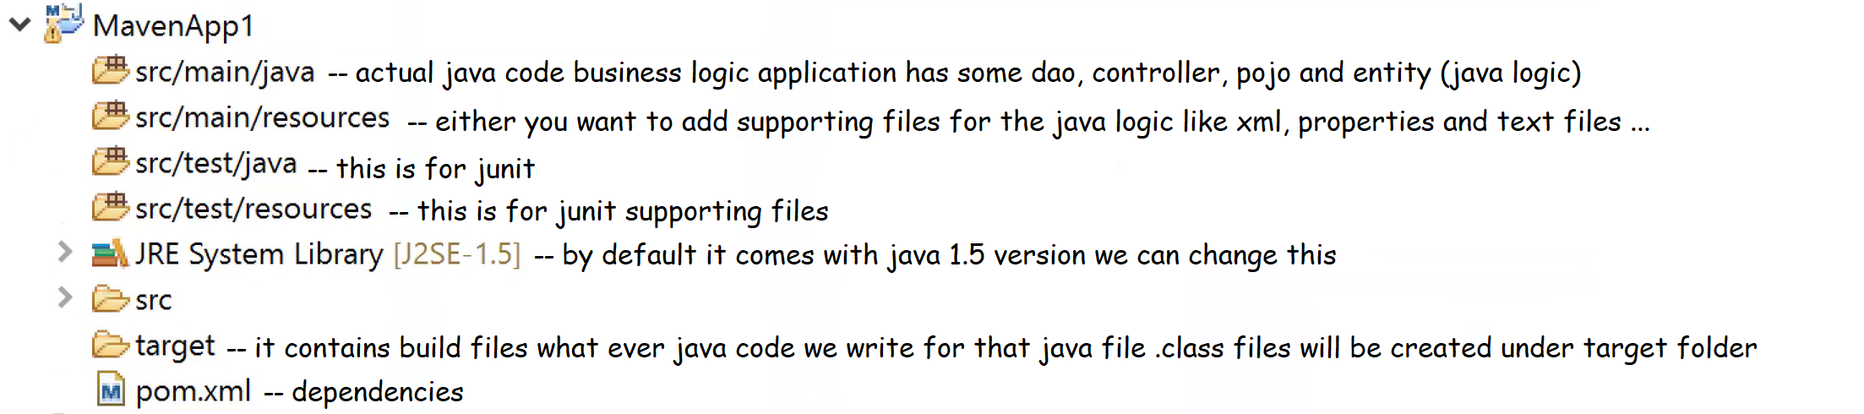

**Repositories in maven**

1. local repository 🡪 (.m2) folder created in the local system
2. central repository 🡪 maintained by apache organization
3. remote repository 🡪 jars are available in some other computer in the company that jars location configure to our system

**Installing 3rd party jar files into local repository**

mvn install:install-file -DgroupId=com.abdul -DartifactId=oracle-ojdbc -Dversion=1.0.1 -Dpackaging=jar **-Dfile=ojdbc6.jar 🡪location**

**Maven goals**

Perform some task by maven

1. I have maven project I want to compile that project then the goal will be **compile** then all the .class files will be created
2. Some default code is missing like junit code generate that code for that we have option **generate-source**
3. What are the .class will be created I want to delete those .class files then we have goal called **clean** then all .class files, jar files and war files will be deleted
4. We want to package our project into jar file (or) war file then goal is **maven build** it will build our project (if our project is standalone project then it will be a **jar file**) (or) if our project is web application then it will be a **war file**