Gender Pay Gap

Nora Mohamed Faqeeh
DAB #16

Agenda

Data Dictionary
Data Handling Summary
Introduction
Problem Statement
Project Approaches
Target Audience
Dataset Overview
Key Findings
Limitations
Recommendations
References

Data Dictionary

Data Handling

Please refer to the Jupyter Notebook.

Introduction

The Minister of State for Employment holds the responsibility for addressing the pay gap in the United Kingdom, with particular focus on the gender pay gap. This gap represents the difference in average gross hourly earnings between women and men.

There are several contributing factors to the gender pay gap. These may include differences in education levels, variations in work experience, and other underlying factors. For instance, a higher proportion of women are employed in certain economic sectors where the average wages tend to be lower compared to other industries.

Furthermore, within the same sector, men are often found in positions that offer higher pay than those typically held by women. As a result, these disparities in sector representation and role distribution contribute to the overall gender pay gap observed across the United Kingdom.

Problem Statement

UK employers continue to have notable gender pay gaps, varying by industry, region, and company size. Late report submissions suggest reduced organizational accountability. employer data from 2017-2025.

Approaches

- Identify employers with extreme gender pay gaps.
- What are the patterns of gender pay disparity across different industries in UK.
- What are the patterns of gender pay disparity across different regions in UK.
- What are the patterns of gender pay disparity across different employer size in UK.
- Does submission timeliness affect the gender pay gap?
- Is there a gap between men and women across low, middle, and top pay quartiles?
- How has the gender pay gap in the UK shifted over time from 2017 to 2025?

Target Audience

Ministry of State for Employment
Officeholder Diana Johnson

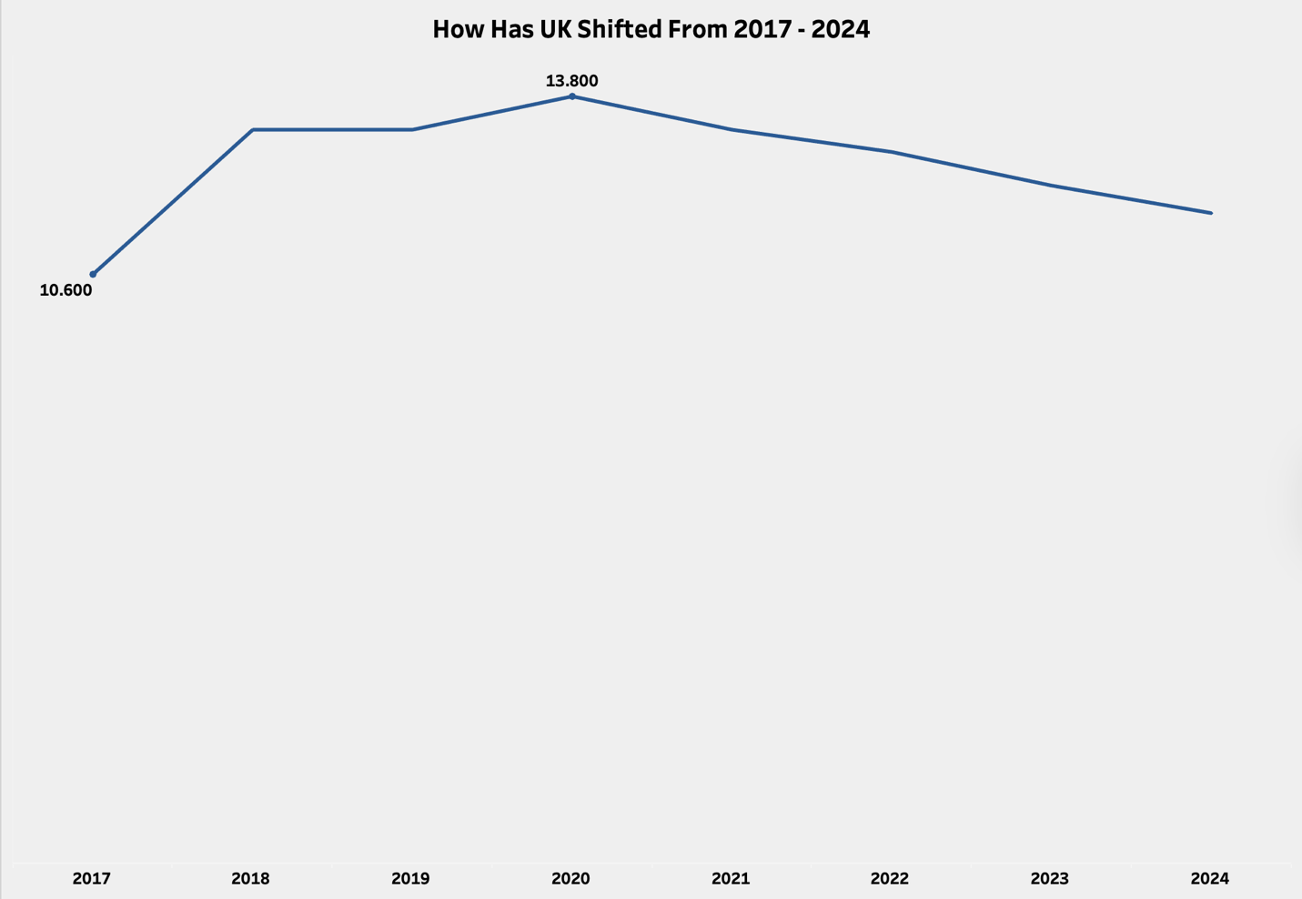
Analysis
The median difference in mean hourly wages was lowest in 2017 at 10.6. The gender pay gap peaked in 2020, then began to decline steadily.
The ONS analysis states that many employers changed their occupation in the first and second quarters of 2020, which is higher by 0.4 compared to 2019. Due to the pandemic, when businesses were operating at limited capacity, travel restrictions, and social distancing measures, some businesses were affected and needed to close, which encouraged occupational switching. The proportion of men switching was higher in managerial, director, and official senior roles, while women were more likely to switch in lower-paying bands, making the situation worse in 2020. However, until 2024, the UK gender pay gap decreased as some employers focused on their recruitment and promotion processes to address gender imbalance in their workforce.

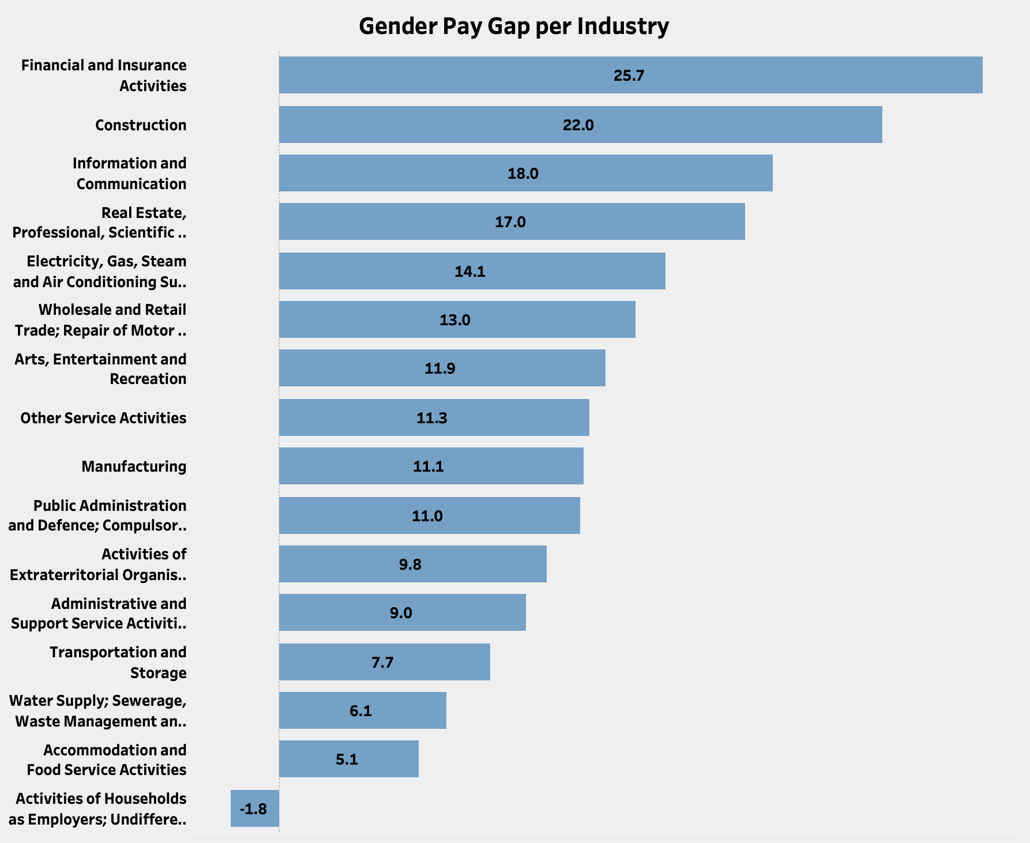

The Financial and Insurance sector has the largest gender pay gap, favoring men at 25.7, while Household Employers shows a gap favoring women at -1.8.

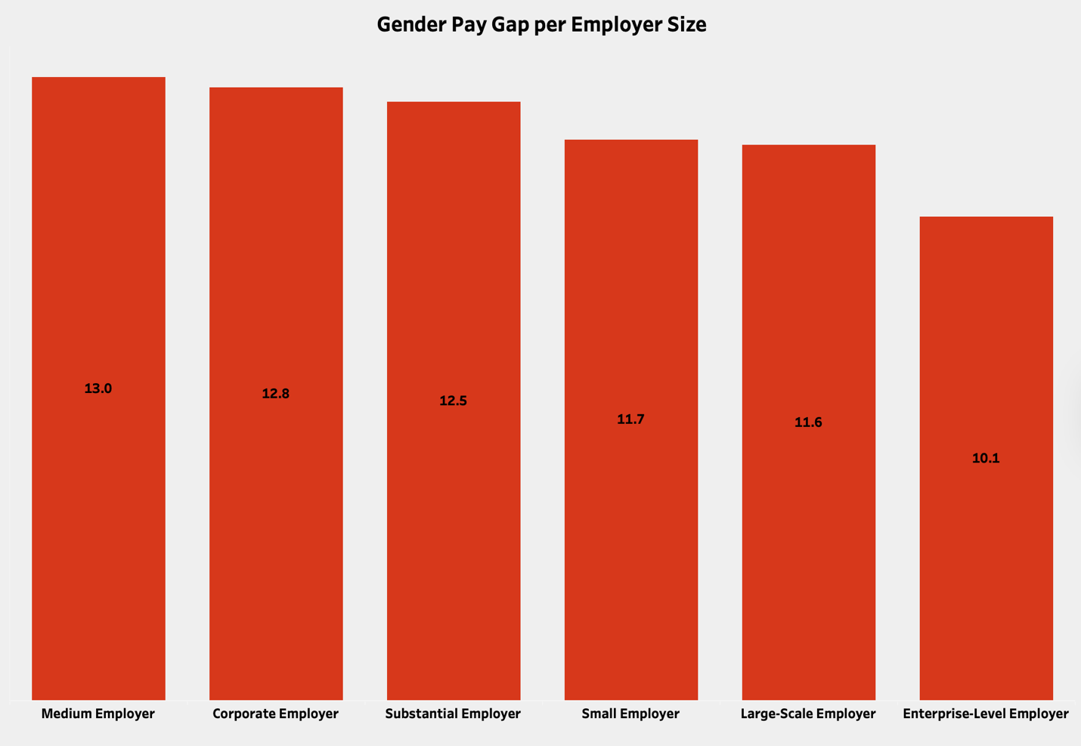

The chart shows the median Gender pay gap across different employer categories in the United Kingdom. Medium Employer has the largest gender pay gap across the 6-employer category at 13%. The chart shows that larger organizations tend to have slightly lower gender pay gaps compared to medium-sized employers.

- less than 250': Small Employer,
- 250 to 499: Medium Employer,
- 500 to 999: Substantial Employer,
- 1,000 to 4,999: Large-Scale Employer,
- 5,000 to 19,999: Corporate Employer,
- 20,000 or more: Enterprise-Level Employer.

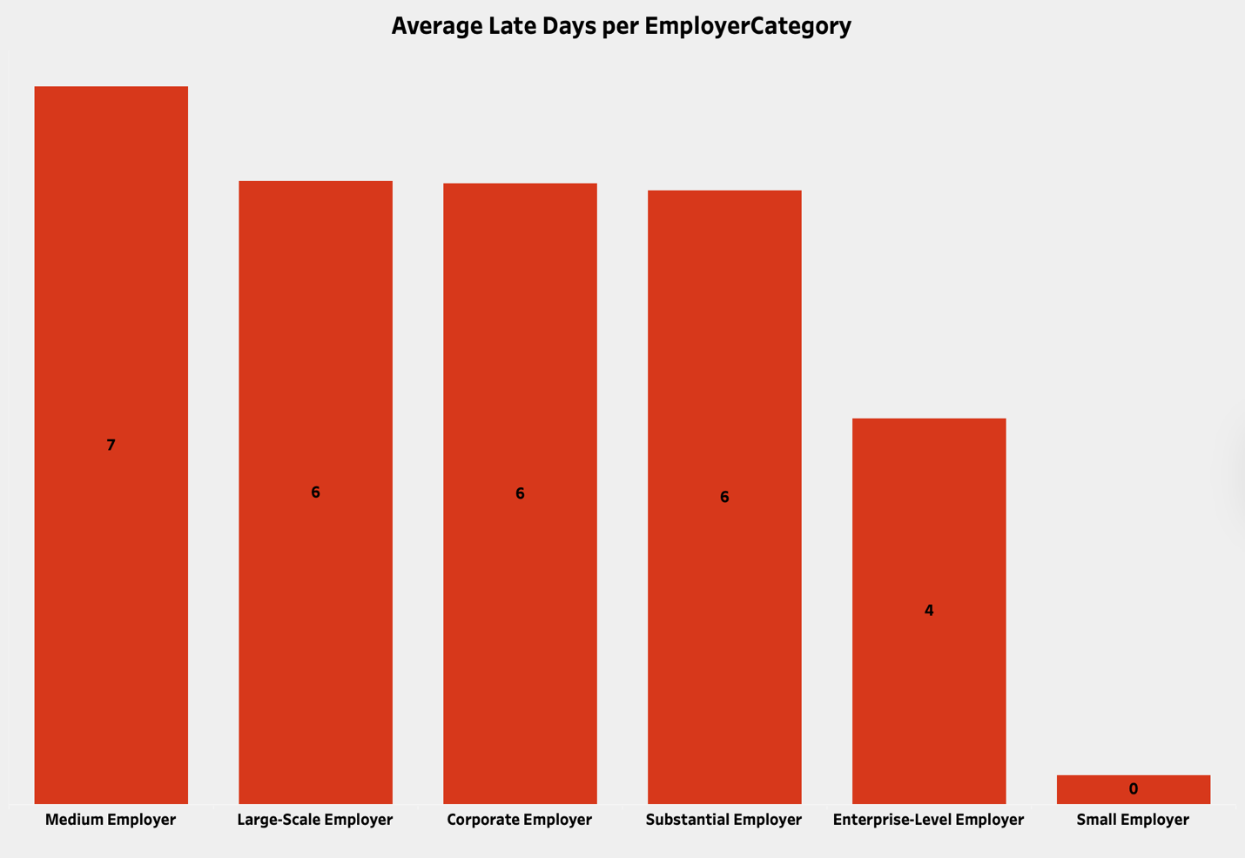

The average number of late days is 7 for medium employers. Large-scale, corporate, and substantial employers each have an average of 6 late days. While small employers show no late days.

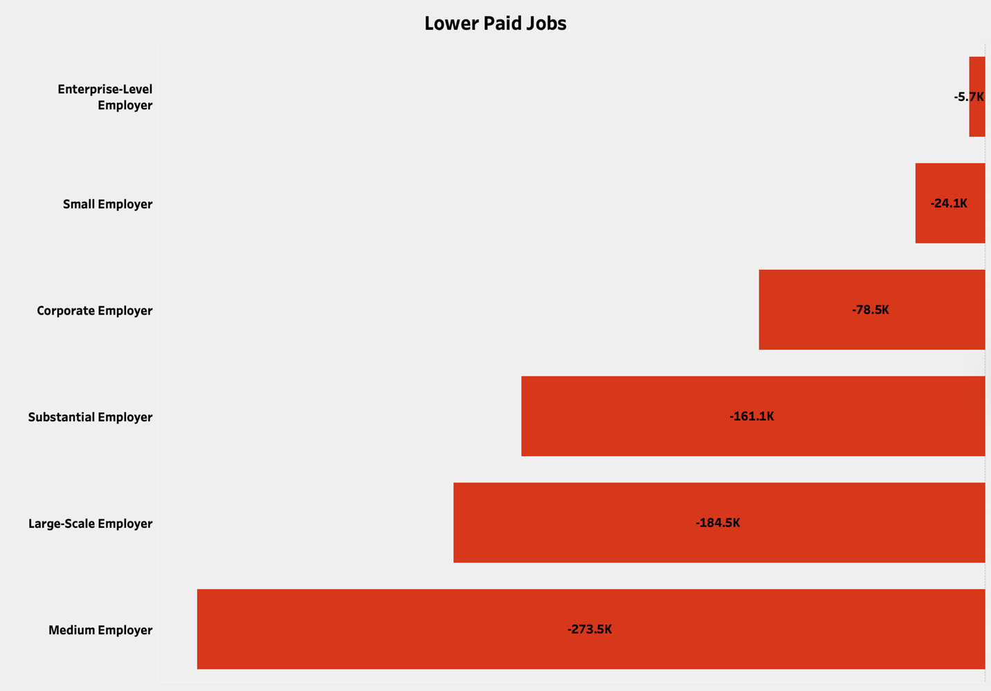
The chart displays lower quartile values by employer type, indicating larger employers have a higher pay gap favoring women, while smaller and enterprise-level employers show the smallest gap.

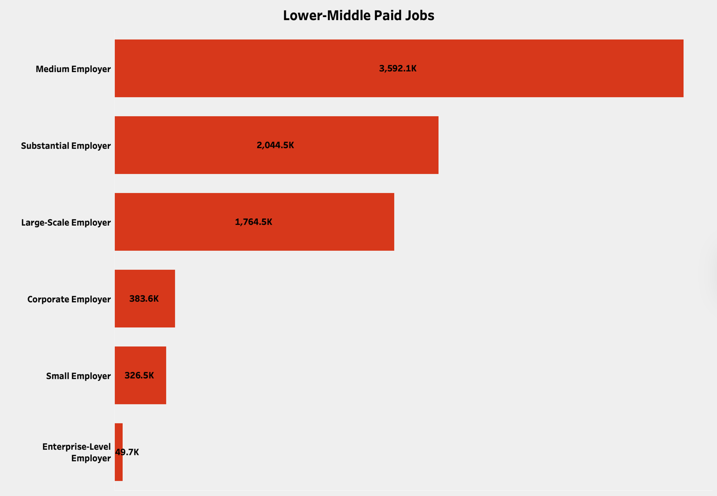
The chart displays lower-middle quartile values by employer type, indicating larger employers have a higher pay gap favoring men, while smaller and enterprise-level employers show the smallest gap.

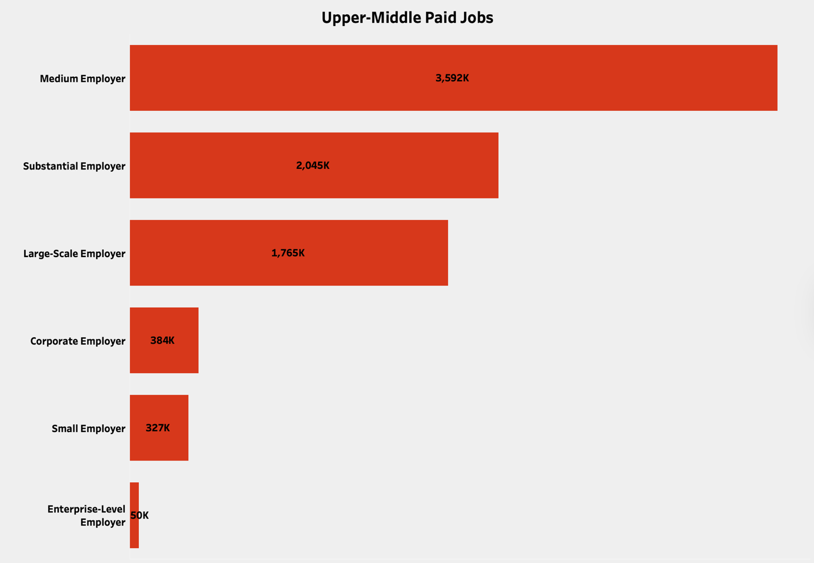
The chart displays upper-middle quartile values by employer type, indicating larger employers have a higher pay gap favoring men, while smaller and enterprise-level employers show the smallest gap.

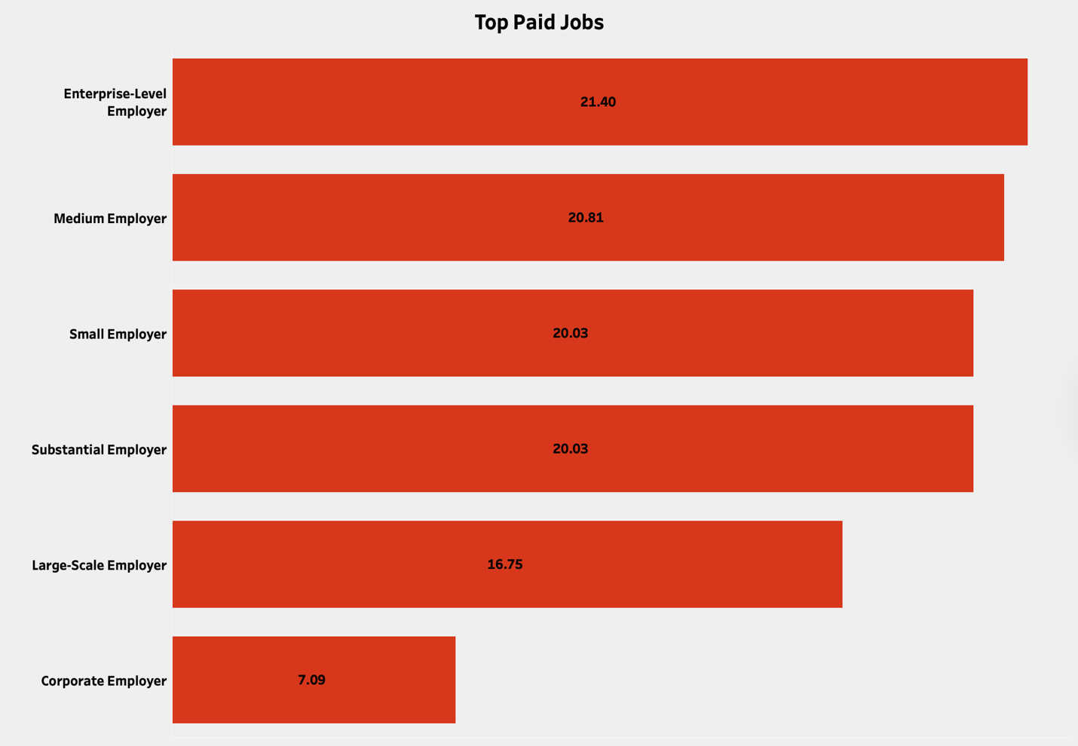
The chart displays top quartile values by employer type, indicating enterprise-level employers have a higher pay gap favoring men, while larger-scale employers and corporate employers show the smallest gap.

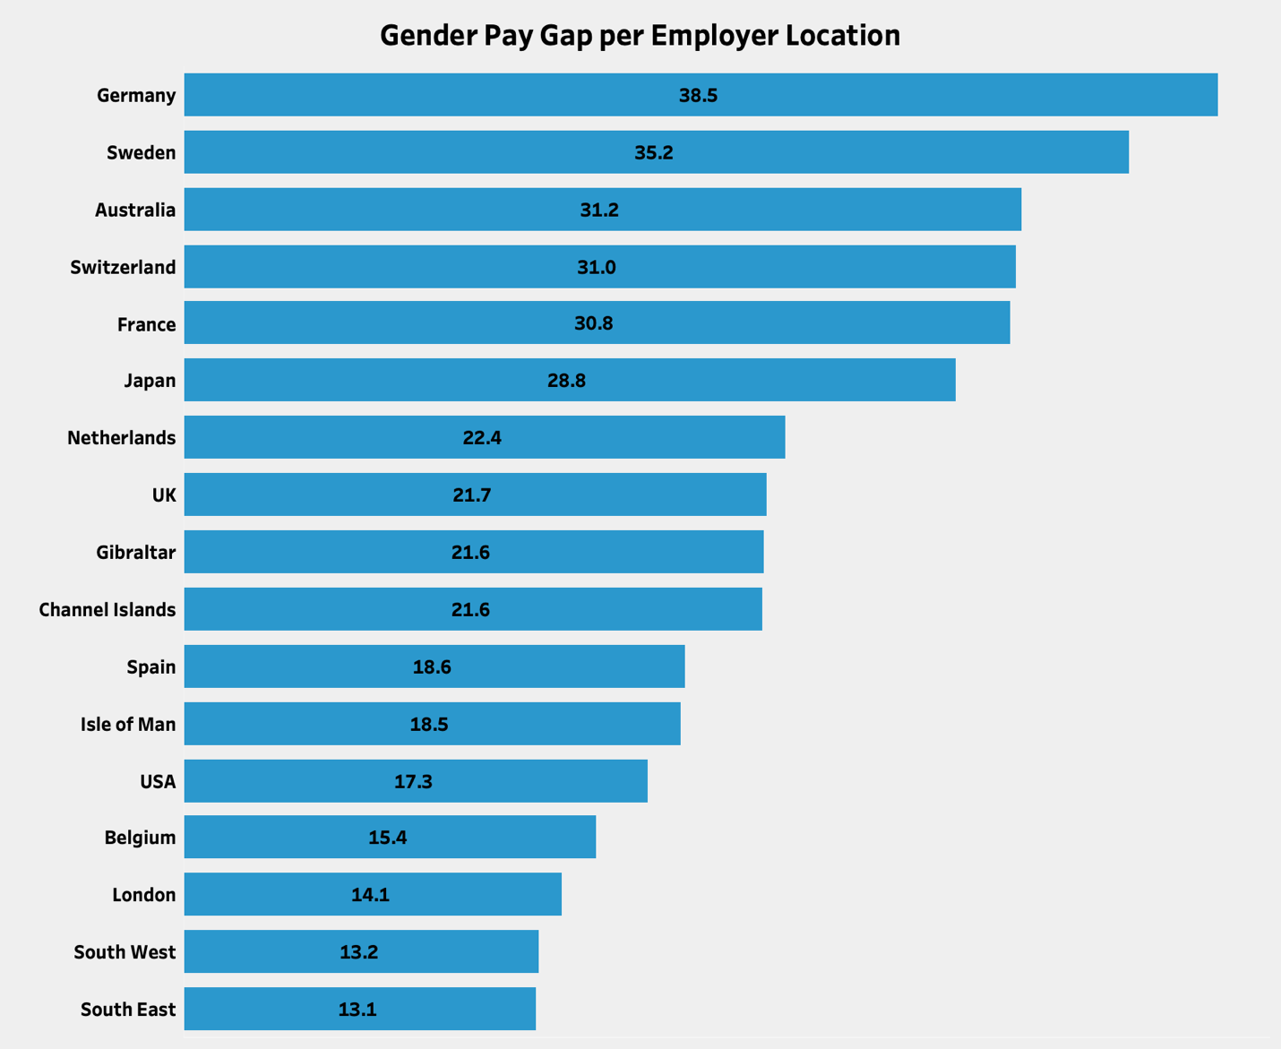

The chart shows that, among countries with branches in the United Kingdom, none display a gender pay gap favoring women. In contrast, Germany and Sweden exhibit a significant pay gap favoring men over women.

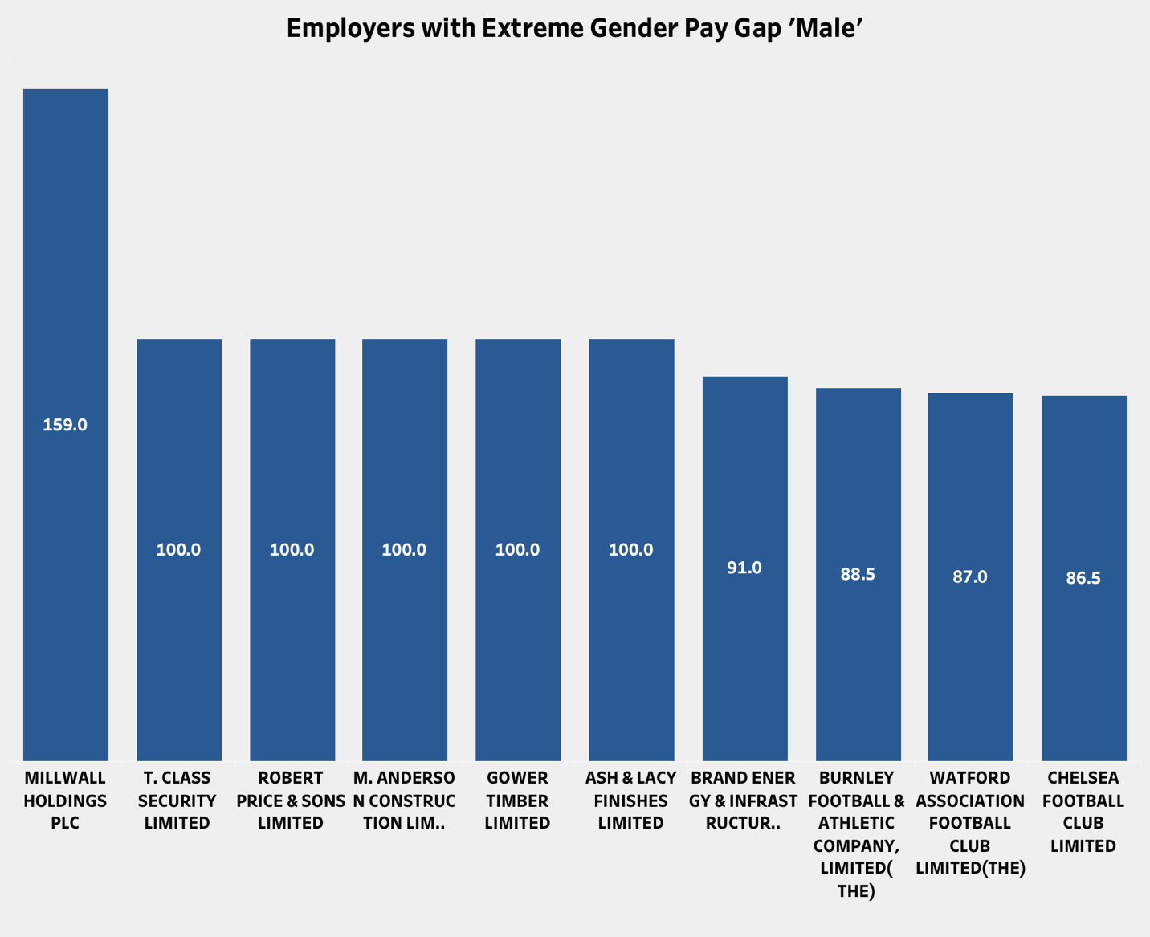

Millwall Holdings PLC exhibited the highest gender pay gap among industries, with a median difference in mean hourly pay percentage of 159 in favor of men.

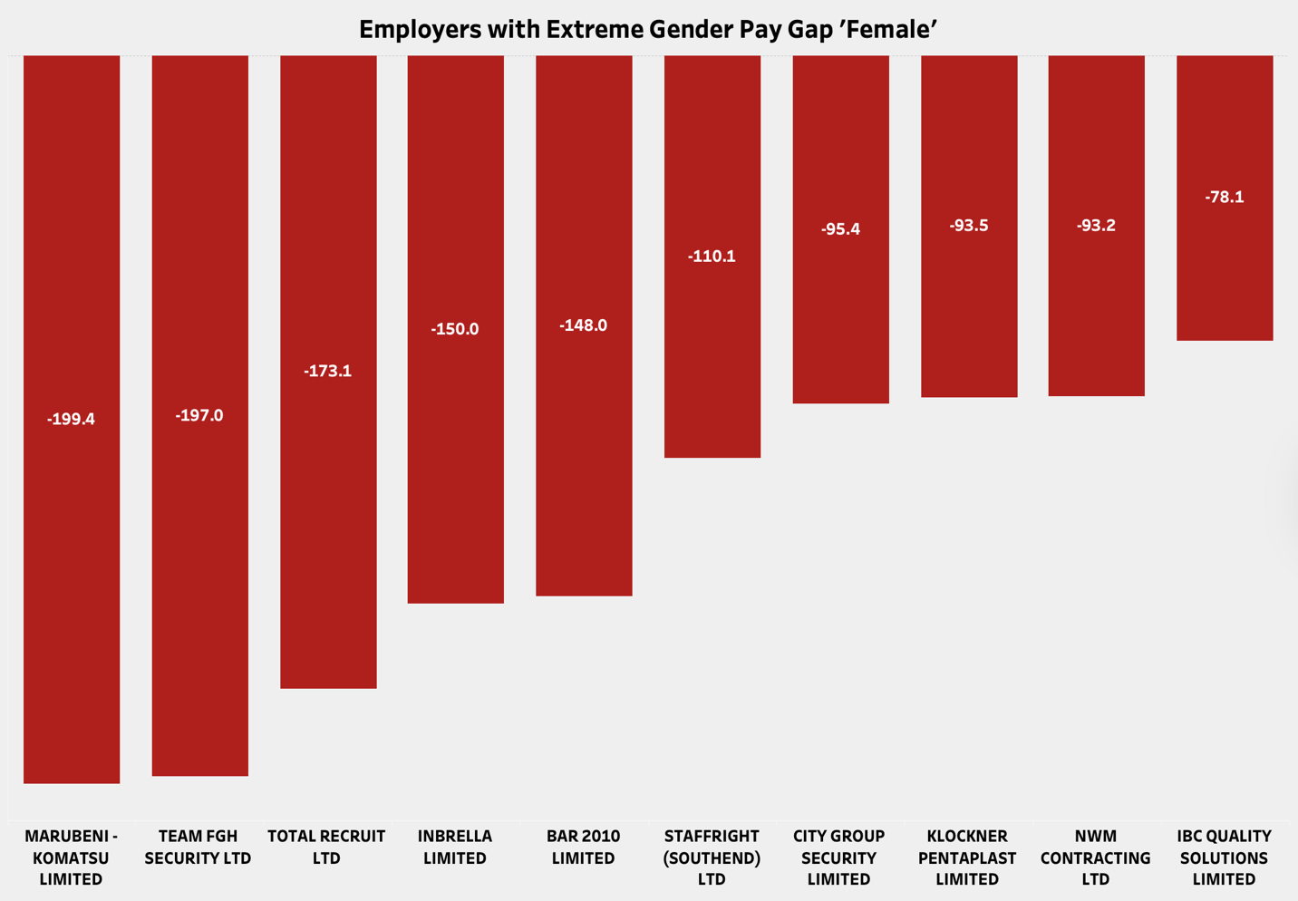

MARUBENI KOMATSU Limited exhibited the highest gender pay gap among industries, with a median difference in mean hourly pay percentage of -199.4 in favor of women

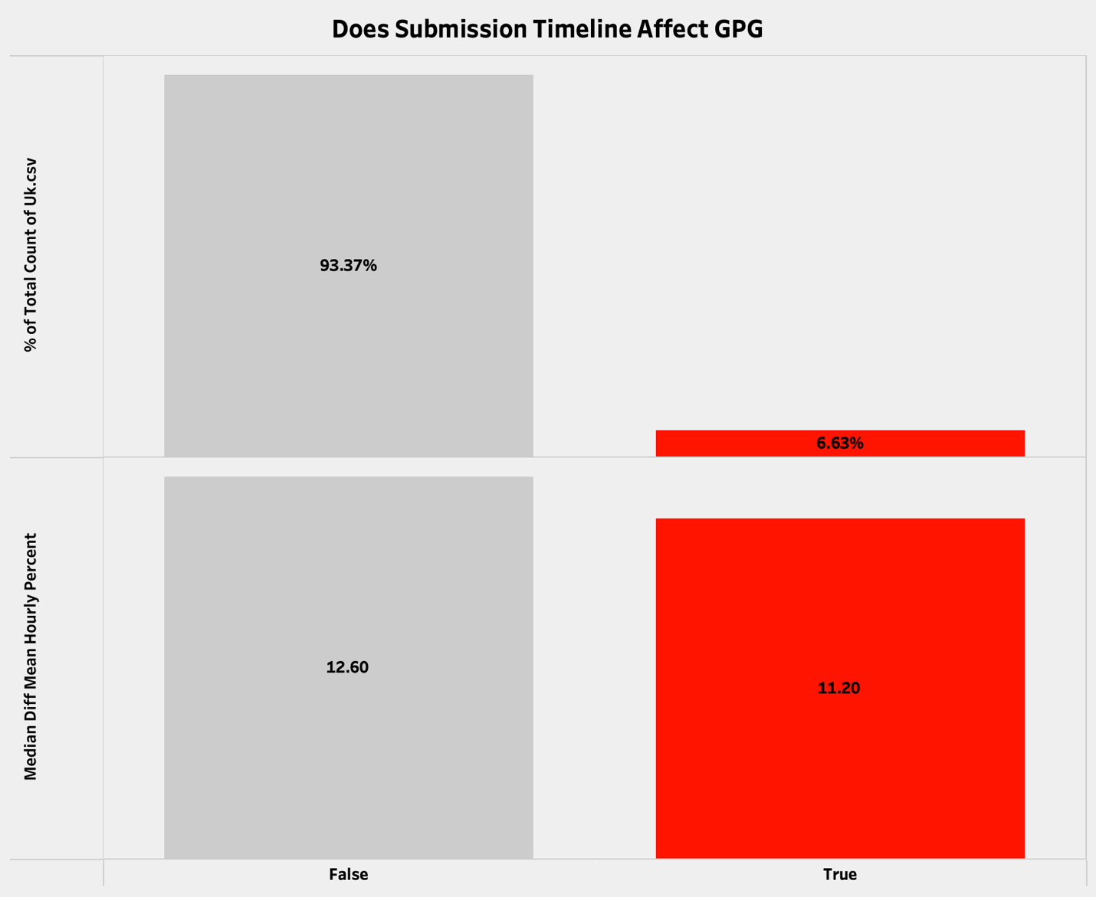
The chart examines whether submission timelines influence the gender pay gap by comparing employers who submitted on time (‘False’) with those who did not (‘True’). The upper portion illustrates that 93.37% of submissions were on time, while only 6.63% were late. Regarding the median hourly pay gap, employers not submitting on time exhibited a higher gap compared to those with on-time submissions. This suggests that late submission correlates with a higher reported gender pay gap.

Conclusion

1. Gender Pay Gap per Industry
- Highest gaps are found in:
Financial & Insurance (22%)
Construction (18%)
Information & Communication (17%)
- Lowest gaps appear in:
Transport (6%)
Accommodation & Food (5%)
Activities of Households (near zero or slightly negative)
-This indicates that male-dominated, high-income industries have the widest gaps.

2 - Gender Pay Gap by Quartile

Lower Quartile
- Medium, large-scale, and substantial employers show the largest negative values, indicating a higher share of women in lower-paid roles.
- Enterprise-level employers show minimal negative values, suggesting more balanced representation at the lowest pay levels.
Lower-Middle & Upper-Middle Quartiles
- Medium employers consistently dominate with the highest values, showing a male-favoured pay distribution in the middle bands.
- Small, corporate, and enterprise-level employers show much lower figures, suggesting less disparity or more equal distribution in mid-level roles.
Top Quartile
- Enterprise, medium, and small employers show the highest values (20%+), indicating men dominate senior, highly paid positions.
- Corporate employers show the lowest top-quartile gap, suggesting relatively better female representation in senior roles.

3- Gender Pay Gap by Location
- Highest gaps are seen in:
Germany (35%)
Sweden (35%)
Australia (31%)
Switzerland (31%)

- UK regions such as London have lower gaps (14%), showing regional variation in workforce structure and pay practices.

4- Employers with Extreme Pay Gaps

Male-Favoured Gap
- Several employers show extremely high gaps (above 80%–150%), indicating men overwhelmingly hold higher-paid roles.
Female-Favoured Gap
- Some employers show extreme negative gaps (−150% to −199%), meaning women earn more than men, often due to sector-specific dynamics (e.g., care, education, or part-time patterns).
Recommendations

1. Target High-Gap Industries
- Industries like financial services, construction, and ICT should implement:
Transparent promotion criteria
Bias-free hiring processes
External Auditor
2. Address Concentration in Lower Quartiles
- Employers with large negative gaps in the lower quartile should review:
Flexible working options
Job design and scheduling
Return-to-work career support

3. Strengthen Representation in Higher-Paid Roles
- Focus on career progression pathways for women, especially in medium and large-scale employers where mid and top quartile gaps are largest.
- Support leadership programs and internal promotions.

4. Encourage Small & Corporate Employers’ Best Practices
- Since these categories show more balanced gaps, their policies can be benchmarked for larger employers.

5. Improve Reporting Quality
- Address gaps in reporting such as:
Missing demographic details (no gender column, no age/education, no years of experience)
Inconsistent employer submissions
6. Regional Tailored Strategies
- Areas with wide gaps should adopt region-specific interventions such as:
Local training initiatives
Sector-specific equality programs

Limitations

This dataset lacks data on employee age and education level, making it difficult to assess how demographics or qualifications affect the gender pay gap. Gender is only indicated within quartile fields, not as a separate column, limiting detailed comparisons between male and female employees.

Columns: 80+ K Rows: 32
Dataset Overview
Reference
UK Gender Pay Gap
SIC code
Cleaned Data: file:///Users/noorafaqih/Desktop/GA/Uk.csv
ONS 2020
ONS 2024
NHS Resolution

