

**DATA VISUALIZATION FINAL PROJECT**

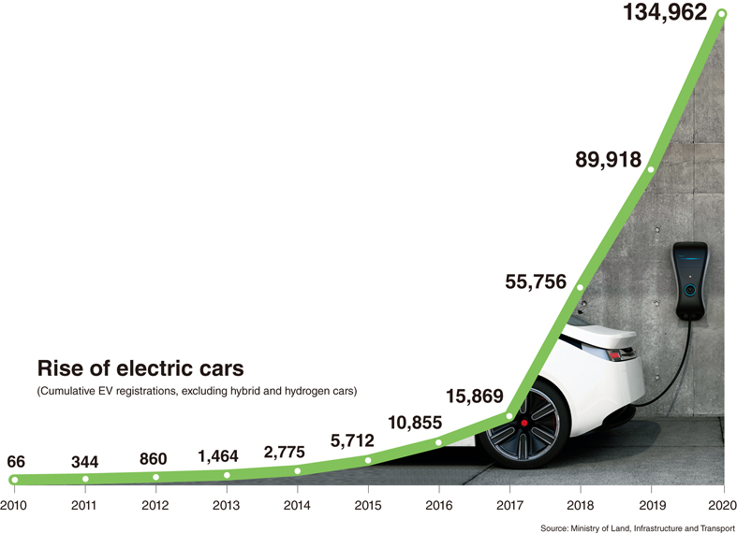 **Title: EV Market Data Analysis**

**By Noor Ahamed Vempalle (U08615464)**

**Introduction:**

Understanding the complex dynamics of the electric vehicle (EV) market, including market shares, sales figures, and their relationship with demographics of the population in various states, is essential for policymakers, industry analysts, and researchers.   
To delve deeper into the complex relationships between market dynamics, population characteristics, and regional variations and to gain a comprehensive understanding of the EV environment we analyze the following datasets:

**1. Alternative Fueling Stations** The dataset contains detailed information on a specific electric vehicle (EV) charging station. Each entry contains several attributes, including the Object ID, access code, access days and times, fuel type code, station name, phone number, location information (latitude and longitude), and other relevant data points. For example, the station under consideration is a private CNG (Compressed Natural Gas) facility located at the Spire - Montgomery Operations Center in Montgomery, Alabama. The station has restricted access and is owned by Spire. The station is active and operates as a standalone facility. The dataset also includes zip codes, street addresses, and cities.

**2. Evadoption EV Share Data:** The dataset contains data on electric vehicle (EV) sales and market share for both Battery Electric Vehicles (BEVs) and Plug-in Hybrid Electric Vehicles (PHEVs) in 2019, organized by state. This dataset allows stakeholders to examine the adoption and market penetration of electric vehicles (both BEVs and PHEVs) in various states, providing useful information about regional preferences, market dynamics, and the efficacy of EV adoption initiatives and policies.

**3. EV Population Size History by County:** The dataset contains data on electric vehicle (EV) adoption by date, year, county, state, vehicle primary use, and the number of Battery Electric Vehicles (BEVs) and Plug-In Hybrid Electric Vehicles (PHEVs) in each category. It also shows the total number of electric vehicles (EV) and non-electric vehicles, as well as the total number of vehicles and the percentage of electric vehicles in each category.

**Methodology:**

To ensure comprehensive coverage of relevant variables pertaining to companies and stocks, datasets were obtained from various sources for this project. The datasets which I have chosen provide a thorough examination of the dynamics and development indices of the electric vehicle (EV) market in several states and regions, mainly in the USA. The data, which was assembled over several years from reliable sources such as government databases, industry reports, and research institutions, includes a wide range of metrics about the adoption of electric vehicles (EVs), their market penetration, and related socioeconomic factors. Understanding the changing landscape of electric mobility and how it intersects with environmental sustainability, and economic development is made possible by these metrics.

Insights derived from the dataset highlight both advancements and persistent challenges in the transition towards electric mobility, offering valuable perspectives on regional disparities and opportunities. By identifying factors influencing EV adoption and market growth, this data analysis serves as a valuable resource for researchers and the vehicle companies to promote sustainable transportation solutions, reduce carbon emissions, and enhance energy security.

**Research Questions:**

1. What are the factors influencing variations in plug-in electric vehicle (PVE) sales and market share across different states? And how do battery electric vehicle (BEV) market shares compare to sales figures, and what factors contribute to any disparities between the two metrics?

2. What percentage of the US population has access to electric vehicles, and how does this vary across different demographic groups and geographic regions?

3. How has the primary use of vehicles by electric vehicle owners evolved over time, and what implications does this have for infrastructure planning and policy development?

4.How do demographic factors influence the adoption of electric vehicles at the county level across US states?

5.How do infrastructure investments, including the availability of charging stations and grid capacity, impact the growth of electric vehicle usage in different counties across US states over the years?

**Order of datasets that are connected:**

**Insight Analysis:**

1. **Chart.1 - States with PVE sales and Market share:**

The bubble chart shows the sales of vehicles. In 2019, California emerged as the undeniable leader in plug-in hybrid electric vehicle (PHEV) sales, commanding a significant market share. This figure not only reflects the state's sizeable population but also underscores its strong commitment to sustainable transportation solutions. Following California, the District of Columbia (DC) stood out with 289 PHEV sales, showcasing a notable presence despite its smaller geographical area and population.

1. **Chart.2 - Comparison of BEV Market share and Sales**

From this dual axis chart, we can see that California continues to show its dominance, leading not only in plug-in hybrid electric vehicle (PHEV) sales but also in the broader battery electric vehicle (BEV) market. We can say that the robust infrastructure, supportive policies and increasing population makes California standout in the EV revolution.

1. A screenshot of a computer

   Description automatically generated**Chart.3 - Graph representing primary use and the access codes in the United States:**

* 'Access code' word is used to show usage provides interesting insights into charging station utilization, with the "Public" category emerging as the primary leader.
* This result highlights how important public infrastructure is to the general adoption of electric vehicles. In addition to serving individual EV owners, public access points facilitate shared mobility services and commercial fleets, making the charging network more accessible and inclusive.

1. **Chart.4 - Total vehicles manufactured in the year:**

* This chart depicts annual vehicle manufacturing trends, with a focus on the production of electric vehicles (EVs) over time. The graph clearly depicts how the manufacturing landscape has evolved, highlighting any fluctuations or significant changes in production volumes.
* Tracking the total number of vehicles manufactured each year allows stakeholders to gain insight into the EV market's growth trajectory and assess the industry's overall progress toward sustainability and electrification goals. Furthermore, the graph may reveal patterns or trends in manufacturing output, providing valuable information to policymakers, and investors. As the demand for EVs grows and manufacturing capabilities expand, this graph becomes an important tool for understanding the dynamics of the automotive industry's transition to electrification.

1. A graph of a growing graph

   Description automatically generated with medium confidence**Chart.5: Vehicles primary use by EV Vehicles over years**

* An interesting pattern can be seen in the area chart showing the production of electric vehicles (EVs) over time, with 2023 emerging as the year with the highest production volume.
* The rapid increase in EV production highlights the growing movement toward environmentally friendly mobility options. The strong expansion in 2023 is a result of the EV market's development as well as rising consumer demand for EVs.
* We can say that the bright future for cutting carbon emissions and reducing the effects of climate change is being marked by the growth of EV manufacturing.

1. A screenshot of a computer

   Description automatically generated**Chart.6 – Open date with different Fuel Type codes (EV Vehicles adoption over years)**

* The animated charging station chart, which tracks years against fuel type codes, tells an interactive story about the dominance of electric fuel types over time.
* With an increasing number of charging stations aimed at electric vehicles, this trend demonstrates the growing importance of electrification in the transportation sector.
* The animation shows that the use of electric fuel has consistently outpaced that of other fuel types, indicating a shift toward sustainable energy sources. The animation depicts the rapid expansion of the electric charging infrastructure, pointing to a promising future for EV adoption.

1. **Chart.7 - EV share and Sales by States:**A graph with orange and blue lines

   Description automatically generated

* Again, from this chart we can see that California is clearly at the cutting edge of electric mobility, as seen by the dual-axis chart that compares EV sales and share across states. California leads the nation not just in terms of total EV sales but also in terms of EV market share. California is defenitely setting an example for other states to follow and improving their own efforts to transition to a more sustainable future.

1. **Chart – 8: States with Charging stations:**

* This pie chart depicts the distribution of charging stations across the states. In this regard, California emerges as the explicit leader, with the most charging stations among the states. California sets an example for other states to prioritize infrastructure development, accelerating the national transition to widespread electric vehicle adoption.

1. **Chart.9 - Battery Vehicles by Vehicle primary usage**

* This pie chart showing the primary use of a vehicle in relation to battery usage provides useful information about the various applications of electric vehicle (EV) technology. The chart provides an in-depth analysis of how battery technology is being applied across multiple industries by depicting the distribution of EVs based on their primary applications. Recent developments in battery technology and encouraging policies are driving the continued expansion of EV adoption.

1. **Chart.10 - County using EV’s:**

* The graphic depicts a captivating pattern in the use of EV vehicles by county in US states over time, with Adams County emerging as the top county in 2023. This shows the county's forward-thinking strategy for implementing electric vehicle technology and promoting environmentally friendly transportation options.
* **Dashboard 1: (California's Dominance in Electric Vehicle Market Share and Sales)**

**California's Commitment to Sustainable Transportation:** The data in both charts demonstrate California's strong commitment to sustainable transportation solutions. Its commanding lead in both BEV market share and total EV sales reflects the state's proactive efforts to combat climate change and reduce emissions through widespread EV adoption.

**Infrastructure and Policy Support:** California's success in the EV market is due to its strong infrastructure, supportive policies, and forward-thinking initiatives. The state's investments in charging infrastructure and incentives for EV buyers have created an environment that promotes EV adoption, resulting in increased sales and market share.

California leads the nation in EV market share and sales, setting a compelling example for other states to follow. Its success emphasizes the importance of prioritizing infrastructure development, enacting supportive policies, and encouraging collaboration among government, industry, and stakeholders to speed up the transition to electric mobility.

* **Dashboard-2:**  
  A screenshot of a graph

  Description automatically generated
* This comprehensive dashboard provides insights into the evolving landscape of electric vehicle adoption and infrastructure development in the United States. Users can explore key trends influencing the future of electric mobility using interactive charts and dynamic visuals. It provides a detailed breakdown of EV usage by primary application, emphasizing the various ways in which battery technology is integrated across industries. Whether you're looking to understand market dynamics, track infrastructure growth, or identify regional trends, this dashboard is an invaluable resource for stakeholders interested in accelerating the transition to electric mobility.

**References:**

<https://evadoption.com/ev-market-share/ev-market-share-state/>

<https://data-usdot.opendata.arcgis.com/datasets/alternative-fueling-stations/explore>

https://catalog.data.gov/dataset/electric-vehicle-population-size-history-by-county

**Conclusion**

In conclusion, this research has addressed the research questions pertaining to the adoption of electric vehicles (EVs) at the county level across US states. Firstly, by examining demographic factors, including population density, income levels, and urbanization, I have elucidated their significant influence on EV adoption.

The findings underscore the importance of understanding socio-economic dynamics in shaping EV uptake, highlighting the need for targeted policies and interventions tailored to the unique characteristics of each county.

Secondly, the policy initiatives and incentives have provided insights into the key factors contributing to higher rates of EV adoption, particularly in leading counties like Adams County in 2023. Through an analysis of policy frameworks and incentives at the county level, we can know the importance of supportive measures such as rebates, tax incentives, and infrastructure investments in fostering an environment conducive to EV adoption.

Lastly, the exploration of infrastructure investments, including the availability of charging stations and grid capacity, has shed light on their impact on the growth of EV usage across different counties over the years. By examining the correlation between charging station density, grid capacity, and EV adoption rates, the critical role of robust infrastructure in facilitating widespread EV adoption has been highlighted.

**Future Scope**

Expanding on these datasets with new data sources can enhance the comprehensiveness and relevance of your analysis. Here are some future scopes and potential data sources to consider:

**1.EV Charging Infrastructure Growth:** Including data on the expansion of EV charging infrastructure over time, including the opening of new charging stations, the deployment of fast-charging networks, and the installation of charging points in various locations such as residential areas, workplaces, and public spaces. Data sources that could include government databases, industry reports, and charging network providers' websites.

**2. Environmental Impact Assessment:** Considering data on the environmental impact of EV adoption, such as reductions in greenhouse gas emissions, air pollution levels, and energy consumption. Environmental agencies, research institutions, and environmental impact assessments can provide valuable data for this analysis.