CAPSTONE PROJECT -1:

You have been hired as a Sr. DevOps Engineer in Abode Software. They want to implement DevOps Lifecycle in their company. You have been asked to implement this lifecycle as fast as possible. Abode Software is a product-based company and their product is available on this GitHub link. https://github.com/hshar/website.git
Following are the specifications of the lifecycle:
1. Install the necessary software on the machines using a configuration management tool
2. Git workflow has to be implemented
3. CodeBuild should automatically be triggered once a commit is made to master branch or develop branch.
a. If a commit is made to master branch, test and push to prod
b. If a commit is made to develop branch, just test the product, do not push to prod
4. The code should be containerized with the help of a Dockerfile. The Dockerfile should be built every time there is a push to GitHub. Use the following pre-built container for your application: hshar/webapp. The code should reside in '/var/www/html'
5. The above tasks should be defined in a Jenkins Pipeline with the following jobs:
a. Job1: build
b. Job2: test
c. Job3: prod

Services Used:
- Amazon EC2: To create and run a virtual machine.
- GitHub: To create a git workflow
- Ansible: Used as a configuration management tool
- Docker: To build a Docker image inside the container
- Jenkins: To build CI/CD pipeline and to Code build
Implementation Steps:
Step-1: Create 3 instances (master, test and production):

- Log in to AWS Management console.
- Navigate to EC2 Dashboard.
- Click on Launch Instance
- Configure:
- Name- noor-master, noor-test, noor-prod
- AMI- Ubuntu Server 24.04 LTS (HVM), EBS General Purpose (SSD) Volume Type.
- Instance Type: t2.medium
- Keypair: Creating a new keypair (dev1.key)
- Network setting: Keep it as default.
- Storage: Default root volume (8GiB)
- Number of instances: 3
- Click Launch Instance.
- 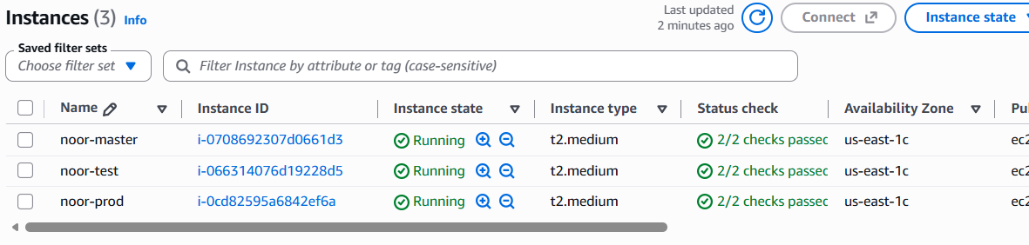
- Select all the Instances.
- Click connect – EC2 Instance connect-connect for all the 3 instances.
Step-2: Run the following commands to install Ansible:
- Sudo apt update (update all the 3 machines)
- Sudo apt install python3 -y (in order to install ansible, we have to install python first in all the 3 machines)
- Python3 –version (to check the version)
- 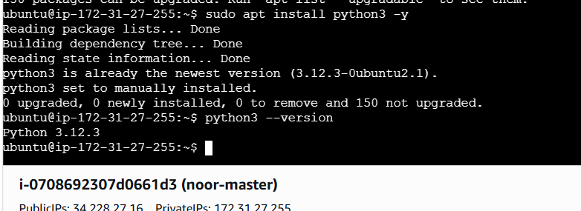
- Sudo apt install python3-pip -y (in order to install package manager in all the 3 machines)
- Sudo nano ansible.sh (create a script file) only in master machine
- Open the browser and type: install ansible on ubuntu and copy the code and paste it in the script file
- sudo apt update
- sudo apt install software-properties-common -y
- sudo apt-add-repository ppa:ansible/ansible
- sudo apt install ansible -y
- 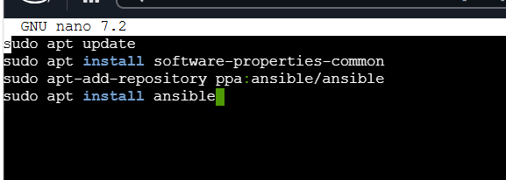
- Ctrl+O. enter, Ctrl+X
- Bash ansible.sh (to run the file)
Step-3: Connect master machine to test and prod:
- Ssh-keygen -t rsa -b 4096(byte limit)
- 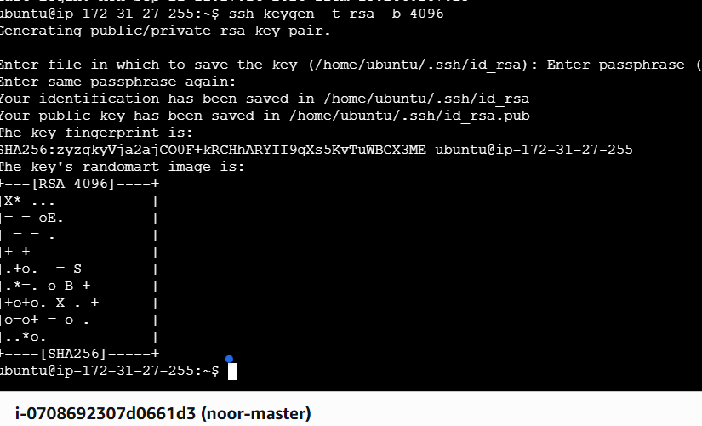
- Press enter thrice
- Cd .ssh
- Sudo cat id_rsa.pub (to get a key to connect in test and prod)
- Copy the generated entire key
- 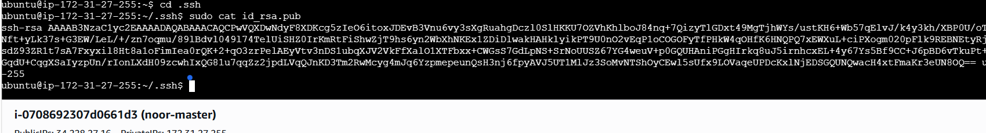
- Go to test and prod machines and enter the following commands:
- Cd .ssh
- Ls (to check the keys)
- Sudo nano authorized_keys
- Paste the entire key and press Ctrl+o, enter, Ctrl+X and repeat the same in prod machine.
- 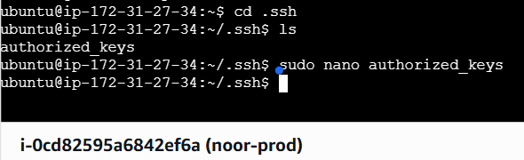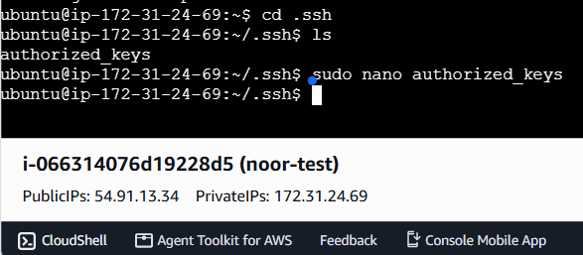
Step-4: Setting up the IP addresses of test and prod inside the host(master):
- In the master machine run the command: cd /etc/ansible
- Ls
- Sudo nano hosts (to create groups)
- 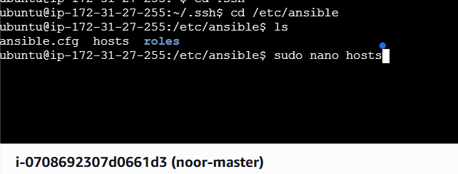
- Enter the code:
[slaves]
172.31.24.69 (private IP of test machine)
172.31.27.34 (private IP of prod machine)
- Ctrl+O, enter, Ctrl+X
- 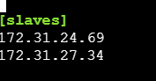
Step-5: Check the connectivity:
- Ssh ubuntu@ 172.31.24.69 (private IP of test machine)
- Enter yes

- 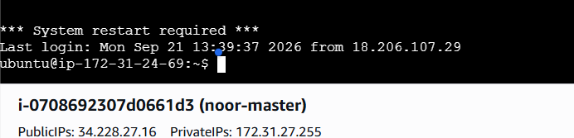
- Enter exit.
- Ssh ubuntu@ 172.31.27.34 (private IP of prod machine)
- Enter Yes
- 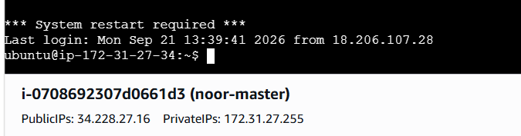
- Exit.
- Ansible -m ping all
- 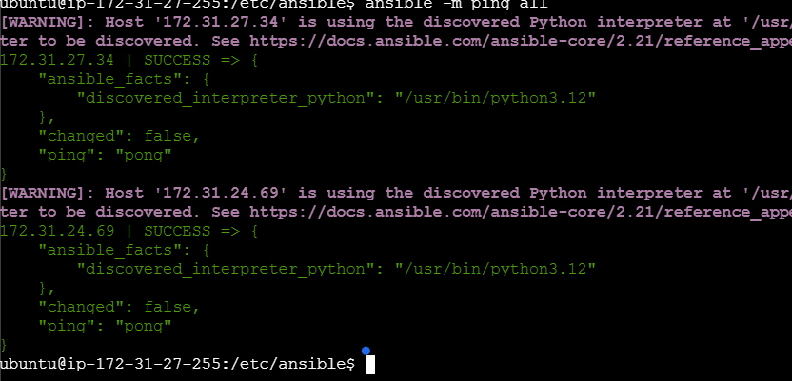

Step-6: Create a Playbook in master machine:
- sudo nano play.yml (correct the indentation before saving)
- 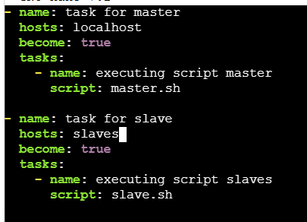

Step-7: Install jenkins inside the master machine:
- sudo nano master.sh
- In the browser, search for install Jenkins on ubuntu. Before that, we have to install java, so copy the code and paste it inside the machine.
- Copy the 2 lines of java code and code of long-term support release code and paste it inside the master machine. Also, enter -y near the install to avoid verification.
- 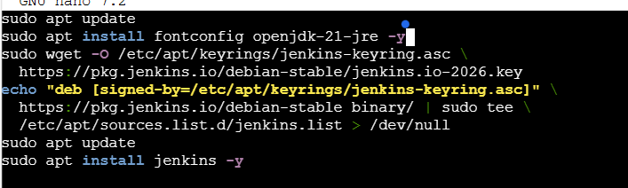

Step-8: Install docker and java inside the salve machine:
- Sudo nano slave.sh
- Enter the following commands:
- sudo apt update
- sudo apt install fontconfig openjdk-21-jre
- sudo apt install docker.io -y
- 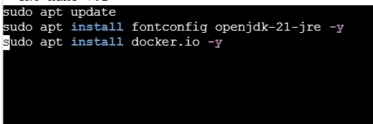
- Run the playbook: ansible-playbook play.yml
- 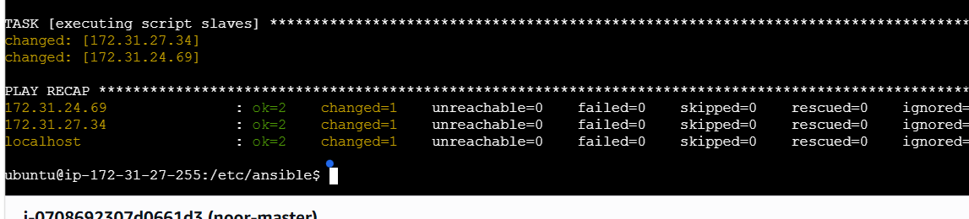

Step-9: Install the Jenkins Dashboard:
- Open the EC2 instance and select master instance and go to security.
- Add new custom rule t enable port 8080 and enter port no:8080 (default port) and save.
- Copy the public IP of master machine and paste it in the browser as: http:// 34.228.27.16:8080
- 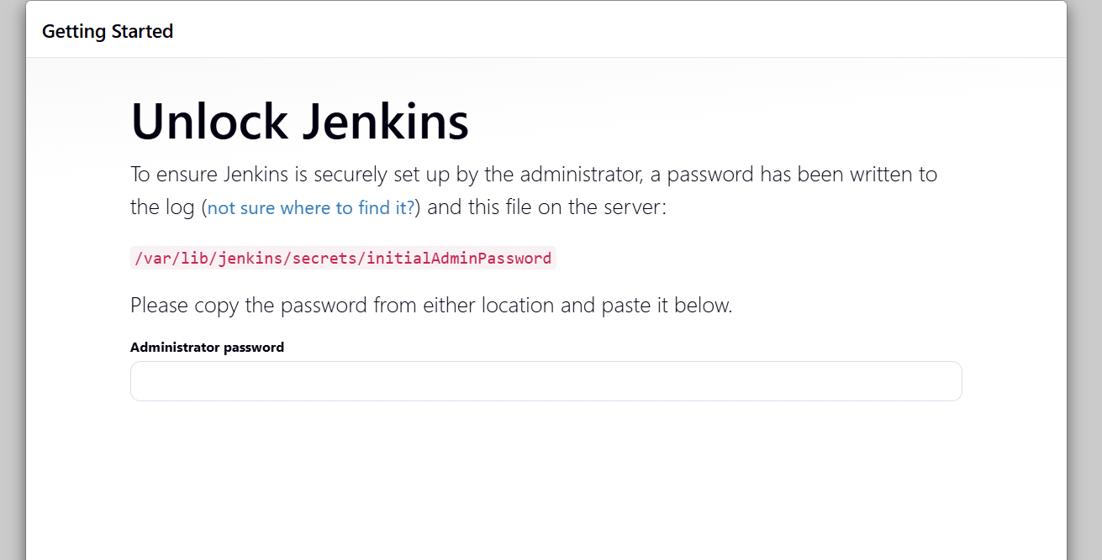
- To unlock, copy the path and paste it in the master machine as:
Sudo cat /var/lib/jenkins/secrets/initialAdminPassword
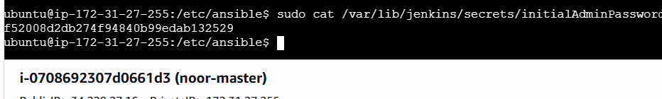
- Now, copy the password from the master and paste it in the Jenkins.
- select install the plugins
- Enter all the credentials:
- 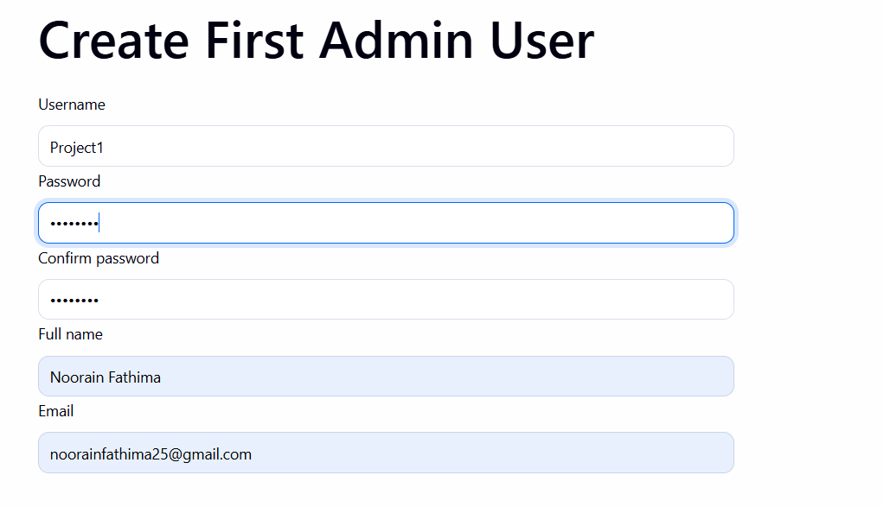
- Enter save and continue.

Step-10: Create 2 nodes to connect to prod and test EC2 instances:
- Go to settings and select nodes
- 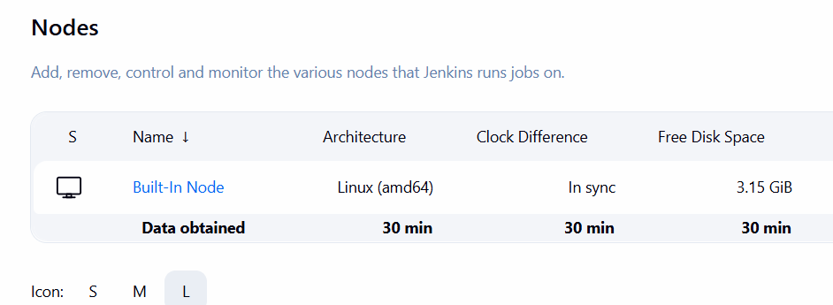
- Click on new node
- 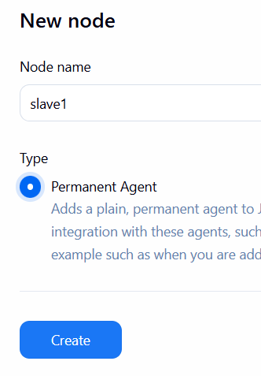
- Click on create.
- 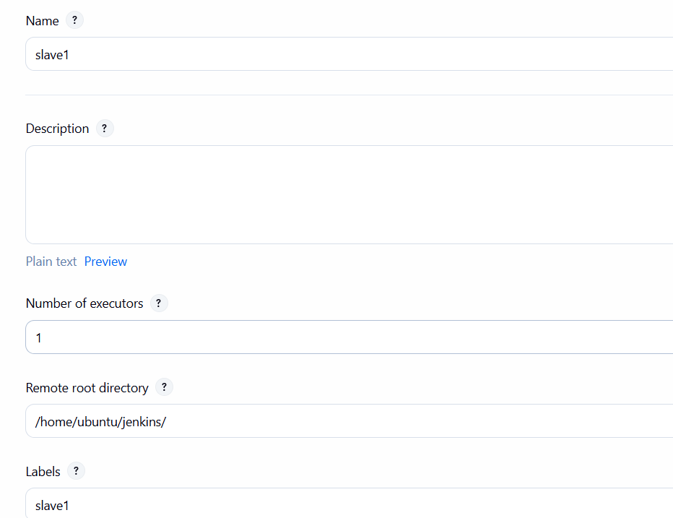
- Launch method: launch agents via SSH
- Host: Private IP of test machine (172.31.24.69)
- Credentials: click on add and select SSH username with private key
- 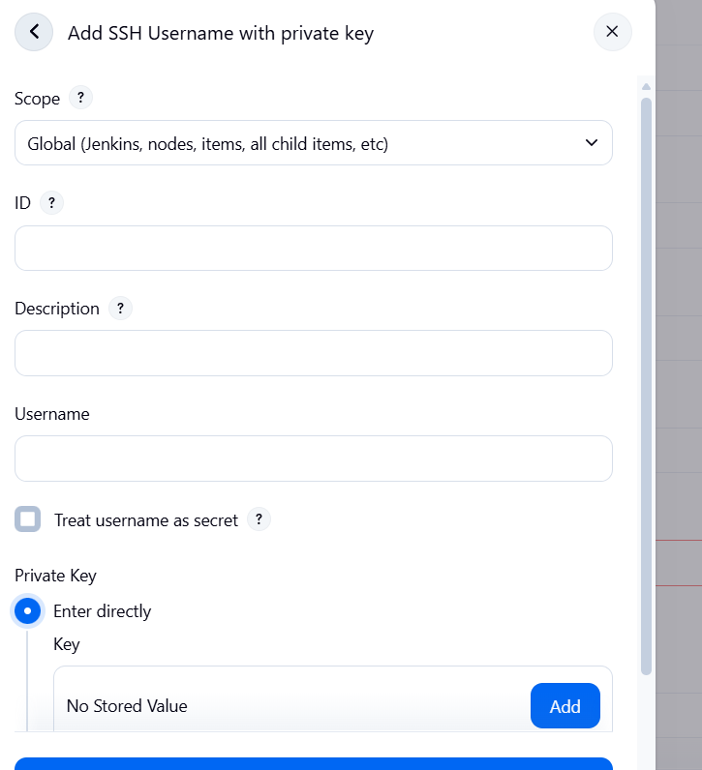
- Now open the keypair key of an instance and copy the key and paste it in Add key.
- Click on create
- 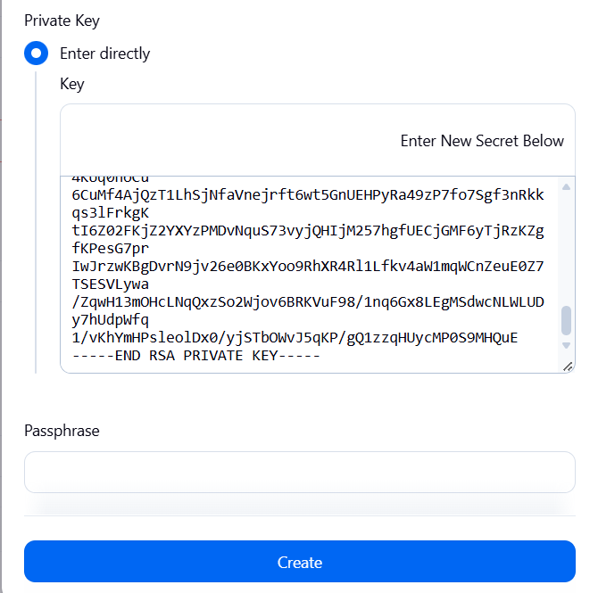
- key should be new.
- 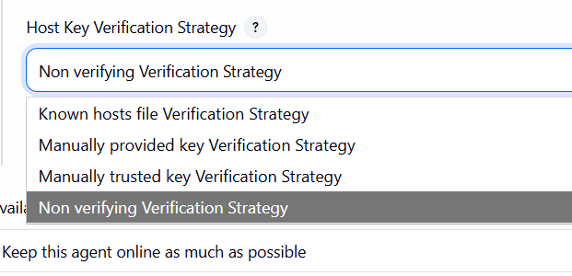
- Now, keep everything as default and save.
- 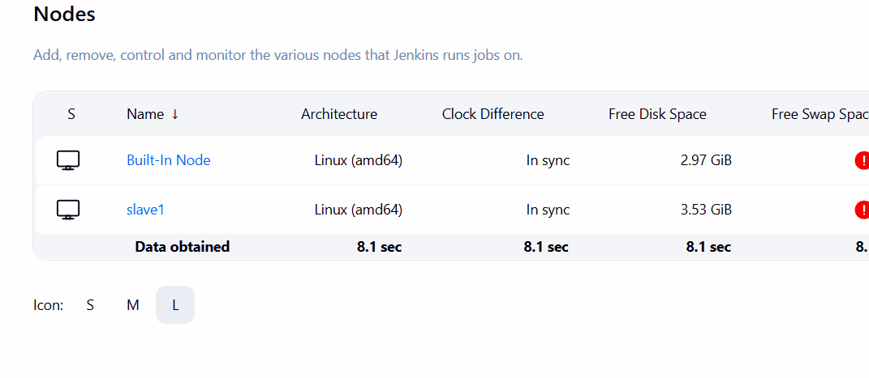
- Similarly, create another node as slave2 using private IP of prod machine.
- 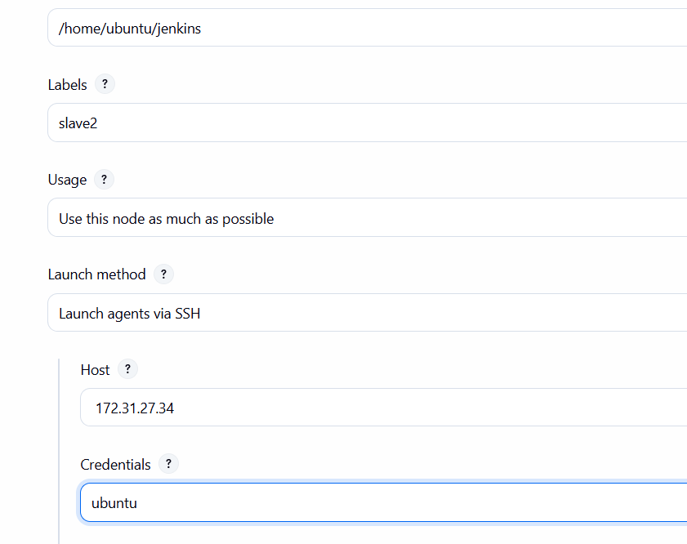
- Save the credentials.
- 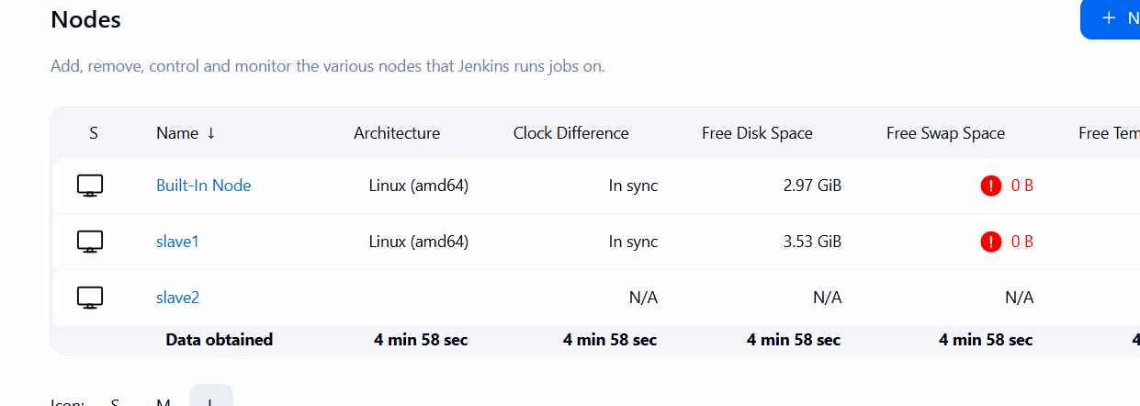
Step-11: Create a DockerFile inside the Github repository:
- Fork the given repository to our own repository (means creating copy of repository):
- 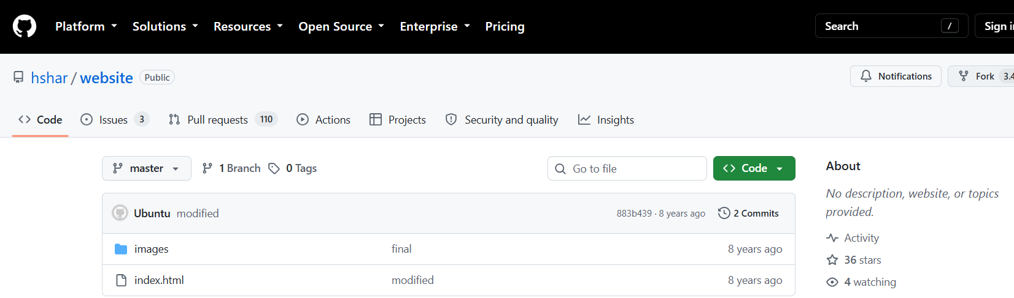
- Click on fork option and select create a new fork.
- 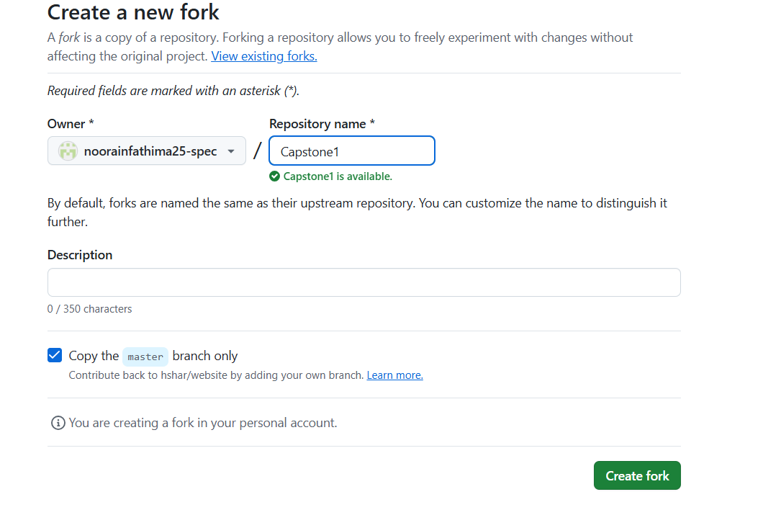
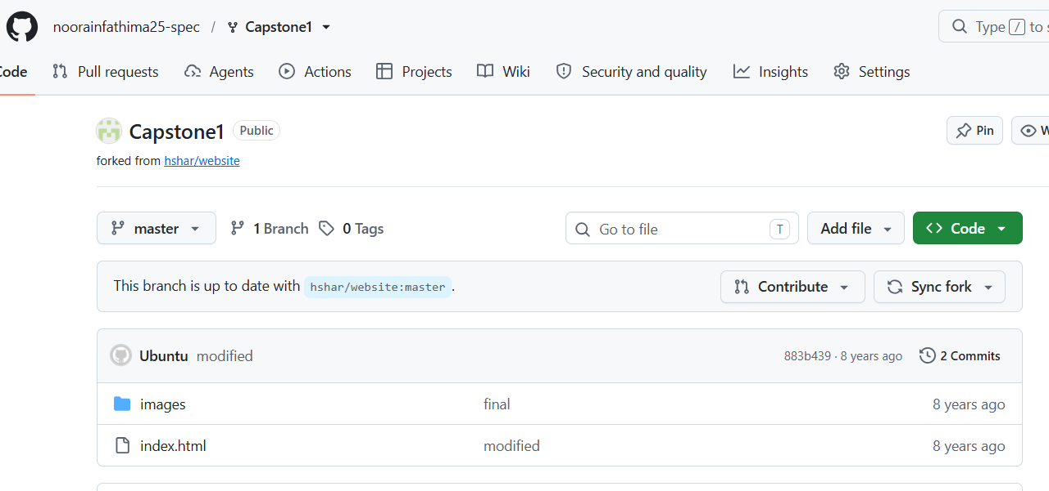
- Copied the project file into our own repository.
- Create the docker file by clicking on create new file.
- 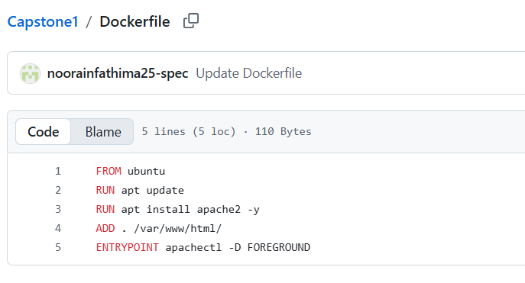
- Save the file as Dockerfile and click on commit changes.
- 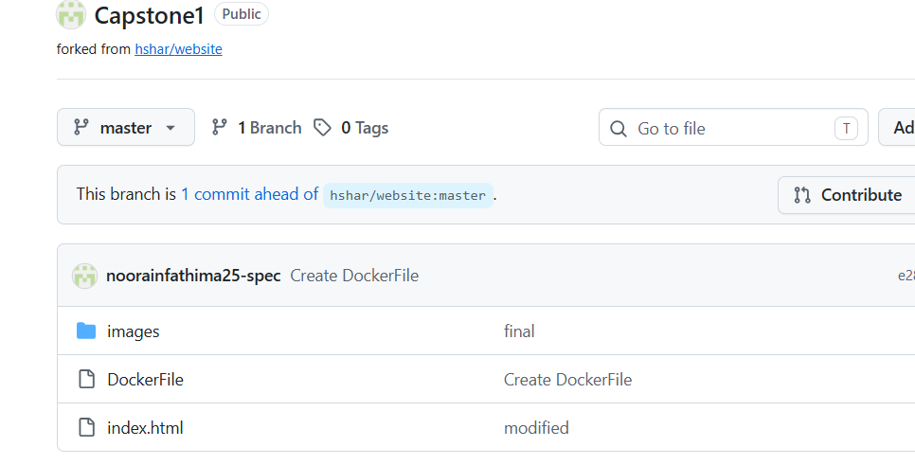

Step-12: Create the jobs in jenkins:
- Click on create a new job
- Enter name: job1
- Select: Freestyle project
- Click ok
- Now, select Github project and paste the github URL:
- 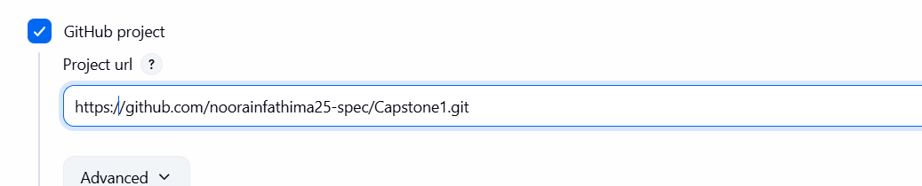
- Now, select restrict where this project can be run:
- 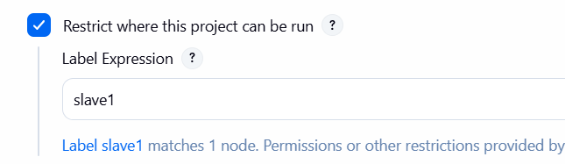
- Source code: Git and paste the URL
- 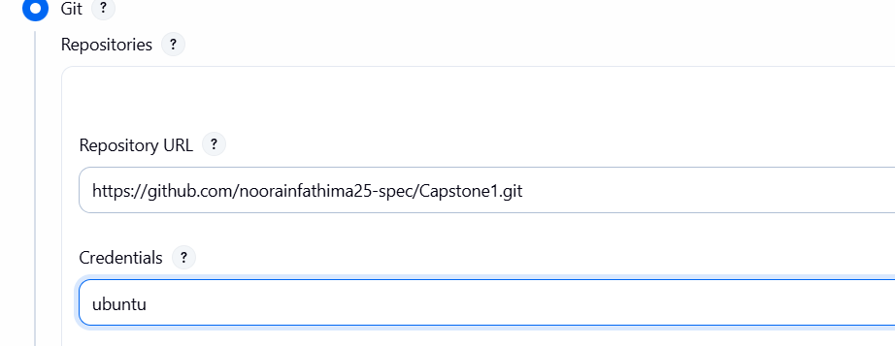
- Branch specifier: */develop
- Go back to Github and create a new branch: develop branch
- Click on master branch- view all branches- new branch.
- 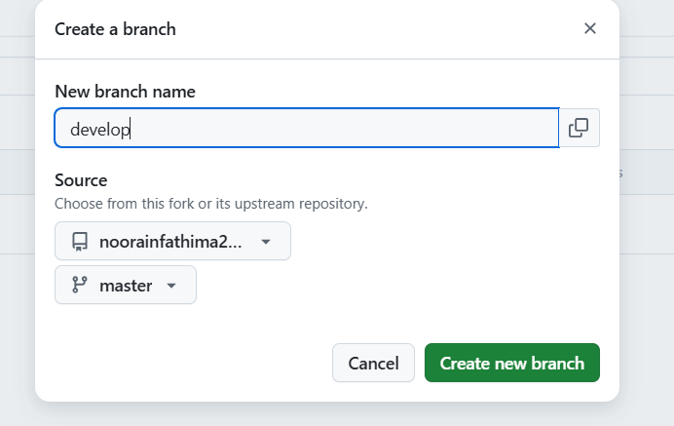
Step-13: Create a webhook to connect Jenkins to github:
- Select github hook trigger option from triggers section.
- Now, copy the URL of Jenkins and open github repository.
- Select settings, and click on webhooks the click on Add webhook.
- Paste the copied URL of Jenkins in payload URL and edit the last part as /github-webhook/
- 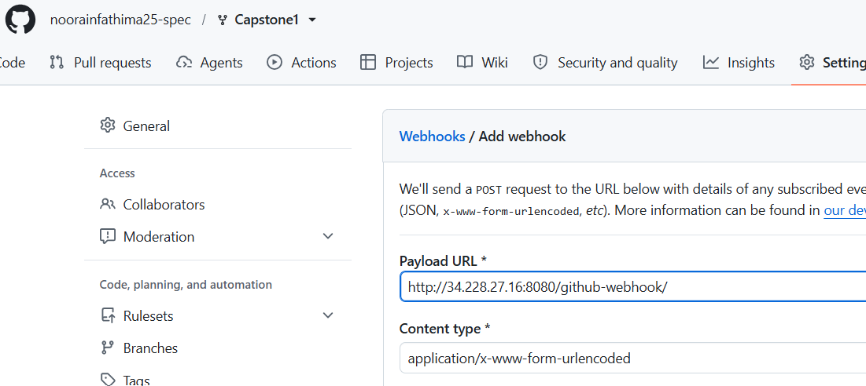
- Click on add webhook.
- 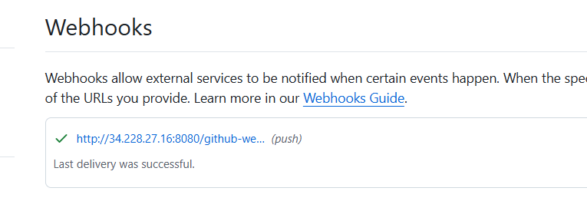
Step-14: Create a Build:
- Now, keep other things as default and click on create.
- Now to check the build status, select build now option.
- 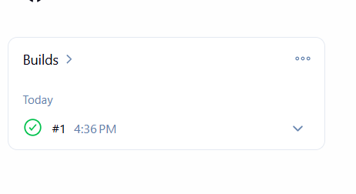
- Build is success.
Step-15: Verification in the test machine:
- 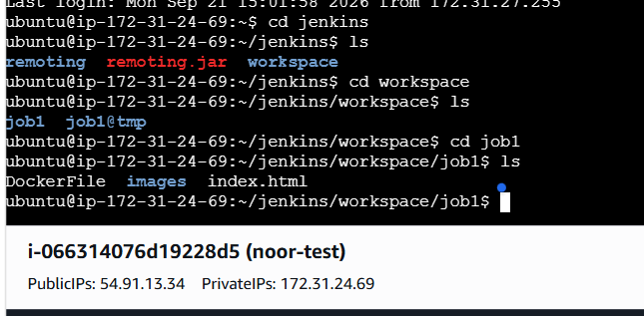
- Here, we can see all the files in the test machine.
Step-16: Build an image in Jenkins:
- Go to Jenkins dashboard and click on configure.
- Go to build steps, click on add build step and select execute shell.
- 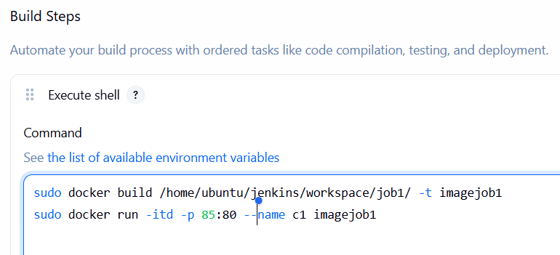
- Click on apply and save.
- Now, click on Build Now
- 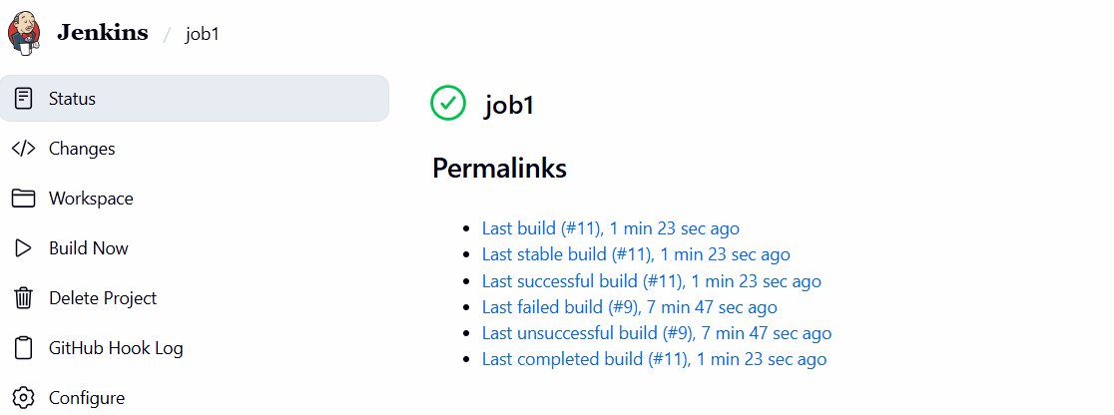
- 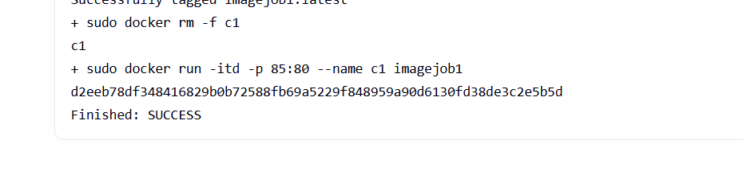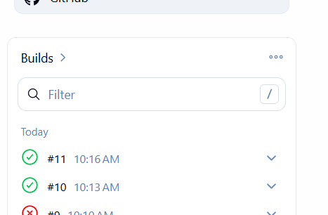
Step-17: Verify the output of job1:
- Go to the security group and add new rule: custom TCP: port 85:IPv4: save rule
- 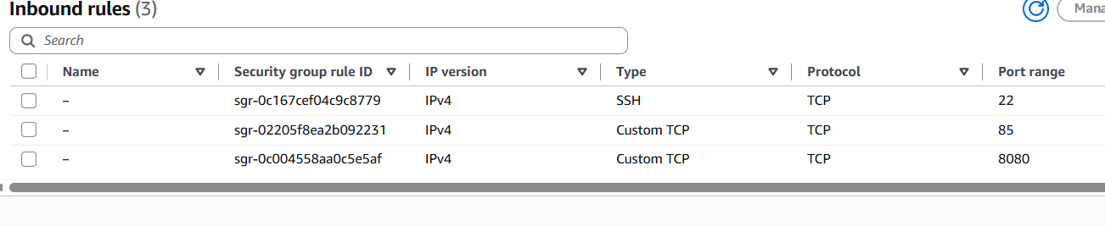
- Copy the public IP of test machine and open the browser and paste:
http:// 54.88.195.157:85
- 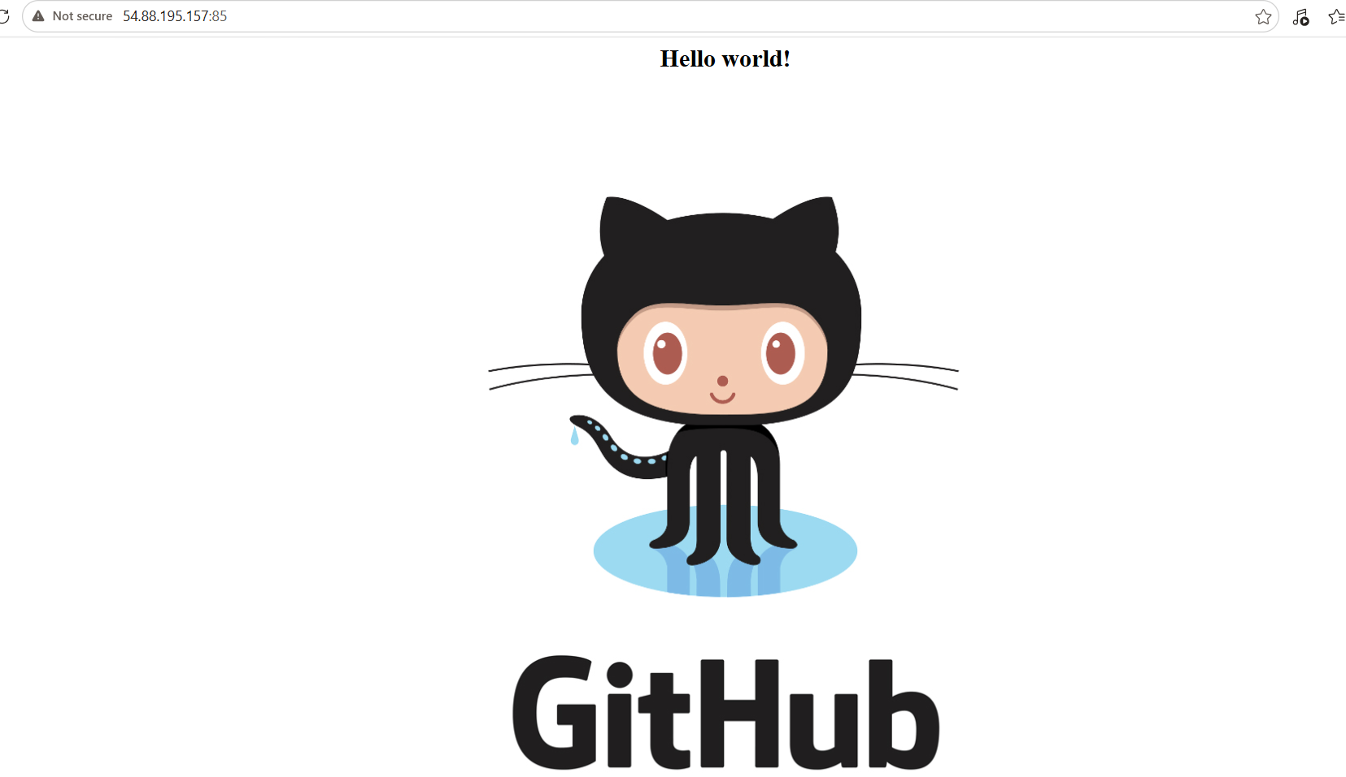
Step-18: Build job2:
- Repeat the same for job 2 and change the branch to master branch
- Execute the following commands inside the test machine:
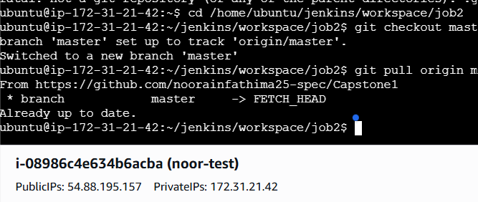
- Now, build job2 in Jenkins as:
Name: job2
Lablel: slave1
Add build: Execute shell:
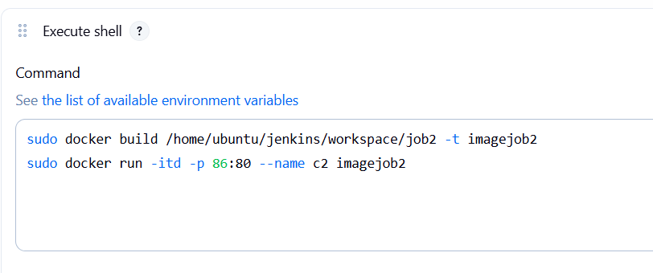
- Save and apply
- Click on build now.
- 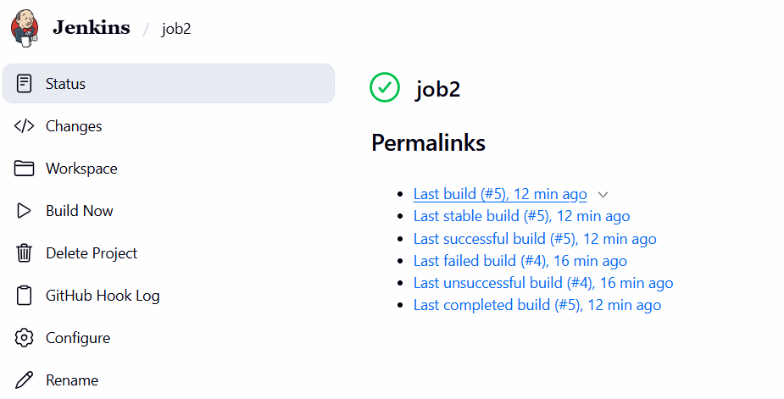
- 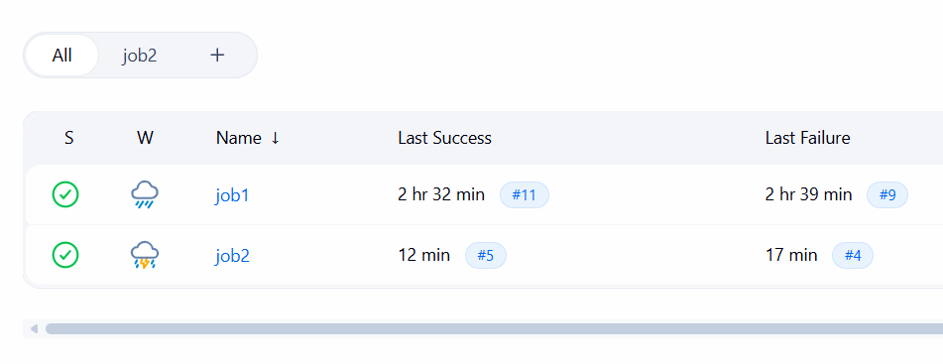
- Verify the build:
- Go to the security group and add new rule: custom TCP: port 86: IPv4: save rule
- Copy the public IP of test machine and open the browser and paste:
http:// 54.88.195.157:86

- 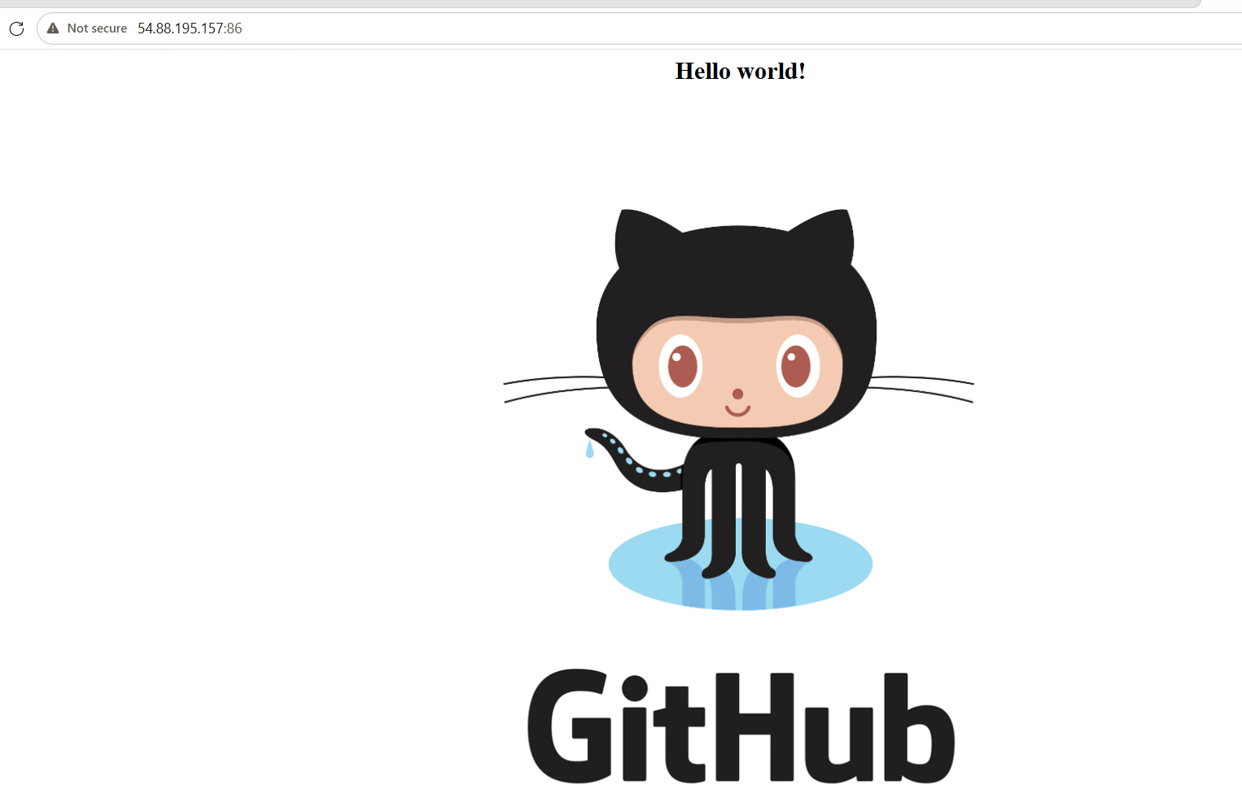
Step-19: Build job3:
- Now, build job3 in Jenkins as:
Name: job3
Lablel: slave1
Add build: Execute shell:
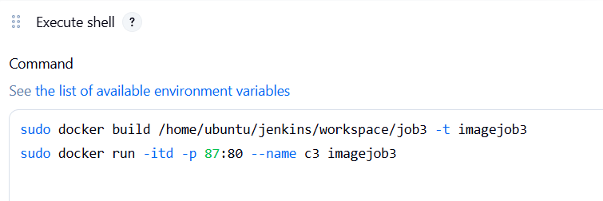
- Save and apply
- Click on build now.
- 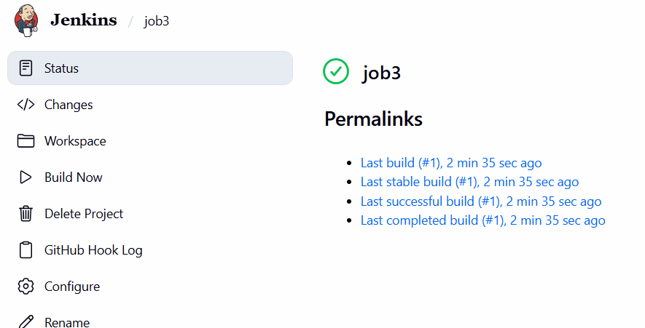
- Successfully build 3 jobs:
- 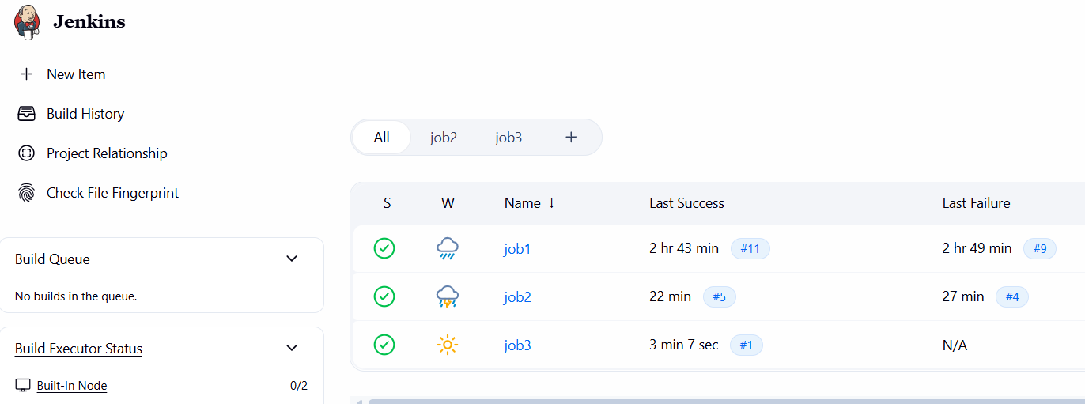
- Verify the build:
- Go to the security group and add new rule: custom TCP: port 88: IPv4: save rule
- 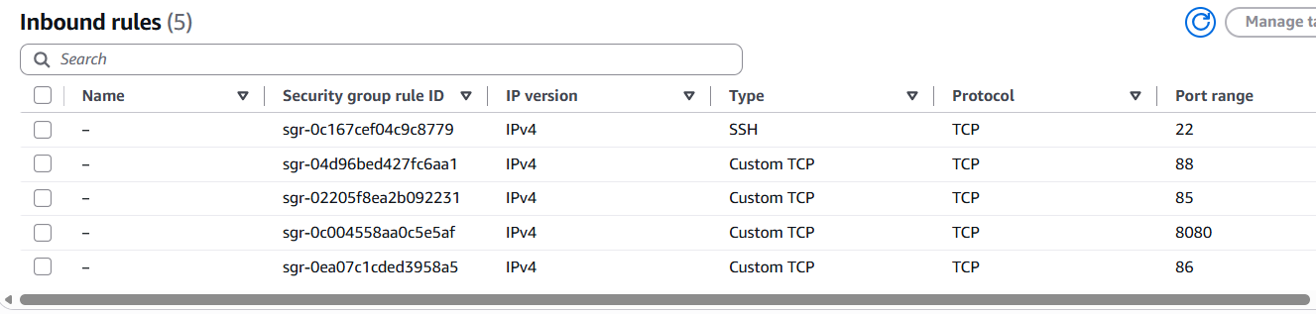
- Copy the public IP of test machine and open the browser and paste:
http:// 54.88.195.157:87
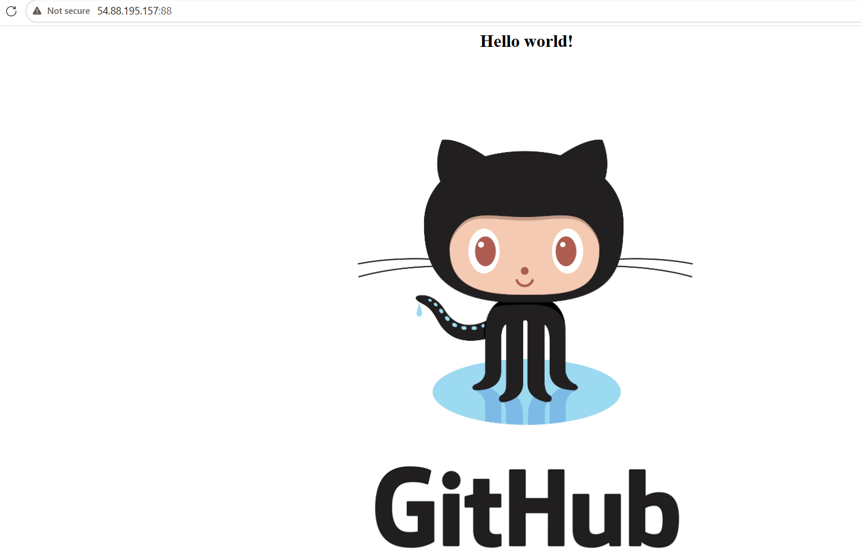

Result:
- Successfully implemented a branch-based CI/CD workflow for a static web application using GitHub, Docker, AWS CodeBuild, Jenkins, and Ansible.
- The develop branch was configured to perform the build and testing activities, while changes pushed to the master branch proceeded through the complete CI/CD pipeline, including build, testing, and production deployment.
- Jenkins was used to automate the pipeline stages, Docker was used for application containerization, Github was used for automated build processes of Dockerfile, and Ansible was configured for deployment and server management.
- As a result, the project achieved an automated and structured CI/CD workflow that separates development testing from production deployment and reduces manual deployment effort.

