Here you will find information to construct repository and set up the SMILK-dexter Named Entity linking tools as Web-services (smilkNel-rest Jersey Webapp)

1- Construct the repository from the wikipedia dump (dexter-core/preparation/)

- Preparation folder ---> prepare.sh will provide you the repository in target language (en: English, fr: French):

- sh prepare.sh fr fr.data ( will create required files in fr.data folder for French )

- sh prepare.sh en en.data ( will create required files in en.data folder for English )

2- Set the path to the repository folder in the "dexter-config.xml" in "smilkNel-rest" folder as follow:

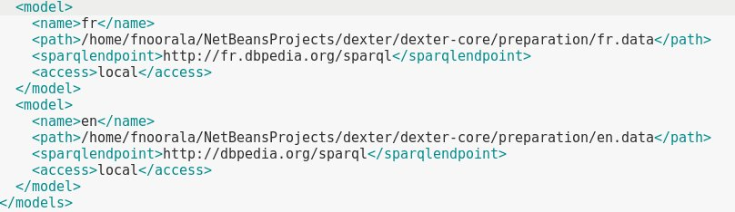

3- Build the "smilkNel-rest" project to have proper "smilkNel-rest.war" file. ( beacuse the “dexter-config.xml” is embedded in the “WEB-INF” folder.

4- Call the web service :

http://localhost:8080/smilkNel-rest/webresources/annotate

* To annotate french text:
  + “/fr?spotter=NE&tool=<[renco,openNLP]>&method=<[pagerank,linear]>” :

It is based on named entity recognition and you can select “renco” or “openNLP” as tool for spotting and “pagerank” or “linear” method for linking method.

* + “/fr?spotter=wiki&method=<[pagerank,linear]>”:

It is based on wiki-dictionary spotting and you can select “pagerank” or “linear” method for linking method.

* To annotate english text
  + “/en?spotter=NE&tool=<[inria,stanford]>&method=<[pagerank,linear]>”:

It is based on named entity recognition and you can select “inria” or “stanford” as tool for spotting and “pagerank” or “linear” method for linking method.

* + “/en?spotter=wiki&method=<[pagerank,linear]>”:

It is based on wiki-dictionary spotting and you can select “pagerank” or “linear” method for linking method.

The architecture of web- service :