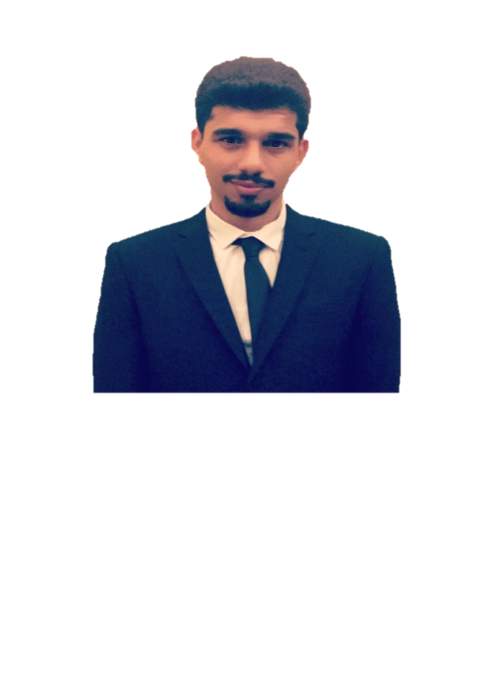

Sadiq Ameer

AlHawaj

Saudi Arabia, Al-Ahsa

(+966) 597171212

(+966) 545703737

Sadiq1428@hotmail.com

Nationality: Saudi Arabia

National ID: 1064504143

Birthday: 08/17/1989

Telecommunication Technical Support

Objective

I am seeking employment with a company where I can use my talents and skills to grow and expand the company.

I am seeking a competitive and challenging environment where I can serve your organization and establish an enjoyable career for myself.

Academic Qualifications

* Cybersecurity in progress Bachelor Degree.
* Graduate from College of Telecom & Information of Riyadh in Diploma Certificate in Telecommunication field

26 of June 2013 with GPA: 4.11 out of 5.

Electricity and Electronics Technology - Digital Communications - Transmission lines and fiber optics - Data and network communication - Antennas and wave propagation - Microwave and satellite technologies - Mobile communications.

* Certificate of English language from KSA taken in 2014.
* Certificate of English language from US taken in 2016 level5 out of 7.

Experience

Currently I have been working at (Sky Band company) as V-sat engineer since 2021.

I worked at (Aramco Rowan Drilling Company) as a Roustabout 2018 - 2021.

I worked at Malabar Gold & Diamond company as a salesman, 2017 - 2018.

I worked at (Extensia) subcontract of Zain company as a call center, 2016 - 2017.

I worked at (CCC) subcontract of STC company as a call center, 2014 - 2015.

I worked at (NCBS) subcontract of Mobily company as a call center, 2011 - 2012.

Skills

Fluently speaking English excellent customer service skills, professional computer using and perfect communication skill.

Languages

* Arabic (Native)
* English (Advance)