INF214 – Obligatory 2

Noora Rehim Lindeflaten

Nli008

Task 3

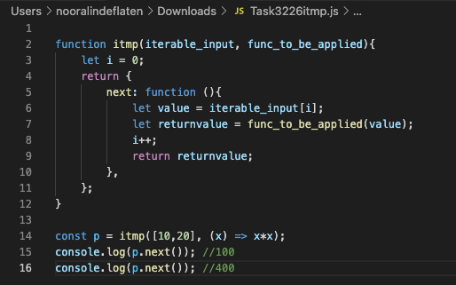

Alternativly you cold wrap the last return statement letting the function know when the current element the functions is applied to is done, and simplifying next with:

Next : () =>

Task 4

The reason the developer has problems with his code is due to the fact that we are returning the wrong promise. The new independent promise that is created as stated in the description, is the one being returned by validateLogin. Problems like this can be fixed by implementing await statments, or making certain parts of the problem wait for the next action.

We want to:

* Have a promise, and store it.
* Handle the promise
* Then return the origional promise

The problem is that we are not returning the origional promise, or it could be because the export to the login function is recieved before the actions in validateLogin are done. Either way we need to make sure that we are returning the right promise.

Task 5:

See presentation in zip-file.