
Faculty of Information Technology
_________________________

Data Analysis for cyber security
_________________________
Instructor: Dr. Shorouq Al-Eidi

Rebort BY:
Student’s names: Noor Al-Shater

Cyber Security Indexes:
Four related to cyber security Indexes presented for each country

ABOUT DATASET:
The Dataset "Cyber Security Indexes" includes four indicators which illustrate the current cyber security situation around the world. The data is provided on 193 countries and territories, grouped by five geographical regions - Africa, North America, South America, Europe and Asia-Pasific.

The Cybersecurity Exposure Index (CEI) defines the level of exposure to cybercrime by country from 0 to 1; the higher the score, the higher the exposure (provided by 10guard). The indicator was last updated in 2020.

The Global Cyber Security Index (GCI) is a trusted reference that measures the commitment of countries to cybersecurity at a global level – to raise awareness of the importance and different dimensions of the issue (provided by the International Telecommunication Union - ITU). The indicator was last updated in 2021.

The National Cyber Security Index (NCSI) measures a country's readiness to address cyber threats and manage cyber incidents. It is composed of categories, capacities, and indicators (provided by NCSI). The indicator was last updated in January 2023.

The Digital Development Level (DDL) defines the average percentage the country received from the maximum value of both indices (provided by NCSI). The indicator was last updated in January 2023

Analysis Section:
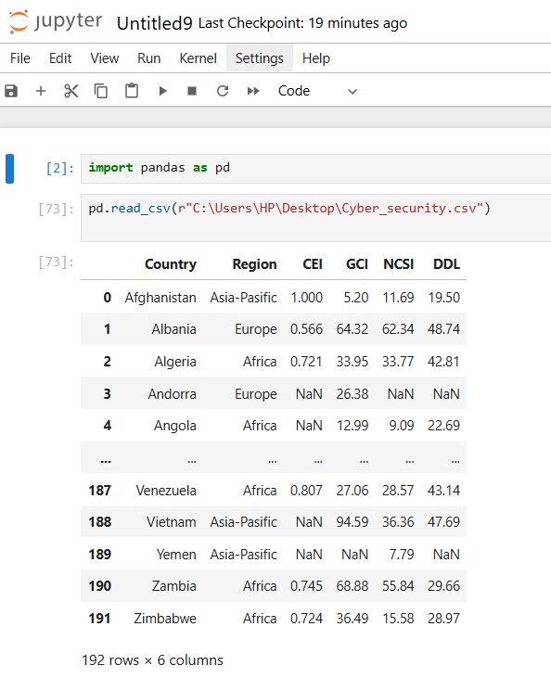
*The Pandas library is imported using import pandas as pd, which provides tools for data analysis. Then, data is loaded from a CSV file using the pd.read_csv() function, where the file path is specified for loading. The result is the conversion of the data into a DataFrame structure for easy manipulation and analysis.
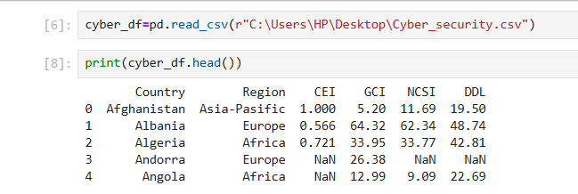
*The print(cyber_df.head()) command displays the first five rows of the DataFrame cyber_df, allowing a quick preview of the data.
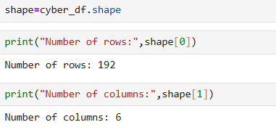
*The cyber_df.shape command returns the dimensions of the DataFrame cyber_df as a tuple (number of rows, number of columns). The subsequent print() statements display the number of rows (shape[0]) and columns (shape[1]) in the DataFrame

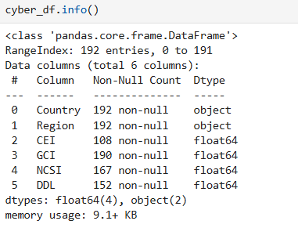
The cyber_df.info() method is used to get a comprehensive summary of the DataFrame.
- It displays the number of rows and columns in the dataset.
- It shows the column names, data types (int, float, object), and the count of non-null values in each column.
- This helps in understanding data quality and identifying columns with missing or inconsistent values.
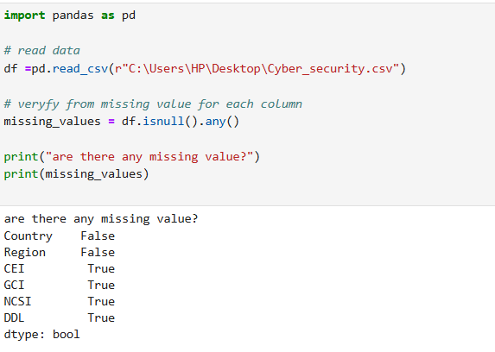
This code checks for missing values in each column of the dataset.
- The data is read using pd.read_csv() and stored in a DataFrame named df.
- The df.isnull().any() function checks whether any missing values exist in each column, returning a list of Boolean values (True/False) for each column.
- The output shows that the columns CEI, GCI, NCSI, and DDL have missing values (True), while the columns Country and Region do not have missing values (False).
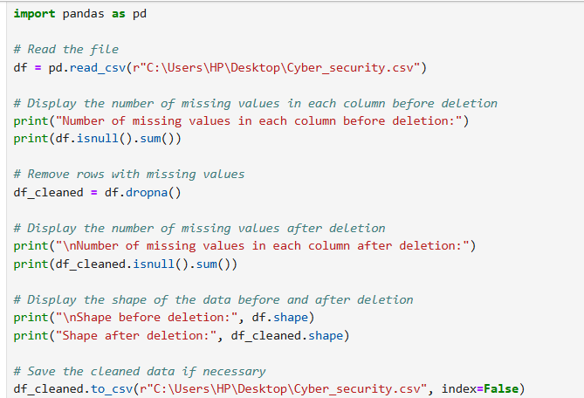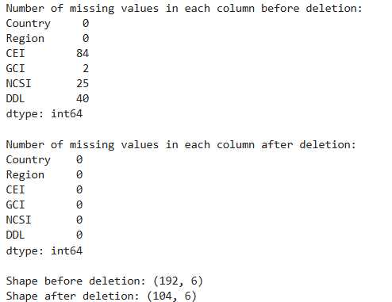
Before deletion, the DataFrame has 192 rows and 6 columns. The Country and Region columns have no missing values, while the other columns like CEI and NCSI have missing values ​​(84 and 25 respectively).
After deleting the rows with missing values ​​using dropna(), all the columns are now free of missing values.
The number of rows has reduced from 192 to 104, which means that 88 rows with missing values ​​have been deleted.
The data is now clean and free of any missing values
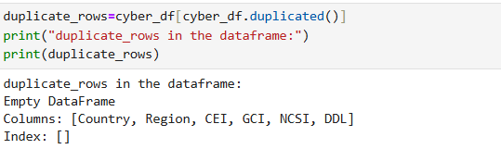
This code identifies duplicate rows in the cyber_df DataFrame using cyber_df.duplicated(), which returns rows that are duplicated based on all columns.
The duplicate rows are stored in a new DataFrame called duplicate_rows.
The output shows that the DataFrame contains no duplicate rows, as the result is an empty DataFrame.
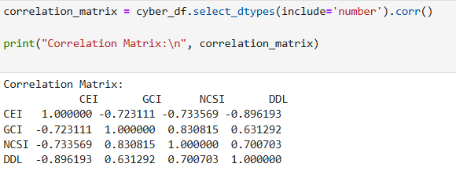

The correlation matrix shows the pairwise correlation between the numerical columns: CEI, GCI, NCSI, and DDL.
- Strong negative correlations are observed between CEI and NCSI (-0.73) and CEI and DDL (-0.90), while GCI and NCSI show a strong positive correlation (0.83).
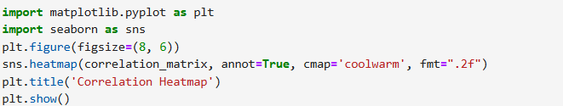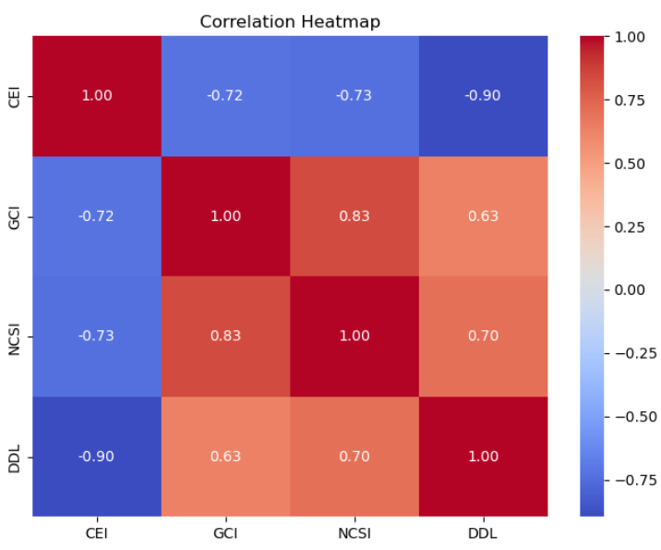
This code generates a heatmap to visualize the correlation matrix using seaborn and matplotlib.
- sns.heatmap() creates the heatmap with annotations (annot=True) to display the correlation values, and the cmap='coolwarm' sets the color palette. The plt.title() adds a title to the plot, and plt.show() displays the heatmap.
____________________________________________________________________________
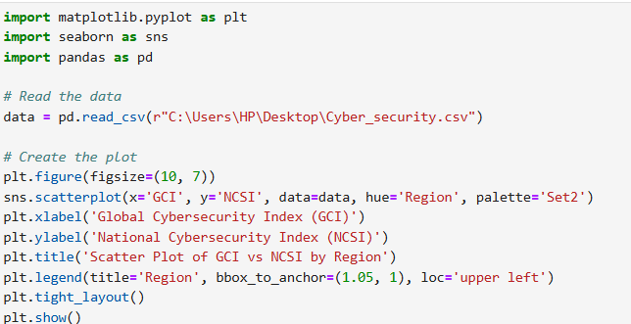

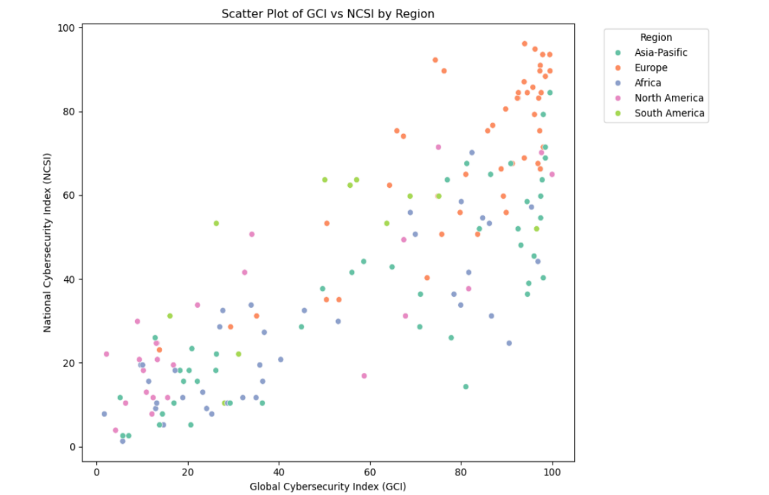
This code creates a scatter plot to visualize the relationship between GCI (Global Cybersecurity Index) and NCSI (National Cybersecurity Index), with different colors representing regions using the hue='Region' parameter.
- sns.scatterplot() plots the data, plt.xlabel() and plt.ylabel() label the axes, and plt.title() adds a title. The legend is placed outside the plot with plt.legend(), and plt.tight_layout() ensures the layout fits well.
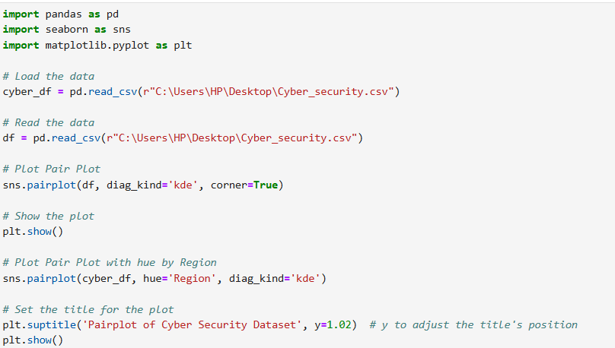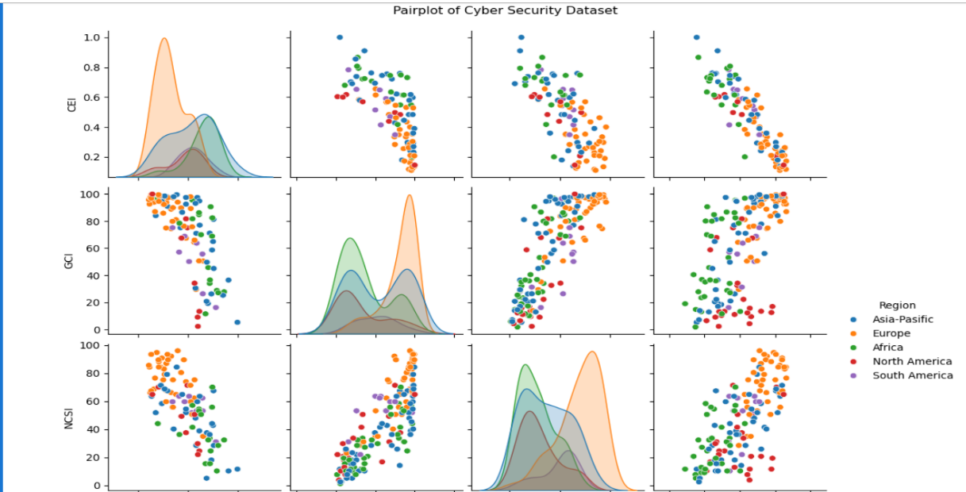
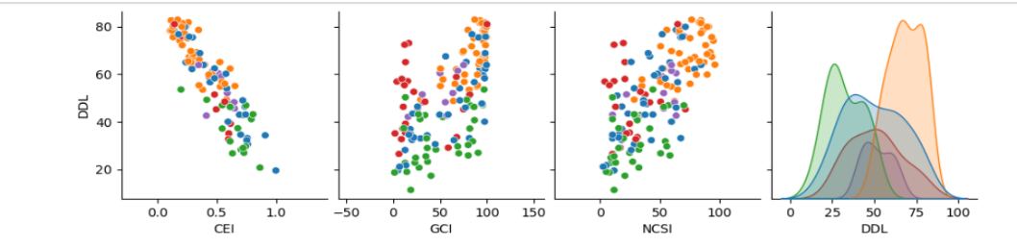
This code generates plots for the Cyber Security dataset using seaborn's pairplot() function.
- plot adds color grouping by the Region column using hue='Region' and also includes KDE on the diagonals.

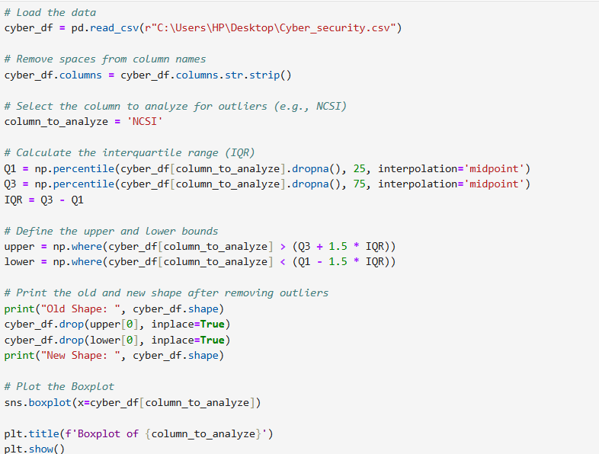

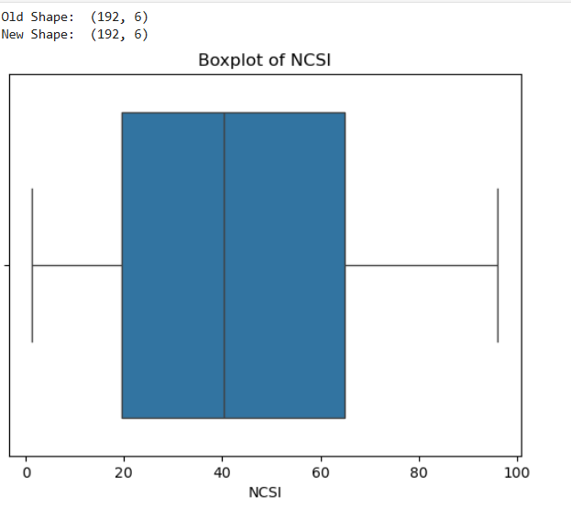
• The code first loads the Cyber Security dataset and removes any spaces from column names.
• It then calculates the interquartile range (IQR) for the NCSI column to detect outliers, defines upper and lower bounds, and removes rows that contain outliers.
• Finally, it prints the dataset shape before and after removing the outliers, and visualizes the distribution of NCSI using a boxplot.

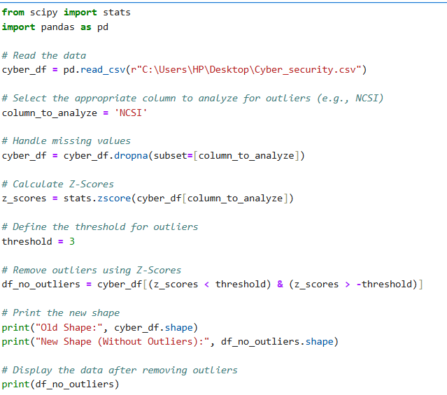
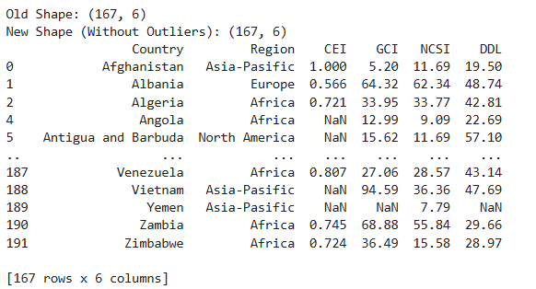
This code calculates the Z-Scores for the NCSI column in the dataset to identify outliers. It then removes the rows with Z-Scores greater than the threshold (3) or less than -3, and prints the shape of the dataset before and after outlier removal, displaying the cleaned data

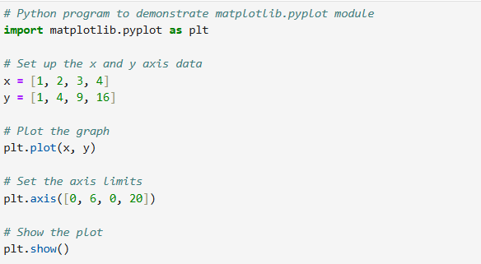
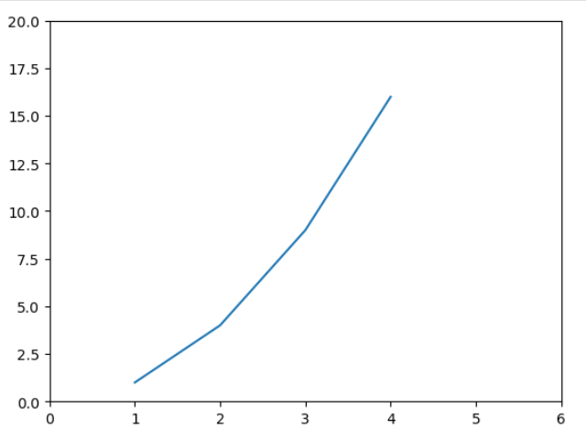
This code uses matplotlib.pyplot to plot a line graph with x and y values.
The axis limits are set to [0, 6] for the x-axis and [0, 20] for the y-axis using plt.axis(), and the graph is displayed with plt.show().

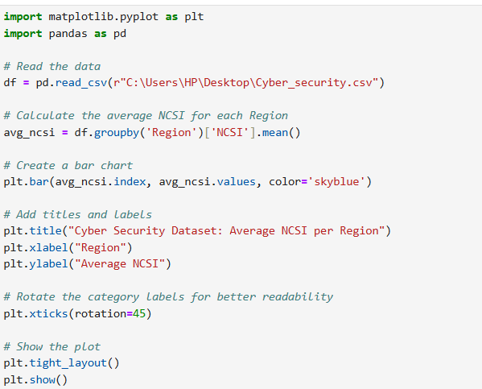
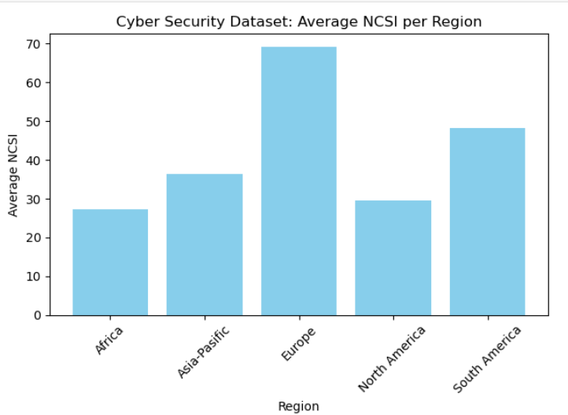
This code creates a bar chart to display the average NCSI (National Cyber Security Index) for each region in the dataset.
- It calculates the average NCSI for each region using groupby('Region')['NCSI'].mean().
- A bar chart is plotted with regions on the x-axis and their corresponding average NCSI values on the y-axis.
- Titles and axis labels are added, and the x-axis labels are rotated for better readability. Finally, the plot is displayed using plt.show()
.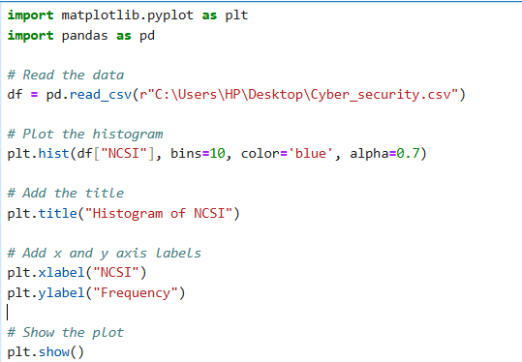
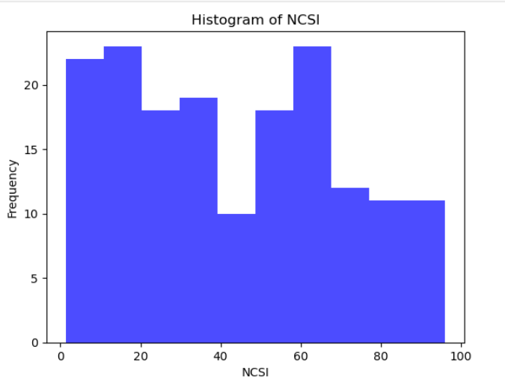
This code creates a histogram to visualize the distribution of the NCSI values in the dataset.
- The plt.hist() function is used with 10 bins to group the data, and the color is set to blue with transparency (alpha=0.7).
- Titles and axis labels are added for clarity, and the plot is displayed using plt.show().

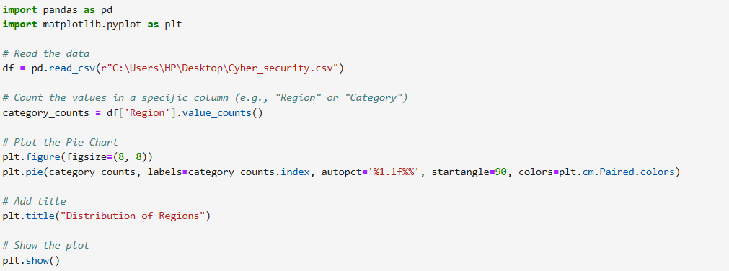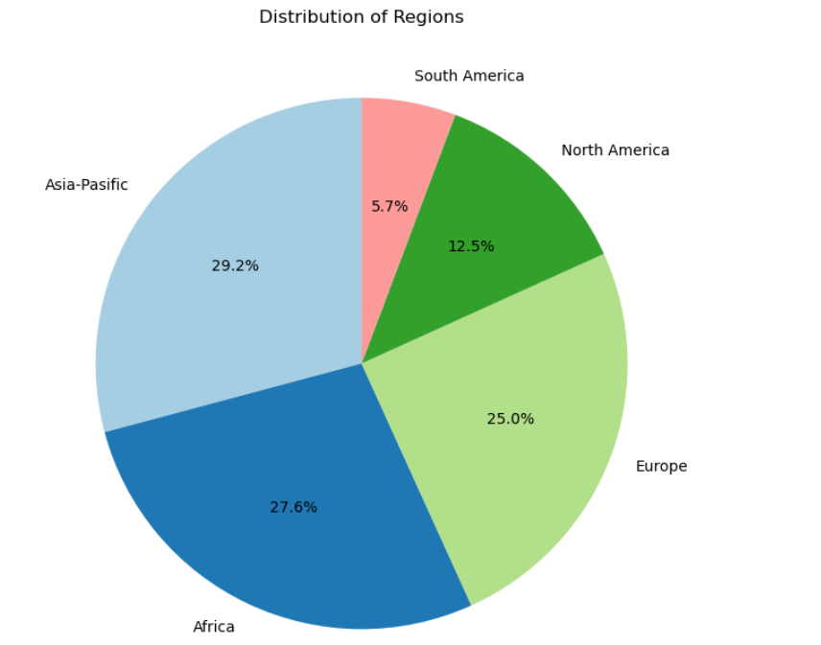
This code generates a pie chart to visualize the distribution of regions in the dataset.
- It first counts the occurrences of each region using value_counts() on the Region column, then uses plt.pie() to plot the distribution, showing percentages (autopct='%1.1f%%'), and colors are chosen from the Paired colormap.
- A title is added, and the plot is displayed using plt.show().

Conclusion
Throughout this analysis of Cyber Security data, we utilized various statistical and visual techniques to gain deeper insights into the dataset. We identified significant relationships between indices, examined the distribution of cybersecurity across regions, and handled outliers to ensure data accuracy. This effort helped us extract clear patterns that can be relied upon to make informed decisions aimed at enhancing cybersecurity standards globally.

