SmartCare v0.3 - Domain Model Workbook
Week 6 student resource

Requirement-to-Concept Trace
Requirement | Concept | State/behaviour | Decision
FR-01 Create patient record | Patient | Patientid,details/create record | Keep patients as a main class
Fr-02 & FR-03 Update and search patient | Patient | Update details/find by patientid | Add behaviors to patient
FR-04 Create practitioner record | Practitioner | practitionerId,details/create record | Keep practitioner as a main class
FR-5 & FR-06 Update practitioner and show availability | Practitioner | Details, availability/ update | Store availability in practitioner
FR-07 Create appointment | Appointment | appointmentId, date and time | Keep appointment as a main class
FR-08 check booking clash | Appointment & practitioner | Data, time, availability | Use existing classes, no new class
FR-09 update appointment and status | Appointment | Details, status | Store status in appointment
FR-10 cancel appointment | Appointment | Status/cancel | Cancellation is a behaviour not a class
FR-11 show appointment history | Patient & appointment | Linked appointments/ show history | Use a patient-appointment association
FR-12 produce basic reports | Appointment | Appointment info/ provide report data | No report class is needed at this stage

CRC Cards

Patient
Responsibilities | Collaborators
Store pateintID and details | Appointment
Provide patient details for appointments and history | Appointment

Practitioner
Responsibilities | Collaborators
Store practitioner ID and details | Appointment
Practitioner availability information | Appointment

Appointment
Responsibilities | Collaborators
Store appointment date, time and status | Patient and Practitioner
Linked a patient and practitioner and allow status to be updated | Patient and Practitioner

Optional class
Responsibilities | Collaborators
Could store clinic details | Patient, practitioner and appointment

UML Class Diagram
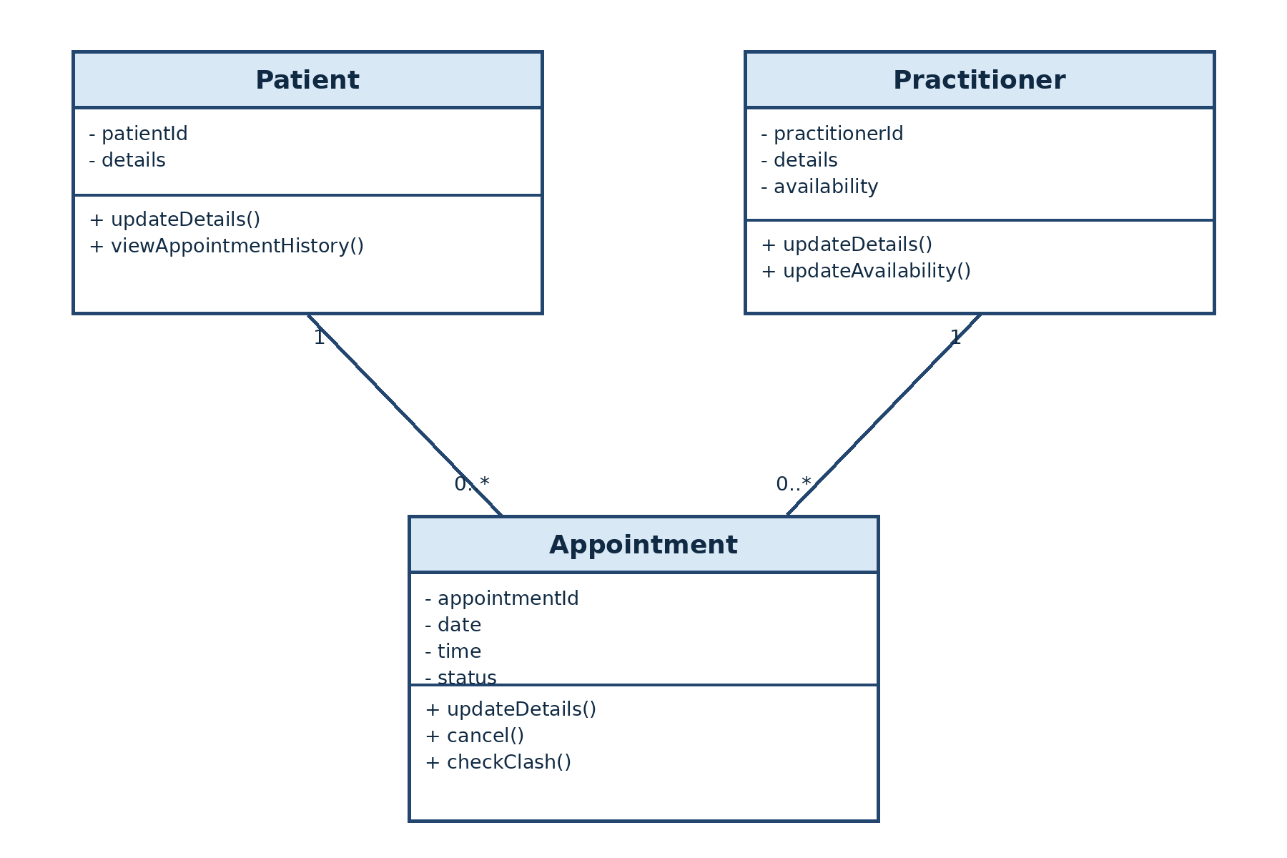
Insert/draw UML here. Include defensible relationships and multiplicities.

Design Rationale
Explain class selection, responsibility allocation and key relationships.
I selected Patient, Practitioner and Appointment as the main classes because they are directly supported by the SmartCare requirements. Patient stores the patient ID and details. Practitioners store the practitioner ID, details and availability. Appointment stores the appointment ID, date, time and status. It also connects one patient with one practitioner.
The responsibilities were given to the class that owns the related information. For example, updating practitioner availability belongs to Practitioner, while cancelling an appointment belongs to Appointment. Cancellation and Status are not separate classes because cancellation is an action and status is information inside Appointment. Name is also information inside Patient or Practitioner.
A patient can have zero or many appointments, but each appointment has one patient. A practitioner can also have zero or many appointments, but each appointment has one practitioner. These are associations, not inheritance, because Appointment is not a type of Patient or Practitioner. Clinic was considered as an optional class, but it was not added because the case study only describes one clinic and does not require clinic details to be managed.

AI Design Review Record
AI suggestion | Evidence | Decision | Reason | Model change
Add PatientManager and PractitionerManager | Not supported | Rejected | They are design classes and are not needed in model | No classes added.
Add AppointmentManager | Not supported | Rejected | Appointment can hold the required appointment responsibilities. | Kept Appointment only.
Add ClinicController | Not supported | Rejected | not a business concept in the case study. | No class added.
Add NotificationManager | No evidence | Rejected | Reminders are not included in the requirements. | No class added.
Add ScheduleEngine | Partly supported | Modified | Not required | Kept these responsibilities in Practitioner and Appointment.

