Assignment 2- Case Study

Stage 3 Lab Activities

SmartCare Domain Modelling
AI OFF -> AI ON -> COMPARE -> VERIFY | 1 hour

A - Requirements Review
Highlight nouns, verbs and business rules in SmartCare v0.2.
Nouns: Patient, Practitioner, Appointment, clinic staff, availability, status, appointment history and reports.
Verbs: create, update, search, show, check, cancel, display and produce.
Business rules:
Each patient, practitioner and appointment must have a unique ID. (NFR-01)
An appointment must be linked to an existing patient and practitioner. (FR-07 and NFR-01)
Before saving, the system must check if the practitioner is already booked at the same date and time. (FR-08)
When an appointment is cancelled, its status changes to Cancelled. (US-05 acceptance criteria)

B - Candidate Classes
Record candidate concepts, supporting requirements, state and behaviour.
Requirement | Concept | State/behaviour | Decision
FR-01 Create patient record | Patient | Patientid,details/create record | Keep patients as a main class
Fr-02 & FR-03 Update and search patient | Patient | Update details/find by patientid | Add behaviors to patient
FR-04 Create practitioner record | Practitioner | practitionerId,details/create record | Keep practitioner as a main class
FR-5 & FR-06 Update practitioner and show availability | Practitioner | Details, availability/ update | Store availability in practitioner
FR-07 Create appointment | Appointment | appointmentId, date and time | Keep appointment as a main class
FR-08 check booking clash | Appointment & practitioner | Data, time, availability | Use existing classes, no new class
FR-09 update appointment and status | Appointment | Details, status | Store status in appointment
FR-10 cancel appointment | Appointment | Status/cancel | Cancellation is a behaviour not a class
FR-11 show appointment history | Patient & appointment | Linked appointments/ show history | Use a patient-appointment association
FR-12 produce basic reports | Appointment | Appointment info/ provide report data | No report class is needed at this stage

C - CRC Cards
Create CRC cards for Patient, Practitioner and Appointment.

Patient
Responsibilities | Collaborators
Store pateintID and details | Appointment
Provide patient details for appointments and history | Appointment

Practitioner
Responsibilities | Collaborators
Store practitioner ID and details | Appointment
Practitioner availability information | Appointment

Appointment
Responsibilities | Collaborators
Store appointment date, time and status | Patient and Practitioner
Linked a patient and practitioner and allow status to be updated | Patient and Practitioner

D - UML Model
Draw classes, attributes, operations, associations and multiplicities.
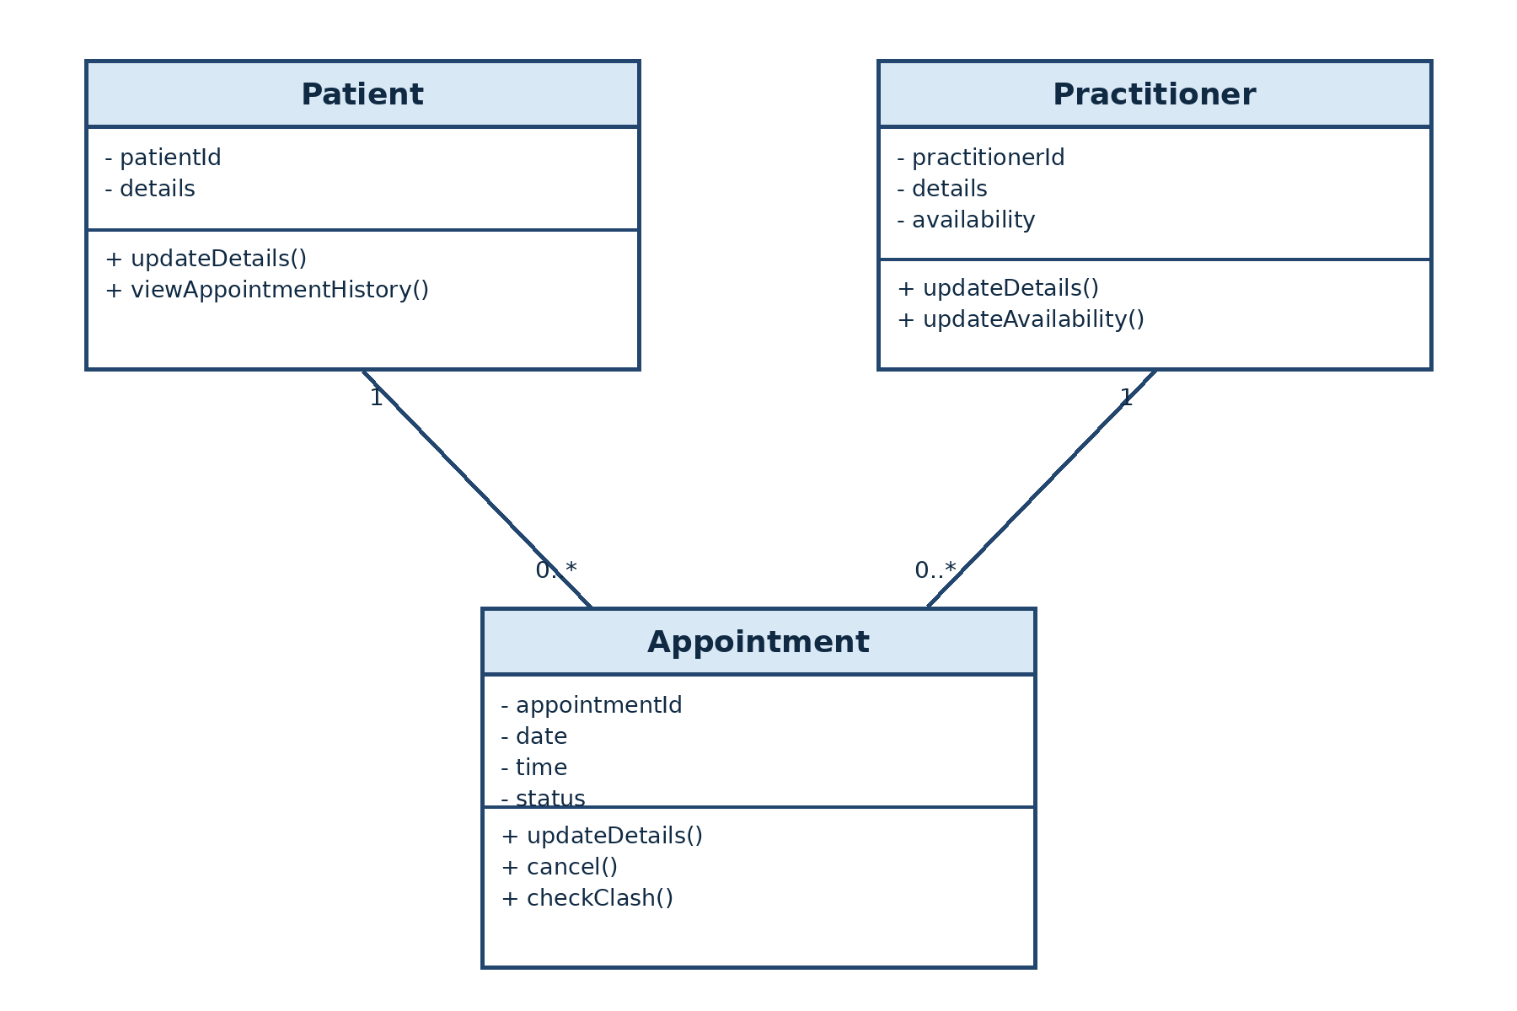

E - AI Design Review
Ask AI to suggest classes and relationships using only confirmed requirements; require supporting requirement IDs.
AI suggestions based on the confirmed requirements:
1. Use Patient, Practitioner and Appointment as the main classes. (FR-01 to FR-11 and NFR-03)
2. Link one Patient to zero or many Appointments. Each Appointment has one Patient. (FR-07 and FR-11)
3. Link one Practitioner to zero or many Appointments. Each Appointment has one Practitioner. (FR-07 and FR-08)
4. Add a ScheduleEngine for availability and clash checking. (FR-06 and FR-08)
5. Add a NotificationManager. No supporting requirement ID was found.

F - Compare and Decide
Record at least one accepted, modified and rejected AI suggestion.
AI suggestion | Decision | Reason
Use Patient, Practitioner and Appointment as the main classes. | Accepted | These classes are directly supported by FR-01 to FR-11.
Add a ScheduleEngine. | Modified | Availability and clash checking are needed, but Practitioner and Appointment can do this for now.
Add a NotificationManager. | Rejected | Notifications are not included in the SmartCare requirements.

G - Python Skeletons
Create simple Patient, Practitioner and Appointment class skeletons.
Check source code folder -> Skeleton.py

H - Consistency Check
Check model-code consistency; do not implement full behaviour yet.
The Python skeletons match the UML class names, attributes and operations. Appointment stores references to Patient and Practitioner, so the code also matches the two associations. The methods use pass because full behaviour is not required yet.

Reflection
What modelling decision was hardest? Where did AI over-design? What evidence supported your final choices?
The hardest decision was whether to add Clinic or ScheduleEngine as classes. I did not add Clinic because the case study describes one clinic and does not say that clinic details need to be managed. I also kept availability and clash checking inside Practitioner and Appointment instead of adding ScheduleEngine. The AI over-designed the model when it suggested manager, controller and notification classes. Patient, Practitioner and Appointment were kept because they are directly supported by FR-01 to FR-11. Their unique IDs and links are also supported by NFR-01.

