1 – Install Nginx

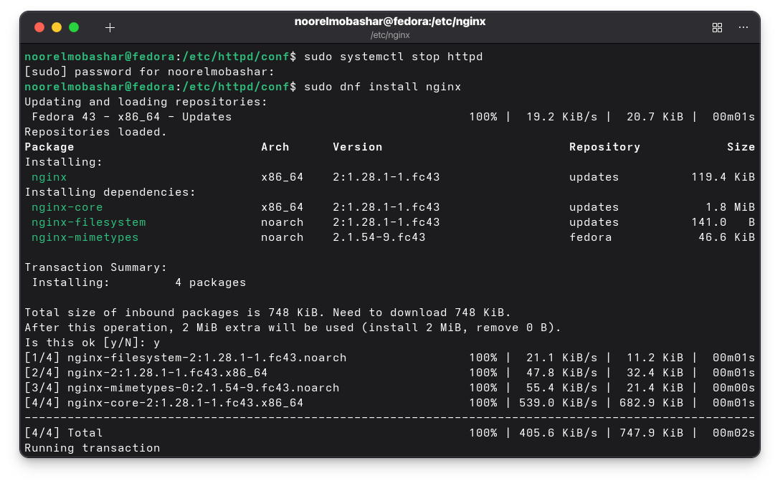
2 – change the default file (index.html) to (yourName.html)

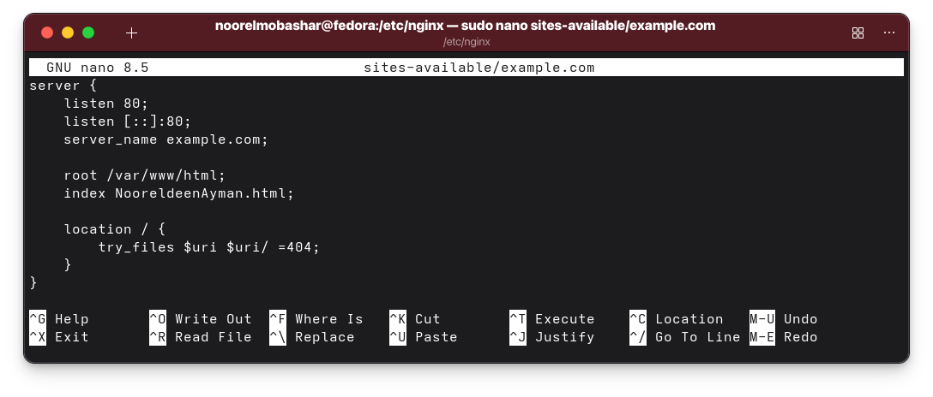

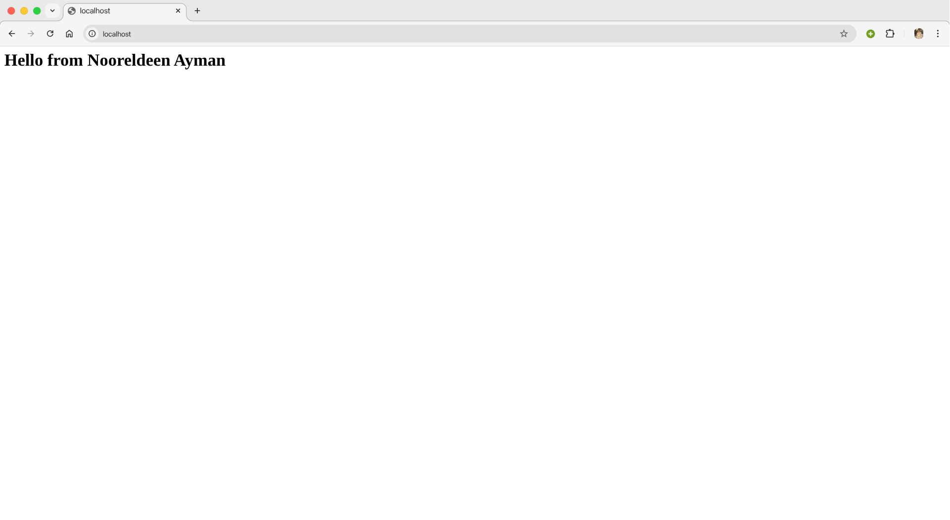

3 – Make two html files, and change the configuration file to access the first file on port 81, and access the second file on port 82.

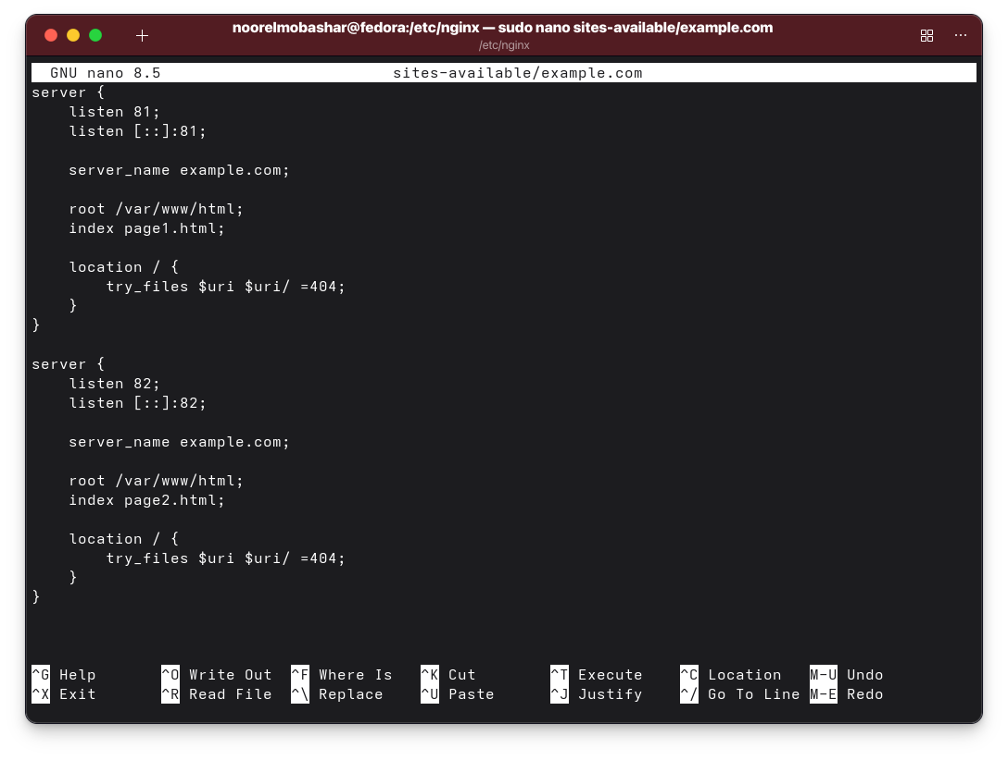
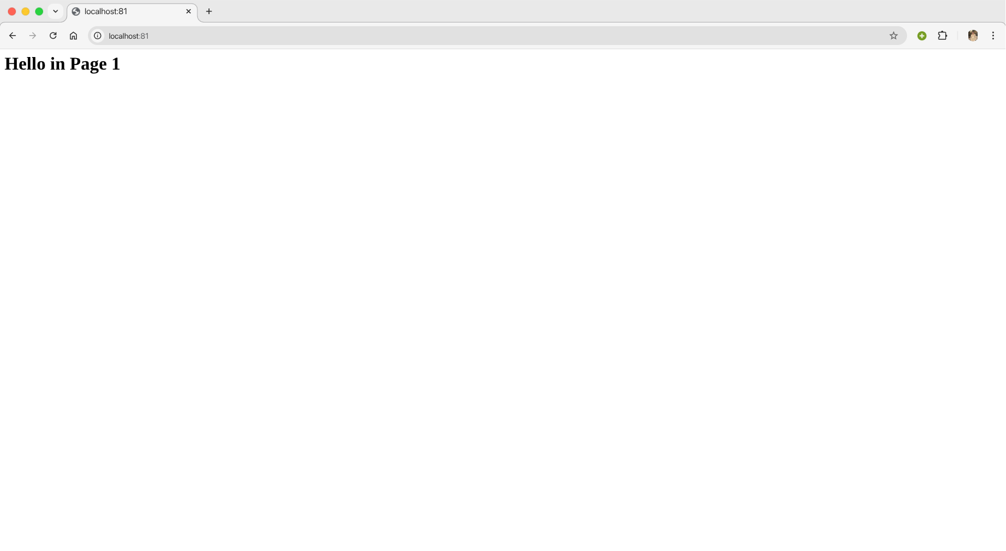
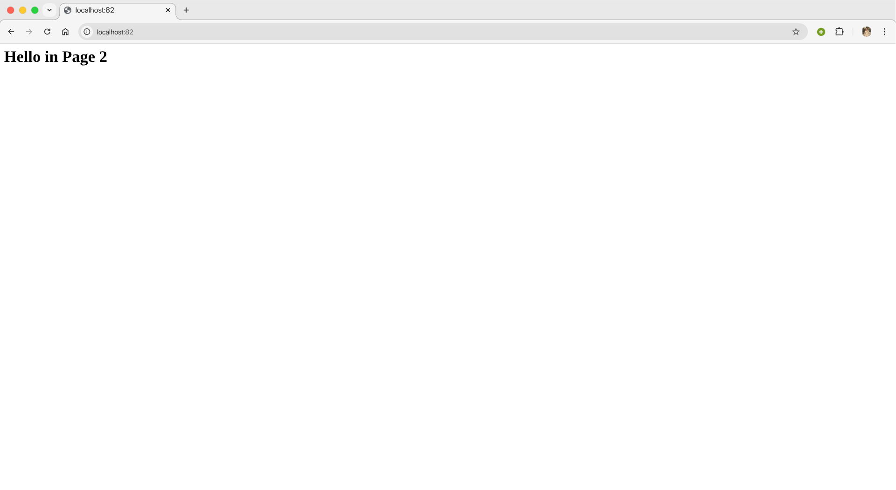

A problem happened while assigning port 82.

SELinux in Fedora blocks nginx from opening them.

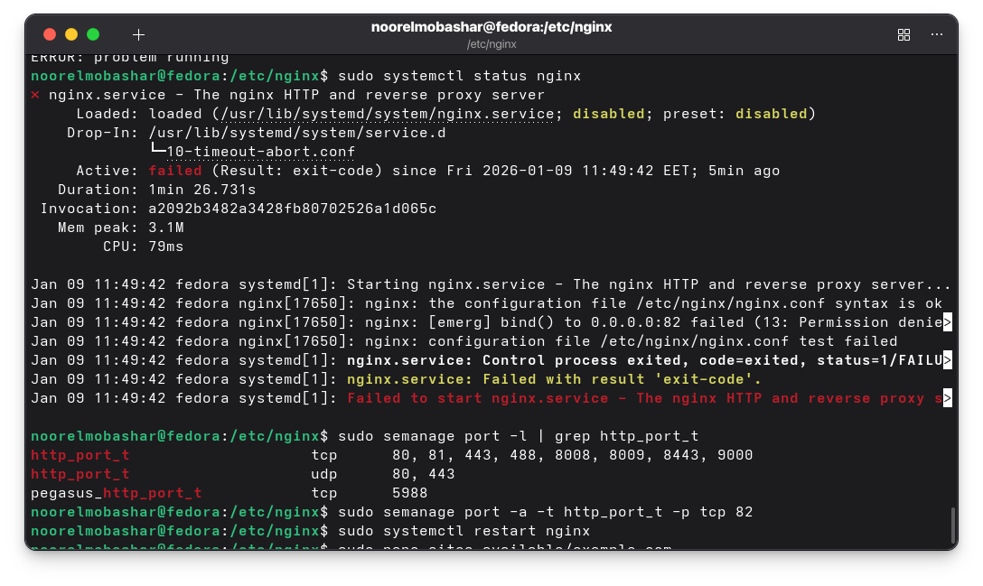
Used sudo semanage port -a -t http_port_t -p tcp 82 to give nginx access to this port.

4 – The main differences between Apache and Nginx

Nginx is built on an event-driven, asynchronous model that allows a single process to handle thousands of concurrent connections with minimal RAM.

Apache uses a process-driven architecture where each connection typically spawns a new thread, it leads to higher memory consumption under heavy traffic.

Apache allows for decentralized configuration through .htaccess file.

Nginx requires a centralized configuration, offering better performance and security.

