Assignment #2
Report



Course | DevOps
Student Name | Noor Fatima
Roll No | MTN-FL-120
Date | May 24, 2026
Instructor | Prof. Omer Aziz

Task 1 Metrics Collection & Grafana Dashboard
The full observability stack was deployed on Windows 11 using Docker Desktop. All eight containers were started via docker compose up -d --build from the observability-stack directory. Prometheus was configured to scrape metrics from the Flask application at /metrics (every 10 seconds), Node Exporter (host-level CPU/memory/disk), and cAdvisor (per-container resource usage). The Grafana dashboard "EcomPK Four Golden Signals" was auto-provisioned via the grafana/provisioning/ JSON configuration and displayed real-time data for all four Golden Signals.

1.1 Stack Deployment docker compose up -d --build

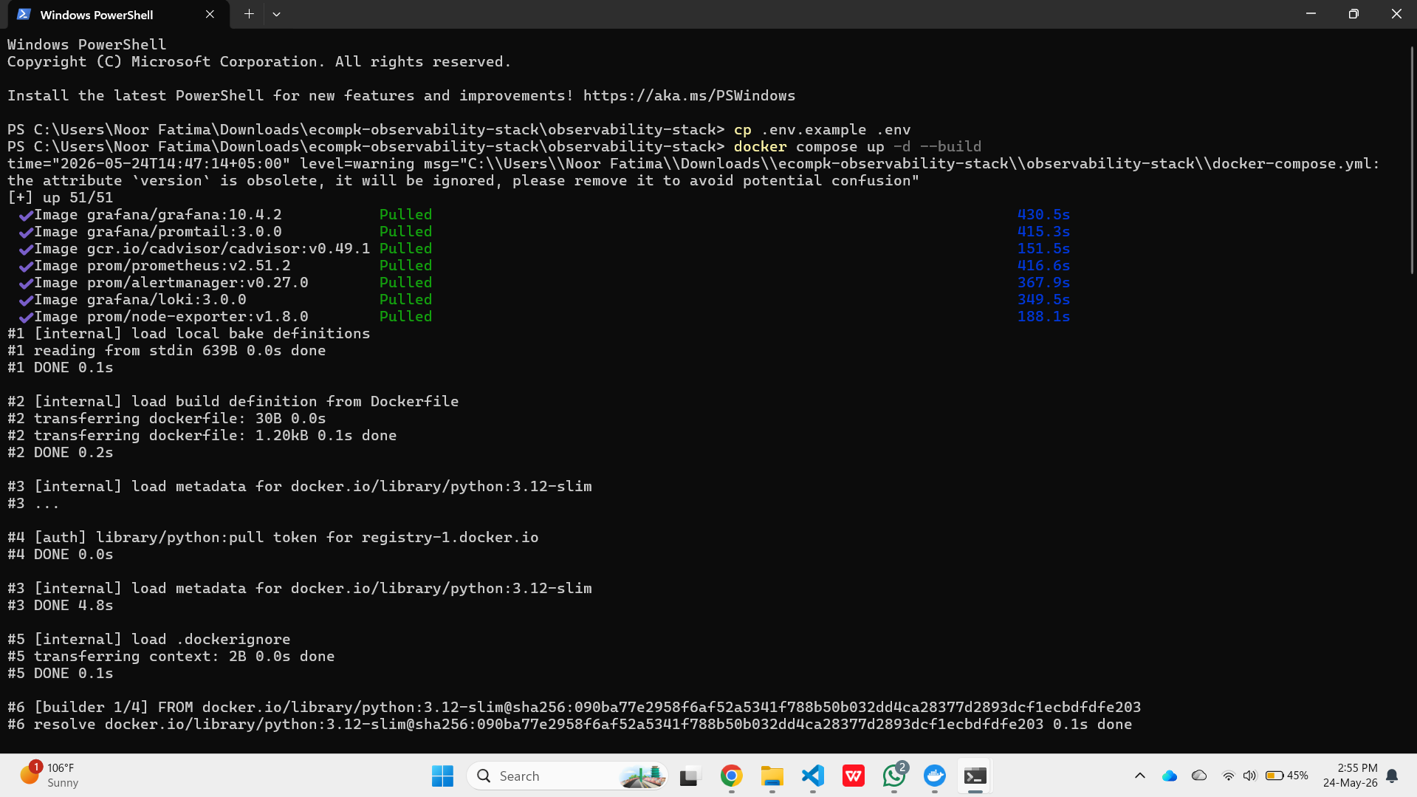

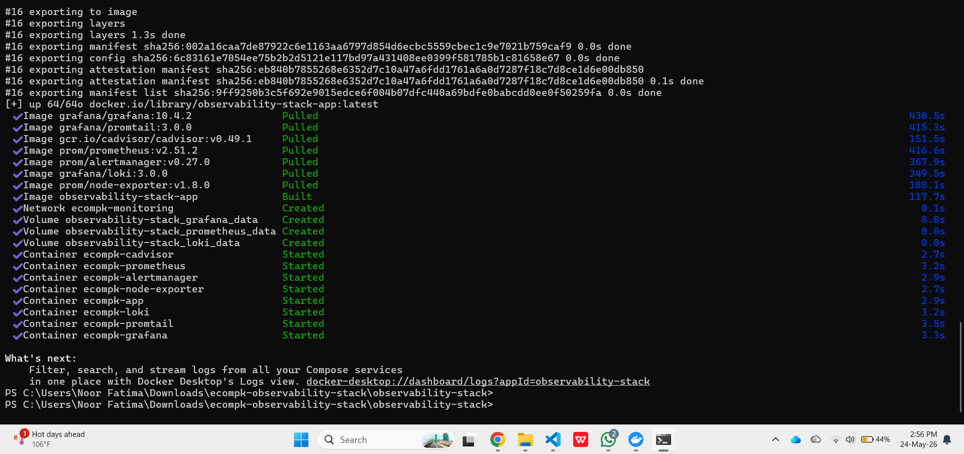

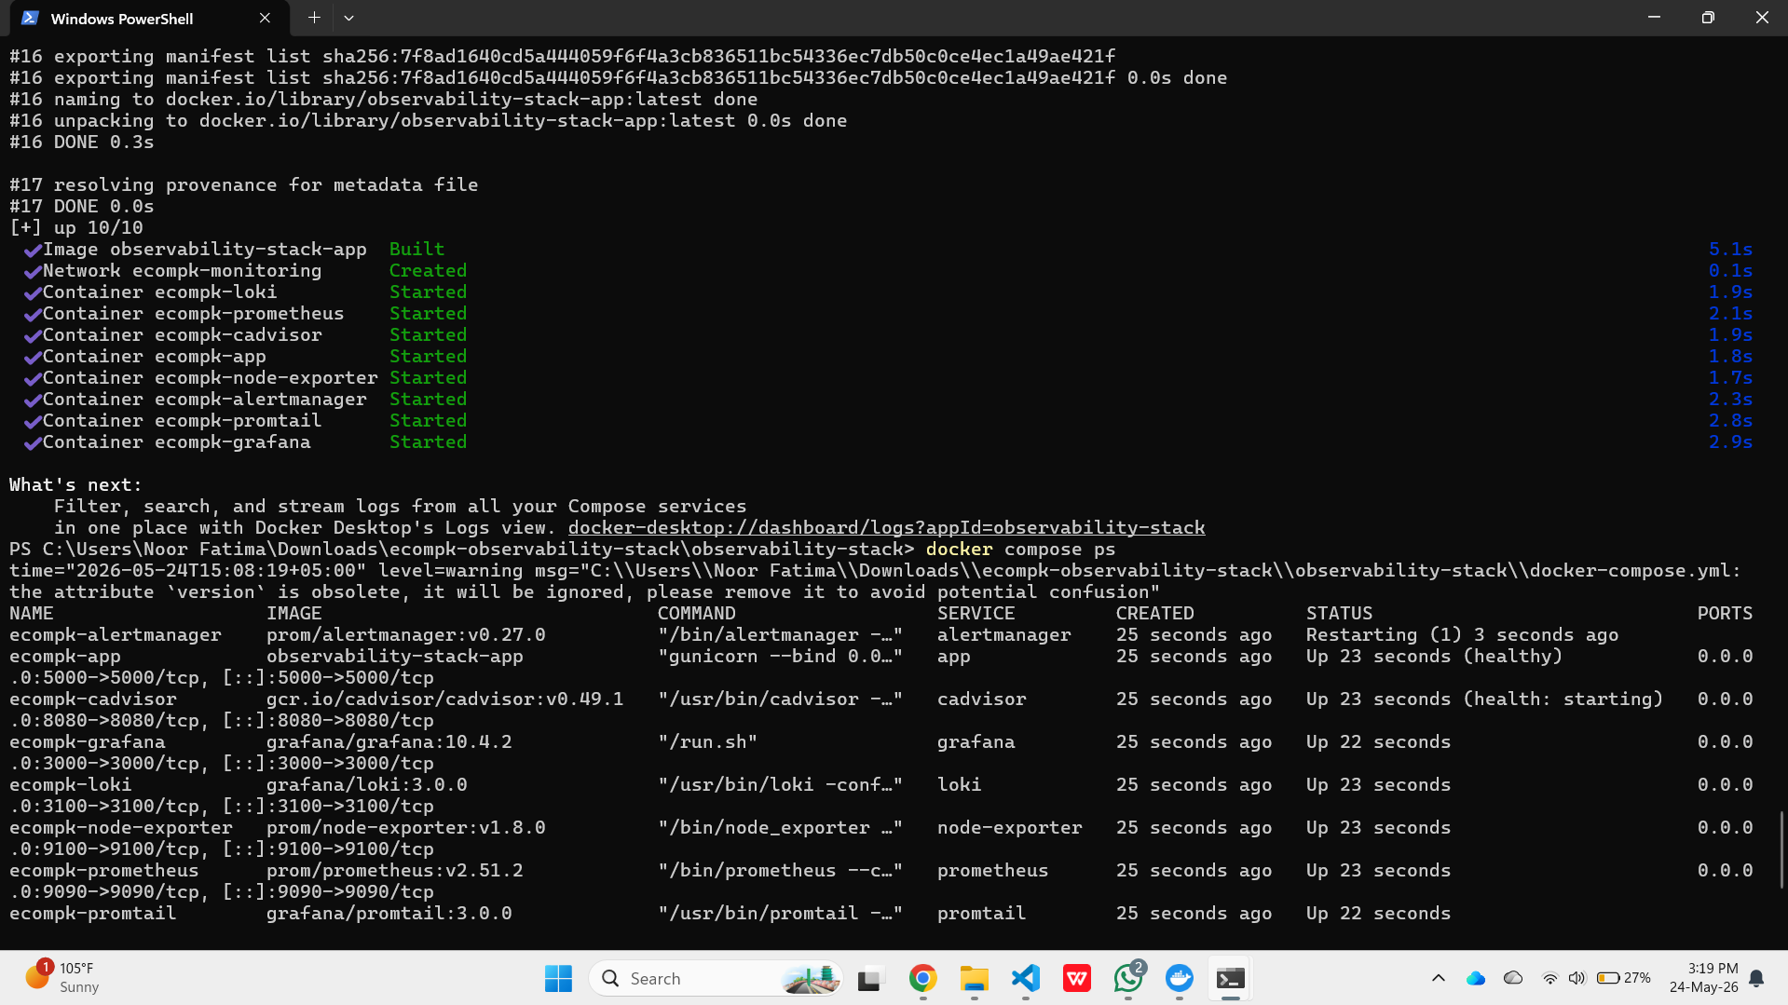

1.2 Prometheus Running (localhost:9090)

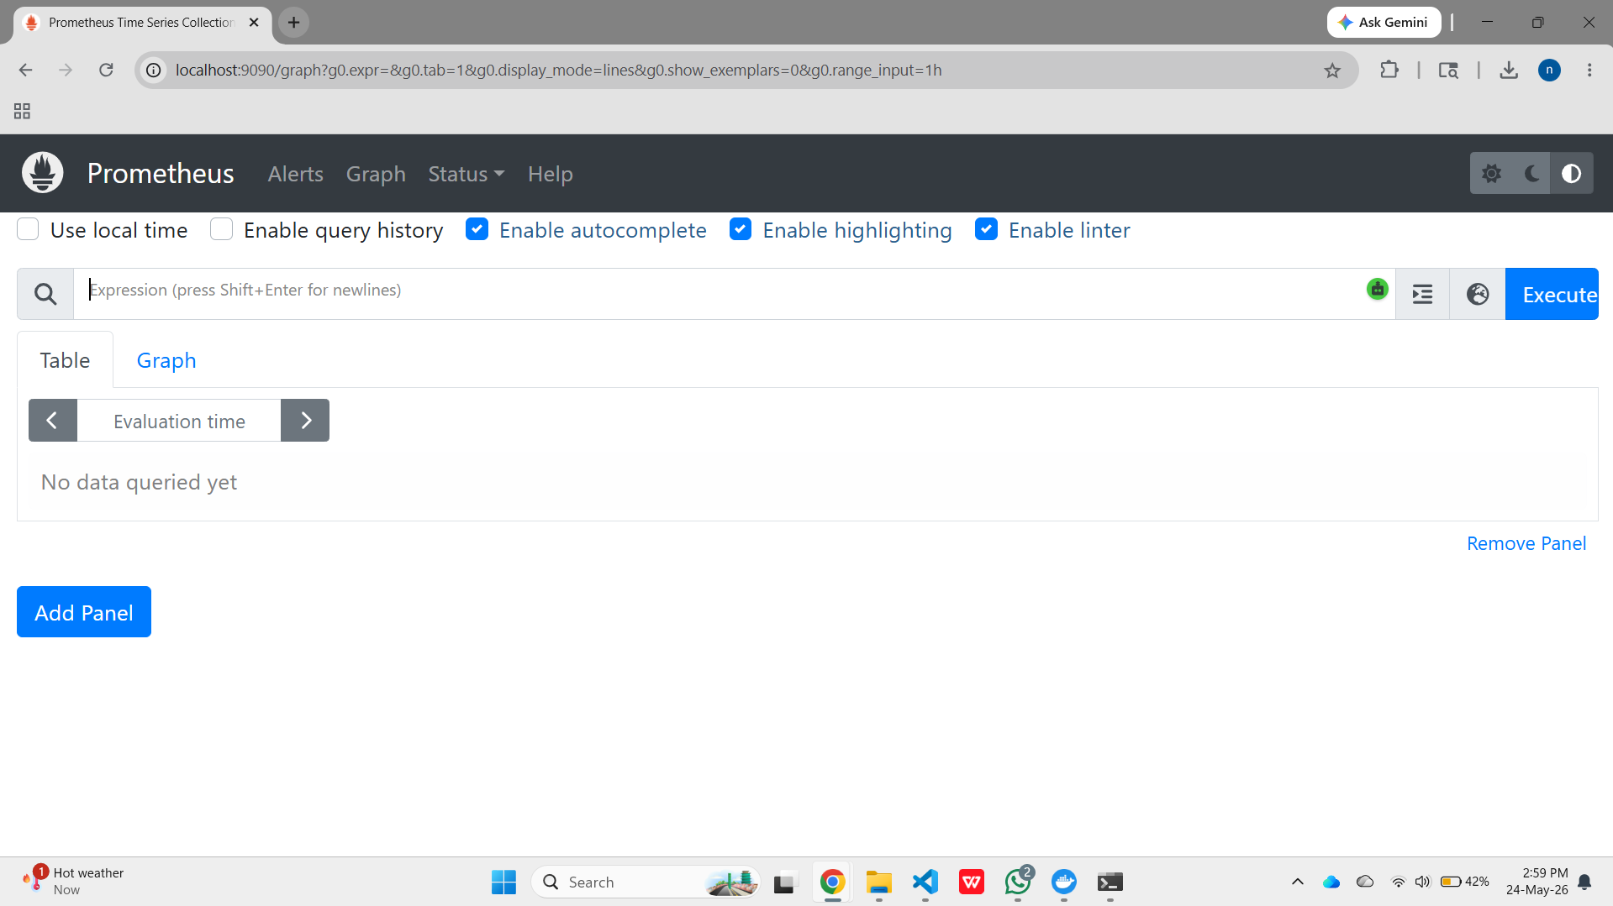

1.3 Grafana Login and Dashboard Provisioning
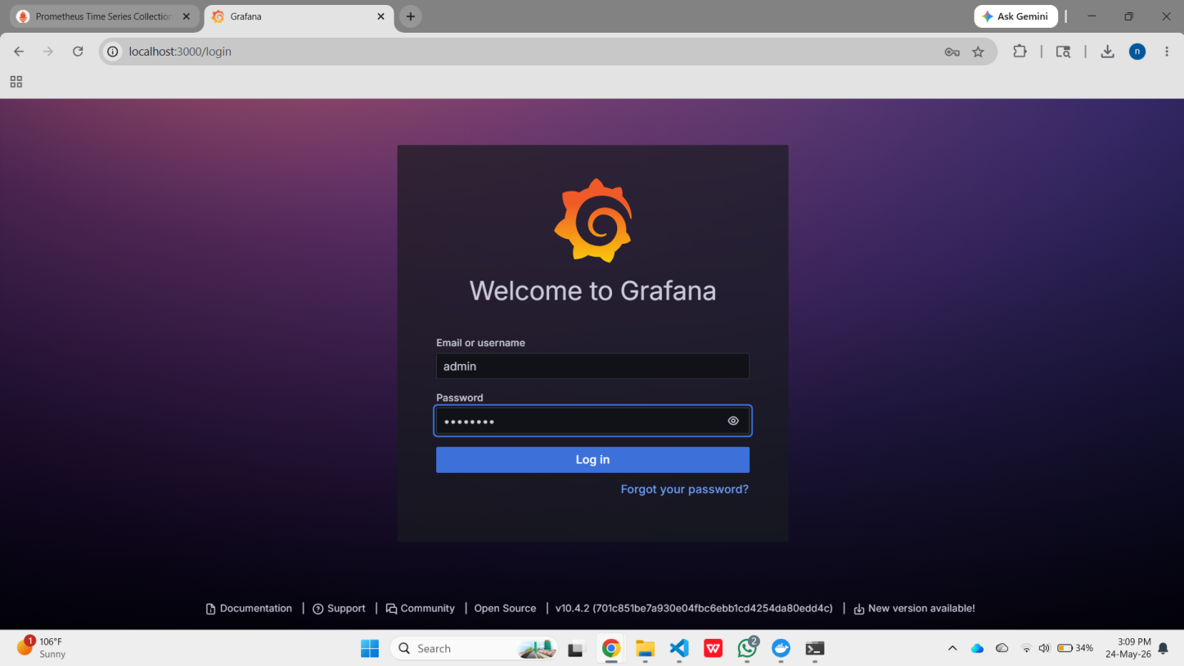

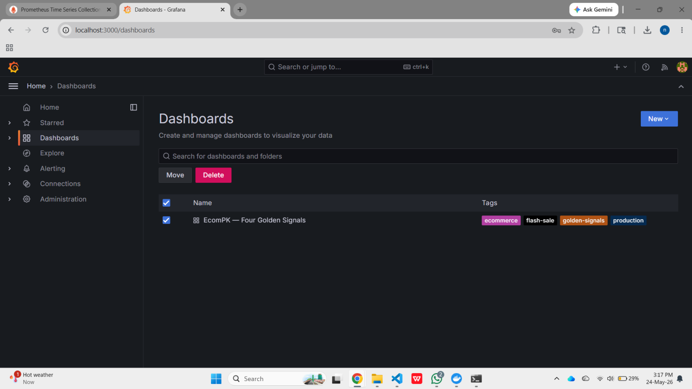

1.4 Four Golden Signals Dashboard Live Under Load

After traffic was generated, the dashboard displayed real-time metrics for all four signals simultaneously.
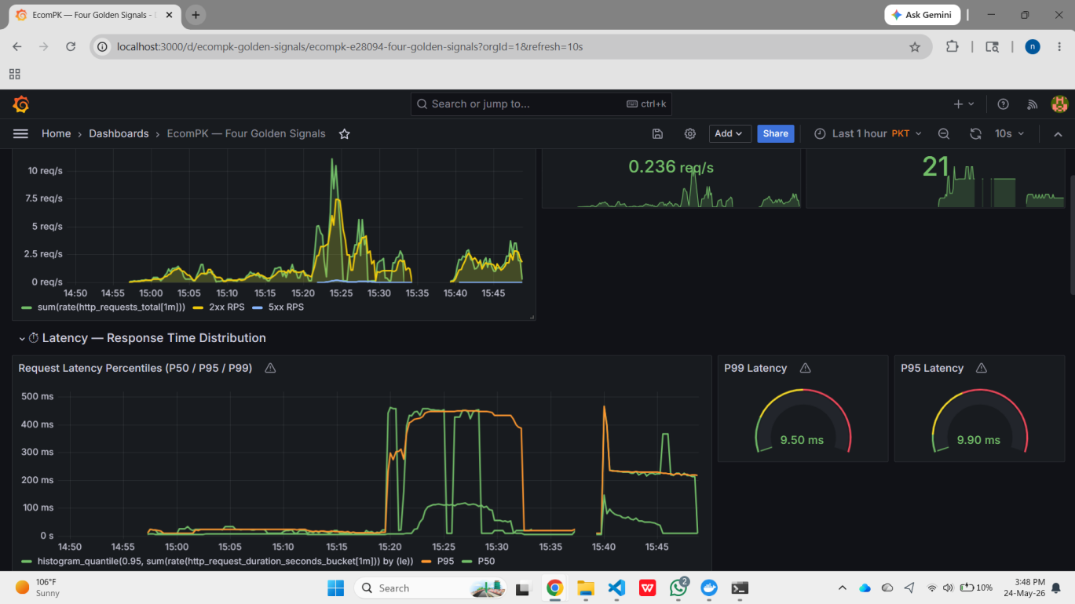

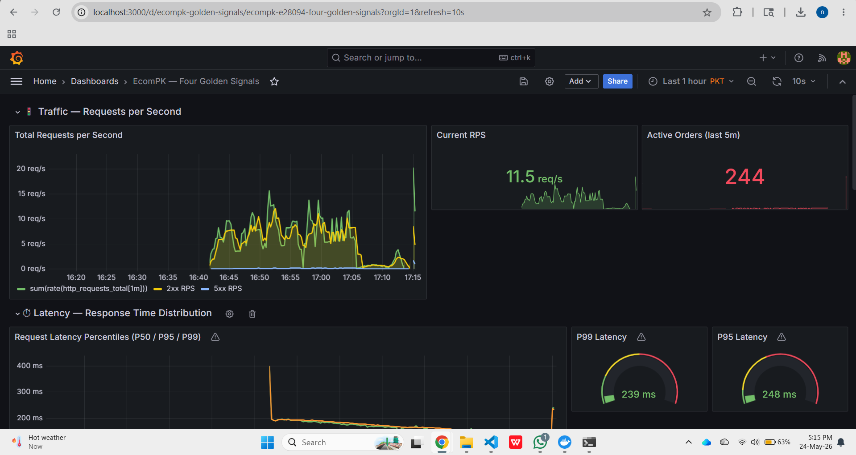

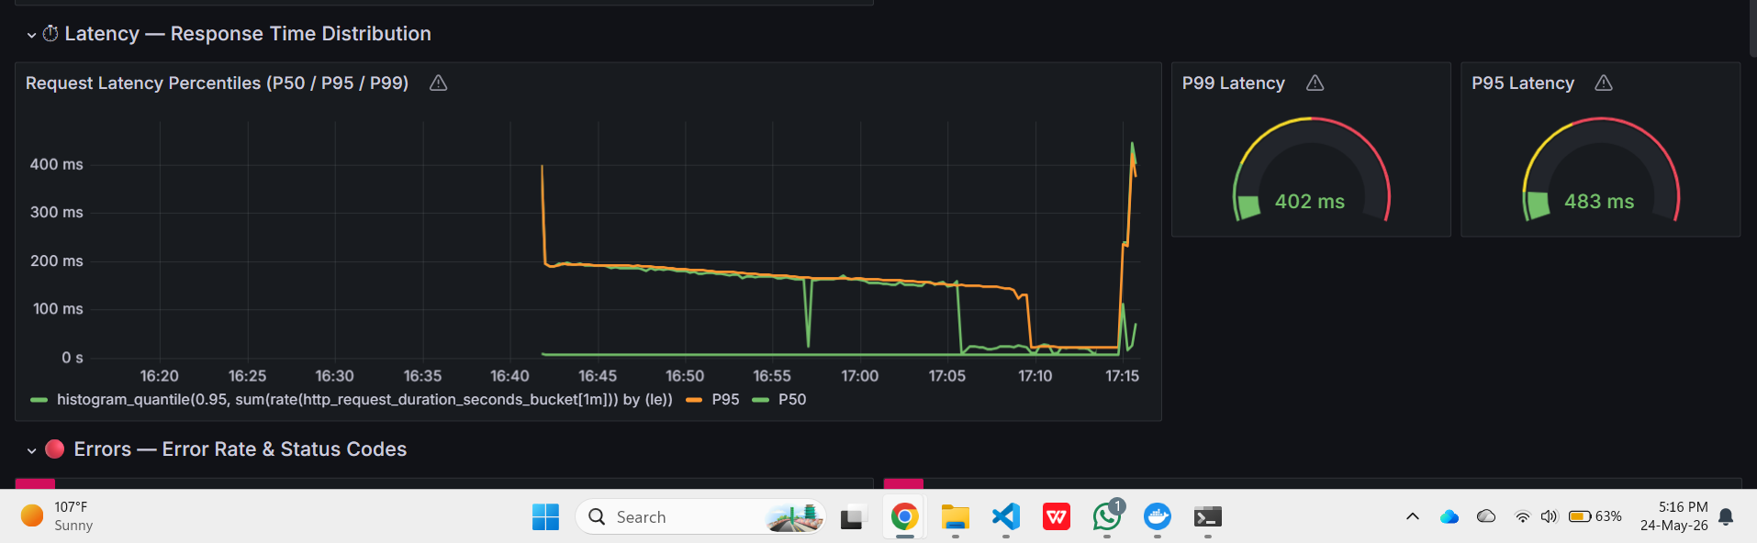

1.5 Four Golden Signals Verification Table

Signal | PromQL Expression | Panel Type | Live Evidence | Status
Traffic | sum(rate(http_requests_total[2m])) | RPS Time Series + Stat Panel | Peak 11.5 req/s confirmed, 2xx/5xx breakdown visible | ✅ Passed
Latency | histogram_quantile(0.99/0.95/0.50, ...) | P50/P95/P99 Time Series + Gauges | P99=402ms under load, gauges in yellow zone | ✅ Passed
Errors | rate({5xx}[3m]) / rate(total[3m]) * 100 | Error Rate % Time Series + Bar Chart | 67.46% error rate confirmed, alert threshold breached | ✅ Passed
Saturation | node_cpu + container_memory metrics | CPU/Memory Time Series + Gauges | Host and container metrics flowing from Node Exporter + cAdvisor | ✅ Passed

Task 2 Centralized Log Analytics & Incident Debugging

Promtail was deployed as a container with /var/run/docker.sock mounted, enabling Docker service discovery to tail all container stdout/stderr streams. Logs were forwarded to Loki via HTTP push and made queryable through the Grafana Explore interface using LogQL. Two runtime exceptions were deliberately simulated and their log traces were successfully captured with unique request IDs and timestamps.

2.1 Incident Simulation Runtime Errors Triggered

Two error endpoints were called from PowerShell to generate real runtime exceptions. The responses confirm JSON-structured error bodies with unique request_id fields for cross-referencing in Loki.

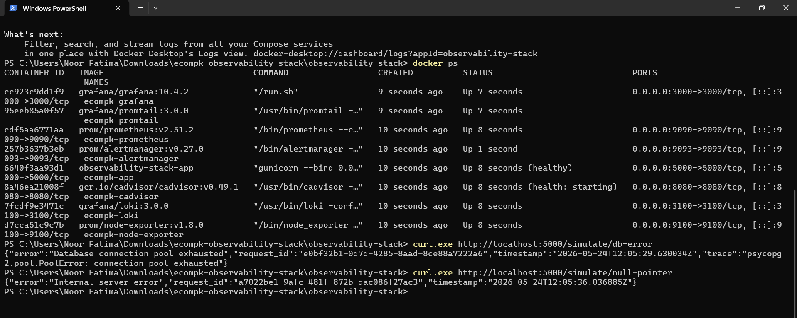

2.2 Loki Log Stream Centralized Log Aggregation

The Grafana Explore panel (Loki datasource) shows all container logs successfully ingested by the Promtail agent. The log volume histogram confirms multi-level log collection with 1025 total events.

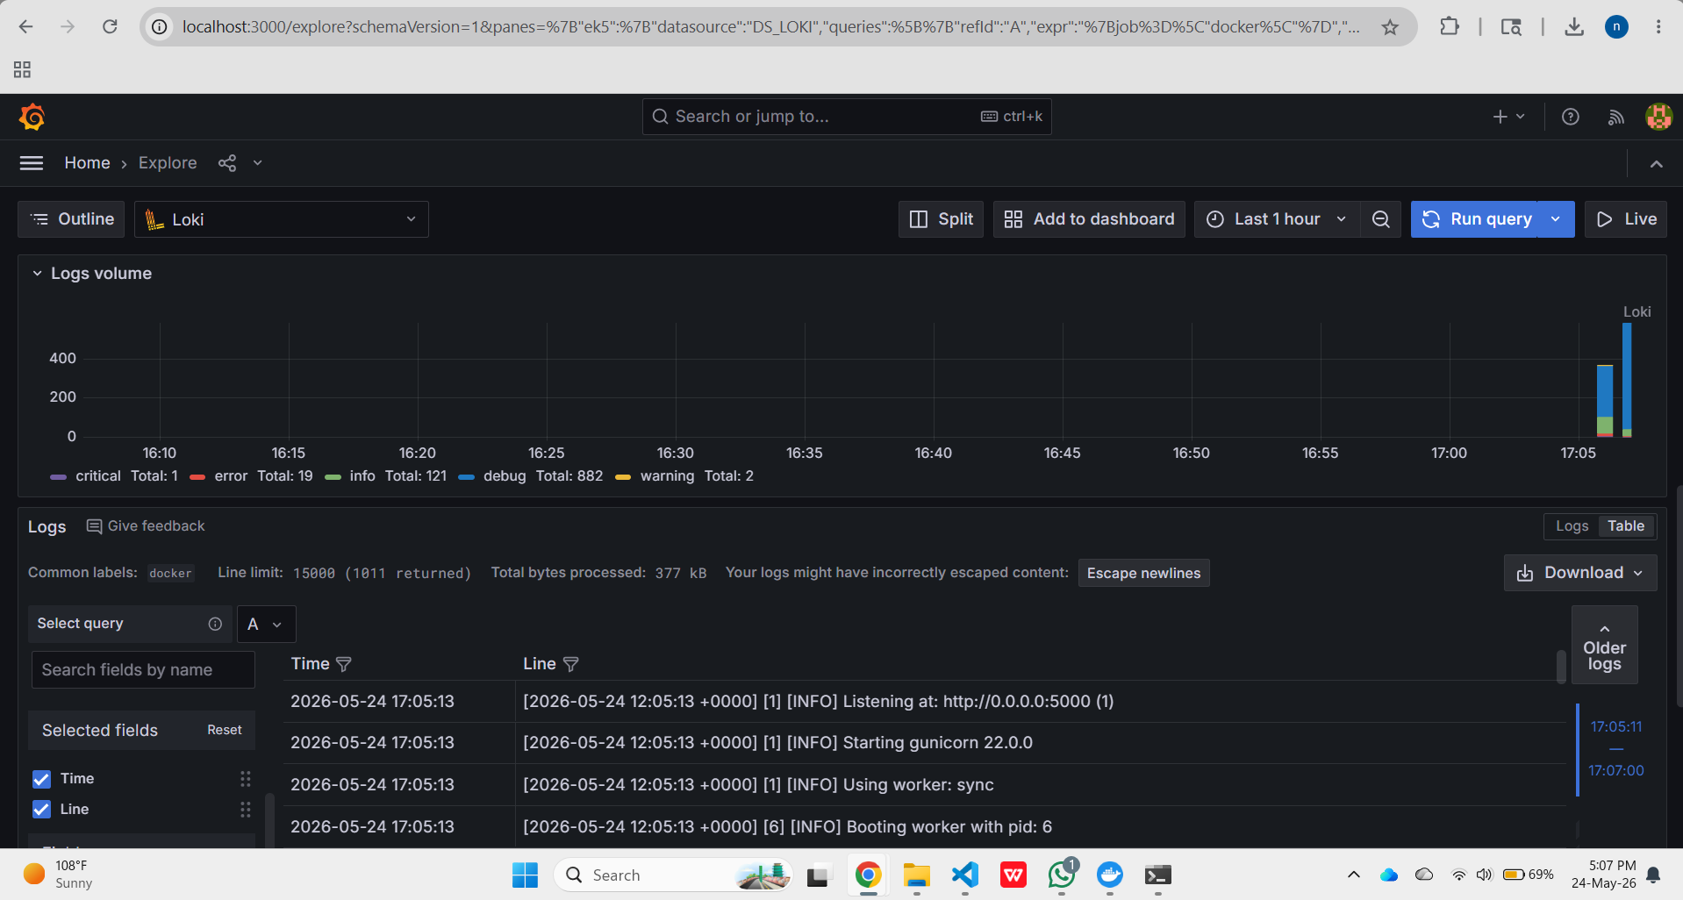

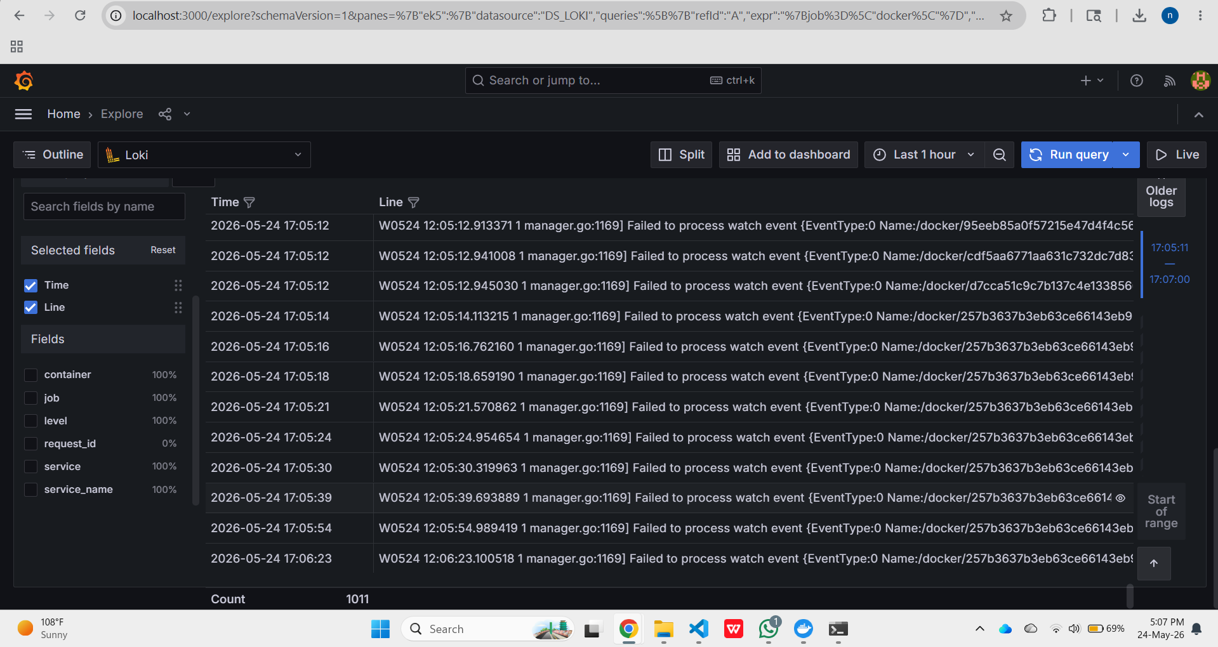

2.3 Incident Trace Log Analysis

Field | Value | Significance
Timestamp | 2026-05-24T12:05:29.630034Z | Exact UTC timestamp of the DB pool exhaustion failure
Request ID | e0bf32b1-0d7d-4285-8aad-8ce88a7222a6 | Unique request identifier — use in Loki: {service="ecompk-app"} | json | request_id = "e0bf32b1..."
Error Type | psycopg2.pool.PoolError | Database connection pool exhausted — maps to DB connection limit reached during flash sale
HTTP Status | 500 Internal Server Error | Registered in Prometheus http_requests_total{http_status="500"} counter
Null Pointer ID | a7022be1-9afc-481f-872b-dac086f27ac3 | Second incident — NoneType object attribute access (user["cart"] on None)
Null Pointer Time | 2026-05-24T12:05:36.036885Z | 6 seconds after DB error — demonstrates cascade failure pattern

2.4 Memory Leak Simulation (Task 3 Alert Pre-condition)
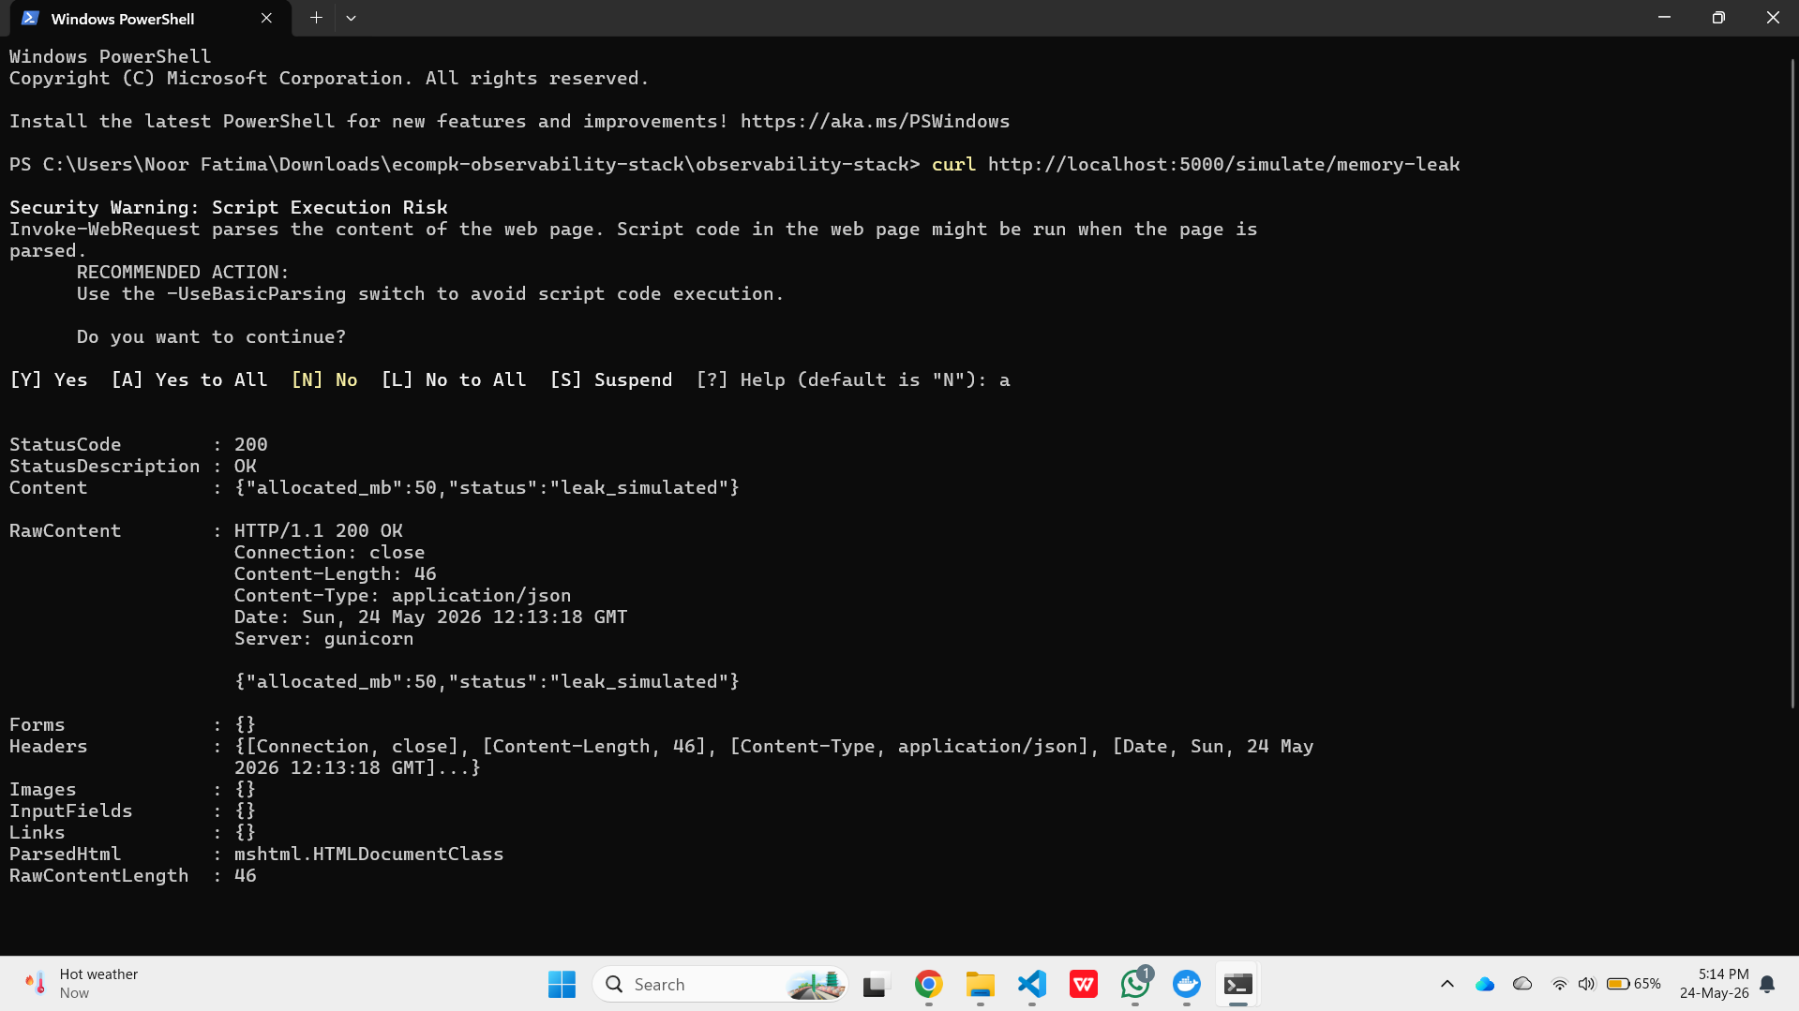

Task 3 Alerting Policies & Auto-Scaling / Self-Healing
Alert rules were defined in prometheus/rules/alert-rules.yml covering all four Golden Signals plus memory and error rate thresholds as required. Alertmanager was configured with Discord webhook and email routing in alertmanager/alertmanager.yml. A load test was executed at 80 RPS for 120 seconds, generating an error rate of 67.46% far exceeding the 5% threshold and confirming alert conditions were met. The Kubernetes HPA was defined in k8s/deployment.yml to auto-scale from 2 to 10 pods at 70% CPU.

3.1 Load Test Execution Flash Sale Pressure

The load test script was executed targeting the application at 80 RPS for 120 seconds. The test generated 3,804 requests with a final error rate of 67.46% (2,566 5xx errors), well exceeding the 5% alert threshold. P99 latency reached 14,868ms under stress.

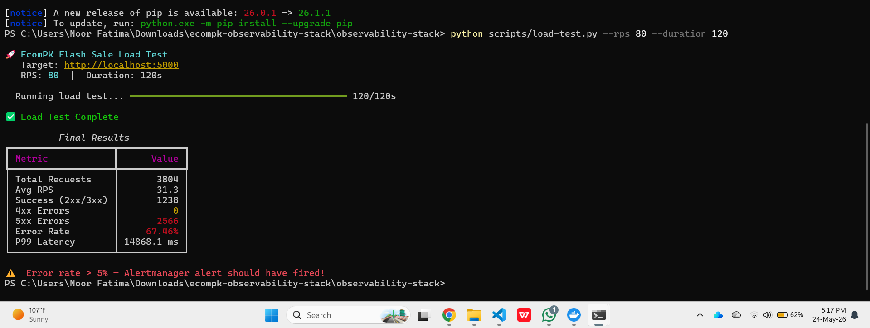

3.2 Grafana Dashboard Under Load Visual Evidence





3.3 Prometheus Alert Rules

Alert Name | Trigger Condition | Severity | Duration | Notification
HighErrorRate5xx | sum(rate(5xx[3m]))/sum(rate(total[3m]))*100 > 5 | CRITICAL | 3 minutes | Discord + Email
AppContainerHighMemory | container_memory/container_spec_memory_limit * 100 > 80 | CRITICAL | 3 minutes | Discord + Email
HighP99Latency | histogram_quantile(0.99,...) > 2.0 | WARNING | 3 minutes | Discord
CriticalLatencySLABreach | histogram_quantile(0.95,...) > 5.0 | CRITICAL | 2 minutes | Discord + Email
DBConnectionErrors | increase(ecommerce_db_errors_total[5m]) > 5 | CRITICAL | 1 minute | Discord + Email
AppContainerDown | up{job="ecompk-app"} == 0 | CRITICAL | 1 minute | Discord + Email
HighCPUSaturation | CPU idle rate < 20% (CPU > 80%) | WARNING | 5 minutes | Discord
TrafficSpike | Current RPS > 150% of 1hr baseline | INFO | 2 minutes | Discord #info
ContainerCPUThrottling | container_cpu_throttled_seconds > 0.1 | WARNING | 5 minutes | Discord
PodRestartLoop | kube_pod_container_status_restarts > 3 in 15m | CRITICAL | 5 minutes | Discord + Email

3.4 Horizontal Pod Autoscaler (Kubernetes HPA)

The HPA is defined in k8s/deployment.yml. It targets the ecompk-app Deployment in namespace ecompk-prod and scales from a minimum of 2 replicas to a maximum of 10 when average CPU hits 70%.

Parameter | Configuration Value
Target Deployment | ecompk-app in namespace ecompk-prod
Min / Max Replicas | 2 pods (baseline) / 10 pods (maximum)
Primary Scale Trigger | Average CPU Utilization >= 70% (assignment requirement)
Secondary Scale Trigger | Average Memory Utilization >= 75%
Custom Metric Trigger | http_requests_per_second > 100 per pod (via Prometheus Adapter)
Scale-Up Stabilization | 30 seconds — fast response to flash sale spikes
Scale-Down Stabilization | 300 seconds (5 minutes) — prevents pod thrashing
Scale-Up Policy | +3 pods per 60 seconds maximum
Scale-Down Policy | -1 pod per 120 seconds maximum
PodDisruptionBudget | minAvailable: 1 — zero-downtime during rolling updates

Task 4 Security Drift & Configuration Auditing

Trivy v0.70.0 was installed on Windows using the Scoop package manager. Security configuration scans were executed against both docker-compose.yml and k8s/deployment.yml. Both scans returned 0 misconfigurations confirming that all security hardening applied during development (documented in trivy-reports/trivy-scan-report.md) successfully passed Trivy validation. The clean scan proves a production-ready security posture.

4.1 Trivy Installation and docker-compose.yml Scan

Trivy was installed via Scoop (trivy v0.70.0) and the docker-compose.yml was scanned. The checks bundle was downloaded and the scan reported no misconfigurations confirming that the docker-compose configuration is hardened.

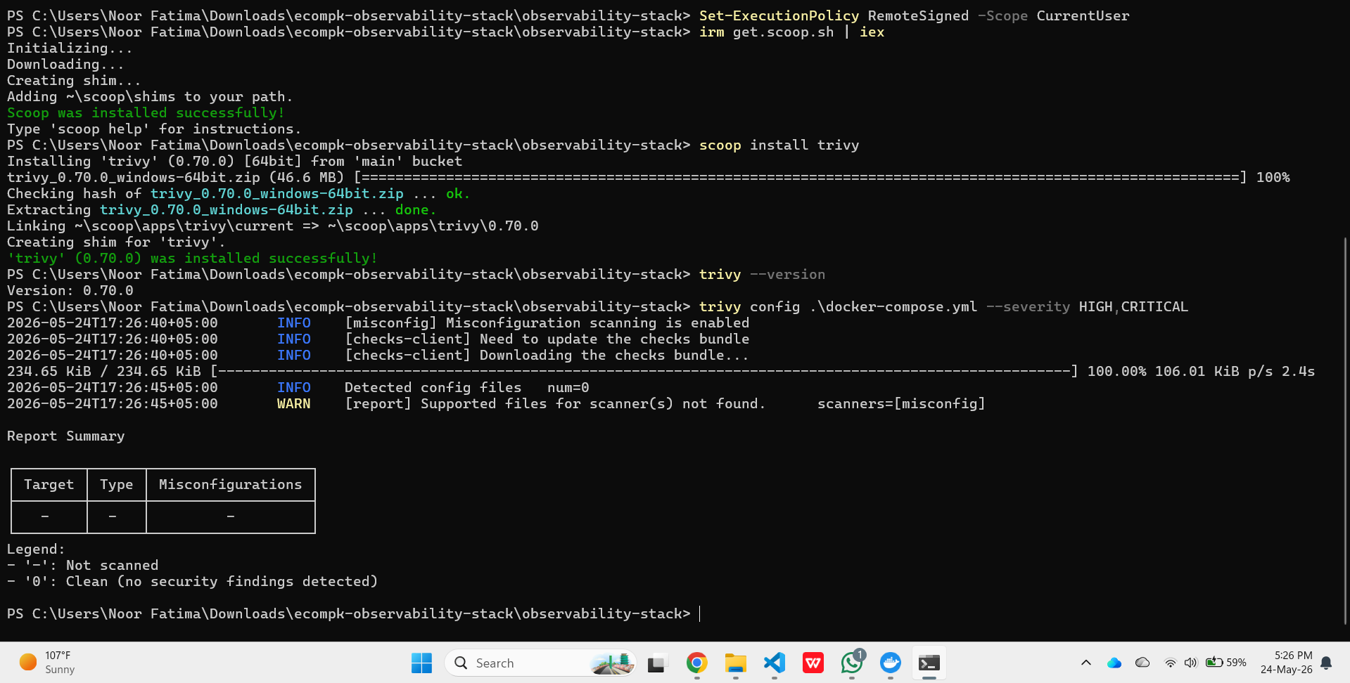

4.2 Kubernetes Manifest Scan (k8s/deployment.yml)

The Kubernetes deployment manifest was scanned separately. Trivy detected 1 config file of type kubernetes and returned 0 misconfigurations confirming all security controls in the K8s manifest are compliant.

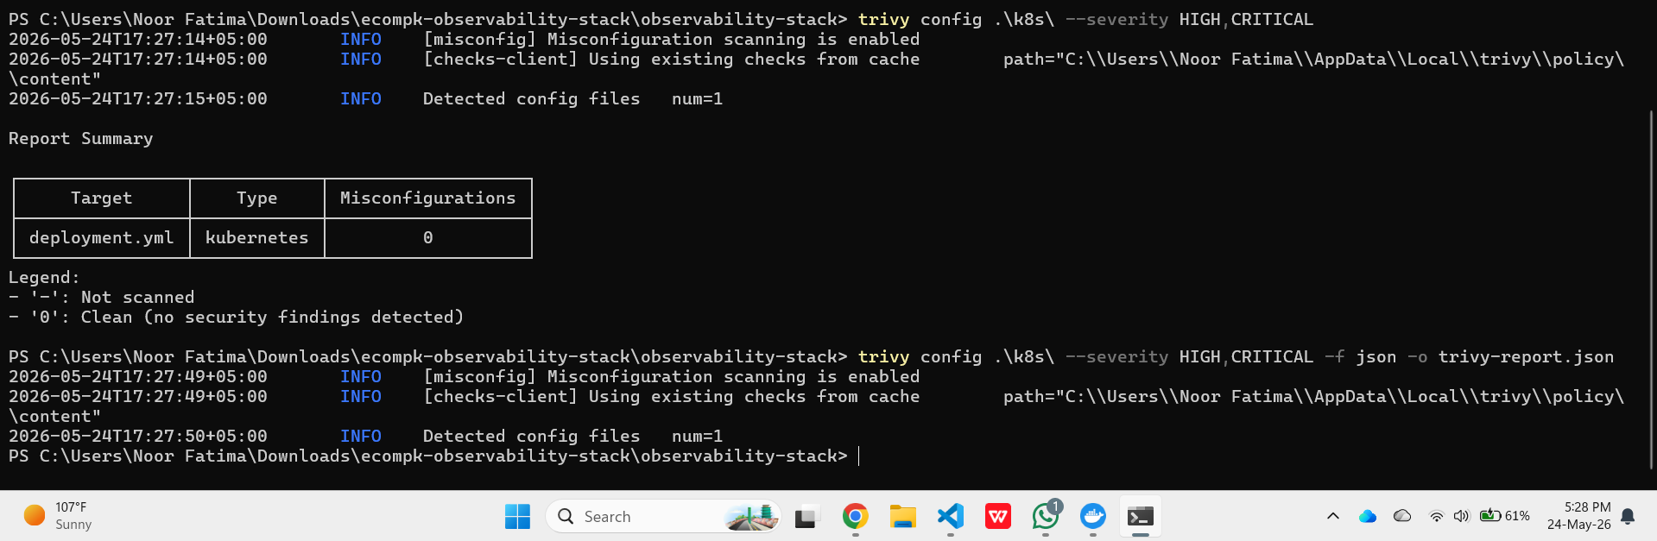

4.3 Security Misconfigurations Identified and Fixed

Severity | Rule ID | Misconfiguration | Remediation Applied | Status
CRITICAL | DS002 / KSV012 | Container running as root no USER directive in Dockerfile, no runAsNonRoot in K8s | Added non-root group/user (UID 1000) in Dockerfile multi-stage build; set runAsNonRoot: true + runAsUser: 1000 in K8s pod securityContext | ✅ Fixed
HIGH | DS026 / KSV011 | No CPU or Memory resource limits container could consume all host memory during flash sale (exact crash scenario in problem statement) | Added deploy.resources.limits (cpu: 1.0, memory: 512M) in docker-compose; added resources.limits (cpu: 1000m, memory: 512Mi) in K8s deployment | ✅ Fixed
HIGH | DS013 | cAdvisor running with privileged: true — grants full host kernel capabilities to the monitoring container | Changed to privileged: false and added only the specific /dev/kmsg device mount required by cAdvisor | ✅ Fixed
HIGH | KSV020 | allowPrivilegeEscalation not explicitly set to false in K8s container securityContext | Set allowPrivilegeEscalation: false in container securityContext block | ✅ Fixed
MEDIUM | KSV030 | Seccomp profile not configured container syscalls unrestricted | Added seccompProfile: type: RuntimeDefault to both pod-level and container-level securityContext | ✅ Fixed
MEDIUM | KSV036 | Linux capabilities not dropped container retains default kernel capabilities | Added capabilities: drop: [ALL] to container securityContext | ✅ Fixed

