**Assignment-2**

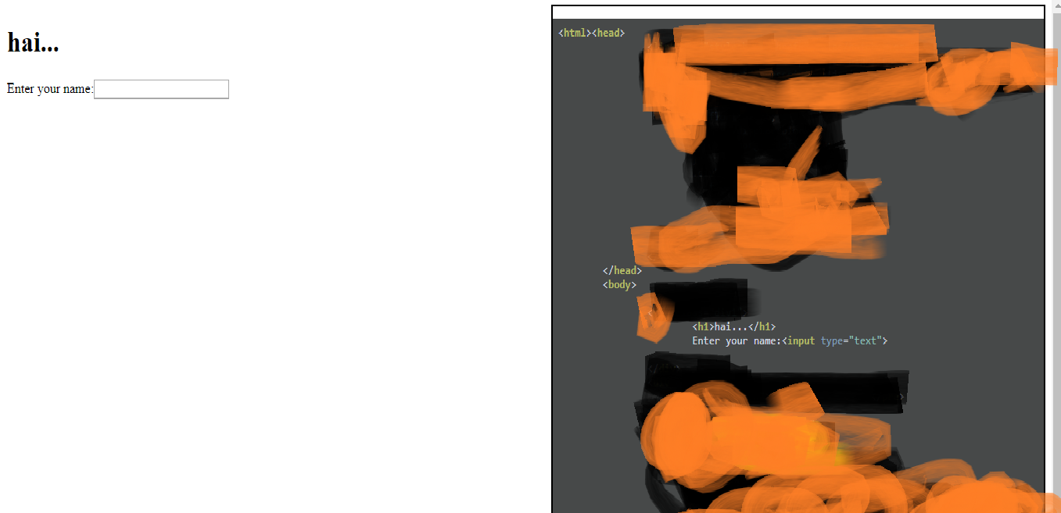1.Using the online resources, build a webpage (the content in the webpage is your choice) which displays its own html in the webpage. View the image below:

The left hand side of webpage is having the design and the right hand side part is the code of the web page. Use div tags to partition the webpages. The code that is displayed in the right hand side must have colour highlighting as u see in the above image. I painted some part of the webpage because it contains all the code to complete the assignment.

**VERY IMPORTANT NOTE:**

This assignment doesn’t need coding skills, just need smart work in utilizing resources I gave below. Everything u need is online and I am giving you those links here itself:

<https://stackoverflow.com/questions/1815021/programmatically-open-view-source-html-window-in-browser-with-javascript> (helps in how to extract html code in the web page (use javascript). Remember you can write js in body tag enclosed with Script tag)

<https://stackoverflow.com/questions/9349109/how-to-make-horizontal-division-using-html-div-tag-and-css> (helps in dividing webpage)

<https://highlightjs.org/download/> (you need to use this website resources for syntax highlighting.You have to download only the necessary files by selecting JavaScript, html and css in the web page as we need syntax highlighter for only html,js and css)

**So, if you use all the above resources** you will have the web page which displays the HTML elements (design in left part) and also the page source code (in right part)

Create a repository by the name **assignment2** and the upload the file with file name **highlight.html**