PROJECT REPORT
Summer Training — Power BI

Project Title | Bank Loan Default Risk Dashboard
Student Name | Harnoor Kaur
Roll Number | 2405039380
Course & Batch | B.Tech
Department | CSE
Institute | CGC University,Mohali (CCE)
Training Period | [8/6/26] to [6/7/26]
Submission Date | [3/7/2026]
Guided By | [Ms Ashima , Ms Mandeep]

1. Declaration

I hereby declare that the project report entitled "[Project Title]" submitted in partial fulfilment of the Summer Training Programme is an original piece of work carried out by me. The data used in this report has been collected from publicly available sources. The dashboards, visuals shown in this report have been independently created by me in Microsoft Power BI Desktop.

I further confirm that this report or any part of it has not been submitted previously for any academic award.

Signature: ___________________________
Name: [Harnoor Kaur]
Date: [03/ 06/ 2006]

2. Abstract

This project presents a Bank Loan Default Risk Dashboard developed using Microsoft Power BI to help financial institutions monitor loan performance and identify borrowers who are at a higher risk of default. The dashboard provides an interactive and data-driven approach to analysing loan records, enabling risk management teams to make informed lending decisions instead of relying on manual analysis.
The final dashboard combines KPI cards, charts, and interactive filters to analyse borrower distribution, loan purposes, income bands, and financial trends. The analysis reveals that the overall default rate is very low, most borrowers belong to higher income groups, and Debt Consolidation is the most common reason for taking loans. Overall, the dashboard provides valuable insights that support better risk assessment and loan approval decisions.
3. Introduction

3.1 Background
The banking and financial sector generates large volumes of loan data every day. Managing this information manually is both time-consuming and prone to errors, making it difficult for financial institutions to identify high-risk borrowers efficiently. Business Intelligence tools such as Microsoft Power BI enable organisations to transform raw financial data into interactive dashboards that support faster and more informed decision-making. Loan risk analysis plays an important role in maintaining the financial stability of banks. By monitoring borrower characteristics, loan performance, and repayment behaviour, financial institutions can identify trends that indicate potential defaults. Visual dashboards make this information easier to understand, allowing managers to analyse multiple aspects of loan data through interactive charts and key performance indicators.

3.2 Problem Statement
Banks provide loans to thousands of customers every year, making it increasingly difficult for risk management teams to manually monitor every loan record. Without a centralized analytical dashboard, identifying borrowers who are more likely to default becomes time-consuming and inefficient.

- Monitor overall loan performance using key performance indicators (KPIs).
- Analyse borrower characteristics based on Loan Grade, Income Band, Loan Purpose, and Loan Status.
- Identify high-risk borrower segments that are more likely to default.
- Provide clear visual insights to support risk analysis.
- Enable loan managers and risk management teams to make faster, data-driven lending decisions.

3.3 Objectives
- Import the Lending Club loan dataset into Microsoft Power BI.
- Clean and transform the raw data using Power Query.
- Design an efficient Star Schema data model with appropriate relationships.
- Create DAX measures to calculate important loan performance metrics.
- Build an interactive dashboard using KPI cards, charts, and slicers.
- Analyse loan data based on income band, loan grade, loan purpose, and loan status.
- Identify borrower segments that have a higher likelihood of default.
4. Dataset Description

4.1 Data Source

Source Name | Kaggle
Dataset Name | Lending Club Loan Dataset
File Format | CSV
Number of Records | 10,000 Rows
Number of Columns | 55 Columns
Time Period Covered | June 2026 – July 2026
Download Link | https://www.kaggle.com/datasets/utkarshx27/lending-club-loan-dataset

4.2 Key Fields / Columns
List and describe the important columns used in your analysis:

Column Name | Data Type | Description / Role in Analysis
Loan Amount | Decimal | Total amount borrowed by the customer.
Annual Income | Decimal | Annual income of the borrower.
Grade | Text | Credit grade assigned based on the borrower's risk profile.
Loan Purpose | Text | Primary reason for applying for the loan.
Loan Status | Text | Current loan status such as Fully Paid, Current, or Charged Off.
Income Band (Created) | Text | Indicates whether a loan has defaulted (1 = Default, 0 = No Default).

4.3 Data Quality Issues & Cleaning Steps
- Imported the Lending Club dataset from a CSV file into Power BI.
- Checked the dataset for missing and inconsistent values.
- Removed duplicate records to ensure data accuracy.
- Corrected data types for columns such as Loan Amount, Annual Income, Interest Rate, and Loan Status.
- Renamed column headers for better readability and consistency.
- Created a new Income Band column by grouping borrowers based on their annual income.
- Created a Default Flag column to classify loans as Default (1) or Non-Default (0).
- Verified the cleaned dataset before loading it into the Power BI data model.

5. Data Modelling

5.1 Schema Design

Schema Type | Single Table Mode
Fact Table | Loan Amount, Total Loans , Income Band , Loan Status, Default Rate , Default Flag
Calculated Tables | Income Band, Default Flag
Relationships | Not Applicable (single-table model)

5.2 Model Diagram
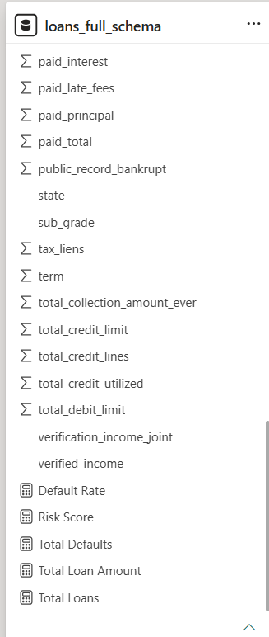 [ Screenshot of Data Model — paste here ]

6. Dashboard & Visuals

Overview

The Bank Loan Default Risk Dashboard provides an interactive overview of loan performance and borrower risk. It enables users to monitor key metrics, analyse borrower characteristics, and identify high-risk segments through intuitive visualizations.

6.1 Page 1 — Summary / Overview
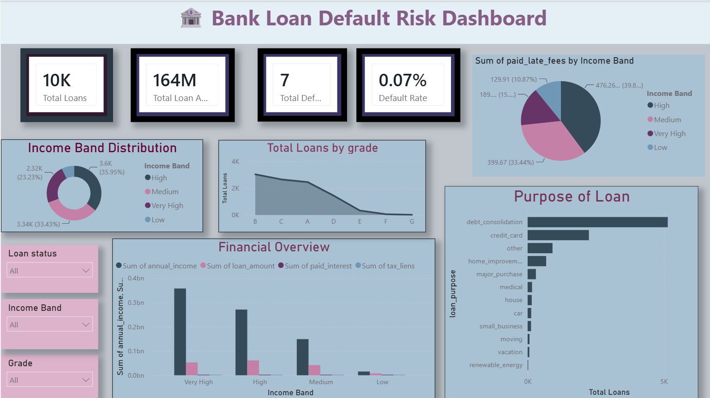 Visuals Used:
- KPI Cards
Total Loans
Total Loan Amount
Total Defaults
Default Rate
- Donut Chart :
Income Band Distribution - Displays the distribution of borrowers across Low, Medium, High, and Very High income groups.
- Clustered Bar Chart
Loan Purpose Analysis - Shows the number of loans issued for different loan purposes.
- Column/Bar Chart
Financial Overview - Compares Annual Income, Loan Amount, Paid Interest, and Tax Liens across different income bands.
- Slicers
Loan Grade
Loan Status
Income Band
Loan Purpose

7. Key Findings & Insights

- The overall Default Rate is 0.07%, indicating that only a small percentage of borrowers defaulted.
- The High and Very High income bands contain the largest number of borrowers.
- Most loans are issued to borrowers with Grade A, B, and C, reflecting stronger credit profiles.
- Borrowers with higher annual incomes generally take larger loans and pay higher amounts of interest.
- Debt Consolidation is the most common purpose for obtaining a loan.
- The dashboard enables quick identification of borrower trends and supports data-driven lending decisions.

8. Learnings & Challenges

8.1 Skills Learned
- During the development of this project, the following skills were acquired:
- Imported and transformed raw CSV data using Power Query.
- Cleaned and prepared data for analysis by handling inconsistencies and formatting issues.
- Created calculated columns and DAX measures to derive meaningful business metrics.
- Designed an interactive dashboard using various Power BI visualizations.
- Applied data modelling concepts to organize and analyse financial data efficiently.
- Developed KPI cards to monitor key loan performance indicators.
- Used filters and slicers to improve dashboard interactivity.
- Gained practical knowledge of business intelligence and data visualization techniques.

8.2 Challenges Faced
- Understanding the structure of the Lending Club dataset and identifying relevant columns.
- Choosing appropriate visualizations to represent different types of financial data.
- Writing DAX measures for KPI calculations such as Default Rate and Total Loan Amount.
- Creating meaningful calculated columns like Income Band and Default Flag.
- Ensuring consistency between the dataset, DAX calculations, and dashboard visuals.
- Designing a dashboard that is informative, interactive, and easy to understand.

9. Conclusion

This project successfully demonstrates the use of Microsoft Power BI to analyse and visualize bank loan data for risk assessment. By transforming raw loan records into an interactive dashboard, the project enables users to monitor loan performance, identify borrower trends, and evaluate default risk more efficiently.

The dashboard provides valuable insights through KPIs and visualizations, helping loan managers and risk teams make informed, data-driven decisions. It highlights key borrower characteristics such as income band, loan grade, and loan purpose, making it easier to identify high-risk segments.

Overall, the project enhanced practical knowledge of Power BI, including data transformation, DAX calculations, dashboard design, and business intelligence concepts. In the future, predictive analytics and machine learning models could be integrated to improve loan default prediction and support more proactive risk management.

10. References
Kaggle – Lending Club Loan Dataset (https://www.kaggle.com/datasets/utkarshx27/lending-club-loan-dataset)
Microsoft Power BI Documentation
Microsoft Power Query Documentation
DAX Guide
Microsoft Learn – Power BI Learning Resources (https://www.microsoft.com/en-in/power-platform/products/power-bi/learning)

