GITHUD LINK:

TASK: 1
// TASK : 1
#include<iostream> //NAME:NOORFATIMA ROLL NUMBER:BSCS0095
using namespace std;
int main()
{
//PRINT HELLO WORLD
cout << "HELLO WORLD\n";
cout << "University of Central \n Punjab Faculty of Information \nTechnology Orientation Day 2026 ";
cout << "\nWELCOME!\n";
cout << 2026<< endl;
cout << 45 <<endl;
cout << 45*3 << endl;
cout << 1000 + 500 - 250 << endl;
//print total fee using an expression
cout << "total fee :" << 4500 + 9000 << endl;
}

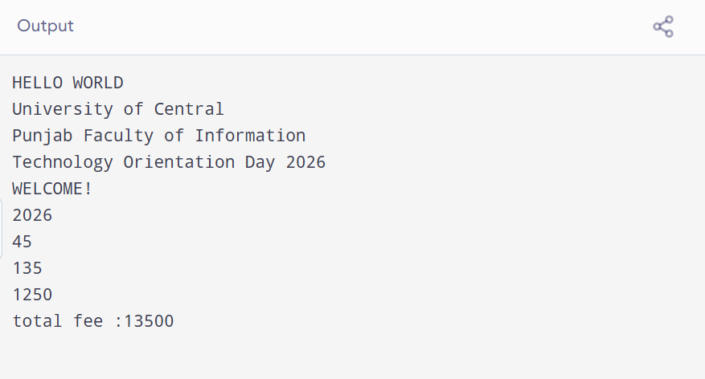

TASK: 2
#include <iostream> //TASK2
using namespace std; //using namespace std;was not used
int main()
{
cout << "Orientation Day" << endl; //statement terminator wss not used
cout << "Total students: "<< 450 << endl; //<< was not use after total students
cout << "Seats left: " << 500 - 450 << endl;
cout << "Have a nice day" << endl; //commas was not used
return 0;
}

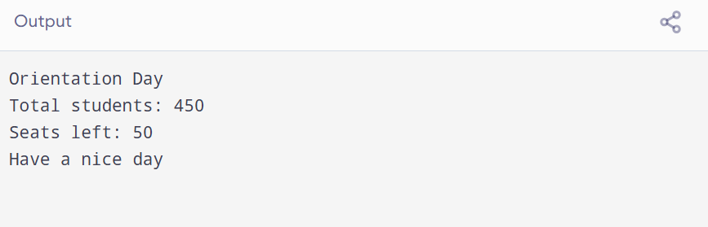
FOUR ERRORS
- A semicolon (;) is missing at the end of the first cout statement.
- The insertion operator (<<) is missing before 450.
- Single quotation marks are used instead of double quotation marks around the text.
- The quotation marks in the last cout statement are incorrect.
PART B
#include <iostream> // TASK 3
using namespace std; //using namespace std;was not used
int main()
{
cout << "Orientation Day" << endl; //statement terminator wss not used
cout << "Total students: "<< 450 << endl; //<< was not use after total students
cout << "Seats left: " << 500 - 450 << endl;
cout << "Have a nice day" << endl; //commas was not used
cout << "Average: " << (60 + 70 + 80 )/ 3 << endl;
//if we add bracket before 60 and after 80 the output will be accodring to our expected result
return 0;

}

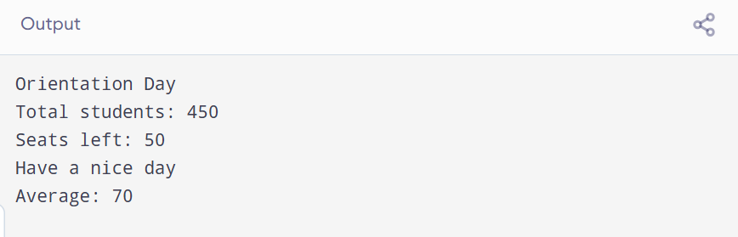

TASK: 3
/*#include <iostream> // TASK 3
using namespace std;

int main() {
cout << "Expression 1: " << 10 + 5 * 2 << endl;
cout << "Expression 2: " << (10 + 5) * 2 << endl;
cout << "Expression 3: " << 20 - 5 - 3 << endl; // The operators are evaluated from left to right.
cout << "Expression 4: " << 100 / 7 << endl;
cout << "Expression 5: " << 100 % 7 << endl;
cout << "Expression 6: " << 2 * 3 + 8 / 4 - 1 << endl;
// The brackets change the order of calculation and the result becomes 8
return 0;
}
*/

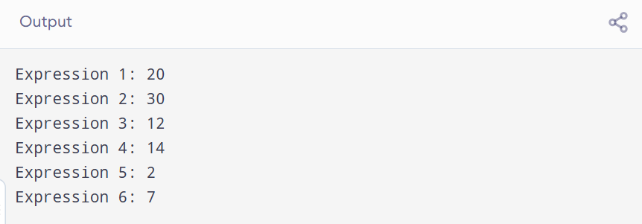
The operators are evaluated from left to right. First, 20 - 5 = 15, and then 15 - 3 = 12
The corrected expression is:
2 * (3 + 8 / 4 - 1)
The brackets change the order of calculation, and the final answer becomes 8.

No. | Expression | Your Prediction | Actual Output
1 | 10 + 5 * 2 | 20 | 20
2 | (10 + 5) * 2 | 30 | 30
3 | 20 - 5 - 3 | 12 | 12
4 | 100 / 7 | 14 | 14
5 | 100 % 7 | 2 | 2
6 | 2 * 3 + 8 / 4 - 1 | 7 | 7

TASK:4
/*
#include <iostream>
using namespace std;

int main() {

int rollNo = 1045;
int semester = 1;
char section = 'B';
float cgpa = 3.5;
int totalFee = 45000;
int feepaid = 20000;

cout << "Roll No: " << rollNo << endl; // Display student information
cout << "Semester: " << semester << endl;
cout << "Section: " << section << endl;
cout << "CGPA: " << cgpa << endl;
cout << "Total Fee: " << totalFee << endl;
cout << "Fee paid: " << feepaid << endl;

semester = semester + 1; // UPDATE SEMESTER AND STUDENT FEE
feepaid = feepaid + 5000;

cout << "Semester: " << semester << endl;
cout << "Fee Paid: " << feepaid << endl;

int remainingFee = totalFee - feepaid;// CALCULATE REMAINING FEE AND SUBMISSION
int percentagepaid = feepaid * 100 / totalFee;

cout << "Remaining Fee: " << remainingFee << endl;
cout << "Percentage Paid: " << percentagepaid << endl;

return 0;
}

*/

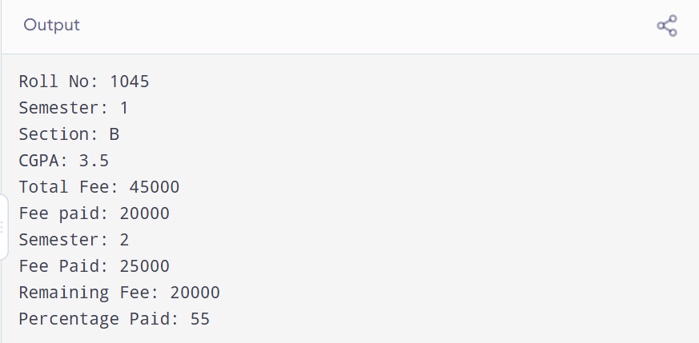

- 2ndYear – Invalid because a variable name cannot start with a number.
- student_name – Valid because an underscore can be used in a variable name.
- total-marks – Invalid because a hyphen is not allowed in a variable name.
- _fee – Valid because it starts with an underscore.
- Roll No – Invalid because variable names cannot contain spaces.
- marks2 – Valid because numbers can be used in a variable name after the first character.
- When we print an integer variable without giving it an initial value, it may show an unpredictable result. We should always initialize a variable before using it to avoid unexpected results.
TASK : 5
#include<iostream> // NAME: NOORFATIMA ROLL NUMBER: BSCS0095
using namespace std;

int main()
{
// PRINT HELLO WORLD
cout << "HELLO WORLD\n";
cout << "University of Central \n Punjab Faculty of Information \nTechnology Orientation Day 2026 ";
cout << "\nWELCOME!\n";
cout << 2026 << endl;
cout << 45 << endl;
cout << 45*3 << endl;
cout << 1000 + 500 - 250 << endl;

// PRINT TOTAL FEE USING AN EXPRESSION
cout << "Total fee: " << 4500 + 9000 << endl;

// TASK 05: FEE CALCULATOR
int age, creditHours, feePerCreditHour;

cout << "Enter your age: ";
cin >> age;

cout << "Enter credit hours: ";
cin >> creditHours;

cout << "Enter fee per credit hour: ";
cin >> feePerCreditHour;

int totalFee = creditHours * feePerCreditHour;
int discountedFee = totalFee - 2000;

cout << "Total Fee: Rs. " << totalFee << endl;
cout << "Fee after discount: Rs. " << discountedFee << endl;
cout << "Year of Birth: " << 2026 - age << endl;
cout << "Year you will turn 25: "
<< 2026 + (25 - age) << endl;

/*
Experiment 1:
I got the same result when entering values with spaces,
on separate lines, or with tabs because cin skips whitespace.

Experiment 2:
When I entered 19.8, the age variable read 19, but the
remaining .8 could cause the next input to fail.
This happens because age is an int variable.
*/

return 0;
}

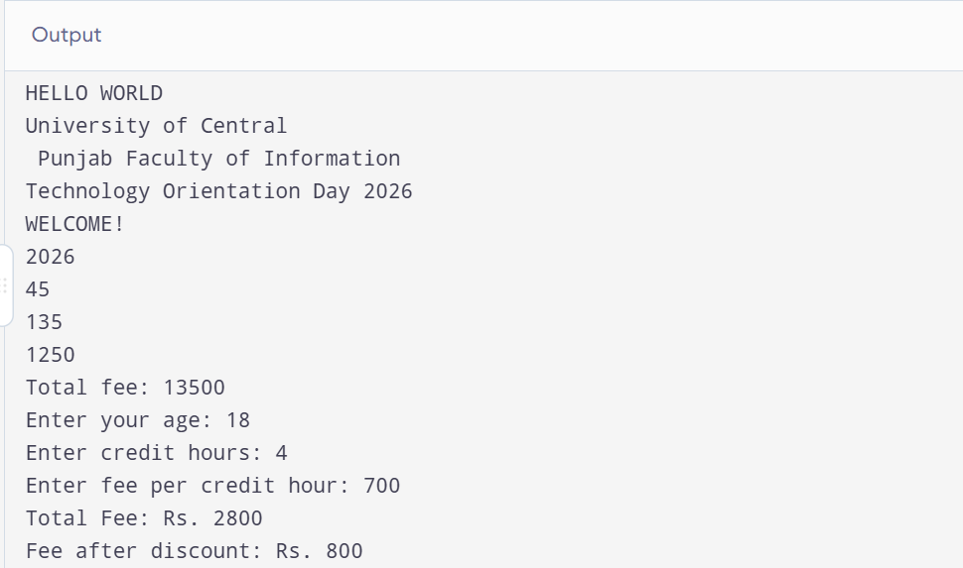
1. No, the result is not different. I got the same output when I entered the values on one line, separate lines, or with tabs because cin ignores extra spaces and reads each value one by one.
2. When I entered 19.8 for age, only 19 was stored in the age variable because it is an integer. The remaining .8 causes the next input to fail because cin cannot read it as an integer.
TASK: 6
#include <iostream>
using namespace std;

int main()
{
int price, quantity;
int total, tax, grandTotal;

cout << "Enter price: ";
cin >> price;

cout << "Enter quantity: ";
cin >> quantity;

total = price * quantity;
tax = total * 5 / 100;
grandTotal = total + tax;

cout << "Total: " << total << endl;
cout << "Tax: " << tax << endl;
cout << "Grand Total: " << grandTotal << endl;

// For price 99 and quantity 7, the tax is 34 instead of 34.65.
// This is because int does not store decimal values.

return 0;
}
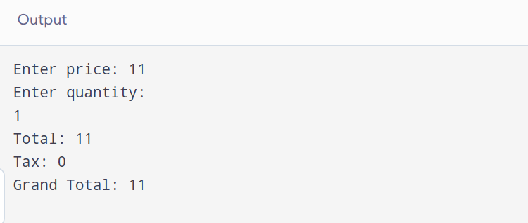
. When I entered price = 99 and quantity = 7, the program showed the tax as 34 instead of 34.65. This happened because I used int for all variables, so the decimal part was removed and only the whole number was stored.
Dry Run Table
Variable | My Prediction | Actual Output
total | 750 | 750
tax | 37 | 37
grandtotal | 787 | 787
TASK: 7
#include <iostream>
using namespace std;

int main()
{
int celsius, fahrenheit;

cout << "Enter temperature in Celsius: ";
cin >> celsius;

fahrenheit = celsius * 9 / 5 + 32;

cout << "Temperature in Celsius: " << celsius << endl;
cout << "Temperature in Fahrenheit: " << fahrenheit << endl;

// For 37 Celsius, the answer is 98 instead of 98.6
// because int removes the decimal part.

return 0;
}
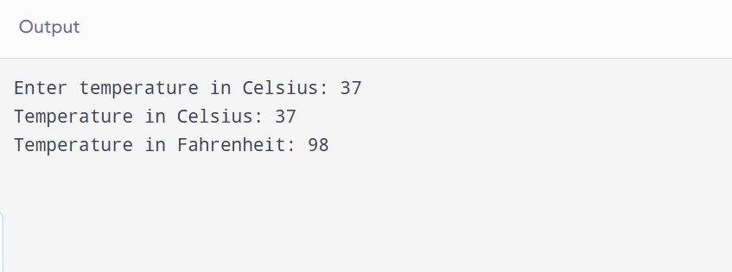
Celsius input | Fahrenheit output
0 | 32
100 | 212
37 | 98
When I entered 37, the program showed 98 instead of 98.6 because I used int variables, which do not store decimal values
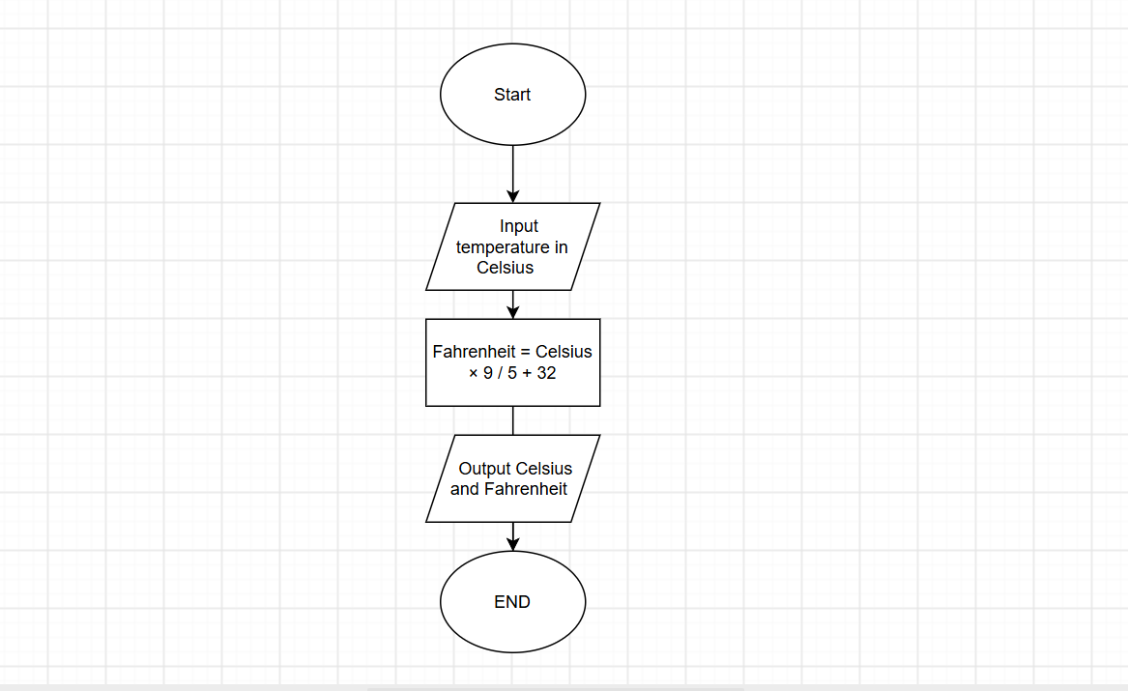
TASK: 8
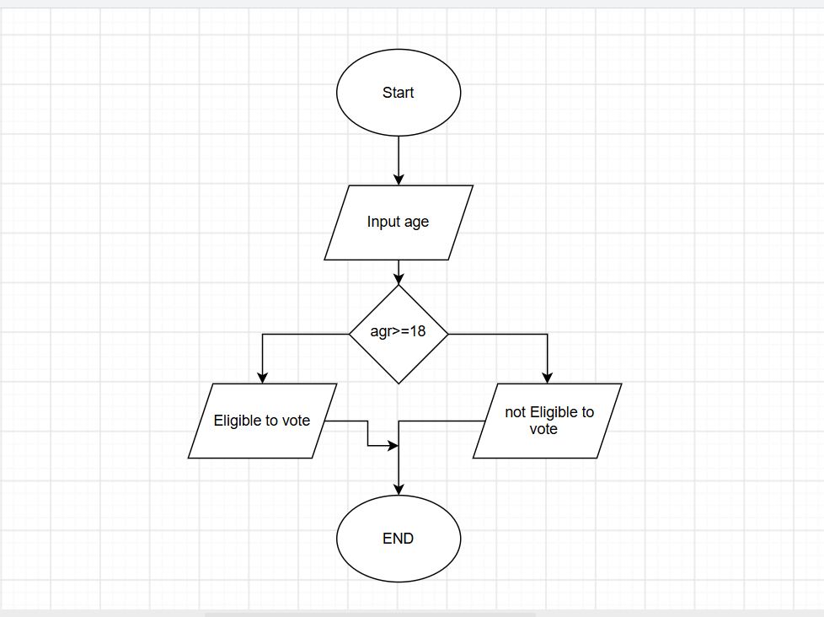

2. Dry Run: Cinema Tickets
Age | Ticket
8 | Half ticket
12 | Full ticket
30 | Full ticket
• At age 8, a half ticket is given because the child is under 12.
• At age 12, a full ticket is given because the child is no longer under 12.
• At age 30, a full ticket is given because the person is over 12.

