**University of the Punjab**

**Gujranwala Campus**

**Department of Information Technology**



**Assignment: Computer Vision**

**Prepared by:**Noor Ikram

**Roll #:**BIT21230

**Submitted to:**

Miss Fouqia Zafeer

**Question**

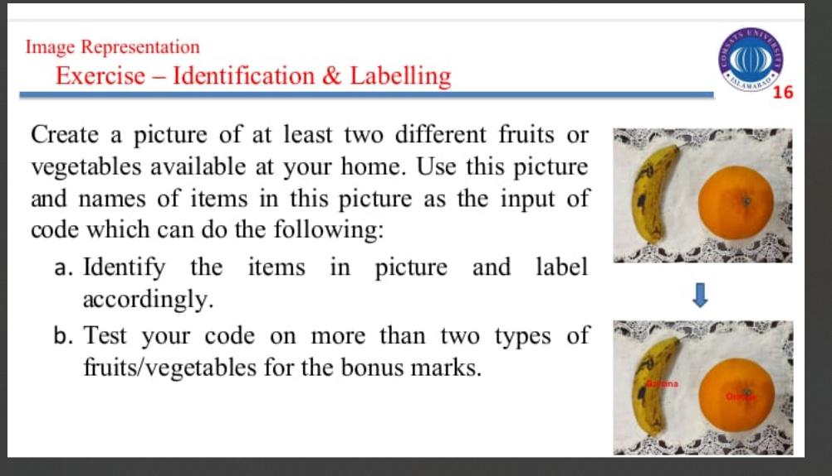

**Solution**

clc; clear; close all;

% Load Image

img = imread('image.png'); % Ensure correct image

figure, imshow(img), title('Original Image');

% Convert to HSV Color Space

hsvImg = rgb2hsv(img);

hue = hsvImg(:,:,1);

% Define Color Ranges

bananaMask = (hue > 0.10 & hue < 0.20); % Yellow range for banana

orangeMask = (hue > 0.02 & hue < 0.08); % Orange range for orange

% Remove Small Objects

bananaMask = bwareaopen(bananaMask, 1500);

orangeMask = bwareaopen(orangeMask, 1500);

% Get Properties of Detected Objects

bananaProps = regionprops(bananaMask, 'BoundingBox', 'Centroid', 'Area');

orangeProps = regionprops(orangeMask, 'BoundingBox', 'Centroid', 'Area');

% Display Image

figure, imshow(img), title('Correctly Labeled Image');

hold on;

% Label Banana

if ~isempty(bananaProps)

[~, idx] = max([bananaProps.Area]); % Select largest banana

bananaCentroid = bananaProps(idx).Centroid;

text(bananaCentroid(1), bananaCentroid(2) + 20, 'Banana', ...

'Color', 'r', 'FontSize', 14, 'FontWeight', 'bold', 'HorizontalAlignment', 'center');

end

% Label Orange

if ~isempty(orangeProps)

[~, idx] = max([orangeProps.Area]); % Select largest orange

orangeCentroid = orangeProps(idx).Centroid;

text(orangeCentroid(1), orangeCentroid(2) + 20, 'Orange', ...

'Color', 'r', 'FontSize', 14, 'FontWeight', 'bold', 'HorizontalAlignment', 'center');

end

hold off;

