

ARTIFICIAL INTELLIGENCE TRACK
TASK 2 SUBMISSION REPORT
Context-Aware Intelligent FAQ Chatbot

Intern Name | Noor ul Huda
Offer ID | IGO-00239
Track | Artificial Intelligence Track
Task Assigned | Task 2: Context-Aware Intelligent FAQ Chatbot
Repository | InternGrow_FAQChatbot

1. Introduction
I am Noor ul Huda, currently enrolled as an intern in the Artificial Intelligence Track at InternGrow (Offer ID: IGO-00239). This report documents the design, development, and testing of my submission for Task 2 of the internship: a Context-Aware Intelligent FAQ Chatbot. The chatbot is built using Python, and it applies Natural Language Processing (NLP) techniques together with cosine similarity to understand user questions and return the most relevant answer from a prepared FAQ dataset, even when the user's wording differs from the original questions.
The goal of this report is to walk through every stage of the project — from environment setup and dependency installation, to writing the core logic, building the user interface, and finally testing the chatbot with a variety of questions, including ones phrased differently from the dataset and one completely unrelated question to confirm the chatbot correctly declines to answer out-of-scope queries.

2. Task 2 — Official Description
As specified in the InternGrow Artificial Intelligence Track manual, Task 2 is defined as follows:
TASK 2: Context-Aware Intelligent FAQ Chatbot
Core Requirement: Preprocess dataset texts using NLP libraries (NLTK or SpaCy) and match user queries using cosine similarity.
Upgrade Feature: Transition to a Retrieval-Augmented Generation (RAG) system using modern vector embeddings for highly contextual, fluid conversational replies.

This report covers the completion of the core requirement in full: dataset preprocessing with spaCy, and query matching using TF-IDF vectorization combined with cosine similarity.

3. Tools & Libraries Used
- Python 3.14 — core programming language
- spaCy (en_core_web_sm) — text preprocessing: tokenization, lemmatization, stop-word removal
- pandas — reading and managing the FAQ dataset (CSV)
- scikit-learn (TfidfVectorizer, cosine_similarity) — converting text to vectors and measuring similarity
- Streamlit — building the interactive chat web interface
- Visual Studio Code — development environment
- Rainbow CSV (VS Code extension) — for easier CSV dataset editing

4. Implementation — Step by Step
The following section walks through the actual build process with screenshots taken directly from my development environment.

Step 1: Environment Setup — Installing Required Libraries
Python was installed and a project folder named InternGrow_FAQChatbot was created in Visual Studio Code. All required libraries (pandas, spaCy, scikit-learn, Streamlit) along with the spaCy English language model (en_core_web_sm) were installed through the VS Code terminal using pip.
Screenshot 1 — Library & Model Installation
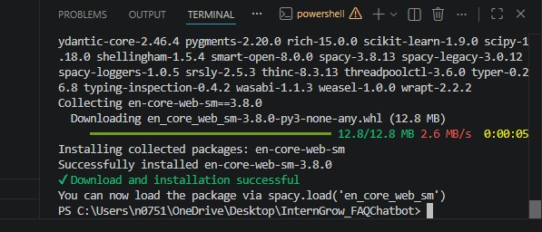
Terminal output confirming successful installation of spaCy, scikit-learn, pandas and the en_core_web_sm language model.

Step 2: Preparing the CSV Dataset with Rainbow CSV
Since the FAQ dataset (faqs.csv) needed to store two columns — question and answer — the Rainbow CSV extension was installed in VS Code. This extension color-codes CSV columns, making it much easier to verify that the dataset is structured correctly before it is read by pandas.
Screenshot 2 — Rainbow CSV Extension
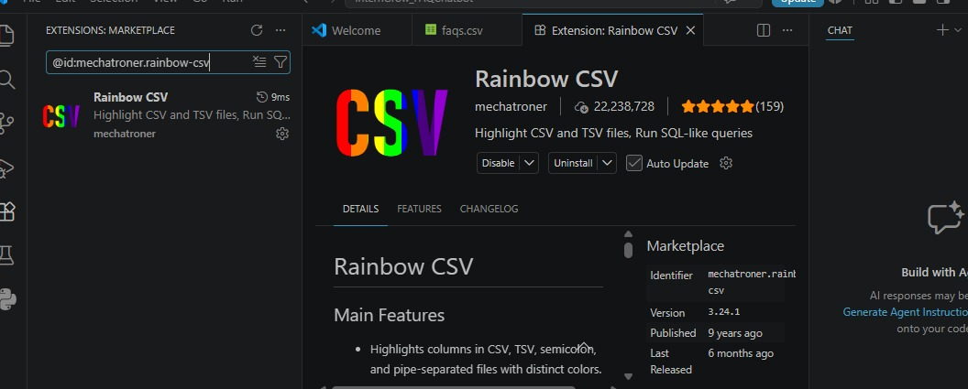
Rainbow CSV extension installed from the VS Code Marketplace to visually organize the CSV columns.

Step 3: Building the FAQ Dataset (faqs.csv)
A dataset of 10 frequently asked questions and their answers was created, covering common topics such as refunds, password resets, payment methods, order tracking, delivery times, and account creation. Each row follows a simple question,answer format so it can be loaded directly with pandas.
Screenshot 3 — Final FAQ Dataset
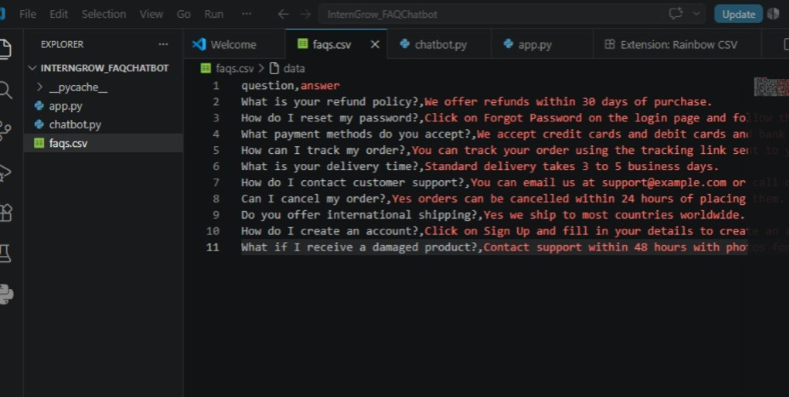
The completed faqs.csv dataset opened in VS Code, showing the question and answer columns highlighted by Rainbow CSV.

Step 4: Writing the Core NLP & Matching Logic (chatbot.py)
This file contains the chatbot's 'brain'. It loads the dataset, preprocesses every question using spaCy (lowercasing, lemmatization, and stop-word/punctuation removal), then converts all questions into TF-IDF vectors. When a user submits a query, the same preprocessing is applied to it, and cosine similarity is used to find the FAQ question that is semantically closest to it. If the best similarity score is below a threshold of 0.3, the chatbot responds that it could not understand the question, instead of guessing.
Screenshot 4 — chatbot.py Logic
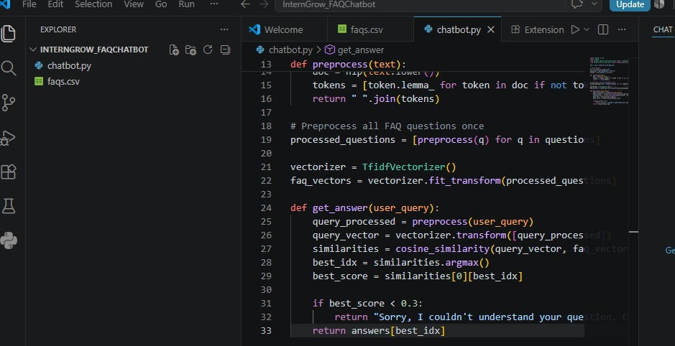
chatbot.py — the preprocessing function, TF-IDF vectorization, and the get_answer() function that performs cosine similarity matching.

Step 5: Building the Chat Interface (app.py)
A Streamlit-based chat interface was built on top of the chatbot logic. The interface includes a sidebar with example questions and a 'Clear Chat' button, custom styling for a dark professional theme, and a proper chat-bubble layout using Streamlit's st.chat_message and st.chat_input components with distinct avatars for the user and the bot.
Screenshot 5 — app.py Interface Code
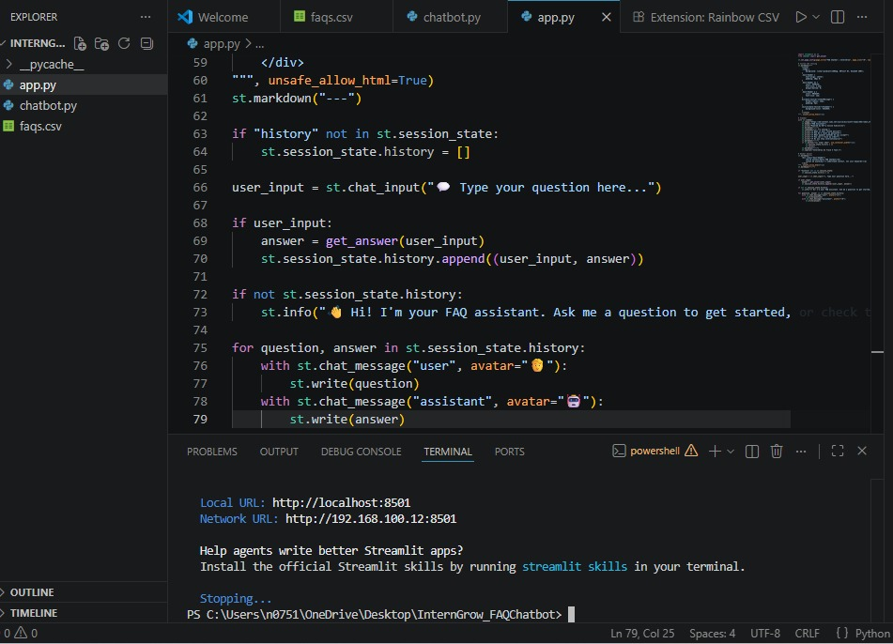
app.py — the final version of the Streamlit interface code, including the chat history loop with custom user and bot avatars.

Step 6: Running the Application
The application was launched from the integrated terminal using the Streamlit run command, which starts a local development server and automatically opens the chatbot in the default web browser.
Screenshot 6 — Launching the Chatbot
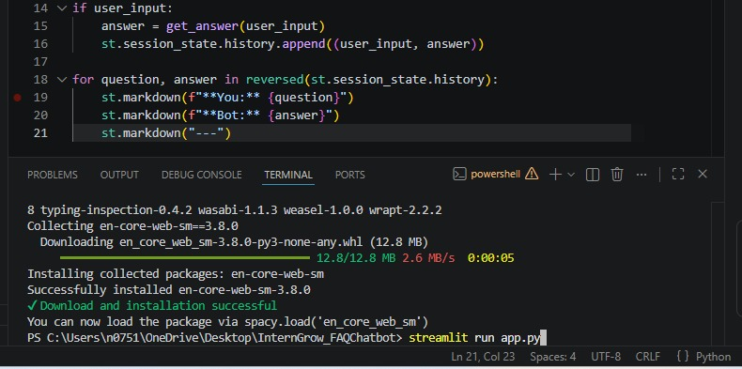
The 'streamlit run app.py' command being executed in the VS Code terminal.

Step 7: Final Interface
Once launched, the chatbot opens in the browser at localhost:8501, displaying the sidebar with sample questions, the chatbot title, and an empty chat window ready to accept input.
Screenshot 7 — Chatbot Interface (Live)
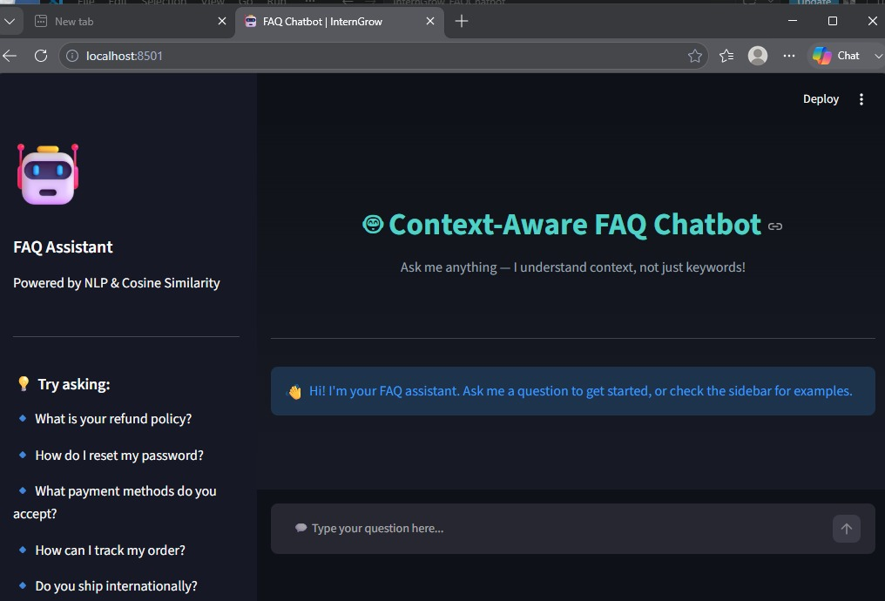
The completed FAQ Chatbot interface running in the browser, showing the sidebar with example questions and the welcome message.

Step 8: Testing the Chatbot
The chatbot was tested with multiple questions phrased differently from the original dataset wording, to confirm that the NLP preprocessing and cosine similarity matching correctly identify the intended FAQ even when exact keywords are not used. It correctly matched 'How do I track my order?' even though the dataset entry uses different phrasing, and correctly returned a fallback message for an unrelated question.
Screenshot 8 — Chatbot Testing
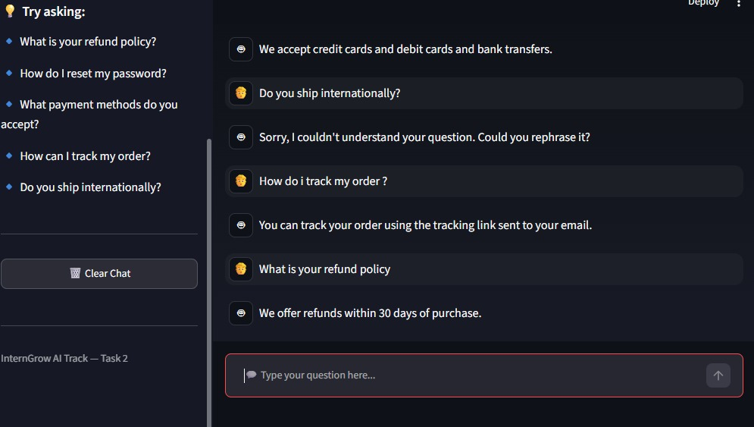
Test conversation showing the chatbot correctly matching differently-worded questions, and returning a fallback response for a question outside the FAQ dataset.

5. Complete Source Code
The full source code for all three files used in this project is included below for reference.

5.1 faqs.csv — FAQ Dataset
question,answer
What is your refund policy?,We offer refunds within 30 days of purchase.
How do I reset my password?,Click on Forgot Password on the login page and follow the instructions.
What payment methods do you accept?,We accept credit cards and debit cards and bank transfers.
How can I track my order?,You can track your order using the tracking link sent to your email.
What is your delivery time?,Standard delivery takes 3 to 5 business days.
How do I contact customer support?,You can email us at support@example.com or call our helpline.
Can I cancel my order?,Yes orders can be cancelled within 24 hours of placing them.
Do you offer international shipping?,Yes we ship to most countries worldwide.
How do I create an account?,Click on Sign Up and fill in your details to create an account.
What if I receive a damaged product?,Contact support within 48 hours with photos for a replacement.

5.2 chatbot.py — NLP Preprocessing & Cosine Similarity Matching
import pandas as pd
import spacy
from sklearn.feature_extraction.text import TfidfVectorizer
from sklearn.metrics.pairwise import cosine_similarity

nlp = spacy.load("en_core_web_sm")

# Load dataset
df = pd.read_csv("faqs.csv")
questions = df["question"].tolist()
answers = df["answer"].tolist()

def preprocess(text):
doc = nlp(text.lower())
tokens = [token.lemma_ for token in doc if not token.is_stop and not token.is_punct]
return " ".join(tokens)

# Preprocess all FAQ questions once
processed_questions = [preprocess(q) for q in questions]

vectorizer = TfidfVectorizer()
faq_vectors = vectorizer.fit_transform(processed_questions)

def get_answer(user_query):
query_processed = preprocess(user_query)
query_vector = vectorizer.transform([query_processed])
similarities = cosine_similarity(query_vector, faq_vectors)
best_idx = similarities.argmax()
best_score = similarities[0][best_idx]

if best_score < 0.3:
return "Sorry, I couldn't understand your question. Could you rephrase it?"
return answers[best_idx]

5.3 app.py — Streamlit Chat Interface
import streamlit as st
from chatbot import get_answer

st.set_page_config(page_title="FAQ Chatbot | InternGrow", page_icon="🤖", layout="centered")

# Custom CSS styling
st.markdown("""
<style>
.stApp {
background: linear-gradient(180deg, #0f1117 0%, #1a1d29 100%);
}
.main-header { text-align: center; padding: 20px 0; }
.main-header h1 { color: #4FD1C5; font-size: 2.2em; margin-bottom: 0; }
.main-header p { color: #9CA3AF; font-size: 1em; }
div[data-testid="stChatMessage"] { border-radius: 12px; padding: 5px; }
section[data-testid="stSidebar"] { background-color: #161925; }
</style>
""", unsafe_allow_html=True)

# Sidebar
with st.sidebar:
st.image("https://em-content.zobj.net/source/microsoft-teams/363/robot_1f916.png", width=80)
st.header("FAQ Assistant")
st.write("Powered by NLP & Cosine Similarity")
st.markdown("---")
st.subheader("💡 Try asking:")
st.write("🔹 What is your refund policy?")
st.write("🔹 How do I reset my password?")
st.write("🔹 What payment methods do you accept?")
st.write("🔹 How can I track my order?")
st.write("🔹 Do you ship internationally?")
st.markdown("---")
if st.button("🗑️ Clear Chat", use_container_width=True):
st.session_state.history = []
st.rerun()
st.markdown("---")
st.caption("InternGrow AI Track — Task 2")

# Header banner
st.markdown("""
<div class="main-header">
<h1>🤖 Context-Aware FAQ Chatbot</h1>
<p>Ask me anything — I understand context, not just keywords!</p>
</div>
""", unsafe_allow_html=True)
st.markdown("---")

if "history" not in st.session_state:
st.session_state.history = []

user_input = st.chat_input("💬 Type your question here...")

if user_input:
answer = get_answer(user_input)
st.session_state.history.append((user_input, answer))

if not st.session_state.history:
st.info("👋 Hi! I'm your FAQ assistant. Ask me a question to get started, or check the sidebar for examples.")

for question, answer in st.session_state.history:
with st.chat_message("user", avatar="🧑"):
st.write(question)
with st.chat_message("assistant", avatar="🤖"):
st.write(answer)

6. Conclusion
This report has documented the complete process of building Task 2 of the InternGrow Artificial Intelligence Track: a Context-Aware Intelligent FAQ Chatbot. The chatbot successfully preprocesses the FAQ dataset using spaCy's NLP pipeline, converts text into TF-IDF vectors, and uses cosine similarity to match user queries to the most relevant FAQ answer — even when the user's phrasing differs from the dataset. A similarity threshold ensures the chatbot gracefully declines to answer questions that fall outside the scope of the dataset, rather than returning an incorrect or misleading response.
The final deliverable includes a fully functional Streamlit-based chat interface with a custom theme, sidebar guidance, avatars, and a clear-chat feature, making it both functionally sound and presentable. The complete source code and dataset have been organized in the InternGrow_FAQChatbot repository as per the submission guidelines.

— Noor ul Huda (IGO-00239)

