Artificial Intelligence Track
Task 3: AI Music & Soundscape Generator
Internship Project Report
Intern Name | Noor ul Huda
Intern / Student ID | IGO-00239
Domain | Artificial Intelligence
Task | Task 3 — AI Music & Soundscape Generator
Internship Duration | 1st July 2026 – 1st August 2026
Organization | InternGrow

1. Internship & Task Overview
This report documents the work completed for Task 3 of the InternGrow Artificial Intelligence Track internship: the AI Music & Soundscape Generator. Interns on the AI track are required to complete 2–3 of 4 listed tasks; Task 3 was selected as the primary focus of this report.
Task 3 required training a deep learning architecture (RNN, LSTM, or GAN) on preprocessed MIDI musical sequences to learn the underlying musical patterns, and — as the listed Upgrade Feature — building an application interface that lets the user pick a mood and dynamically generates music matching that mood.
This project was carried out under Intern ID IGO-00239, in the Artificial Intelligence domain of the InternGrow internship program.

2. Objective
- Train a Long Short-Term Memory (LSTM) neural network on real MIDI piano performance data to learn note and chord patterns.
- Use the trained model to generate new, original musical note sequences that were never part of the training data.
- Convert the generated sequences into a playable MIDI (.mid) file.
- Implement the task's Upgrade Feature: extend the base generator into a mood-driven composer — the user selects a mood (Happy, Sad, Emotional, Sleepy, or Energetic) and the system dynamically adjusts tempo, instrument, note spacing, and generation randomness (temperature) to match that mood.

3. Tools, Technologies & Libraries Used
Tool / Library | Purpose in this Project
Python 3.11 | Core programming language for the entire pipeline
TensorFlow / Keras | Building, compiling, and training the LSTM neural network
NumPy | Encoding note sequences into numerical arrays for the network
music21 | Parsing MIDI files into notes/chords, and building the final generated MIDI output
pickle | Serializing processed notes (notes_data.pkl) and note-to-index mappings (note_mapping.pkl)
rich | Styled terminal interface — progress bars, panels, and result tables
requests | Downloading the MIDI dataset archive from Google Cloud Storage
Google Colab (T4 GPU) | Free cloud GPU used to train the full model after local CPU training proved too slow
VS Code | Primary local development environment
venv | Isolated Python virtual environment for project dependencies

Dataset
The MAESTRO v3.0.0 MIDI dataset (Magenta project, Google) was used as the training data — a large collection of classical piano performance MIDI recordings, downloaded directly from Google's public storage bucket.

4. Project Pipeline
The project was structured as four sequential Python scripts, each handing off its output to the next stage:
- download_dataset.py → downloads and extracts the MAESTRO MIDI dataset (midi_dataset/)
- preprocess_data.py → parses MIDI files with music21, extracts notes/chords, saves notes_data.pkl
- train_model.py → builds and trains the LSTM model, saves music_model.keras and note_mapping.pkl
- generate_music.py → loads the trained model and generates mood-based .mid compositions

5. Step-by-Step Implementation

Step 1 — Environment Setup
A dedicated Python virtual environment was created for the project to keep dependencies isolated, followed by installation of all required libraries.
python -m venv venv
venv\Scripts\activate

pip install music21 pretty_midi numpy tensorflow streamlit pygame
pip install requests

Step 2 — Dataset Acquisition (download_dataset.py)
A script was written to download the MAESTRO v3.0.0 MIDI archive (~58 MB) from Google's storage bucket with a live progress bar, then extract it into a local midi_dataset/ folder.
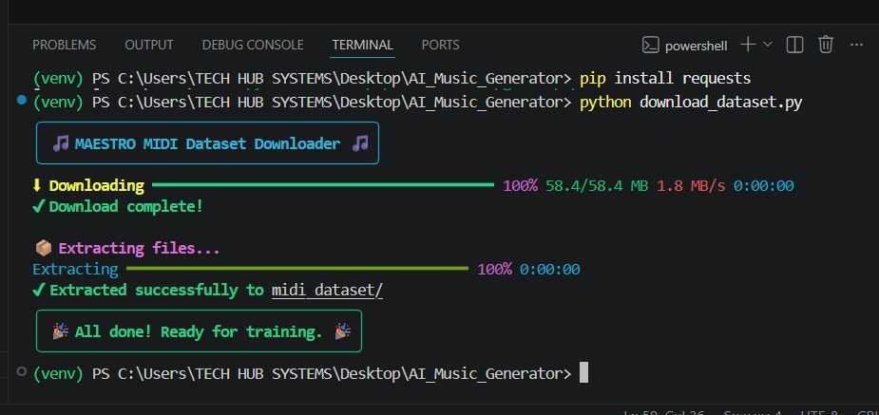
Figure 1: Dataset downloaded (58.4 MB) and extracted successfully to midi_dataset/.

Step 3 — Data Preprocessing (preprocess_data.py)
Each MIDI file was parsed with music21.converter.parse(). Note objects were captured as their pitch, and Chord objects as a dot-separated string of their normal-order pitch classes, producing one flat sequence of musical tokens. The first run was limited to 100 files to validate the pipeline before scaling up.
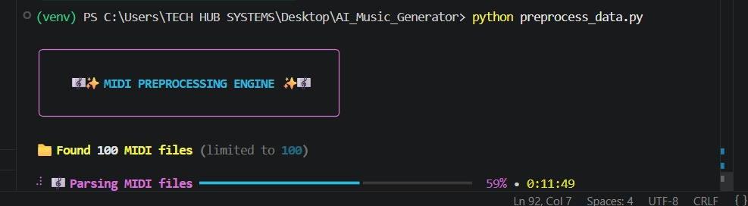
Figure 2: Preprocessing in progress — parsing MIDI files (59% complete).
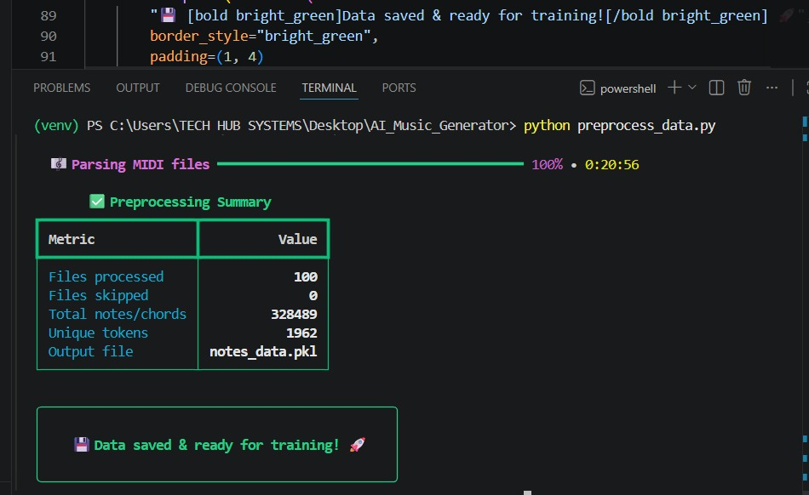
Figure 3: Preprocessing summary — 100 files processed, 328,489 notes/chords extracted, 1,962 unique tokens, saved to notes_data.pkl.

Step 4 — Building the LSTM Model (train_model.py)
The model architecture: an LSTM(256) layer returning sequences, followed by Dropout(0.3), a second LSTM(256), a Dense(256) layer, another Dropout(0.3), and a final Dense(n_vocab) layer with softmax activation — compiled with categorical_crossentropy loss and the Adam optimizer. A ModelCheckpoint callback saved only the best-performing weights, and a custom RichEpochLogger callback fed live epoch/loss information into a rich progress bar.
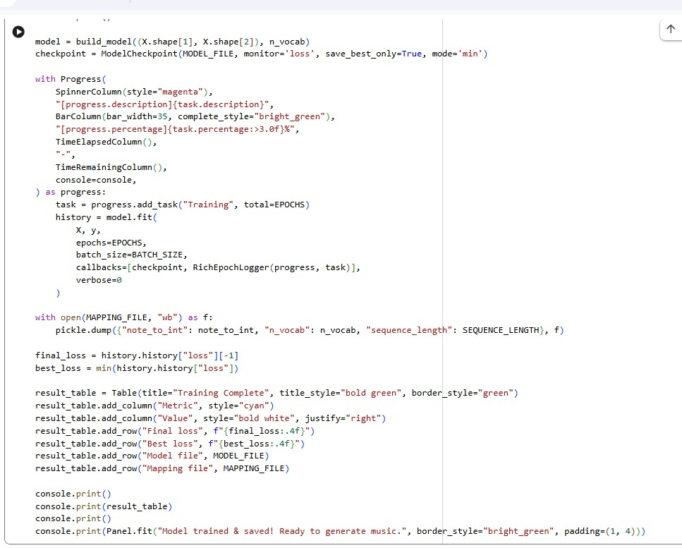
Figure 4: Model-building and training loop code, including the ModelCheckpoint and rich-based progress bar.
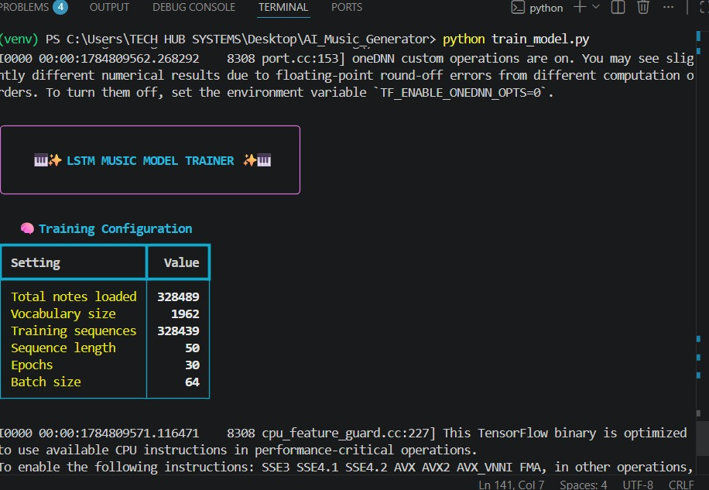
Figure 5: Training configuration for the first (local) run — 328,439 training sequences, vocabulary size 1,962, 30 planned epochs, batch size 64.

Step 5 — Problem Faced: Extremely Slow CPU Training
TensorFlow reported that native GPU acceleration is not available on Windows for TensorFlow ≥ 2.11, so training ran entirely on the CPU. With 328,439 training sequences and a two-layer 256-unit LSTM, a single epoch took roughly 10 minutes; after more than 7 hours of continuous training the run had completed only a fraction of the planned 30 epochs.
To confirm the pipeline itself was correct without waiting hours for every test, EPOCHS was temporarily reduced to 5 and both LSTM layers reduced to 128 units for a smaller local test run.
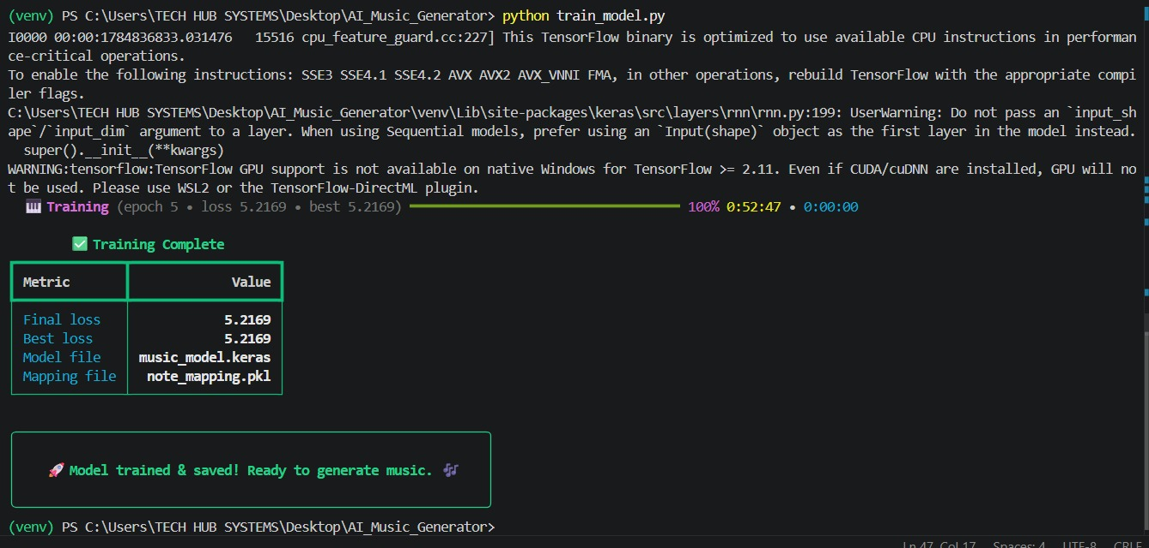
Figure 6: Reduced local CPU test run — 5 epochs completed in 52 minutes 47 seconds, final/best loss 5.2169. This confirmed the pipeline worked correctly, but also confirmed that the full 30-epoch, 256-unit configuration would require 5–6+ hours on CPU alone.

Step 6 — Migrating Training to Google Colab (Free GPU)
Rather than run the full training for several hours on CPU, the training step was moved to Google Colab, which provides a free NVIDIA T4 GPU. A new notebook was created, the runtime type was changed to GPU under Runtime → Change runtime type, and GPU availability was confirmed with tf.config.list_physical_devices('GPU'). The notes_data.pkl file was then uploaded directly into the Colab session.
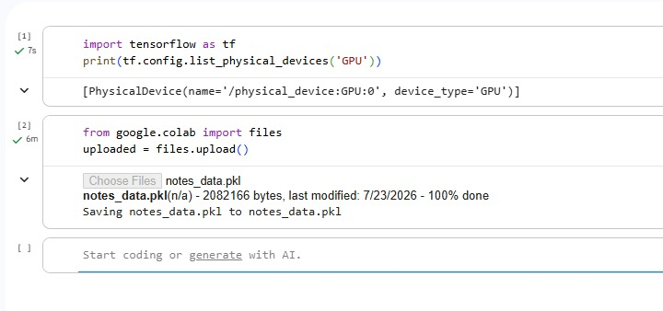
Figure 7: Colab session — T4 GPU detected, and notes_data.pkl (2,082,166 bytes) uploaded successfully.

Step 7 — Full Training on GPU
With GPU acceleration available, the model was restored to its full configuration (two LSTM(256) layers, 30 epochs) and trained again inside Colab.
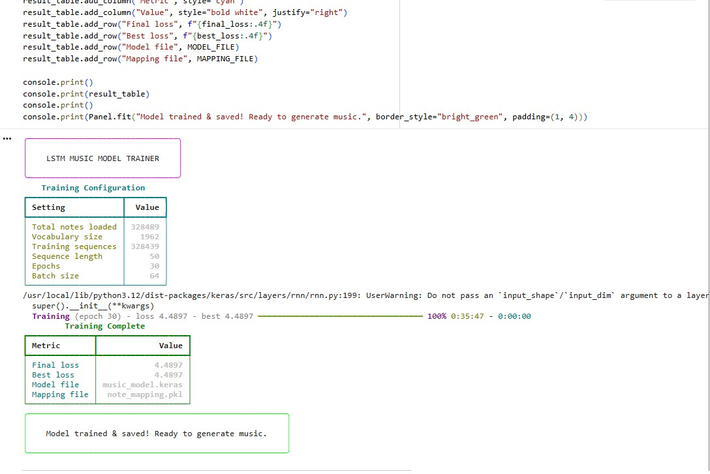
Figure 8: Full GPU training complete — all 30 epochs finished in 35 minutes 47 seconds. Final/best loss improved to 4.4897, compared to 5.2169 from the partial CPU run. Files music_model.keras and note_mapping.pkl were saved.
This represents a roughly 9–10x speed-up over the projected CPU training time for the same configuration, and produced a materially better-trained model.

Step 8 — Retrieving the Trained Model
The trained model and its mapping file were downloaded from Colab back to the local machine using files.download(), then moved into the project's AI_Music_Generator folder, overwriting the earlier CPU-trained versions.
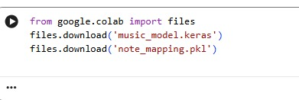
Figure 9: Colab download cell — music_model.keras and note_mapping.pkl.
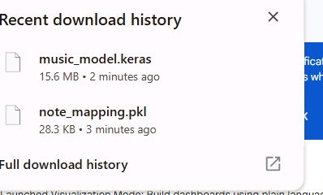
Figure 10: Browser download confirmation — music_model.keras (15.6 MB) and note_mapping.pkl (28.3 KB).
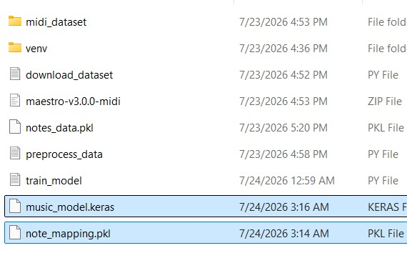
Figure 11: Updated GPU-trained files (music_model.keras, note_mapping.pkl) placed in the local project folder, replacing the earlier CPU-trained versions.

Step 9 — Building the Mood-Based Generator (Upgrade Feature)
generate_music.py implements the task's required Upgrade Feature. Each of five moods maps to its own tempo, MIDI instrument, note velocity, note spacing, and "temperature" value — temperature controls how much randomness is injected into the model's note-by-note predictions (sample_with_temperature), so the same trained model can produce noticeably different musical character depending on the chosen mood.
Mood | Tempo | Instrument | Temperature | Character
Happy | 140 BPM | Piano | 0.9 | Bright, upbeat, closely-spaced notes
Sad | 65 BPM | Piano | 0.6 | Slow, sparse, lower dynamic level
Emotional | 90 BPM | Violin | 1.1 | Expressive, more melodic variation
Sleepy | 50 BPM | Flute | 0.4 | Very slow, soft, minimal randomness
Energetic | 160 BPM | Electric Guitar | 1.3 | Fast, loud, highly varied
The generator loads music_model.keras and note_mapping.pkl, seeds itself with a random sequence from the original training data, then predicts one note at a time — feeding each prediction back in as new input (a sliding window) — for the requested number of notes. music21 then converts this sequence of notes/chords into a proper MIDI file, applying the mood's tempo, instrument and velocity settings.

Step 10 — Running the Generator
The music21 library, required for MIDI construction, was installed, after which the generator was run from the terminal.
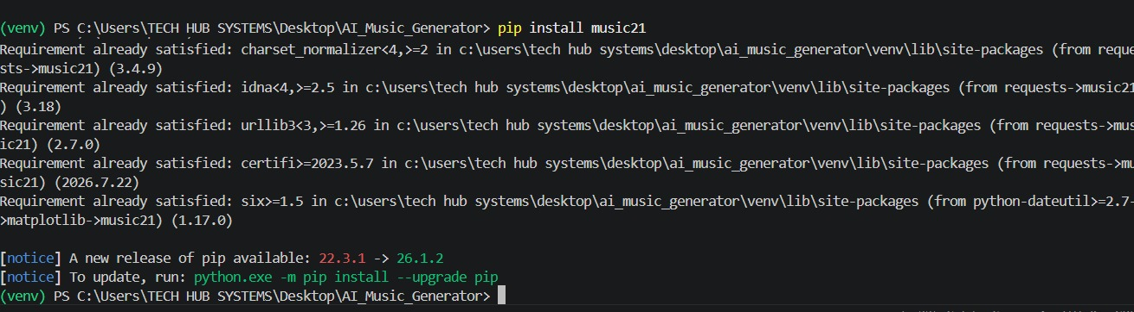
Figure 12: Installing the music21 library.
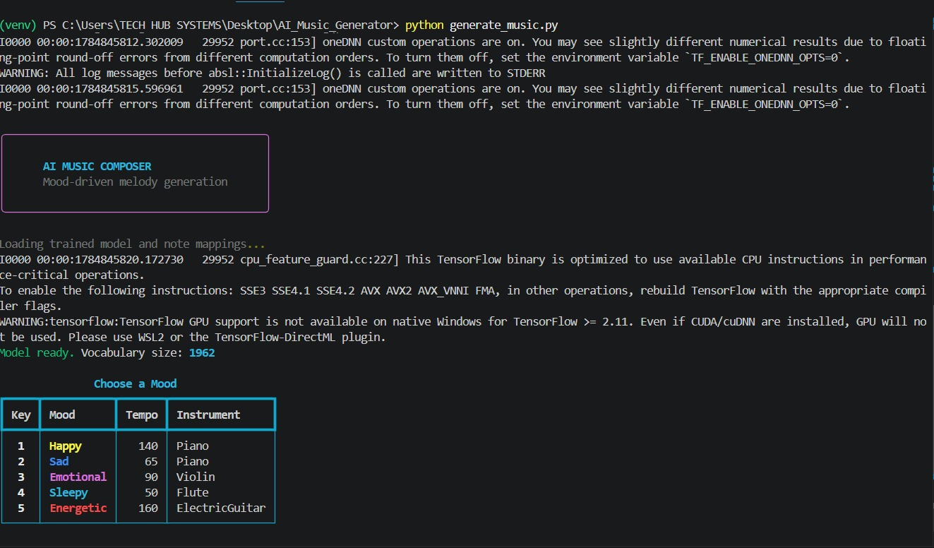
Figure 13: Generator started — trained model loaded (vocabulary size 1,962) and the mood-selection menu displayed.
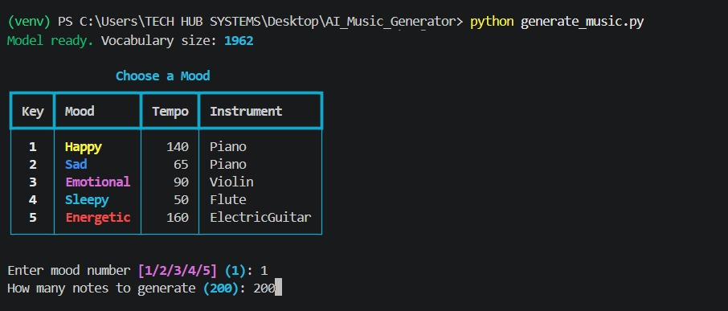
Figure 14: "Happy" mood selected, 200 notes requested for generation.
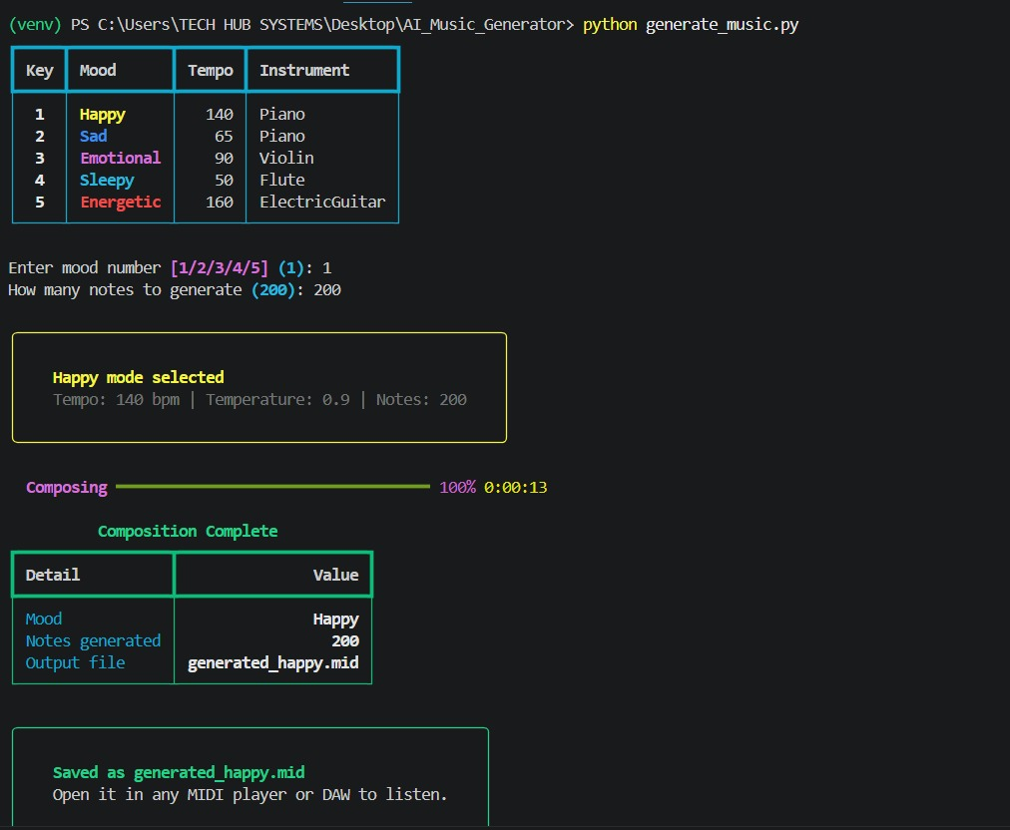
Figure 15: Composition completed in 13 seconds — output saved as generated_happy.mid.

Step 11 — Problem Faced: MIDI Playback
Double-clicking the generated .mid file initially produced no audible playback, because Windows had no MIDI player configured by default. Windows Media Player Legacy's first-run setup wizard appeared; selecting "Recommended settings" and Finish completed the required one-time setup so the file could be played. VLC Media Player was noted as a more consistently reliable alternative for MIDI playback.
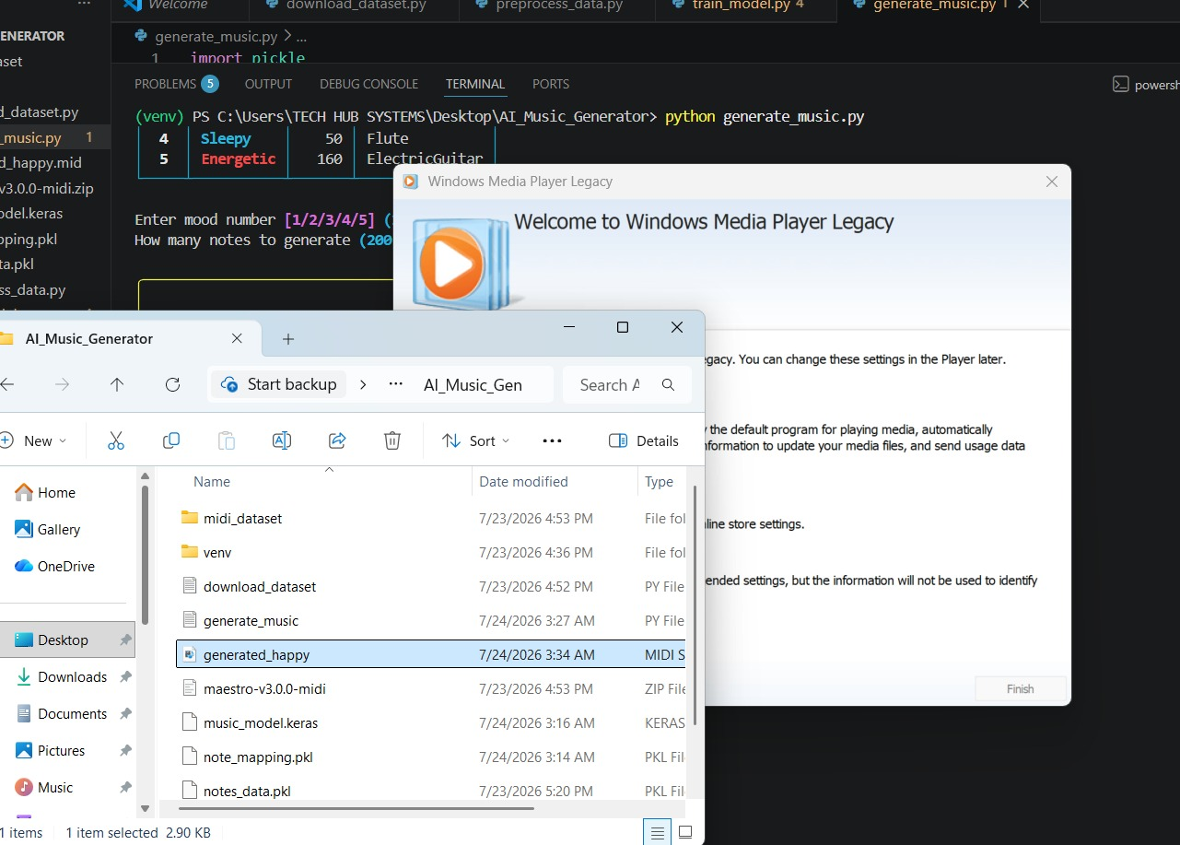
Figure 16: Windows Media Player Legacy's one-time setup wizard, triggered the first time a MIDI file was opened.

6. Problems Faced & Solutions
Problem | Cause | Solution
Extremely slow CPU training (7+ hours, still incomplete) | No native GPU support on Windows for TensorFlow ≥ 2.11; large dataset (328K+ sequences) with a 2×LSTM(256) model | Ran a reduced local test (5 epochs, LSTM(128)) to confirm correctness, then migrated full training to Google Colab's free GPU
Full 30-epoch training projected to take 5–6+ hours on CPU | Same as above | Same 30-epoch configuration completed in 35m 47s on a Colab T4 GPU
"Loss" and "Best loss" showing the same value every epoch | best_loss only updates when a new lower value is reached — expected behaviour while loss is still falling every epoch | Confirmed loss was genuinely decreasing across epochs (5.37 → 4.83 → 4.49)
Antivirus (AVG) pop-ups appearing during development | Unrelated marketing/upsell notifications ("performance issues found", TuneUp trial offer) | Identified as non-critical marketing pop-ups and dismissed via "Skip for now"
Generated .mid file produced no sound on double-click | Windows had no default MIDI player configured | Completed the one-time Windows Media Player Legacy setup wizard; VLC suggested as a more reliable fallback
Downloaded model files needed to reach the exact project folder | Browser downloads land in the Downloads folder by default | Manually moved and replaced music_model.keras and note_mapping.pkl inside the AI_Music_Generator project folder

7. Results
- Dataset processed: 100 MIDI files → 328,489 notes/chords extracted, 1,962 unique tokens.
- Model: 2-layer LSTM(256) network, trained for 30 epochs on a Colab T4 GPU in 35 minutes 47 seconds.
- Final / best training loss: 4.4897 — a clear improvement over the random-guess baseline of ln(1,962) ≈ 7.58, and over the partial CPU run's 5.2169.
- Upgrade Feature delivered: 5 selectable moods (Happy, Sad, Emotional, Sleepy, Energetic), each altering tempo, instrument, note spacing and generation randomness.
- Output: mood-conditioned .mid files, e.g. generated_happy.mid (200 notes, Piano, 140 BPM), generated in 13 seconds.

8. Conclusion
This task provided hands-on experience across the full lifecycle of a generative deep learning project: acquiring and preprocessing a real-world MIDI dataset, designing and training a sequence model (LSTM) to learn musical structure, diagnosing and resolving a genuine hardware performance bottleneck by moving training to a cloud GPU, and building a creative, user-facing generation tool. The mood-based generation feature fulfils Task 3's Upgrade Feature requirement by letting a user directly influence the emotional character of the AI-generated music, extending the base task from a single fixed generator into a flexible, mood-aware music composer.

Appendix A — Full Source Code

A.1 download_dataset.py
import os
import zipfile
import requests
from rich.console import Console
from rich.progress import Progress, BarColumn, DownloadColumn, TransferSpeedColumn, TimeRemainingColumn
from rich.panel import Panel

console = Console()

URL = "https://storage.googleapis.com/magentadata/datasets/maestro/v3.0.0/maestro-v3.0.0-midi.zip"
DEST_ZIP = "maestro-v3.0.0-midi.zip"
DEST_DIR = "midi_dataset"

def download_file(url, dest):
console.print(Panel.fit("MAESTRO MIDI Dataset Downloader", border_style="cyan"))
response = requests.get(url, stream=True)
response.raise_for_status()
total = int(response.headers.get('content-length', 0))

with Progress(
"[progress.description]{task.description}",
BarColumn(bar_width=40, complete_style="green", finished_style="bright_green"),
"[progress.percentage]{task.percentage:>3.0f}%",
DownloadColumn(),
TransferSpeedColumn(),
TimeRemainingColumn(),
console=console,
) as progress:
task = progress.add_task("Downloading", total=total)
with open(dest, 'wb') as f:
for chunk in response.iter_content(chunk_size=8192):
f.write(chunk)
progress.update(task, advance=len(chunk))

console.print("Download complete!")

def extract_zip(zip_path, dest_dir):
console.print("Extracting files...")
with zipfile.ZipFile(zip_path, 'r') as zip_ref:
files = zip_ref.namelist()
with Progress(console=console) as progress:
task = progress.add_task("Extracting", total=len(files))
for file in files:
zip_ref.extract(file, dest_dir)
progress.update(task, advance=1)

console.print(f"Extracted successfully to {dest_dir}/")
console.print(Panel.fit("All done! Ready for training.", border_style="green"))

if __name__ == "__main__":
if not os.path.exists(DEST_ZIP):
download_file(URL, DEST_ZIP)
else:
console.print("Zip already downloaded, skipping download.")
extract_zip(DEST_ZIP, DEST_DIR)

A.2 preprocess_data.py
import os
import pickle
from music21 import converter, instrument, note, chord
from rich.console import Console
from rich.progress import Progress, SpinnerColumn, BarColumn, TimeElapsedColumn
from rich.panel import Panel
from rich.table import Table

console = Console()

DATASET_DIR = "midi_dataset"
OUTPUT_FILE = "notes_data.pkl"
MAX_FILES = 100 # start with a small subset, increase later

def get_midi_files(root_dir):
midi_files = []
for dirpath, _, filenames in os.walk(root_dir):
for f in filenames:
if f.endswith(".midi") or f.endswith(".mid"):
midi_files.append(os.path.join(dirpath, f))
return midi_files

def extract_notes(midi_files):
notes = []
skipped = 0

with Progress(
SpinnerColumn(style="magenta"),
"[progress.description]{task.description}",
BarColumn(bar_width=40, complete_style="bright_cyan", finished_style="bright_green"),
"[progress.percentage]{task.percentage:>3.0f}%",
"-",
TimeElapsedColumn(),
console=console,
) as progress:
task = progress.add_task("Parsing MIDI files", total=len(midi_files))
for file in midi_files:
try:
midi = converter.parse(file)
parts = instrument.partitionByInstrument(midi)
elements = parts.parts[0].recurse() if parts else midi.flat.notes

for el in elements:
if isinstance(el, note.Note):
notes.append(str(el.pitch))
elif isinstance(el, chord.Chord):
notes.append('.'.join(str(n) for n in el.normalOrder))
except Exception:
skipped += 1
progress.update(task, advance=1)

return notes, skipped

if __name__ == "__main__":
files = get_midi_files(DATASET_DIR)[:MAX_FILES]
notes, skipped = extract_notes(files)

with open(OUTPUT_FILE, "wb") as f:
pickle.dump(notes, f)

table = Table(title="Preprocessing Summary")
table.add_column("Metric")
table.add_column("Value")
table.add_row("Files processed", str(len(files) - skipped))
table.add_row("Files skipped", str(skipped))
table.add_row("Total notes/chords", str(len(notes)))
table.add_row("Unique tokens", str(len(set(notes))))
table.add_row("Output file", OUTPUT_FILE)
console.print(table)

A.3 train_model.py
import pickle
import numpy as np
from tensorflow.keras.models import Sequential
from tensorflow.keras.layers import LSTM, Dense, Dropout, Activation
from tensorflow.keras.callbacks import ModelCheckpoint, Callback
from tensorflow.keras.utils import to_categorical
from rich.console import Console
from rich.panel import Panel
from rich.table import Table
from rich.progress import Progress, SpinnerColumn, BarColumn, TimeElapsedColumn, TimeRemainingColumn

console = Console()

NOTES_FILE = "notes_data.pkl"
SEQUENCE_LENGTH = 50
EPOCHS = 30
BATCH_SIZE = 64
MODEL_FILE = "music_model.keras"
MAPPING_FILE = "note_mapping.pkl"

def prepare_sequences(notes, sequence_length):
pitch_names = sorted(set(notes))
note_to_int = {note: num for num, note in enumerate(pitch_names)}

network_input = []
network_output = []

for i in range(len(notes) - sequence_length):
seq_in = notes[i:i + sequence_length]
seq_out = notes[i + sequence_length]
network_input.append([note_to_int[n] for n in seq_in])
network_output.append(note_to_int[seq_out])

n_vocab = len(pitch_names)
X = np.reshape(network_input, (len(network_input), sequence_length, 1))
X = X / float(n_vocab)
y = to_categorical(network_output, num_classes=n_vocab)

return X, y, note_to_int, n_vocab

def build_model(input_shape, n_vocab):
model = Sequential([
LSTM(256, input_shape=input_shape, return_sequences=True),
Dropout(0.3),
LSTM(256),
Dense(256),
Dropout(0.3),
Dense(n_vocab),
Activation('softmax')
])
model.compile(loss='categorical_crossentropy', optimizer='adam')
return model

class RichEpochLogger(Callback):
def __init__(self, progress, task):
super().__init__()
self.progress = progress
self.task = task
self.best_loss = float("inf")

def on_epoch_end(self, epoch, logs=None):
loss = logs.get('loss', 0)
if loss < self.best_loss:
self.best_loss = loss
self.progress.update(
self.task, advance=1,
description=f"Training (epoch {epoch+1} - loss {loss:.4f} - best {self.best_loss:.4f})"
)

if __name__ == "__main__":
console.print()
console.print(Panel.fit("LSTM MUSIC MODEL TRAINER", border_style="bright_magenta", padding=(1, 4)))
console.print()

with open(NOTES_FILE, "rb") as f:
notes = pickle.load(f)

X, y, note_to_int, n_vocab = prepare_sequences(notes, SEQUENCE_LENGTH)

info_table = Table(title="Training Configuration")
info_table.add_column("Setting")
info_table.add_column("Value")
info_table.add_row("Total notes loaded", str(len(notes)))
info_table.add_row("Vocabulary size", str(n_vocab))
info_table.add_row("Training sequences", str(len(X)))
info_table.add_row("Sequence length", str(SEQUENCE_LENGTH))
info_table.add_row("Epochs", str(EPOCHS))
info_table.add_row("Batch size", str(BATCH_SIZE))
console.print(info_table)
console.print()

model = build_model((X.shape[1], X.shape[2]), n_vocab)
checkpoint = ModelCheckpoint(MODEL_FILE, monitor='loss', save_best_only=True, mode='min')

with Progress(
SpinnerColumn(style="magenta"),
"[progress.description]{task.description}",
BarColumn(bar_width=35, complete_style="bright_green"),
"[progress.percentage]{task.percentage:>3.0f}%",
TimeElapsedColumn(),
"-",
TimeRemainingColumn(),
console=console,
) as progress:
task = progress.add_task("Training", total=EPOCHS)
history = model.fit(
X, y,
epochs=EPOCHS,
batch_size=BATCH_SIZE,
callbacks=[checkpoint, RichEpochLogger(progress, task)],
verbose=0
)

with open(MAPPING_FILE, "wb") as f:
pickle.dump({"note_to_int": note_to_int, "n_vocab": n_vocab, "sequence_length": SEQUENCE_LENGTH}, f)

final_loss = history.history["loss"][-1]
best_loss = min(history.history["loss"])

result_table = Table(title="Training Complete")
result_table.add_column("Metric")
result_table.add_column("Value")
result_table.add_row("Final loss", f"{final_loss:.4f}")
result_table.add_row("Best loss", f"{best_loss:.4f}")
result_table.add_row("Model file", MODEL_FILE)
result_table.add_row("Mapping file", MAPPING_FILE)

console.print()
console.print(result_table)
console.print()
console.print(Panel.fit("Model trained & saved! Ready to generate music.", border_style="bright_green", padding=(1, 4)))

A.4 generate_music.py
import pickle
import random
import numpy as np
from tensorflow.keras.models import load_model
from music21 import stream, note, chord, tempo, instrument
from rich.console import Console
from rich.panel import Panel
from rich.table import Table
from rich.prompt import Prompt
from rich.progress import Progress, SpinnerColumn, BarColumn, TimeElapsedColumn

console = Console()

MODEL_FILE = "music_model.keras"
MAPPING_FILE = "note_mapping.pkl"

MOODS = {
"1": {"name": "Happy", "temperature": 0.9, "tempo": 140, "instrument": instrument.Piano(),
"velocity": 90, "note_gap": 0.25, "color": "bright_yellow"},
"2": {"name": "Sad", "temperature": 0.6, "tempo": 65, "instrument": instrument.Piano(),
"velocity": 55, "note_gap": 0.6, "color": "blue"},
"3": {"name": "Emotional", "temperature": 1.1, "tempo": 90, "instrument": instrument.Violin(),
"velocity": 70, "note_gap": 0.45, "color": "magenta"},
"4": {"name": "Sleepy", "temperature": 0.4, "tempo": 50, "instrument": instrument.Flute(),
"velocity": 40, "note_gap": 0.8, "color": "cyan"},
"5": {"name": "Energetic", "temperature": 1.3, "tempo": 160, "instrument": instrument.ElectricGuitar(),
"velocity": 100, "note_gap": 0.2, "color": "red"},
}

def sample_with_temperature(predictions, temperature):
predictions = np.asarray(predictions).astype("float64")
predictions = np.log(predictions + 1e-9) / temperature
exp_preds = np.exp(predictions)
predictions = exp_preds / np.sum(exp_preds)
probas = np.random.multinomial(1, predictions, 1)
return np.argmax(probas)

def generate_notes(model, network_input, int_to_note, n_vocab, num_notes, temperature):
start = random.randint(0, len(network_input) - 1)
pattern = list(network_input[start])
prediction_output = []

with Progress(
SpinnerColumn(style="magenta"),
"[progress.description]{task.description}",
BarColumn(bar_width=35, complete_style="bright_green"),
"[progress.percentage]{task.percentage:>3.0f}%",
TimeElapsedColumn(),
console=console,
) as progress:
task = progress.add_task("Composing", total=num_notes)

for _ in range(num_notes):
prediction_input = np.reshape(pattern, (1, len(pattern), 1))
prediction_input = prediction_input / float(n_vocab)

prediction = model.predict(prediction_input, verbose=0)[0]
index = sample_with_temperature(prediction, temperature)
result = int_to_note[index]
prediction_output.append(result)

pattern.append(index)
pattern = pattern[1:]

progress.update(task, advance=1)

return prediction_output

def create_midi(prediction_output, mood, output_file):
offset = 0
output_notes = []
instr = mood["instrument"]

for pattern in prediction_output:
if ("." in pattern) or pattern.isdigit():
notes_in_chord = pattern.split(".")
chord_notes = []
for current_note in notes_in_chord:
new_note = note.Note(int(current_note))
new_note.storedInstrument = instr
new_note.volume.velocity = mood["velocity"]
chord_notes.append(new_note)
new_chord = chord.Chord(chord_notes)
new_chord.offset = offset
output_notes.append(new_chord)
else:
new_note = note.Note(pattern)
new_note.offset = offset
new_note.storedInstrument = instr
new_note.volume.velocity = mood["velocity"]
output_notes.append(new_note)

offset += mood["note_gap"]

midi_stream = stream.Stream()
midi_stream.append(tempo.MetronomeMark(number=mood["tempo"]))
midi_stream.append(instr)
for n in output_notes:
midi_stream.append(n)

midi_stream.write("midi", fp=output_file)

def show_mood_menu():
table = Table(title="Choose a Mood")
table.add_column("Key")
table.add_column("Mood")
table.add_column("Tempo")
table.add_column("Instrument")

for key, m in MOODS.items():
table.add_row(key, m["name"], str(m["tempo"]), type(m["instrument"]).__name__)

console.print(table)
console.print()

if __name__ == "__main__":
console.print()
console.print(Panel.fit("AI MUSIC COMPOSER\nMood-driven melody generation", border_style="bright_magenta"))
console.print()

model = load_model(MODEL_FILE)

with open(MAPPING_FILE, "rb") as f:
mapping_data = pickle.load(f)

note_to_int = mapping_data["note_to_int"]
n_vocab = mapping_data["n_vocab"]
sequence_length = mapping_data["sequence_length"]
int_to_note = {num: note_ for note_, num in note_to_int.items()}

with open("notes_data.pkl", "rb") as f:
notes = pickle.load(f)

network_input = []
for i in range(len(notes) - sequence_length):
seq_in = notes[i:i + sequence_length]
network_input.append([note_to_int[n] for n in seq_in])

console.print(f"Model ready. Vocabulary size: {n_vocab}\n")

show_mood_menu()
choice = Prompt.ask("Enter mood number", choices=list(MOODS.keys()), default="1")
mood = MOODS[choice]

num_notes_str = Prompt.ask("How many notes to generate", default="200")
num_notes = int(num_notes_str)

prediction_output = generate_notes(model, network_input, int_to_note, n_vocab, num_notes, mood["temperature"])

output_file = f"generated_{mood['name'].lower()}.mid"
create_midi(prediction_output, mood, output_file)

result_table = Table(title="Composition Complete")
result_table.add_column("Detail")
result_table.add_column("Value")
result_table.add_row("Mood", mood["name"])
result_table.add_row("Notes generated", str(num_notes))
result_table.add_row("Output file", output_file)
console.print()
console.print(result_table)
console.print()
console.print(Panel.fit(f"Saved as {output_file}\nOpen it in any MIDI player or DAW to listen.", border_style="bright_green"))

