## **Installing**

### **Dependencies**

For all platforms (Raspberry Pi and Beaglebone Black) make sure your system is able to compile and download Python extensions with ****pip****:

On Raspbian or Beaglebone Black's Debian/Ubuntu image you can ensure your system is ready by running one or two of the following sets of commands:

**Python 2:**

sudo apt-get update

sudo apt-get install python-pip

sudo python -m pip install --upgrade pip setuptools wheel

**Python 3:**

sudo apt-get update

sudo apt-get install python3-pip

sudo python3 -m pip install --upgrade pip setuptools wheel

### **Install with pip**

Use pip to install from PyPI.

Python 2:

sudo pip install Adafruit_DHT

Python 3:

sudo pip3 install Adafruit_DHT

# Wiring Dht22 sensor with rasspbrry pi

Dht22 rasspbrry pi

Vcc vcc

Gno gno

Do gpio 4

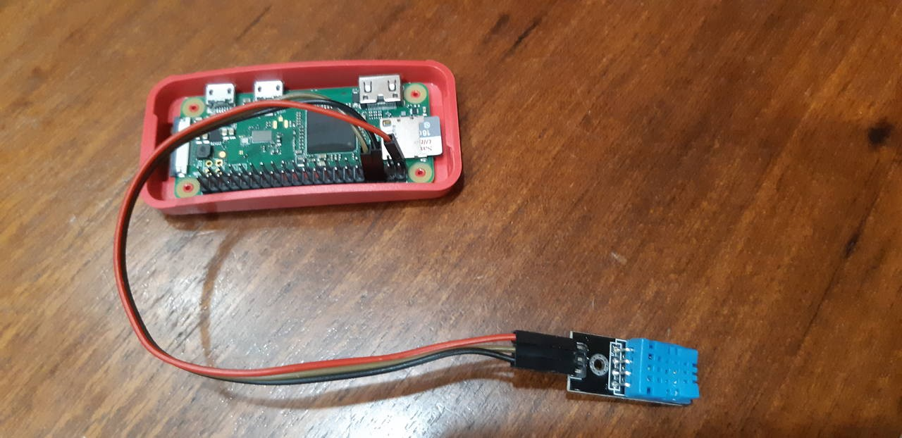

## **Basics**

Of course, you must import the library to use it:

|  |
| --- |
|  |
| Import Adafruit_DHT |
|  |

The DHT type devices use single data wire, so import the board pin

|  |
| --- |
| DHT_SENSOR =4 Adafruit_DHT.DHT22 |
|  |  |

While loop for continous wokring

|  |
| --- |
|  |
| While True: |
|  |

OR initialize the DHT22 device:

|  |
| --- |
|  |
| humidity, temperature = Adafruit_DHT.read_retry(DHT_SENSOR, DHT_PIN) |
|  |

## **Read temperature and humidity**

Now get the temperature and humidity values

|  |
| --- |
|  |
| if humidity is not None and temperature is not None: |
| |  | | --- | | print("Temp={0:0.1f}*C Humidity={1:0.1f}%".format(temperature, humidity)) | |  | else: | |  | print("Failed to retrieve data from humidity sensor") | |

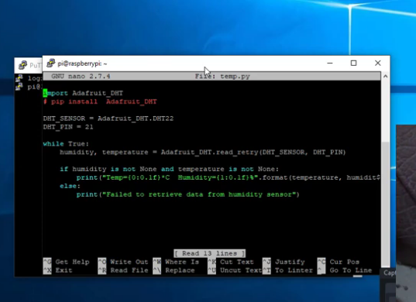

Run python filename.py

