# **Making a LED blink using the Raspberry Pi and Python**

## Setting up the circuit

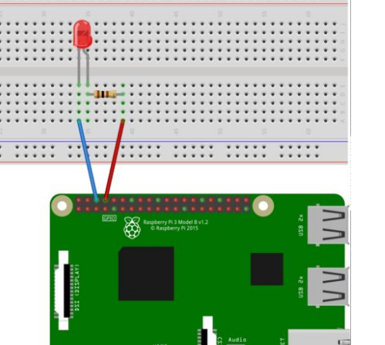

## Writing the Python Software to blink the LED

To install the Python library open a terminal and execute the following

sudo apt-get install python-rpi.gpio python3-rpi.gpio

Our script needs to do the following:

* Initialize the GPIO ports
* Turn the LED on and off in 1 second intervals

To initialize the GPIO ports on the Raspberry Pi we need to first import the Python library, the initialize the library and setup pin 8 as an output pin.

import RPi.GPIO as GPIO # Import Raspberry Pi GPIO library

from time import sleep # Import the sleep function from the time module

GPIO.setwarnings(False) # Ignore warning for now

GPIO.setmode(GPIO.BOARD) # Use physical pin numbering

GPIO.setup(8, GPIO.OUT, initial=GPIO.LOW) # Set pin 8 to be an output pin and set initial value to low (off)

Combining the initialization and the blink code should give you the following full Python program:

import RPi.GPIO as GPIO # Import Raspberry Pi GPIO library

from time import sleep # Import the sleep function from the time module

GPIO.setwarnings(False) # Ignore warning for now

GPIO.setmode(GPIO.BOARD) # Use physical pin numbering

GPIO.setup(8, GPIO.OUT, initial=GPIO.LOW) # Set pin 8 to be an output pin and set initial value to low (off)

while True: # Run forever

GPIO.output(8, GPIO.HIGH) # Turn on

sleep(1) # Sleep for 1 second

GPIO.output(8, GPIO.LOW) # Turn off

sleep(1) # Sleep for 1 second

With our program finished, save it as blinking_led.py and run it either inside your IDE or in the console with:

python blinking_led.py