🛒Customer Shopping Behavior — End-to-End Data Analytics Project

Analyzing customer purchasing patterns using Python, SQL, and Power BI to uncover revenue drivers, seasonal trends, and customer segments.

---

📌 Overview
This project is a complete, end-to-end data analytics workflow built to demonstrate real-world skills across the full analytics stack — from raw data ingestion to executive-ready reporting.

The goal was to analyze customer shopping behavior, identify high-value segments, and surface actionable business insights through interactive dashboards and a structured report.

Key questions answered:
- Which age groups generate the most revenue?
- How does purchase behavior shift across seasons?
- Do discounts grow sales or just erode margins?
- What does the customer base look like by loyalty segment?
- Does shipping preference correlate with higher order value?

---

📂 Dataset
| Attribute | Detail |
|----------------|---------------------------------|
| **Source** | [Specify source — e.g., Kaggle] |
| **File** | `shopping_behavior.csv` |
| **Rows** | ~3,900 records |
| **Key Columns** | Age, Gender, Category, Season, Purchase Amount, Discount Applied, Shipping Type, Frequency of Purchases |

---

🛠️ Tools & Technologies
| Layer | Tool / Technology |
|--------------------------|------------------------------------|
| Language | Python |
| Data Manipulation | pandas |
| Visualization (EDA) | Power Bi |
| Database | MySQL |
| BI Dashboard | Power BI Desktop|
| Reporting | Microsoft Word (`.docx`) |
| Presentation | Gamma (AI-powered slides) |
| Environment | Jupyter Notebook |

🔄 Project Workflow

```
Raw CSV → Python (EDA & Cleaning) → SQL Database → Power BI → Report & PPT
```

Step 1 — Load & Explore Data (Python)
- Loaded the dataset using `pandas`
- Inspected shape, data types, null values, and duplicates
- Performed Exploratory Data Analysis (EDA):
- Distribution of age, purchase amount, and category
- Revenue breakdown by age group, season, and shipping type

Step 2 — Data Cleaning (Python)
- Handled missing values
- Standardised column names
- Exported the cleaned dataset for SQL ingestion

Step 3 — SQL Analysis (MySQL)
- Imported cleaned data into a relational database
- Wrote queries covering:
- Revenue aggregation by age group, season, and category
- Window functions (`RANK`, `ROW_NUMBER`, `LAG`) for trend analysis
- CTEs for customer segmentation logic
- `CASE WHEN` logic for discount tier classification
- `GROUP BY` / `HAVING` for filtering high-value cohorts

📁 All SQL queries are saved in the `/sql/` folder.
Step 4 — Power BI Dashboard
- Connected Power BI Desktop to the SQL database
- Built an interactive dashboard with:
- No. of customers (cardboard)
- Average Purchase Amount (cardboard)
- Average Review Rating (cardboard)
- Revenue by Category (column chart)
- Sales by Category (column chart)
- Revenue by Age Group (bar chart)
- Sales by Age Group (bar chart)
- Customer Segment Distribution (donut chart)
- Applied slicers for Subscription_status, Gender, Category and shipping_type

📁 Dashboard file: `/powerbi/shopping_dashboard.pbix`
Step 5 — Report & Presentation
- Wrote a structured project report (`.docx`) covering Executive Summary, Problem Statement, Data Source & Description, Methodology, SQL Queries Used, Key Findings, Visualizations Summary, Recommendations.
- Built a presentation using **Gamma** with AI-assisted slide design

📁 Report: `/Project Report.docx`
📁 Slides: `/Customer-Shopping-Behavior-Analysis.pptx`
📊 Dashboard Preview

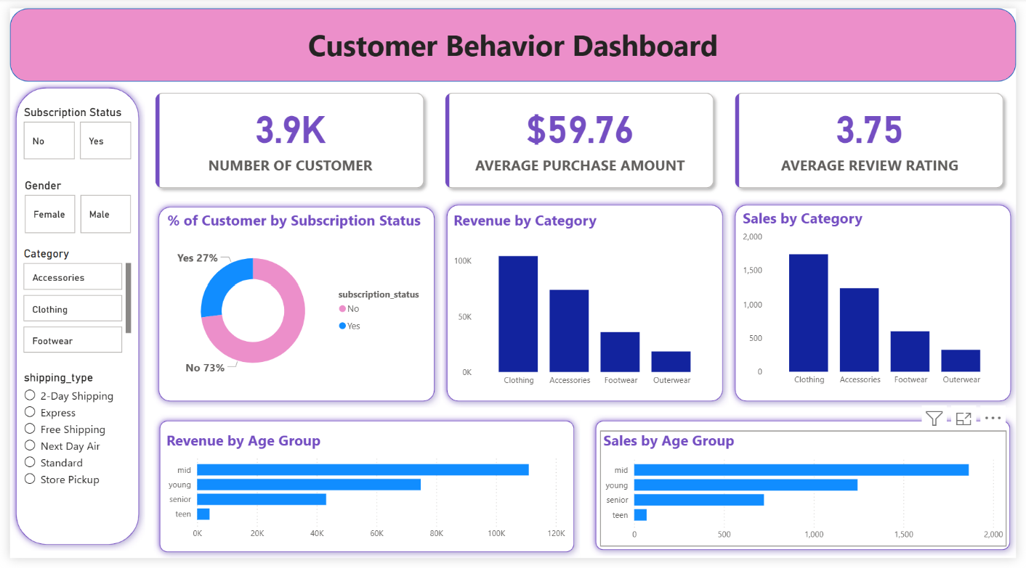

---

📈 Key Results

| Finding | Insight |
|--------|---------|

| Age Group Revenue | Certain age group (mid) generate disproportionately higher revenue ($110945), indicating prime target demographics for marketing |

| Seasonal Patterns | Purchase behavior varies across seasons, with specific categories peaking in different seasons. Clothing in spring generating $27692, accessories in fall $19847, footwear in spring $9555, outerwear in fall $5259 |

| Discount Effect | Discounts influence purchase amounts, requiring careful balance between volume growth and margin control |

| Customer Segments | The majority of customers fall in the ‘Loyal’ segment, total no. of customers 3116 with avg_spend of $59.5 |

| Shipping Preference | 2-Day Shipping users tend to have higher average order values |

---

🗂️ Folder Structure

```
📦 customer-shopping-analytics/
├── 📁 data/
│ └── shopping_behavior_raw.csv
| └──shopping_behavior.csv
│ └── shopping_behavior_cleaned.csv
├── 📁 notebooks/
│ └── 01_eda.ipynb
│ └── 02_cleaning.ipynb
├── 📁 sql/
│ └── analysis queries.sql
├── 📁 powerbi/
│ └── shopping_behavior_dashboard.pbix
├── 📁 report/
│ └── Project Report docx
├── 📁 presentation/
│ └── shopping_behavior_Deck.pdf
└── README.md
```

---

How to Run
1. Clone the repo and install dependencies: `pandas`, `numpy`, `sqlalchemy`, `pymysql`, `jupyter`
2. Run notebooks in `notebooks/` to clean and explore the data
3. Load cleaned data into MySQL and run `sql/analysis_queries.sql`
4. Open `powerbi/shopping_dashboard.pbix`, update the data source, and refresh## 🙋 About

📧 Mail : noormohd139802@gmail.com, 💼 LinkedIn Profile : https://www.linkedin.com/in/noor-mohammad-9a0831169/ 🐙 [GitHub Profile : https://github.com/noormohd139802-svg

---

Built as part of a portfolio project to demonstrate end-to-end data analytics skills.

