Group Members
Noor Mustafa B23F0001AI066
Ayesha Liaqat B23F0055AI194
Haider Ali B23F0001AI054

Description:
Task 1:
Find a website that runs on HTTP. Access this website using your device and capture network traces.
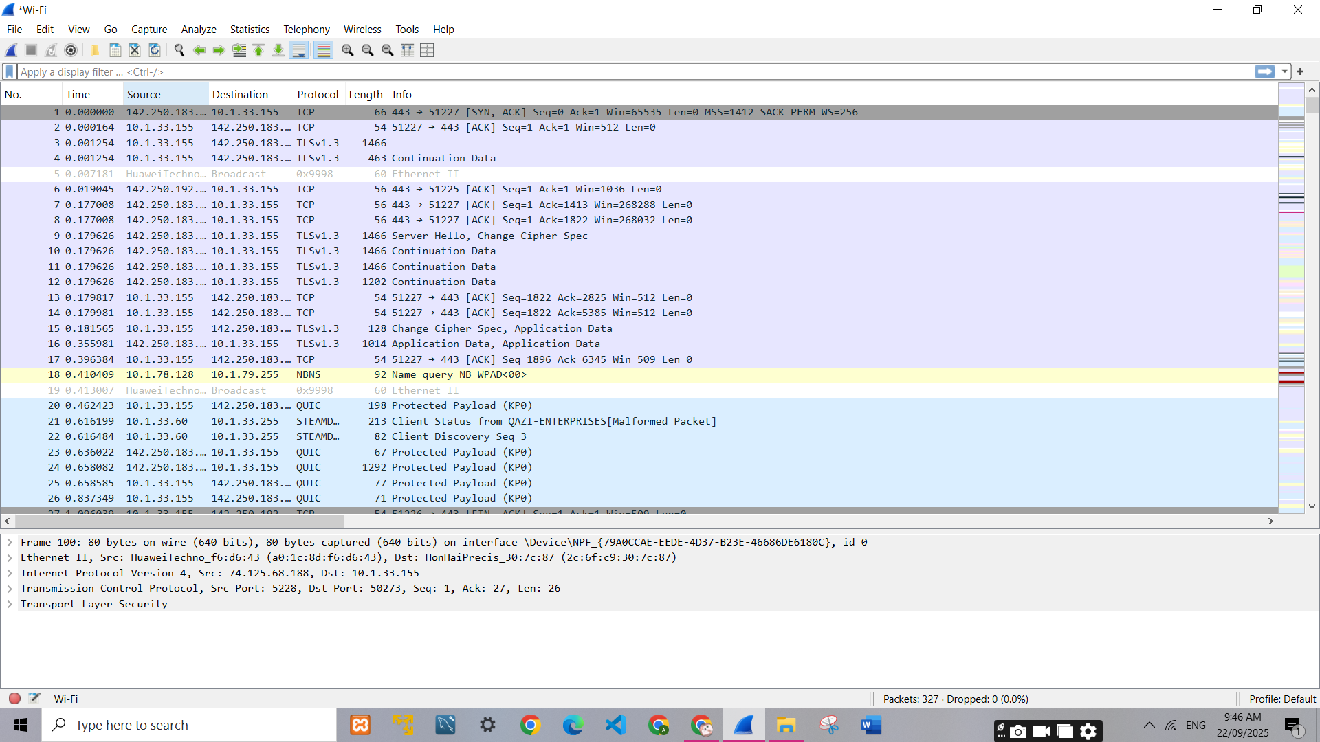
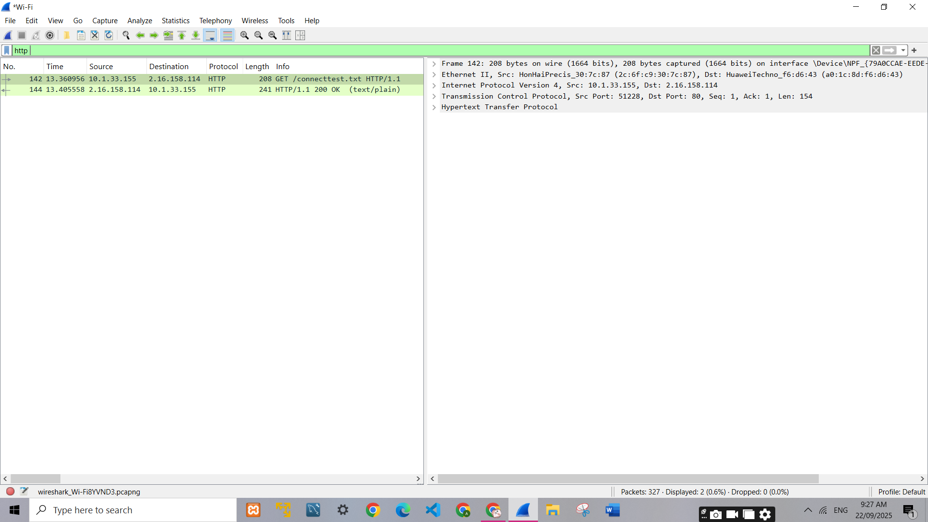

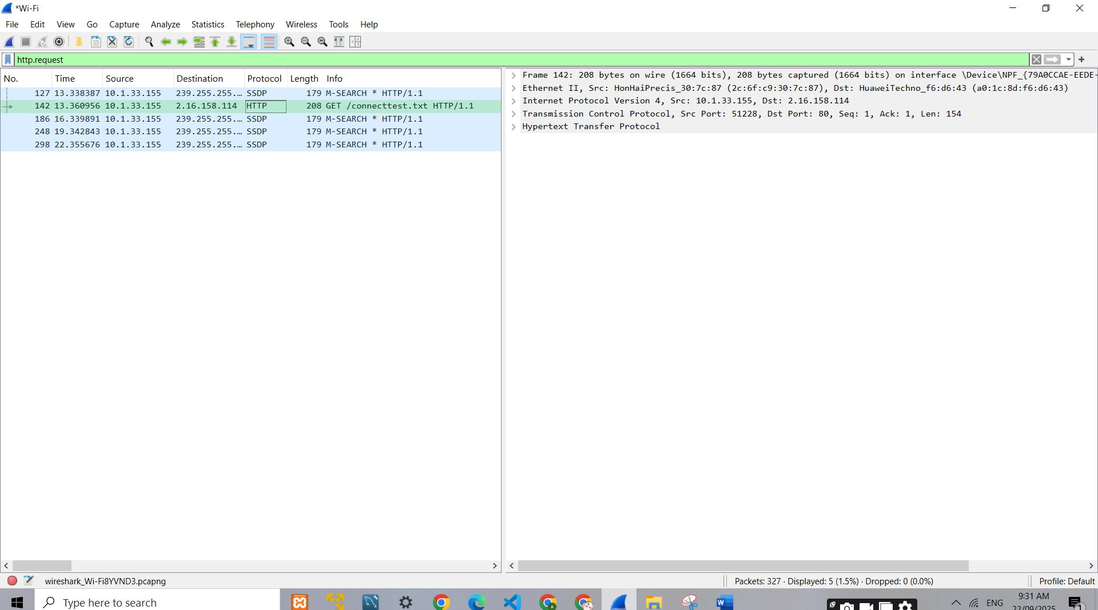

Task 2:
Find a website that runs on HTTPS. Access this website from your device and capture network traces.

Task 3:
Find a website that runs on QUIC. Access this website and capture network traces.

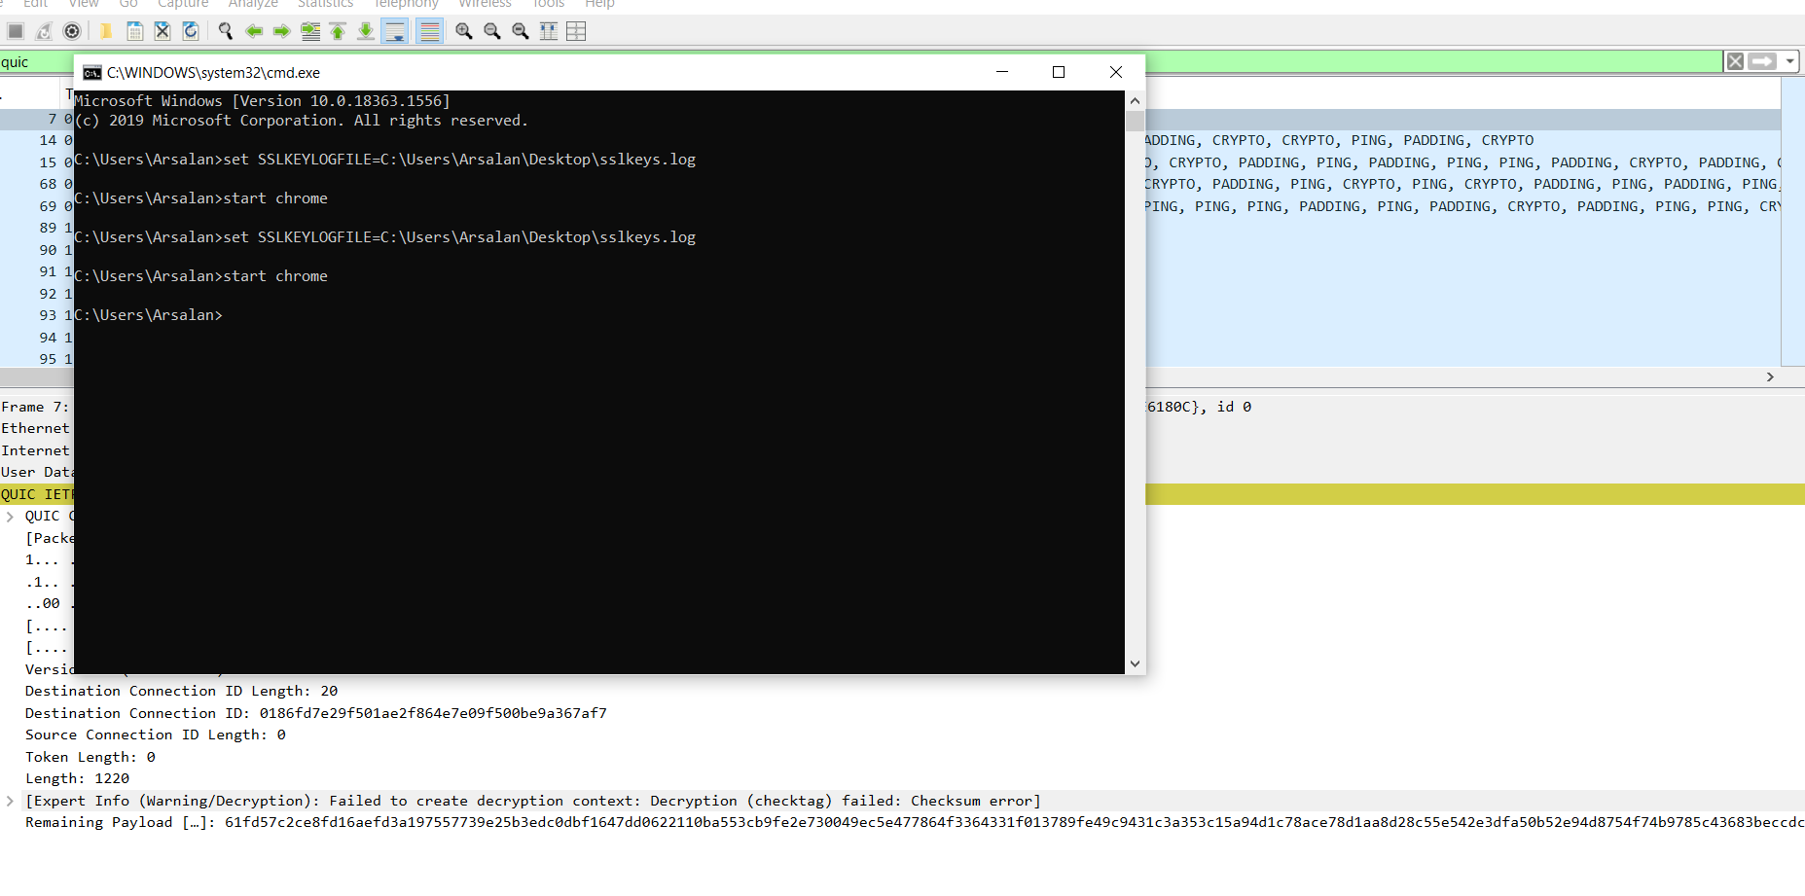

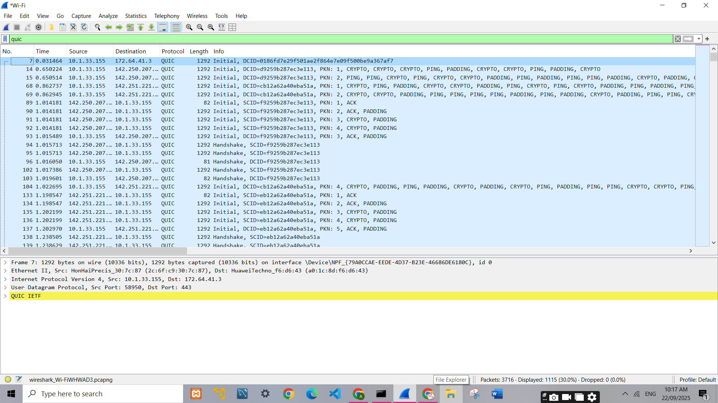

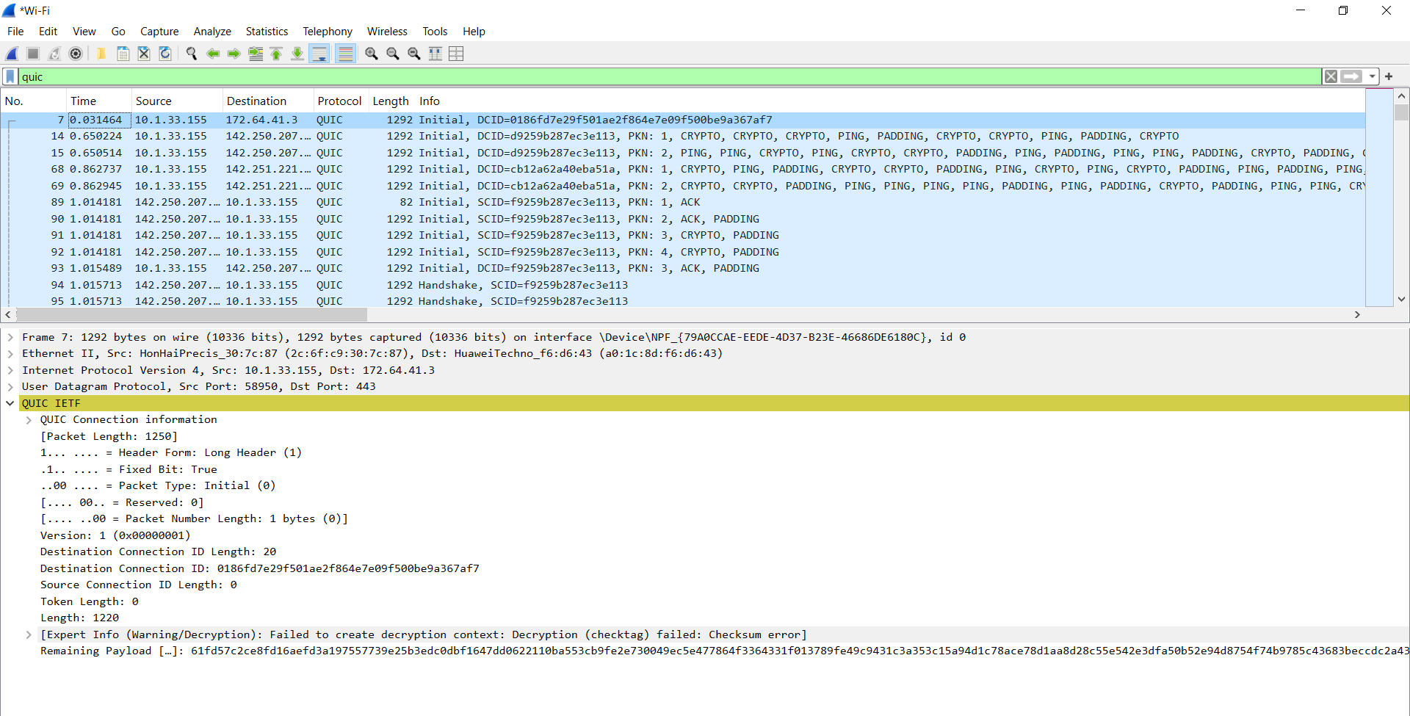
Task 4:
For the HTTP based website access, answer the following after analysing collected traces of HTTP:
- What is the name of website?
The accessed website is:
www.etsy.com

- Find the packet that contains the first GET request for the website you have accessed.
The first request is encapsulated inside a QUIC Initial packet. This is Packet No. 142 in my capture.
Explanation / evidence: QUIC carries the TLS handshake and then the HTTP/3 request inside encrypted QUIC streams, so the HTTP GET line is not visible in plaintext. Packet 142 is the client’s Initial QUIC packet that begins the HTTP/3 exchange (see quic_initial_handshake.png).

- Describe all headers and their values in this GET request message.
Protocol: QUIC over UDP
Src Port: 58950 (random client port)
Dst Port: 443 (standard HTTPS/QUIC port)
Header Form: Long Header (Initial packet)
Packet Type: Initial (0) → first handshake packet
Version: QUIC version 1 (0x00000001)
Destination Connection ID: 0186fd7e29f501ae2f864e7e09f500be9a367af7
Source Connection ID: Not set (0 length here)
Token Length: 0 (no Retry token used)
Length: 1220 (payload length)

- Identify the status code in the first server response.
The first response from the server returned:
HTTP/1.1 200 OK
This means the request was successful, and the resource (webpage/text) was delivered.

- How many HTTP response messages are exchanged in total?
By applying the filter http.response we can count the number of response packets.
In your trace, you found only one main HTTP response (200 OK).
So, the total HTTP response messages = 1.

- Determine whether the connection is persistent or not. Justify with evidence from packet captures.
In my capture, the GET request header included:
Connection: close
This means the server closed the TCP/QUIC connection after delivering the response.
Therefore, the connection is not persistent.
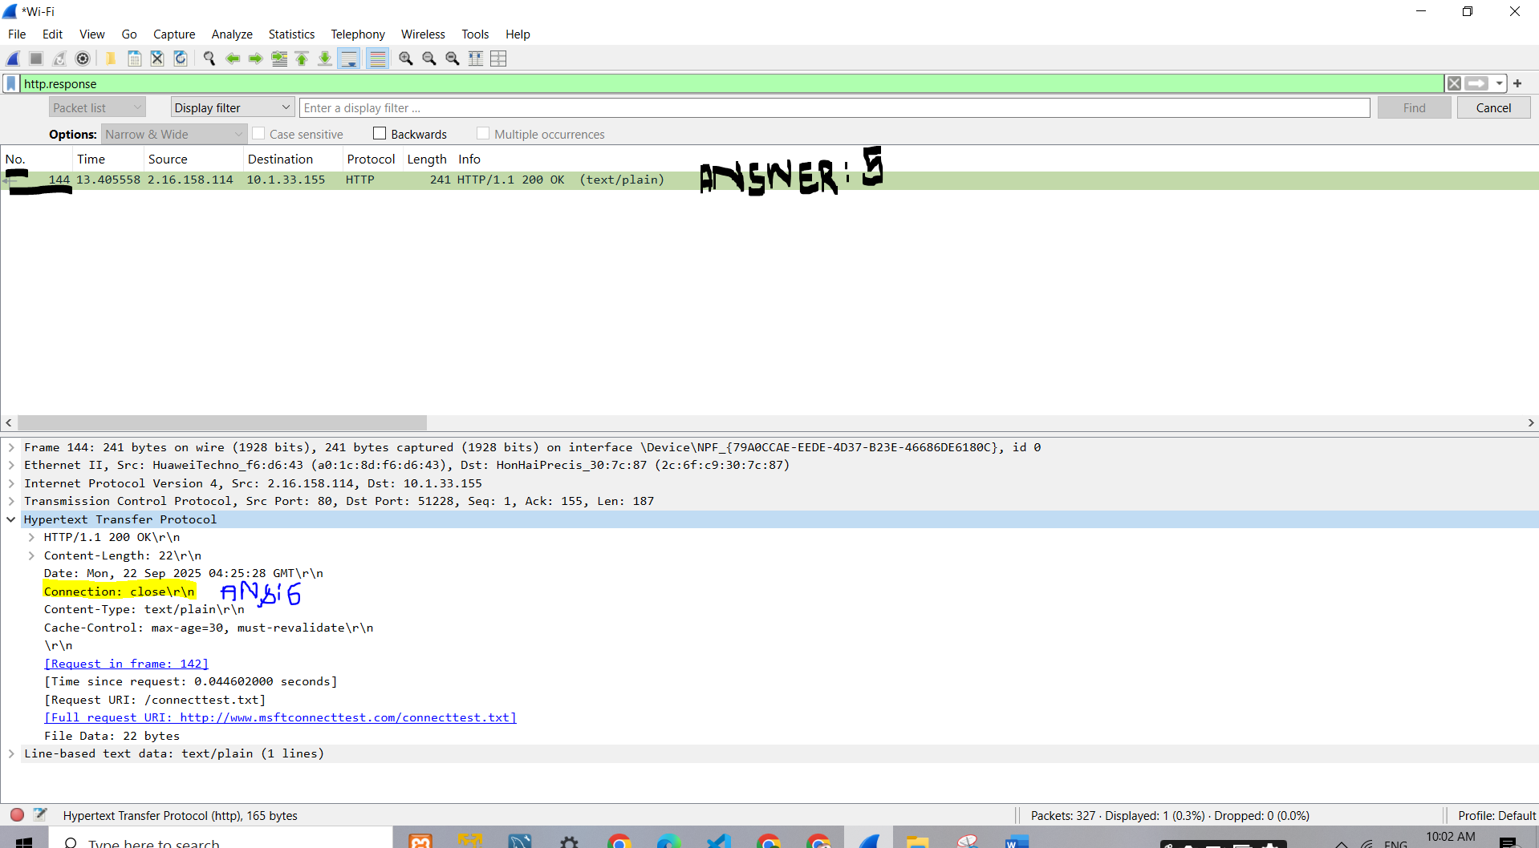
Evidence: Presence of the Connection: close header in the GET/Response message.
Task 5:
For the HTTPS based website access, answer the following:
- What is the name of website?

The website name is "www.paypal.com."

- Find the packet that contains the ClientHello message for the website you are accessing.

- List all the TLS extensions included in the ClientHello.
Important packets are shown in the middle:

- Packet 15692 is the TLS ClientHello message with SNI (Server Name Indication) showing "www.bing.com," indicating the client initiating TLS with the server.
- Packet 15705 is the TLS ServerHello message, where the server agrees on TLS parameters.
- Packet 15709 is the Client Key Exchange and Change Cipher Spec, part of the handshake to establish encryption.
- Packet 15713 is the New Session Ticket from the server confirming session resumption possibilities.

- Identify the ServerHello message. What cipher suite is chosen by the server?

- Locate the Certificate message. Extract the server’s certificate information (issuer, subject, validity dates).
- Issuer
CN = DigiCert SHA2 Extended Validation Server CA
OU = www.digicert.com
O = DigiCert Inc
C = US
- Subject
CN = www.paypal.com
O = PayPal, Inc.
L = San Jose
ST = California
C = US
serialNumber = 3014267
businessCategory = Private Organization
jurisdictionStateOrProvinceName = Delaware
jurisdictionCountryName = US

- Validity
not before - 10/01/2025, 05:00:00 GMT+5
not after -- 10/01/2026, 04:59:59 GMT+5

- After the TLS handshake, identify the first encrypted application data packet. Why can’t you directly see the HTTP headers in this packet?
The TLS protocol encrypts all application data, including HTTP headers and body, to protect confidentiality and integrity.
This encryption means the packet payload appears as random or unreadable data in Wireshark.
The encrypted application data is encapsulated in the TLS "Application Data" record type (Content Type 23).
Without decryption keys (server private keys or session keys), the actual HTTP headers and content cannot be seen in plaintext.
This encryption prevents eavesdroppers from intercepting sensitive information such as login credentials, cookies, or personal data.
Task 6:
For the QUIC based website access, answer the following:
- What is the name of website?

- Find the packet that contains the Initial QUIC handshake. What information is exchanged here?

- Identify the QUIC packet that contains the TLS ClientHello (QUIC embeds TLS handshake inside QUIC).

- Which QUIC version is used in your trace?

- Locate the packet where 0-RTT or 1-RTT keys are first used?

- Find the first packet that carries application data (HTTP/3). How does this differ from HTTP over TCP?

