**User management :**

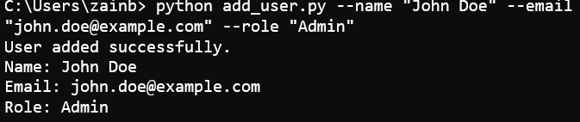

**File management :**

**Storage management :**

**Billing managenment :**

**User analytics :**

