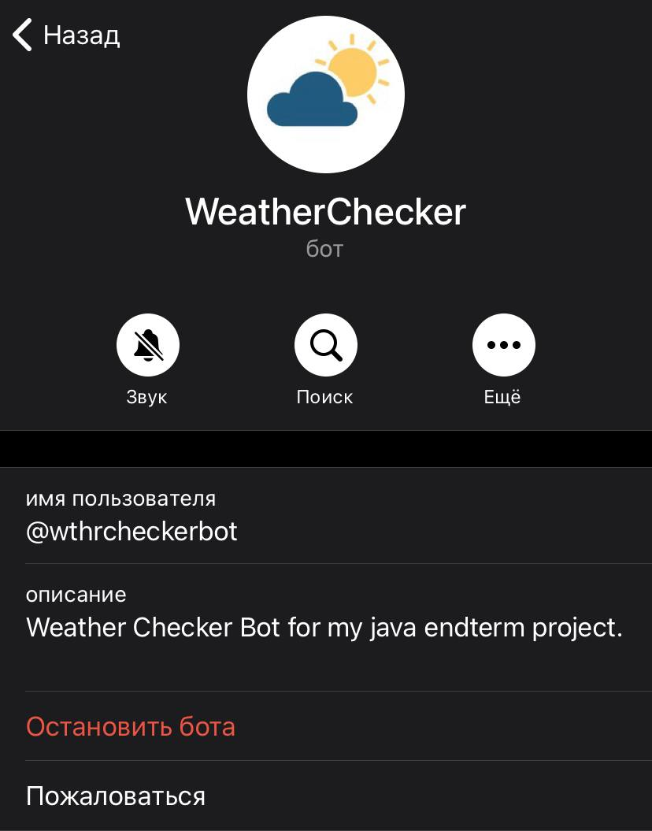

Here you can see info about my telegram bot that helps you find out weather forecast for your city. Very simple to use and very useful in daily life. Can be upgraded via adding some other new functions thus extending bot’s ability.

Let’s see how it works! At first you will this sign. That describes the bot. We need to press “Start” button.

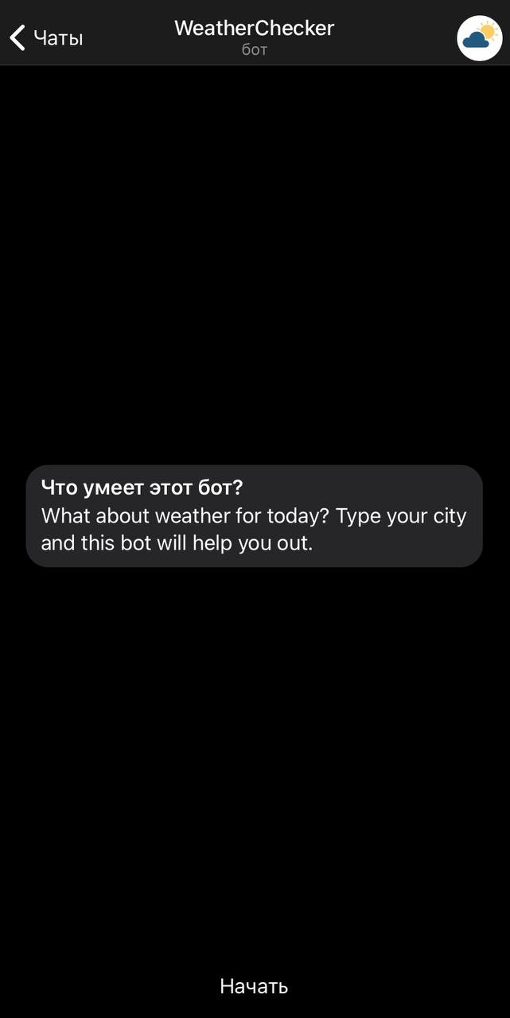

Step 2. What we can do next? Let’s try to type /help to get some help from our bot.

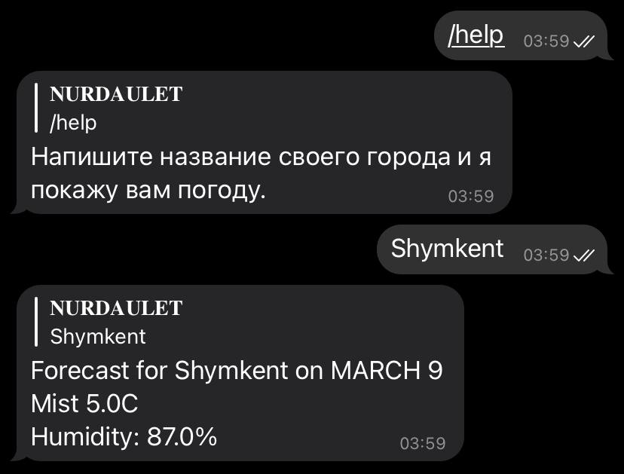

Step 3. Type your city name and receive your forecast for today!



To create this project I used my brain, hands (just joking, please don’t take it seriously), some answers from google and Telegram. Coded everything in Intellij Idea.

Here’s link for github : <https://github.com/noorsace/weathercheckerbot/tree/main/TelegramBotApi>