1. Creating and Renaming Files/Directories

Create a directory named test_dir using mkdir.

Inside test_dir, create an empty file called example.txt.

Rename example.txt to renamed_example.txt using mv

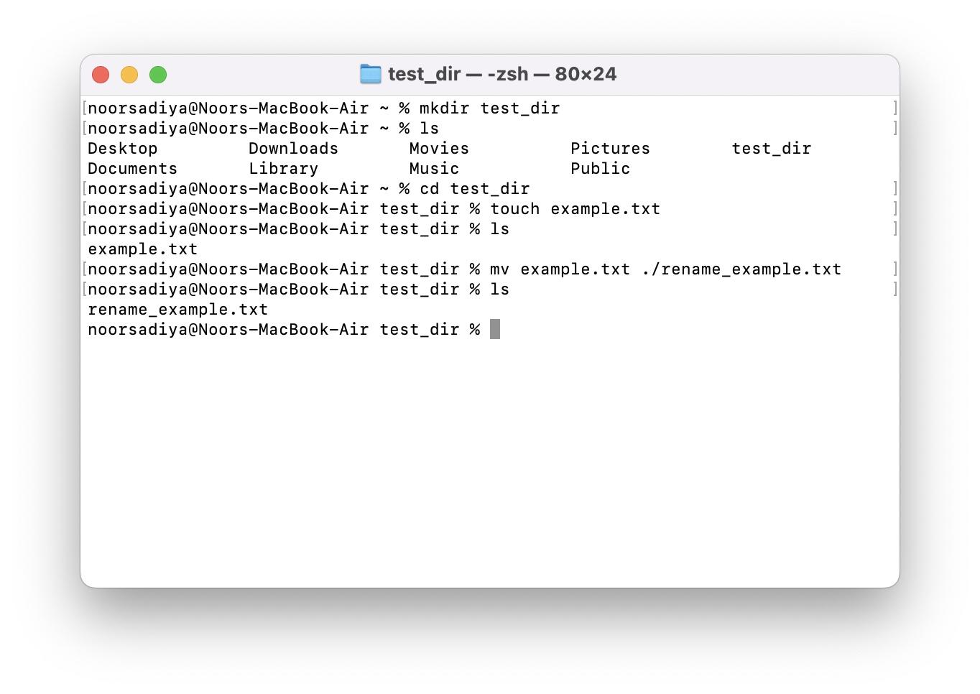

Explanation:

1. mkdir command creates test_dir which can be confirmed with ls command.

2. example.txt file is created using touch file under test_dir directory, can be seen as

a file created using ls command.

3. mv command used to rename the file to rename_example.tx, can be seen as a file

created using ls command.

2. Viewing File Contents

Use cat to display the contents of /etc/passwd.

Display only the first 5 lines of /etc/passwd using head.

Display only the last 5 lines of /etc/passwd using tail.

Explanation:

1. cat /etc/passwd shows the contents of the passwd file.
2. head -n 5 /etc/passwd shows the first 5 lines of the passwd file.
3. tail -n 5 /etc/passed shows the last 5 lines of the passwd file.

3.Searching for Patterns

Use grep to find all lines containing the word "root" in /etc/passwd.

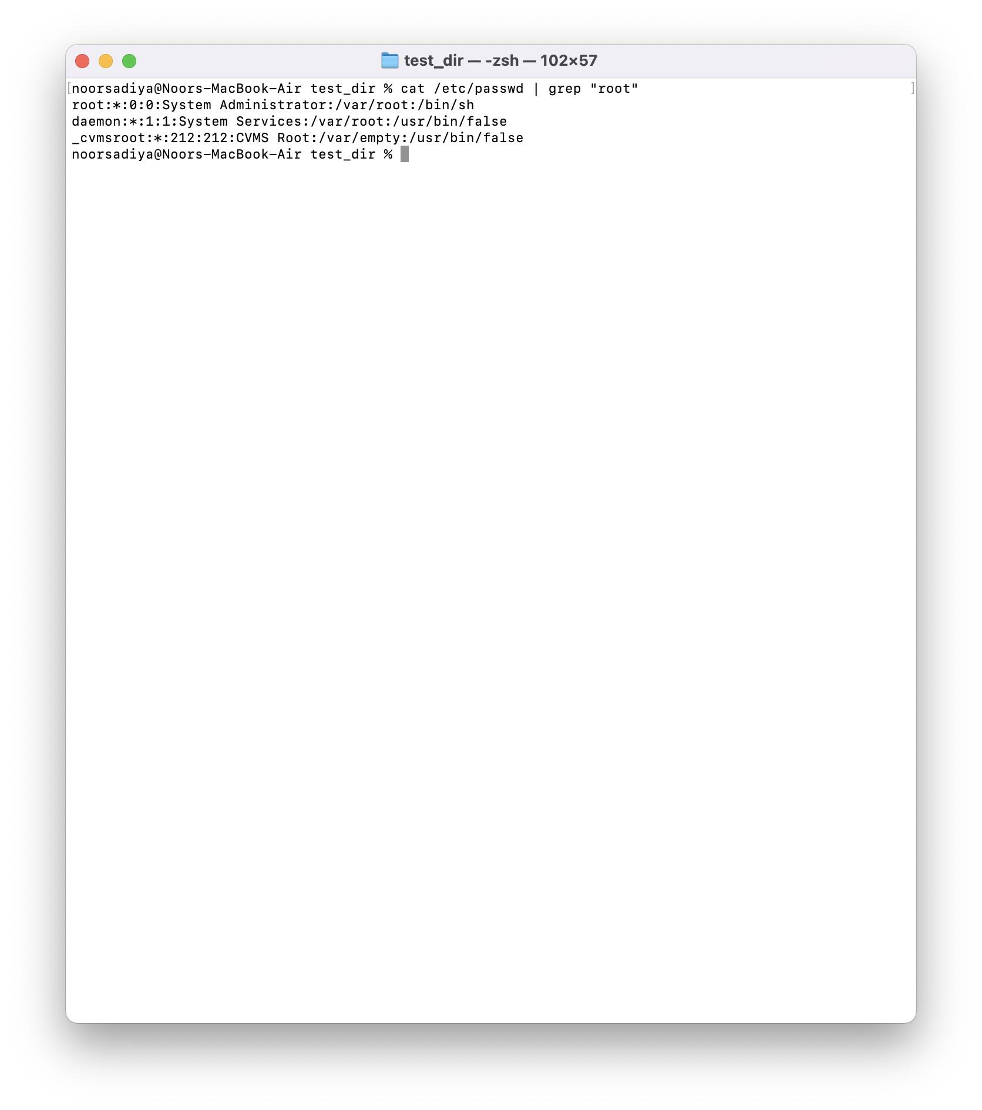

Explanation:

1. Cat /etc/passwd | grep “root” - output of cat is piped to grep command to search pattern “root”.

4. Zipping and Unzipping

Compress the test_dir directory into a file named test_dir.zip using zip.

Unzip test_dir.zip into a new directory named unzipped_dir.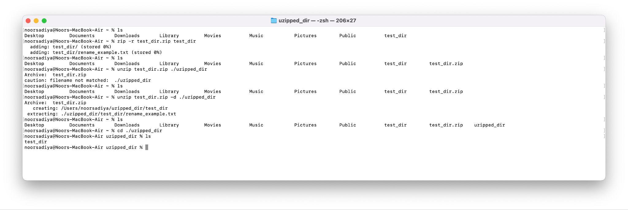

Explanation:

1. Compress the file with “zip -r test_dir.zip test_dir” command where test_dir.zip is the name of the zipped file.
2. Unzip the file using “unzip test_dir.zip -d ./unzipped_dir” command where -d allows the path of the folder where the zip./ file to be unzipped.

5. Downloading Files

Use wget to download a file from a URL (e.g., <https://example.com/sample.txt>).

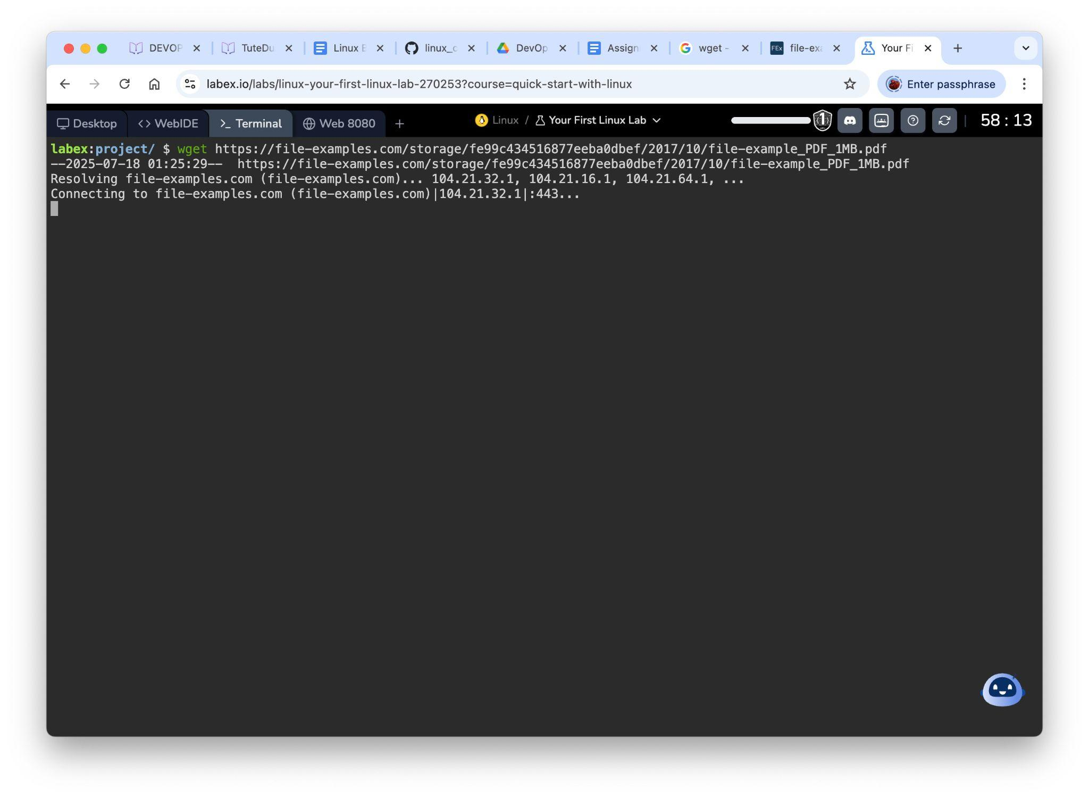

Explanation: wget used to download document from the internet.

6. Changing Permissions

Create a file named secure.txt and change its permissions to read-only for everyone

using chmod.

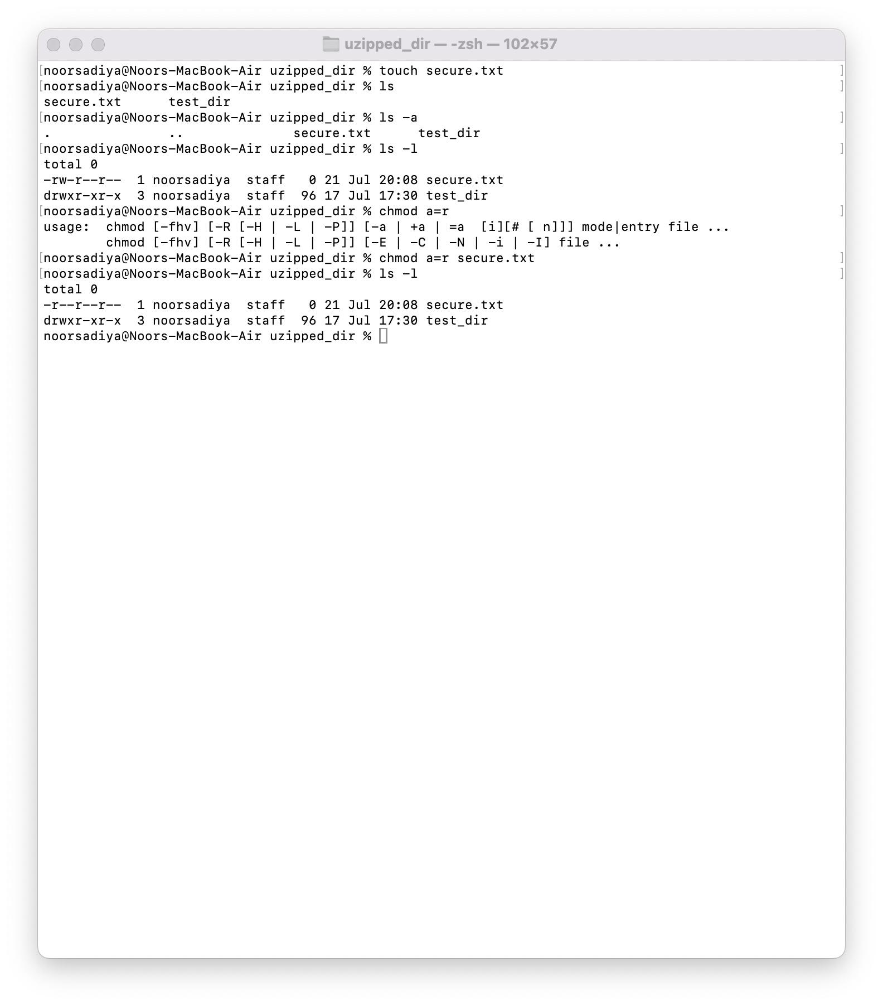

Explanation: Chmod change permission for all(owner, group and others) by using a. The permission can be verified with ls - l.

7. Working with Environment Variables

Use export to set a new environment variable called MY_VAR with the value "Hello, Linux!".

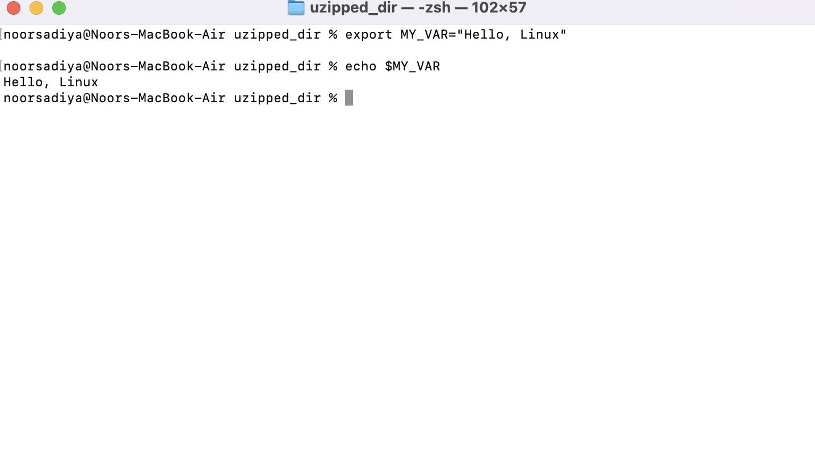

Explanation: export MY_VAR=”Hello, Linux”, value of MY_VAR can seen through echo command.