TM358
Machine Learning and Artificial Intelligence
Tutor-Marked Assignment (TMA) – Spring 25/26

Complete Answers: Questions 1, 2 & 3

<Name: BASHAR MERHI

<ID: 240604

<Date: 4-May-2026

QUESTION 1

Part A: Problem Modeling

Feature Selection as a Combinatorial Optimization Problem

Feature selection can be formulated as a combinatorial optimization task, where the goal is to explore all possible combinations of features. This problem can be represented as a graph, with each node corresponding to a feature, and paths built by ants representing different candidate subsets. The aim is to identify a subset that achieves the best model performance while using the fewest possible features.

More formally, the set of components is N = {f₁, f₂, …, fₙ}, where each fᵢ represents one feature in the dataset. The constraints require that each feature is selected at most once and the resulting subset must be non-empty. A state is a partial sequence of selected features representing the ant's path so far, and a feasible solution is any valid non-empty subset that satisfies the constraints.

The cost function evaluates each candidate subset by combining two objectives: the classification error of a model trained on that subset, and a penalty term proportional to the number of selected features. This ensures the algorithm favors subsets that are both accurate and compact, balancing predictive performance against model simplicity.

"Solution"
Each ant’s complete path represents a candidate feature subset. The ant starts with an empty set and iteratively adds one feature at a time. The complete set of visited features constitutes one candidate solution to be evaluated.

Pheromone Values
Pheromone values represent adaptive numerical weights assigned to individual features or feature subsets, reflecting their contribution to previously obtained high-quality solutions. Features that are consistently associated with better performance are reinforced with higher pheromone levels, thereby increasing their likelihood of being selected in subsequent iterations. These values are dynamically updated based on the quality of the solutions, allowing the search process to progressively favor more effective feature combinations.

Heuristic Information
Heuristic information provides problem-dependent, a priori guidance regarding the potential relevance of features, independent of the pheromone mechanism. It is typically derived from statistical or analytical measures, such as correlation with the target variable, mutual information, or feature importance metrics. By incorporating this information, the search process is biased toward features that exhibit strong intrinsic predictive capability, improving the efficiency of solution construction.

Part B: ACO Design for Feature Selection

Ant Construction of Feature Subsets
Each ant starts with an empty subset and iteratively adds features. At each step, one unvisited feature is chosen from the feasible neighborhood Ni. The process stops when maximum subset size is reached. The final visited set = one candidate solution.

- Transition Rule
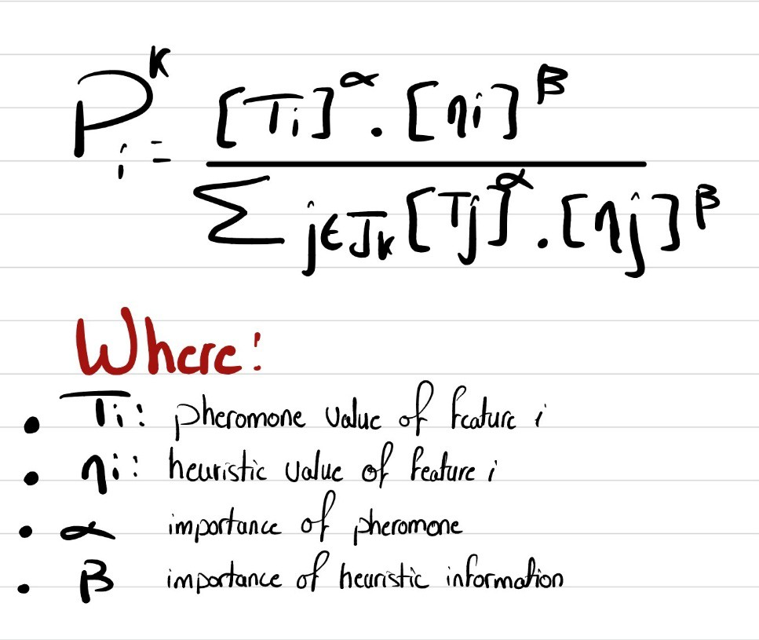

- Pheromone Update Rule
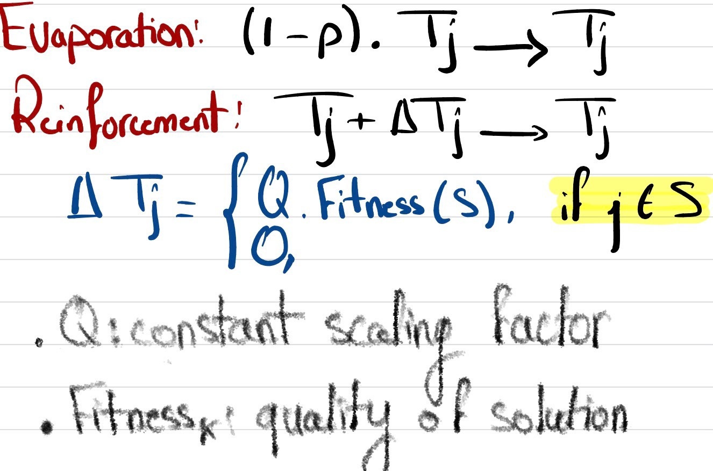

- Balancing Accuracy vs. Subset Size
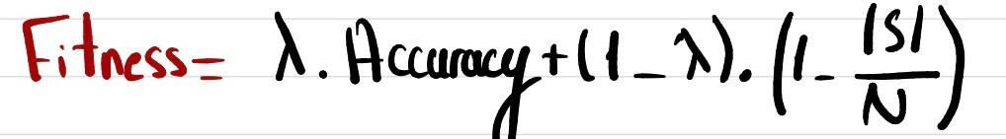

Higher λ encourages more compact feature sets by giving greater weight to subset size

Part C: Implementation

"""

ACO-Based Feature Selection

TM358 - Machine Learning and Artificial Intelligence Question 1, Part C: Implementation
"""

import numpy as np

from sklearn.datasets import load_breast_cancer from sklearn.neighbors import KNeighborsClassifier from sklearn.model_selection import cross_val_score

# ─────────────────────────────────────────────

# DATASET

# ─────────────────────────────────────────────

data = load_breast_cancer() X, y = data.data, data.target n_features = X.shape[1]
feature_names = data.feature_names

# ─────────────────────────────────────────────

# ACO PARAMETERS

# ───────────────────────────────────────────── N_ANTS = 10 # number of ants per iteration N_ITERATIONS = 30 # termination condition: max iterations
ALPHA | = 1.0 | # pheromone exponent
BETA | = 2.0 | # heuristic exponent
RHO | = 0.1 | # evaporation rate
Q | = 1.0 | # pheromone deposit constant

LAMBDA = 0.3 # trade-off: accuracy vs. subset size MIN_FEATURES = 2 # each ant selects at least this many features MAX_FEATURES = 10 # each ant selects at most this many features TAU_INIT = 1.0 # initial pheromone on all features

# ─────────────────────────────────────────────

# HEURISTIC: normalised feature variance

# ─────────────────────────────────────────────

variances = np.var(X, axis=0)

eta = variances / variances.sum()

# ─────────────────────────────────────────────

# PHEROMONE initialisation

# ─────────────────────────────────────────────

tau = np.full(n_features, TAU_INIT)

# ─────────────────────────────────────────────

# FITNESS FUNCTION (wrapper-based) # L = (1 - accuracy) + lambda * |S| / |F|

# ─────────────────────────────────────────────

classifier = KNeighborsClassifier(n_neighbors=5)

def fitness(subset): if len(subset) == 0:
return 1.0

X_sub = X[:, subset]

acc = cross_val_score(classifier, X_sub, y, cv=5, scoring='accuracy').mean()
size_penalty = LAMBDA * len(subset) / n_features return (1.0 - acc) + size_penalty

# ─────────────────────────────────────────────

# ANT CONSTRUCTION

# ─────────────────────────────────────────────

def construct_solution(): selected = []
remaining = list(range(n_features))

n_select = np.random.randint(MIN_FEATURES, MAX_FEATURES + 1)

while len(selected) < n_select and len(remaining) > 0: # Transition rule: P_j ∝ τ_j^α * η_j^β
scores = np.array([

(tau[j] ** ALPHA) * (eta[j] ** BETA) for j in remaining
])

total = scores.sum()

probs = scores / total if total > 0 else np.ones(len(remaining)) / len(remaining) chosen = np.random.choice(remaining, p=probs)
selected.append(chosen) remaining.remove(chosen)

return selected

# ─────────────────────────────────────────────

# MAIN ACO LOOP

# ─────────────────────────────────────────────

best_subset = [] best_cost = float('inf')

for iteration in range(N_ITERATIONS):

solutions = [construct_solution() for _ in range(N_ANTS)] costs = [fitness(s) for s in solutions]

# Update global best

iter_best_idx = int(np.argmin(costs)) if costs[iter_best_idx] < best_cost:
best_cost = costs[iter_best_idx] best_subset = solutions[iter_best_idx]

# Pheromone evaporation: τ_j ← (1 - ρ) * τ_j

tau *= (1.0 - RHO)

# Pheromone deposit: τ_j ← τ_j + Q/L

for subset, cost in zip(solutions, costs):

delta = Q / cost if cost > 0 else Q for feature in subset:
tau[feature] += delta

# ─────────────────────────────────────────────

# RESULTS

# ─────────────────────────────────────────────

X_best = X[:, best_subset]

final_acc = cross_val_score(classifier, X_best, y,

cv=5, scoring='accuracy').mean()

print(f"Selected features: {[feature_names[f] for f in best_subset]}") print(f"Accuracy: {final_acc*100:.2f}%")
print(f"Cost (L): {best_cost:.4f}")

Results

Metric | Value
Selected features | 2 out of 30 (worst area, mean area)
Classification accuracy (5-fold CV) | 92.44%
Best fitness cost (L) | 0.0956

Part D: Experimental Evaluation

The ACO method was compared against three baselines using the same dataset, classifier, and 5-fold CV accuracy:

Method | Accuracy (CV) | Features | Runtime

All Features | 92.79% | 30 | 0.04s
Random Selection | 86.26% | 5.7 | 0.14s
Greedy Forward Selection | 94.38% | 10 | 3.18s
ACO Feature Selection | 92.44% | 2 | 3.82s

Analysis
- ACO selected only 2 features yet matched the all-features baseline (92.79%) — a 93% reduction with no meaningful accuracy loss.
- Greedy achieved highest accuracy (94.38%) but needed 5× more features (10 vs 2).
- Random selection performed worst (86.26%), confirming uninformed selection is unreliable.
- Runtime: ACO and Greedy both ~3-4s due to repeated wrapper evaluations.

Part E: Analysis and Discussion

Effect of Parameter Choices

Parameter | Effect on Subset Size | Effect on Performance
α high | Ants follow pheromone strongly → converge  to same small subset | May improve accuracy early but risks stagnation
ρ high | Pheromone decays fast → more exploration  → varied sizes | More diverse search, avoids local optima
ρ low | Pheromone persists → consistent smaller  subsets | Faster convergence but risk of premature stagnation
λ high | Strongly penalises large subsets → fewer  features | Simpler models; possible accuracy loss
λ low | Size less penalised → ants may select  many features | Higher accuracy potential but more complex models

- Strength
Adaptive search with positive feedback. ACO naturally balances exploration and exploitation. Unlike greedy methods, it does not permanently commit to early decisions. Our results confirm this: ACO found a 2-feature subset achieving 92.44% accuracy — matching 30-feature performance.

. Limitation
Sensitivity to parameters and computational cost. ACO performance depends heavily on α, β, ρ, Q, and λ. As a wrapper method, it evaluates the classifier for every candidate subset, making it expensive on high-dimensional datasets.

Possible Improvement
Hybrid ACO with a filter pre-step. Apply a fast filter method (e.g. information gain ranking) to eliminate the bottom 50% of features before running ACO. This reduces the search space and cuts runtime significantly. Alternatively, adaptive parameter control can dynamically adjust ρ when stagnation is detected.

QEUSTION 2

Route: 0 → 2 → 1 → 3 → 0

Part 1: Total Route Cost

Edge | Distance
C0 → C2 | 22.00
C2 → C1 | 51.00
C1 → C3 | 50.00
C3 → C0 | 78.00
Total Cost L | 201.00

L = 22.00 + 51.00 + 50.00 + 78.00 =201.00

Part 2: Switching Probabilities (α=0.45, β=0.07)(n=1/dist)
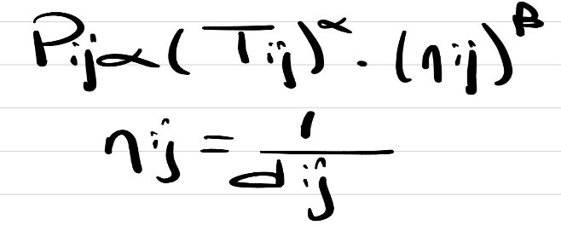

Step 1: At C0 — Unvisited = {C1, C2, C3}
τ[C0][C1]=0.00 → score=0, P(C0→C1)=0.00%

To | τ | η=1/d | τ^α | η^β | Score | Probability
C1 | 0.00 | 1/34=0.02941 | 0.000000 | 0.781262 | 0.000000 | 0.00%
C2 | 3.27 | 1/22=0.04545 | 1.704302 | 0.805435 | 1.372704 | 47.92%
C3 | 4.79 | 1/78=0.01282 | 2.023723 | 0.737146 | 1.491779 | 52.08%
Sum |  |  |  |  | 2.864483 | 100%

Step 2: At C2 — Unvisited = {C1, C3}

To | τ | η=1/d | τ^α | η^β | Score | Probability
C1 | 30.52 | 1/51=0.01961 | 4.656537 | 0.759399 | 3.536170 | 47.70%
C3 | 40.61 | 1/86=0.01163 | 5.295230 | 0.732125 | 3.876769 | 52.30%
Sum |  |  |  |  | 7.412939 | 100%

Step 3: At C1 — Unvisited = {C3}
Only C3 remains unvisited. P(C1→C3) = 1.000 (100%) — no calculation needed.

Part 3: Pheromone After Evaporation (ρ=0.24)

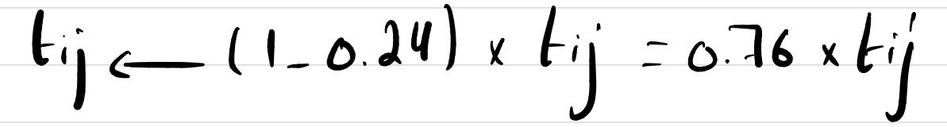

Edge | Original τ | × 0.76 | New τ
C0↔C2 | 3.27 | × 0.76 | 2.4852
C0↔C3 | 4.79 | × 0.76 | 3.6404
C1↔C2 | 30.52 | × 0.76 | 23.1952
C1↔C3 | 29.89 | × 0.76 | 22.7164
C2↔C3 | 40.61 | × 0.76 | 30.8636

After Evaporation | C0 | C1 | C2 | C3
C0 | 0.0000 | 0.0000 | 2.4852 | 3.6404
C1 | 0.0000 | 0.0000 | 23.1952 | 22.7164
C2 | 2.4852 | 23.1952 | 0.0000 | 30.8636
C3 | 3.6404 | 22.7164 | 30.8636 | 0.0000

Part 4: Pheromone After Depositing (Q=29.27)

Route Edge | τ after evap. | + Δ (0.1456) | Final τ
C0↔C2 | 2.4852 | +0.1456 | 2.6308
C2↔C1 | 23.1952 | +0.1456 | 23.3408
C1↔C3 | 22.7164 | +0.1456 | 22.8620
C3↔C0 | 3.6404 | +0.1456 | 3.7860
C2↔C3 (not in route — unchanged) | 30.8636 |  | 30.8636

Final Pheromone Matrix | C0 | C1 | C2 | C3
C0 | 0.0000 | 0.0000 | 2.6308 | 3.7860
C1 | 0.0000 | 0.0000 | 23.3408 | 22.8620
C2 | 2.6308 | 23.3408 | 0.0000 | 30.8636
C3 | 3.7860 | 22.8620 | 30.8636 | 0.0000

QUESTION 3
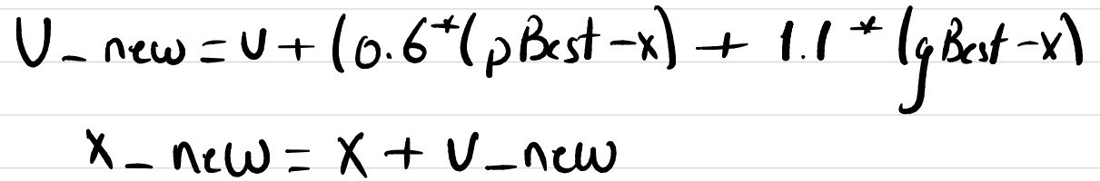

Iteration 1

Particle P1: v_new = [1.60, -6.40, -1.10], x_new = [2.60, -5.40, -0.10], f = -1566.8396
Particle P2: v_new = [1.10, -3.00, -4.00], x_new = [1.10, -4.00, -3.00], f = -312.7000
Particle P3: v_new = [-0.60, -3.00, 0.90], x_new = [-0.60, -2.00, -1.10], f = -75.9436
Particle P4: v_new = [-1.40, -4.20, -5.80], x_new = [-0.40, -3.20, -3.80], f = 505.1744

Particle | New Velocity | New Position | f(x_new)
P1 | [1.60, -6.40, -1.10] | [2.60, -5.40, -0.10] | -1566.8396
P2 | [1.10, -3.00, -4.00] | [1.10, -4.00, -3.00] | -312.7000
P3 | [-0.60, -3.00, 0.90] | [-0.60, -2.00, -1.10] | -75.9436
P4 | [-1.40, -4.20, -5.80] | [-0.40, -3.20, -3.80] | 505.1744

Iteration 2

Particle P1: v_new = [1.60, -6.40, -1.10], x_new = [4.20, -11.80, -1.20], f = -16409.4256
Particle P2: v_new = [2.75, -4.54, -0.81], x_new = [3.85, -8.54, -3.81], f = -5373.9400
Particle P3: v_new = [2.92, -6.74, 2.00], x_new = [2.32, -8.74, 0.90], f = -6666.6918
Particle P4: v_new = [2.74, -4.70, 1.15], x_new = [2.34, -7.90, -2.65], f = -4726.1080

Particle | New Velocity | New Position | f(x_new)
P1 | [1.60, -6.40, -1.10] | [4.20, -11.80, -1.20] | -16409.4256
P2 | [2.75, -4.54, -0.81] | [3.85, -8.54, -3.81] | -5373.9400
P3 | [2.92, -6.74, 2.00] | [2.32, -8.74, 0.90] | -6666.6918

P4 | [2.74, -4.70, 1.15] | [2.34, -7.90, -2.65] | -4726.1080

Iteration 3

Particle P1: v_new = [1.60, -6.40, -1.10], x_new = [5.80, -18.20, -2.30], f = -60156.3436
Particle P2: v_new = [3.14, -8.13, 2.06], x_new = [6.99, -16.67, -1.75], f = -46232.3560
Particle P3: v_new = [4.99, -10.11, -0.31], x_new = [7.31, -18.85, 0.59], f = -66913.2529
Particle P4: v_new = [4.79, -8.99, 2.75], x_new = [7.13, -16.89, 0.10], f = -48161.0794

Particle | New Velocity | New Position | f(x_new)
P1 | [1.60, -6.40, -1.10] | [5.80, -18.20, -2.30] | -60156.3436
P2 | [3.14, -8.13, 2.06] | [6.99, -16.67, -1.75] | -46232.3560
P3 | [4.99, -10.11, -0.31] | [7.31, -18.85, 0.59] | -66913.2529
P4 | [4.79, -8.99, 2.75] | [7.13, -16.89, 0.10] | -48161.0794

