# Creating Own image using Dockerfile

**Dockerfile:**

A Dockerfile is a text file that contains instructions for building a Docker image. An image is aread-only template that includes all the files, dependencies, and configuration needed to run acontainer. A Dockerfile provides a way to automate the process of building an image, ensuringthattheresultingimage isconsistent andreproducible

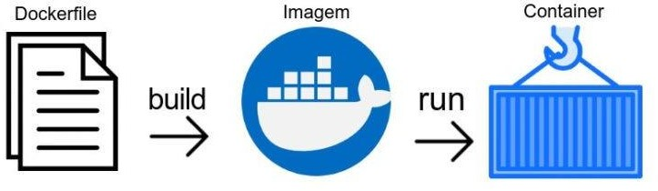

# KEYWORDS:

**FROM:** The FROM instruction specifies the base image to use for the Docker container.This is the starting point for building the image, and all subsequent instructions will buildontopofit.

**Syntax:**

FROM <image-name>Example:**FROM ubuntu:latest**

**RUN:** The RUN instruction executes a command in the Docker container during the buildprocess. This can be used to install packages, update software, or perform other tasksnecessary foryourapplication.

**Syntax:**

RUN<command>

**Example:**

RUNapt-getupdate&&apt-getinstall -ygit

**CMD:** The CMD instruction specifies the command that should be executed when the

container starts running.This is typicallyused to start the mainprocess in thecontainer,suchasa web serverorapplication.

**Syntax:**

CMD["executable","param1","param2",...]

**Example:**

CMD["python","app.py"]

**ADD/COPY:**TheADDandCOPYinstructionsareusedtoaddfilesfromthehostsystemtothe Dockerimage.COPYis preferredoverADD,as itis simpler andless powerful.

**Syntax:**

COPY<src><dest>

**Example:**

COPYapp.py/app/

**EXPOSE:**TheEXPOSEinstructioninformsDockerthatthecontainerwilllistenonthe

specifiednetworkportsatruntime.Thisdoesnotactuallypublishtheport,butsimplydocumentstheintended usage.

**Syntax:**

EXPOSE<port>

**Example:**

EXPOSE8080

**DOCKER INSTALLATION:**

[root@ip-172-31-30-197 ~]# history

1 yum install docker -y

2 systemctl restart docker

3 systemctl status docker

4 docker info

**vim index.html**

<html>

<head>

<title>HOME</title>

</head>

<body bgcolor="pink">

<marquee> WELCOME TO AITS-RAJAMPET</marquee>

<center>

<h2>Employee Details</h2>

<table border="1" cellspacing="0" cellpadding="8">

<thead>

<tr>

<th>Name</th>

<th>Department</th>

<th>Position</th>

<th>Salary</th>

</tr>

</thead>

<tbody>

<tr>

<td>Krishna</td>

<td>IT</td>

<td>Software Developer</td>

<td>$70,000</td>

</tr>

<tr>

<td>Milky</td>

<td>HR</td>

<td>HR Manager</td>

<td>$80,000</td>

</tr>

<tr>

<td>Cherry</td>

<td>Finance</td>

<td>Accountant</td>

<td>$65,000</td>

</tr>

</tbody>

</table>

</center>

</body>

</html>

**vim Dockerfile**

ARG NGINX_VERSION=latest

FROM nginx:${NGINX_VERSION}

ADD index.html /usr/share/nginx/html/index.html

WORKDIR ["nginx","-g","daemon off;"]

EXPOSE 80

LABEL description="krishna"

ENV APP_VERSION=1.0

**[root@ip-172-31-30-197 ~]#** docker images

**REPOSITORY TAG IMAGE ID CREATED SIZE**

myimage latest f6c7dbda9465 16 minutes ago 187MB

nginx latest 2a36393edaf1 33 hours ago 187MB

docker build -t myimage .

docker run -d -p 81:80 --name mycontainer myimage:latest

docker ps

[root@ip-172-31-30-197 ~]# docker ps

CONTAINER ID IMAGE COMMAND CREATED STATUS PORTS NAMES

5bba9b26bed3 myimage:latest "/docker-entrypoint.…" 18 minutes ago Up 18 minutes **0.0.0.0:81->80/tcp, :::81->80/tcp** mycontainer

**RESULT:**

