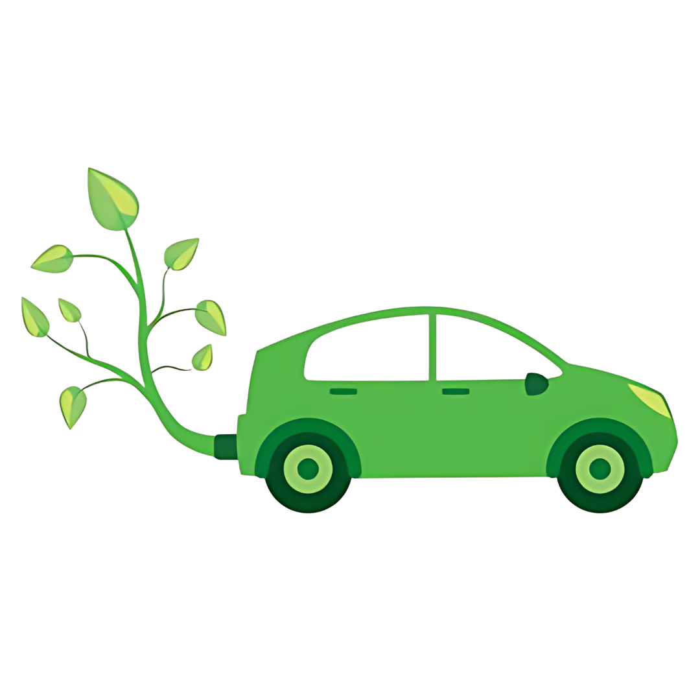

12B

sustainable transport INVOLVING enviromental sustainablity NOORUDIN kHAN

Computer application technology

MEADOWLANDS TECHNICAL HIGHSCHOOL

Sustainable transport: electric vehicle technician

Table of Contents

Table of Figures 2

Introduction 3

Task Definition 4

Focus Question 5

Questions 6

Discussion & Analysis 7

Findings 8

Conclusion 9

Bibliography 10

Appendices 11

# Table of Figures

**No table of figures entries found.**

# Introduction

# Task Definition

Currently in South Africa today, especially in our local city, there is many vehicles we see every day emitting harmful gases that damages our earth’s atmosphere.  
  
In my Investigation I hope to find and reach out to many of the South Africans that own a **non-eco-friendly** vehicle.  
And **visually** show them the effects of their ignorance.  
Hopefully this results in them making a change and swapping towards more **eco-friendly** modes of transport.   
 **I am going about the investigation using:**

* **MS WORD:** For my questions and research on sustainable transport in South Africa.
* **MS EXCEL:** For calculations and visual (graphical) information and answers towards my questions on word.
* **MS ACCESS:** For separating and categorising my findings into more simpler views.

**I hope to reach out to:**Workers and people alike in **South Africa**, starting in my local city **Chatsworth**., everyone who owns a **non-eco-friendly** vehicle that emits harmful substances into the earth’s atmosphere.

# Focus Question

**Can electric vehicles bring sustainability to the transportation section and environments of South Africa?**

# Discussion & Analysis

# Findings

# Conclusion

# Appendices

|  |  |  |  |  |  |  |  |  |
| --- | --- | --- | --- | --- | --- | --- | --- | --- |
| **No.** | **Question** | **Level** | **Category** | **Type of Source** | **Bibliographical Information** | | **Summary of information found** | **Quality of information found** |
| **1.** | **How much energy/money do we save using Electric Vehicles?** | **2** | **Background** | **Electronic Article** | **Author Title of source Date published Publisher** | Robin Smit, Jake Whitehead and Simon Washington Where Are We Heading with Electric Vehicles? Jan 2024 Robin Smit [Included in sources folder](Sources/Where%20Are%20We%20Heading%20With%20Electric%20Vehicles.pdf) | Improving air around your local area. | Good |
| **2.** | **Where are EV charge stations in SA?** | **1** | **Fuel** | **Internet/Website** | **Author Name of page Date updated Date accessed URL** | [Nafisa Akabor Cars Dec 2023 April 2024 https://www.cars.co.za/motoring-news/EV-Charge-Stations-in-SA-How-Many-Where/48117/](https://www.cars.co.za/motoring-news/author/nafisa-akabor/) | Pretoria, Johannesburg, Cape town, Kwa-Zulu-Natal and many other places | Very Good |
| **3.** | **How many EV charge stations are there in SA?** | **1** | **Fuel** | **Internet/Website** | **Author Name of page Date updated Date accessed URL** | Nafisa Akabor Cars Dec 2023 April 2024 https://www.cars.co.za/motoring-news/EV-Charge-Stations-in-SA-How-Many-Where/48117/ | 55 Currently | Okay |
| **4.** | **How fast are EV and hybrid sales growing in SA?** | **2** | **Finance** | **Internet/Website** | **Author Name of page Date updated Date accessed URL** | Ryan Bubear **How fast are EV and hybrid sales growing in SA?** May 2022 April 2024 https://www.cars.co.za/motoring-news/How-Fast-Are-EV-and-Hybrid-Sales-Growing-in-South-Africa/123652/ | 137% year-on-year sales growth | Good |
| **5.** | **How much people own an EV in SA?** | **2** | **Background** | **Internet/Website** | **Author Name of page Date updated Date accessed URL** | Statista Electric vehicles SA March 2024 April 2024 https://www.statista.com/outlook/mmo/electric-vehicles/south-africa#unit-sales | A few thousand | Okay |
| **6.** | **Why should I purchase an EV?** | **2** | **Background** | **Internet/Website** | **Author Name of page Date updated Date accessed URL** | Carolyn Fortuna Why you should buy an EV for your next vehicle March 2024 April 2024 https://cleantechnica.com/2024/03/18/why-you-should-buy-an-ev-for-your-next-vehicle/ | Lower running and maintenance cost | Good |
| **7.** | **What if my EV runs out of charge?** | **3** | **Fuel** | **Internet/Website** | **Author Name of page Date updated Date accessed URL** | Cars.co.za What happens if my EV runs out of charge March 2024 April 2024 https://www.cars.co.za/motoring-news/What-happens-if-my-EV-runs-out-of-charge/151492/ | Find a nearby charge station | Very Good |
| **8.** | **What if you do not swap to an EV?** | **3** | **Background** | **Internet/Website** | **Author Name of page Date updated Date accessed URL** | Steven Rupp The case of not EV converting Dec 2023 April 2024 https://www.motortrend.com/features/ev-conversion-classic-cars/ | Long term expenses are higher and You will contribute to global warming | Good |
| **9.** | **What if your EV loses charge when stranded?** | **3** | **Background** | **Internet/Website** | **Author Name of page Date updated Date accessed URL** | Ecoplexenergy What Happens when your EV runs out of power? Feb 2024 April 2024 https://www.ecoplexenergy.ie/post/what-happens-when-your-ev-runs-out-of-power | You can tow it to the nearest charging station | Very Good |
| **10.** | **What would be the best EV to buy?** | **4** | **Future** | **Internet/Website** | **Author Name of page Date updated Date accessed URL** | Drive electric Top selling EV brands in SA Feb 2024 April 2024 https://www.driveelectric.co.za/blogs/news/top-selling-electric-cars-in-south-africa | Volvo XC40 Recharge | Okay |

# Bibliography