HIGH-PERFORMANCE
ADDRESS NORMALIZATION & PARSING SERVICE

Technical Design Document

C/C++ + Drogon + libpostal + LLM Fallback

PHASE 1  Linux VM Deployment  4 Core | 16 GB RAM | PHASE 2  Kubernetes Infrastructure  Auto-scaling | 4-16 Core | 16-64 GB

Version 1.0 | March 2026
CONFIDENTIAL

Table of Contents
Table of Contents 2
1. Executive Summary 4
1.1 Key Design Decisions 4
2. Architecture Overview 5
2.1 Processing Pipeline 5
2.2 Confidence Scoring 6
2.3 API Endpoints 6
3. Technical Stack 8
4. Phase 1 — Linux VM Deployment 9
4.1 Objectives 9
4.2 Hardware Specification 9
4.3 Memory Layout 9
4.4 Performance Estimates (Single VM) 9
4.5 Installation Steps 10
4.6 Process Management (systemd) 10
4.7 Phase 1 Success Criteria 10
5. Phase 2 — Kubernetes Infrastructure 11
5.1 Objectives 11
5.2 Resource Configuration Per Pod 11
5.3 Horizontal Pod Autoscaler (HPA) Configuration 11
Scale-Up Policy (Aggressive) 11
Scale-Down Policy (Conservative) 11
5.4 Scaling Timeline (Typical Spark Batch Job) 11
5.5 Shared Storage Architecture 12
5.6 Throughput at Scale 12
5.7 Kubernetes Manifests Delivered 12
6. Spark Integration Guide 13
6.1 Client Configuration 13
6.2 Scala Client Pattern 13
7. Monitoring & Observability 14
7.1 Prometheus Metrics 14
7.2 Alerting Rules 14
8. Risk Assessment & Mitigation 15
9. Implementation Timeline 16
Phase 1 — Linux VM (Weeks 1–4) 16
Phase 2 — Kubernetes (Weeks 5–8) 16
10. Appendix 17
A. Project Directory Structure 17
B. Sample API Request/Response 17
Single Parse 17
Batch Parse 18

1. Executive Summary
This document presents the technical design for a high-performance Address Normalization and Parsing Service built using C/C++ with the Drogon framework and libpostal at its core. The service is designed to serve multiple consumers including Apache Spark big data pipelines, Python ML workflows, microservices, and streaming platforms.
The implementation follows a 2-phase approach: Phase 1 deploys on a Linux VM (4 core, 16 GB RAM) for rapid validation and production readiness, while Phase 2 migrates to Kubernetes infrastructure with auto-scaling capabilities (4–16 cores, 16–64 GB RAM per pod) for elastic throughput.

1.1 Key Design Decisions
- C/C++ native stack: Zero language boundary overhead between the Drogon HTTP server and libpostal (C library). No FFI, JNI, or cgo penalties.
- 4-phase processing pipeline: Pre-processor → libpostal core → Rule engine → LLM fallback. Each phase is triggered conditionally based on confidence scoring.
- No MITIE: MITIE was evaluated and rejected. It is not thread-safe, has been unmaintained since 2019, and solves a different problem (NER extraction from unstructured text). Our consumers send address fields directly.
- LLM as selective fallback: A local quantized Mistral 7B model (via llama.cpp) handles only ~2% of traffic — addresses that fail both libpostal and the rule engine. Runs asynchronously, never blocks the main pipeline.
- Batch-first API: The batch endpoint (/api/v1/batch) amortizes HTTP overhead across 500–2000 addresses per call, critical for Spark integration.

2. Architecture Overview
The service exposes a RESTful API over HTTP/1.1 (with optional gRPC support). All parsing and normalization logic runs at the C/C++ level for maximum throughput and minimum latency.

Figure 1: Recommended Production Architecture
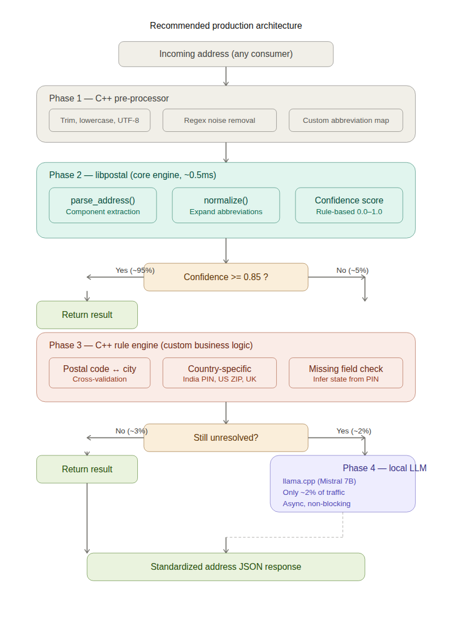

2.1 Processing Pipeline
Every incoming address flows through up to 4 phases. The pipeline short-circuits as soon as confidence exceeds the threshold (default 0.85), meaning ~95% of addresses complete after Phase 2.

Phase | Component | What It Does | Latency | Traffic %
1 | C++ Pre-processor | Trim, UTF-8 normalize, remove junk chars, apply custom abbreviation map | ~0.01 ms | 100%
2 | libpostal Core | Parse into components (house_number, road, city, state, postcode, country), normalize and expand abbreviations | ~0.5 ms | 100%
3 | C++ Rule Engine | Cross-validate PIN/ZIP with state/city, infer missing fields, apply country-specific formatting rules | ~0.1 ms | ~5%
4 | Local LLM (llama.cpp) | Disambiguate malformed addresses, correct OCR errors, handle free-text addresses | ~200 ms | ~2%

2.2 Confidence Scoring
After Phase 2, a rule-based confidence score (0.0–1.0) determines whether additional processing is needed. The score is computed from the following factors:
- Completeness: Are all expected components present (street, city, state, postal code)?
- Postal code validity: Does the postal code match a known format (6-digit for India, 5/9-digit for US)?
- Cross-field consistency: Does the postal code region match the parsed city/state?
- Unassigned tokens: How many input tokens were not mapped to any component?
- Language detection: Was a confident language/country detected for the address?

Threshold configuration: Confidence >= 0.85 returns immediately. Between 0.70–0.85 triggers the rule engine (Phase 3). Below 0.70 routes to LLM fallback (Phase 4).

2.3 API Endpoints
Method | Path | Description
POST | /api/v1/parse | Parse a single address into structured components
POST | /api/v1/normalize | Normalize a single address (expand abbreviations, standardize format)
POST | /api/v1/batch | Batch parse/normalize up to 2000 addresses in a single request
GET | /health/live | Liveness probe — is the process alive?
GET | /health/ready | Readiness probe — is libpostal data loaded and accepting requests?
GET | /metrics | Prometheus metrics endpoint (port 9090)

3. Technical Stack
Layer | Technology | Purpose
HTTP Framework | Drogon 1.9+ | Async non-blocking HTTP server, top TechEmpower benchmarks
Core Parser | libpostal (C) | Statistical NLP address parsing, 233 countries, ~0.5ms per parse
LLM Engine | llama.cpp | C++ native inference for Mistral 7B Q4 quantized model
JSON | rapidjson / nlohmann | High-speed JSON serialization/deserialization
Build System | CMake 3.16+ | Cross-platform build management
Compiler | GCC 11+ / Clang 14+ | C++17 support required
Cache (L1) | Concurrent LRU (in-process) | Thread-safe, lock-free hash map for deduplication
Cache (L2) | Redis 7.x (optional) | Shared distributed cache across instances
Load Balancer | Nginx | TLS termination, least_conn routing, keepalive
Containers | Docker | Multi-stage build: builder + slim runtime
Monitoring | Prometheus + Grafana | Latency histograms, throughput, cache hit ratio, LLM fallback rate

4. Phase 1 — Linux VM Deployment
PHASE 1 | Linux VM | 4 Core | 16 GB RAM

4.1 Objectives
- Validate the full 4-phase pipeline in a production-like environment
- Establish baseline performance metrics on a single node
- Serve initial Spark batch jobs and API consumers
- Build operational confidence before Kubernetes migration

4.2 Hardware Specification
Resource | Specification | Notes
CPU | 4 cores (8 vCPU preferred) | Intel Xeon / AMD EPYC
RAM | 16 GB | libpostal ~2GB + LLM ~4.5GB + cache ~4GB
Disk | 50 GB SSD | libpostal data + LLM model + logs
OS | Ubuntu 22.04 LTS | Long-term support, well-tested
Network | 1 Gbps (minimum) | Same VPC as Spark cluster

4.3 Memory Layout
With 16 GB available, memory is allocated as follows:
Component | Memory | Details
libpostal data | ~2.0 GB | Language models, gazetteers, loaded at startup
LLM model (Mistral 7B Q4) | ~4.5 GB | Quantized GGUF, loaded by llama.cpp
LRU cache (2M entries) | ~3.0 GB | In-process concurrent hash map
Drogon + thread stacks | ~0.5 GB | Event loop + 3 worker threads
OS + overhead | ~1.0 GB | Kernel buffers, file handles, network stack
Total | ~11.0 GB | 5 GB headroom for spikes

4.4 Performance Estimates (Single VM)
Metric | Without Cache | With 30% Cache Hit
Single parse latency (P50) | ~0.5 ms | ~0.35 ms
Throughput (addresses/sec) | ~6,000 | ~8,500
Batch of 500 latency | ~85 ms | ~60 ms
Addresses per hour | ~21.6 M | ~30.6 M
10M addresses (Spark job) | ~28 min | ~20 min
100M addresses (Spark job) | ~4.6 hrs | ~3.3 hrs

4.5 Installation Steps
- Provision a Linux VM (Ubuntu 22.04 LTS) with 4 cores and 16 GB RAM
- Install build dependencies: gcc/g++, cmake, autotools, libssl-dev, libjsoncpp-dev
- Compile libpostal from source and download language data (~2 GB)
- Compile Drogon framework from source (v1.9+)
- Compile llama.cpp and download Mistral 7B Q4 GGUF model (~4.5 GB)
- Build the address-service binary using CMake
- Configure systemd service for auto-restart and log management
- Set up Nginx as reverse proxy with keepalive and rate limiting
- Deploy Prometheus node exporter + application metrics endpoint
- Run integration tests with sample address datasets

4.6 Process Management (systemd)
[Unit]
Description=Address Normalization Service
After=network.target

[Service]
Type=simple
User=address-svc
ExecStart=/opt/address-service/bin/address-service --config /etc/address-service/config.json
Restart=always
RestartSec=5
LimitNOFILE=65535
Environment=LIBPOSTAL_DATA_DIR=/opt/libpostal/data

[Install]
WantedBy=multi-user.target

4.7 Phase 1 Success Criteria
- Service starts and loads libpostal data within 30 seconds
- Single parse latency under 1 ms (P99)
- Batch endpoint processes 500 addresses in under 100 ms
- Sustained throughput of 5,000+ addresses/sec for 1 hour without memory leak
- Successfully processes a 10M address Spark batch job end-to-end
- LLM fallback triggers for less than 5% of addresses
- Zero unplanned restarts over 7 days of continuous operation

5. Phase 2 — Kubernetes Infrastructure
PHASE 2 | Kubernetes | Auto-scaling | 4–16 Core | 16–64 GB

5.1 Objectives
- Enable horizontal auto-scaling to handle variable Spark batch loads
- Achieve zero-downtime deployments with rolling updates
- Support 50,000–200,000+ addresses/sec at peak
- Provide elastic infrastructure that scales down during idle periods to reduce cost

5.2 Resource Configuration Per Pod
Resource | Request (Guaranteed) | Limit (Burstable) | Rationale
CPU | 4 cores | 16 cores | libpostal is CPU-bound
Memory | 16 GB | 64 GB | LRU cache grows with traffic
Min Replicas | 2 pods | — | Always-on for API traffic
Max Replicas | — | 20 pods | Burst capacity for Spark jobs

5.3 Horizontal Pod Autoscaler (HPA) Configuration
The HPA is configured with asymmetric scaling behavior: aggressive scale-up to respond to Spark batch spikes, and conservative scale-down to avoid flapping.

Scale-Up Policy (Aggressive)
- Target CPU utilization: 65%
- Stabilization window: 60 seconds
- Scale-up rate: add up to 4 pods OR double current count every 60 seconds (whichever is larger)
- Result: From 2 pods to 20 pods in approximately 3 minutes under sustained load

Scale-Down Policy (Conservative)
- Stabilization window: 300 seconds (5 minutes)
- Scale-down rate: remove max 2 pods OR 25% of current count every 120 seconds (whichever is smaller)
- Result: Gradual cooldown prevents premature scale-down between consecutive Spark jobs

5.4 Scaling Timeline (Typical Spark Batch Job)
Time | Pods | Throughput | Event
T+0s | 2 | ~12,000 addr/sec | Baseline — serving light API traffic
T+30s | 2 | ~12,000 addr/sec | Spark job starts, CPU spike detected by HPA
T+60s | 6 | ~36,000 addr/sec | First scale-up: 4 pods added
T+120s | 12 | ~72,000 addr/sec | Second scale-up: doubled from 6 to 12
T+180s | 16 | ~96,000 addr/sec | Approaching target — stabilizing
T+10min | 16 | ~96,000 addr/sec | Sustained processing at target
Job ends | 16 | Dropping | Traffic drops, stabilization window starts
+5 min | 12 | ~72,000 addr/sec | First scale-down: removed 4 pods
+15 min | 2 | ~12,000 addr/sec | Back to baseline

5.5 Shared Storage Architecture
Both the libpostal data (~2 GB) and the LLM model (~4.5 GB) are stored on a shared ReadOnlyMany PersistentVolume. All pods mount the same volume, eliminating data duplication and enabling fast pod startup (~15–30 seconds).

Volume | Access Mode | Cloud Provider | Size
libpostal-data | ReadOnlyMany | AWS EFS / GCP Filestore / Azure Files | 5 GB
llm-models | ReadOnlyMany | AWS EFS / GCP Filestore / Azure Files | 10 GB

5.6 Throughput at Scale
Scale | Throughput | 100M Addresses | 1B Addresses
2 pods (min) | ~12K addr/sec | ~2.3 hours | ~23 hours
8 pods | ~48K addr/sec | ~35 minutes | ~5.8 hours
16 pods | ~96K addr/sec | ~17 minutes | ~2.9 hours
20 pods (max) | ~120K addr/sec | ~14 minutes | ~2.3 hours

5.7 Kubernetes Manifests Delivered
The following production-ready manifest files are provided alongside this document:
- deployment.yaml — Pod spec with resource requests/limits, init containers, probes, anti-affinity
- hpa.yaml — HPA with asymmetric scale-up/down behavior
- service-and-infra.yaml — Service, Ingress, PVCs, ConfigMap, PodDisruptionBudget, ServiceMonitor, VPA
- Dockerfile — Multi-stage build (builder + slim runtime)

6. Spark Integration Guide
Optimal integration between Apache Spark and the address service requires careful tuning of batch sizes, partition counts, and connection management.

6.1 Client Configuration
Parameter | Recommended | Rationale
Batch size | 500–1000 | Amortizes HTTP overhead; larger batches hit diminishing returns
Spark partitions | 2–3x server threads | Ensures all server threads stay busy without over-queuing
Connection pool (per executor) | 50 connections | Reuse TCP connections via keepalive
HTTP timeout | 30 seconds | Allows large batch + LLM fallback to complete
Retry policy | 3 retries, exponential backoff | Handles transient failures during pod scaling

6.2 Scala Client Pattern
val parsedDF = inputDF
.repartition(numPartitions)
.mapPartitions { partition =>
val client = AddressServiceClient(
url = "http://address-service:8080",
poolSize = 50,
timeout = 30.seconds
)
partition.grouped(500).flatMap { batch =>
client.parseBatch(batch.map(_.address))
}
}
Key pattern: Use mapPartitions (not map) to reuse HTTP connections across the entire partition. Each executor maintains a connection pool that persists for the partition lifetime.

7. Monitoring & Observability

7.1 Prometheus Metrics
Metric | Type | Description
address_parse_duration_seconds | Histogram | Parse latency distribution
address_batch_size | Histogram | Distribution of batch sizes
address_cache_hit_ratio | Gauge | Cache effectiveness (0.0–1.0)
address_llm_fallback_total | Counter | Number of LLM fallback invocations
address_confidence_score | Histogram | Confidence score distribution
address_requests_total | Counter | Total requests by endpoint and status

7.2 Alerting Rules
- P99 latency > 50 ms (single) or > 5 s (batch) for 5 minutes
- CPU utilization > 85% sustained for 5 minutes
- Cache hit ratio drops below 20% for 10 minutes
- LLM fallback rate exceeds 10% of total requests
- Pod restart count > 0 in 1 hour
- Memory usage > 80% of limit for 10 minutes

8. Risk Assessment & Mitigation
Risk | Severity | Impact | Mitigation
libpostal data corruption | High | Parsing fails or returns garbage | Checksum validation at startup; ReadOnlyMany mount
LLM model loading OOM | Medium | Pod crashes during startup | Memory limits set to 64 GB; startup probe with 30 retries
Spark job overwhelms service | Medium | Timeouts, dropped requests | HPA aggressive scale-up; Nginx rate limiting; client-side retry with backoff
Cache memory growth | Low | Gradual memory increase | LRU eviction with max entries cap; TTL expiry
Single point of failure (Phase 1) | High | Complete service outage | systemd auto-restart; Phase 2 resolves with multi-pod

9. Implementation Timeline

Phase 1 — Linux VM (Weeks 1–4)
Week | Deliverable | Owner
Week 1 | Compile libpostal, Drogon, llama.cpp; build skeleton service with /health endpoint | Backend Engineer
Week 2 | Implement 4-phase pipeline: pre-processor, libpostal integration, rule engine, LLM fallback | Backend Engineer
Week 3 | Batch endpoint, LRU cache, Prometheus metrics, Nginx setup, systemd service | Backend + DevOps
Week 4 | Integration testing with Spark, load testing, performance baseline, documentation | Full Team

Phase 2 — Kubernetes (Weeks 5–8)
Week | Deliverable | Owner
Week 5 | Dockerize service (multi-stage build), set up shared PVCs on EFS/Filestore | DevOps Engineer
Week 6 | Deploy to K8s: Deployment, Service, Ingress, HPA, PDB | DevOps Engineer
Week 7 | Load testing at scale, tune HPA thresholds, validate auto-scaling behavior | DevOps + Backend
Week 8 | Grafana dashboards, alerting rules, runbook documentation, production cutover | Full Team

10. Appendix

A. Project Directory Structure
address-service/
├── CMakeLists.txt
├── Dockerfile
├── config.json
├── src/
│ ├── main.cc
│ ├── controllers/
│ │ ├── ParseController.h/cc
│ │ ├── BatchController.h/cc
│ │ └── HealthController.h/cc
│ ├── services/
│ │ ├── AddressParser.h/cc
│ │ ├── AddressNormalizer.h/cc
│ │ ├── RuleEngine.h/cc
│ │ ├── LLMFallback.h/cc
│ │ └── CacheManager.h/cc
│ └── models/
│ ├── AddressRequest.h
│ └── AddressResponse.h
├── tests/
├── k8s/
│ ├── deployment.yaml
│ ├── hpa.yaml
│ └── service-and-infra.yaml
└── docker-compose.yml

B. Sample API Request/Response

Single Parse
POST /api/v1/parse
{
"address": "123 MG Road, Bengaluru, Karnataka 560001"
}

Response:
{
"house_number": "123",
"road": "mg road",
"city": "bengaluru",
"state": "karnataka",
"postcode": "560001",
"country": "india",
"confidence": 0.95,
"pipeline_phases": [1, 2],
"latency_ms": 0.52
}

Batch Parse
POST /api/v1/batch
{
"addresses": [
"123 MG Road, Bengaluru 560001",
"456 Park Ave, New York NY 10022",
"...up to 2000 addresses..."
]
}

— End of Document —

